September 15, 2007

To The Capstone Readers:
My original Capstone Project Proposal was to be an In-Service Model that focused on assessment and instructional strategies for English Language Learners. It was the advice of the Capstone Committee to narrow down the focus. Over the course of the summer and after consulting with Dr. Karon LeCompte, I changed the idea behind the project. My Capstone Project now focuses on Guided Reading with English Language Learners, with an emphasis on Vocabulary Instruction.
The references for my project did not change; I simply added some more readings about Guided Reading. The content is also the same, just with the more narrow focus. Lastly, the In-Service Model was removed because I am studying to teach children, not teachers. This Capstone Project now contains lesson plans for actually doing Guided Reading lessons with English Language Learners.
Thank you for your time,
Mindie Norman

Running Head: GUIDED READING WITH ELLS

Guided Reading with English Language Learners: An Emphasis on Vocabulary Instruction
Mindie Norman
Peabody College
Vanderbilt University

Abstract:
This project centers on guided reading instruction with English Language Learners (ELLs). The focus of the lessons is vocabulary, since it is important in the development of ELLs. The project contains a few different elements. There is a review of the available literature on the topic. This review contains a variety of articles in journals and books. It was important to review materials that are available to teachers because that is where most of the hands-on information is located. It is necessary to know what teachers are using to educate today’s children. Along with a critical review of the literature, the author also offers her opinion on the literature. This includes but is not limited to personal experiences with the texts and ideas discussed in the articles. The weeklong unit of the project centers on using the If You Give…Books by Laura Numeroff to enhance the vocabulary of ELLs. The premise is to introduce a new book each day, but also a predictable patterned book, which will allow ELLs to acquire new vocabulary yet increase their oral reading fluency. The closing book of the unit is Amy Krouse Rosenthal’s Cookies: Bite-Size Life Lessons, which offers life lessons in the form of cookie vocabulary words. This book was the perfect choice for ELLs since they can apply their knowledge from the week’s books. The reader will next experience a paper, which introduces the author’s rationale for the project while making connections to the literature and demonstrating professional knowledge. The author will also reflect upon her coursework taken at Peabody College and experience with English Language Learners. Lastly, the author discusses implications for future reading specialists, teachers of English language learners and the field of education.

Development of the Project
I felt it necessary to provide some background information on my project. In this section, I am going to explain why I chose this topic and how the project itself was developed. I will then continue with the literature review, lesson unit, and a rationale paper. While this section is in first person, the rest of the project will be in professional language.
This project has changed from the initial proposal that I submitted to the Capstone Committee in the spring of 2007. My original thought was to do an In-Service model on instructional strategies and assessments for teachers of English Language Learners. I thought this would be a great way to have something concrete to market to the schools. A little background on me: my undergraduate degree is in Elementary Education and Art History with a minor in English Language Learners. I currently hold certification in Elementary Education K-6 and am ESOL endorsed. I thought this project would be an ideal way to combine my love of ELLs with reading, yet I encountered a few issues.
My first concern was the actual topic of the project. My Master’s degree will be in Reading Education, yet I was focusing on ELLs. The more I thought about it, the more I felt that my project was not showing what I had learned at Peabody. My second concern was that I have no experience in teaching teachers, just students. So the question was how was I going to design a project that focused on teachers? Over the summer, I thought more and more about addressing reading, narrowing down my focus while still involving ELLs, and solving the problem of teacher education. I tried multiple times to create this project, but it just did not happen.
While I had not solved the issue of teacher education, I did solve my topic dilemma. I realized how much I had learned about Guided Reading at Peabody. I also had a chance to focus on vocabulary instruction in a few of my classes. Why not combine the two and gear the lessons towards ELLs? After meeting with Dr. LeCompte, I decided that I would eliminate an In-Service model and instead focus on a weeklong unit that centered on guided reading with ELLs with an emphasis on vocabulary instruction. This new project would enable me to highlight my knowledge of guided reading, ELLs, and vocabulary. It also provided a chance for me to be creative with my unit.
The unit is based on Laura Numeroff’s books, such as “If You Give a Mouse a Cookie”. Each day we read a different “If You Give…Book”. The beauty of these books is that they have the same format, yet introduce new vocabulary words. The vocabulary words are great for ELLs because they are all commonly used. Words such as crayon, movie, and sweater are used in our daily speech. This enables ELLs to read and speak new vocabulary words. The last book in the unit is unique. It gives little life lessons written on cookies. I chose this book because it is an amazing way to teach about respect and friends, etc., while using a common theme. It is also an excellent way to wrap up the unit.
Lastly, I focused my unit around first grade. I chose this grade because it is where I have the most experience. Thus, the literature was read from a first grade teacher’s perspective. I hope that this introduction helps to put you in my mindset when I was working on this project. I am very proud of it and think that it represents my education here at Peabody. One day, I hope to use this unit in my own classroom. Please know that I hope you enjoy reading it as much as I enjoyed creating it.

Literature Review: Introduction
There is a multitude of literature on reading instruction and English Language Learners. Like most hot topics, there are differing views on what is the best method for teaching reading, teaching ELLs, and teaching reading to ELLs. The aim of this paper is to focus on what the literature says about reading instruction, teaching ELLs, vocabulary instruction and guided reading. After the topics are reviewed, an integration of theories will show the best ways to teach vocabulary to ELLs through guided reading instruction.
English Language Learners in the Classroom
It is imperative to understand that ELLs use the same process to develop their reading and writing skills as native English speakers (Boyle & Peregoy, 2005). Too often teachers underestimate the abilities of ELLs because they do not speak English. Before making any assumptions about your student, you need to find out if they are literate in their home language. There is a huge difference between a non-literate ELL and a literate ELL. In many instances, teachers are often dealing with the issue of how to teach these students.
Many teachers wonder which books are right for these children and can they use the same materials as my other students. The answer is yes, ELLs can use the same books that you use within your classroom; however, additional materials may be necessary for support. It is possible that students will have to use the books in a different way. For example, a picture book is always the most appropriate choice for ELL because they can use the pictures to help determine the meaning of the book (Hadaway, Vardell & Young, 2002). Choosing books for your readers is always a challenge, yet ELLs present a different challenge. Almost immediately, a teacher needs to find out what topics their student is interested in learning about. By giving students access to meaningful texts, teachers are encouraging their students to practice their reading (Hadaway et al., 2002). According to Hadaway et al. (2006), there are four elements to consider in selecting literature for ELLs. Content, language, visual and genre accessibility are four categories that teachers need to be thinking about when selecting literature. However, what are these four categories and what are they saying? Teachers need to ask four questions: is the story or topic familiar or helpful (content accessibility), is the language of the book simple and direct (language accessibility), are there abundant illustrations (visual accessibility), and are there are varieties of genres available (genre accessibility) (Hadaway et al., 2006).
Why are these four questions so important? If a student already has an understanding of a concept in their home language, it is easier for them to work with a book in English that is about the same concept (Hadaway et al., 2006). Likewise, if the language is simple and clear, it will be easier for the student to have a good reading experience. Just like the beginning reader, a predictable, repetitive text is recommended (Hadaway et al., 2006). Hadaway et al. (2006) also agree that pictures are helpful to students. If a student has limited word knowledge, they will rely on pictures to help them out. This same concept also applies to beginning readers, regardless of their first language. Lastly, a good classroom library should have a variety of genres. ELLs need to be exposed to books other than fiction (Hadaway et al., 2006). This is especially crucial because nonfiction books are often more difficult to read, even for native English speakers.
The difference between fiction and nonfiction books becomes increasingly more obvious with ELLs. Specifically, there is a gap between everyday language and content area language (Hadaway et al., 2006). The textbook language is often very confusing, as is the actual textbook setup. For this reason, it is imperative that ELLs be introduced to nonfiction books that supplement the curriculum (Hadaway et al., 2006). Lastly, Hadaway et al. (2006) recommend that teachers share poetry with ELLs. They believe that listening to the spoken word works well for ELLs because of the rhythm, repetition, and rereading.
According to Pamela Shorr (2006), one of the main challenges facing teachers today is the constantly changing dynamics of the American school system. Many teachers agree that now all teachers teach ELL. If teachers do not have the proper training, then ELLs are not receiving adequate instruction.
So, what are some strategies to use with ELLs in the classroom? Martha Young (1996) would agree with Boyle and Peregoy (2005) that small learning groups are great for ELLs. The small protective environment allows the ELL to form a bond with their classmates. It allows them to work without the fear of a large group. Small groups are especially beneficial to the practice of oral language in a low-risk environment (Young, 1996). Young (1996) also advocates the provision of multiple opportunities to practice oral language development.
Assessing English Language Learners
Many teachers face the challenge of having ELL students in their classrooms, without receiving formal training. In order to assess ELLs in the mainstream classroom, teachers need practical ways to evaluate students’ progress (Daniel, Ehlers-Zavala, Lenski, & Sun-Irminger, 2006). By using practical methods of assessment, teachers can better plan their instruction. Daniel et al. (2006) recommend six questions that all teachers should ask themselves before assessing their ELLs. Who am I going to assess? How am I going to assess them? Why am I going to assess them? What specific aspects of literacy am I going to assess? When am I going to administer the assessment? Can I evaluate my students in my own classroom?
While practical methods of assessment are needed, authentic assessments are crucial to the development of ELLs. Authentic Assessment for English Language Learners: Practical Approaches for Teachers by J. Michael O’Malley and Lorraine Valdez Pierce is the answer to teachers’ needs. O’Malley and Valdez Pierce (1996) believe that there are four components that lead to the success of ELLs in reading. Extensive amounts of time in class for reading, direct strategy instruction for reading comprehension, collaborative opportunities and discussions of reading responses all work in reading instruction. Along with these four components, one should include having a teacher that can match books and strategies to the ELL. As Hadaway et al. (2006) previously stated, tapping into students’ prior knowledge is one of the most important aspects of teaching an ELL reading.
In order to call an assessment “authentic”, one should follow a few guidelines to determine assessment. First, identify the purpose of the assessment (O’Malley & Valdez Pierce, 1996). In this case, the purpose is to monitor progress in reading. Second, plan for assessment. What are your instructional goals? Do they match your learning activities (O’Malley & Valdez Pierce, 1996)? The key is to make sure that your assessments link to your instruction and vice versa. O’Malley and Valdez Pierce (1996) agree that students must be involved in the assessment process in order to make the assessments authentic. Students can participate through self-assessment and peer assessment. Obviously, both of these skills require modeling, but can be accomplished in the classroom.
Guided Reading Instruction
Boyle and Peregoy (2005) defined guided reading as “a teaching strategy in which a small group of students is guided by the teacher through reading a text that is at the students’ instructional reading level” (p. 10). They continue to state that:
Guided reading is a powerful tool because it provides frequent opportunities for students to read challenging material in small groups with the support and guidance of the teacher. In this way, guided reading provides a scaffolding routine, a predictable routine with which students become comfortable and secure. Students know that the reading material will be somewhat difficult, but the teacher will be there to help them with it, and that is how they will become better readers. (p. 403)
Fountas and Pinnell (1996) provide a chart that explains the essential elements of guided reading for both the teacher and the student. This information is the same for an ELL and a native English speaker. The roles of the student and the teacher can be further broken down into before the reading, during the reading, and after the reading.
Guided Reading Instruction adapted from Fountas and Pinnell
Before the reading, teachers should make sure to choose an appropriate text to use with their students. An introduction to the story should be prepared based on the knowledge experience and skills of the reader. The teacher should also make sure that there are some questions that can be answered at the end of the story. Students are expected to engage in conversations about the story; both raise questions and build expectations, and notice information in the text.
During the reading, teachers should “listen in” to their students’ discussions while also observing the reading behaviors. A specific emphasis should be placed on using strategies while reading. All of these behaviors should be noted by the teacher. This can be done through anecdotal notes or creating a chart. During this time, teachers need to be able to interact with students to solve problems when appropriate. When reading, students should read silently or very softly to themselves. Students should also be able to ask for help if they need it.
After the reading, teachers should hold conversations with the students after finishing a text. During this time, they ought to invite personal reactions from students. This will help to see if the students have comprehended what they have read. These conversations provide a perfect opportunity for the teacher to assess student understanding as well. At this point, teachers often return to the text for a teaching opportunity. Lastly, teachers may extend the story through another activity such as art or drama. After the reading, students might check their predictions and personally react to the story. Students may want to reread the story with a partner after having conversations about the book. ELLs would benefit from this practice because of the opportunity to work on their oral language acquisition.
Guided Reading: Making It Work
If a teacher does not know how to do guided reading with their students, where do they look? The internet, local bookstores, libraries and other teachers are just a few examples. Mary Browning Schulman and Carleen DaCruz Payne are two teachers who wrote a book on guided reading that describes their insights, strategies, and lessons. A main issue that many teachers have is deciphering between guided reading and traditional reading groups.
Schulman and Payne (2000) have done an excellent job comparing traditional reading and guided reading groups. They found that guided reading focuses on skills and strategies for independent reading of unfamiliar text, while traditional groups focus on skills to read the basals. Guided reading provides a variety of responses, while traditionally a workbook and worksheet were used to respond to reading. Traditional groups used a basal, while guided reading allows for the use of trade books that are chosen by the instructor. In guided reading, groups are flexible and based on ongoing assessment, while traditional groups usually remain the same throughout the year. In traditional groups, vocabulary is pre-taught compared to guided reading which encourages the use of strategies to figure out unknown words. Guided reading also emphasizes a connection to other aspects of language arts, which provides a balanced approach to literacy.
A huge different between guided reading and traditional reading is the focus of instruction. Guided reading allows instruction to focus on the readers’ needs through continuous assessment instead of a progression of skills. The round-robin technique is not utilized by guided reading; instead, students read independently. Tompkins (2005) would agree that a few advantages of guided reading are the scaffolding provided by the teacher and the ability to create predictions. She would also agree that a few disadvantages are that multiple copies of the text are needed, teachers control the reading experience, and not all students will be interested in the text (Tompkins, 2005). Overall, guided reading offers more options for both the teacher and the student. There are many books on guided reading, yet they all say essentially the same steps.
Vocabulary Instruction with English Language Learners
There are books available on teaching vocabulary, but few on teaching vocabulary to ELLs. This next section aims to provide different opinions and techniques on teaching vocabulary to ELLs.
Caldwell, Jennings, and Lerner (2006) suggest six steps to take when teaching ELLs vocabulary:
Select words that are unfamiliar to most of the class. Select words that you think students will need help to learn. Select words that are necessary to students’ understanding of the passage or topic of study. Select words students are likely to encounter again. Select words that will help students learn other words (such as root words with many derivatives). Select words of interest to students. (p. 250)
Caldwell et al. (2006) also decided that the next decision should be to select the best instructional strategies. As previously mentioned, the best instructional strategies originate from assessments designed to track students’ progress. Caldwell et al. (2006) also agreed that in order to build oral language skills, students must be given multiple opportunities to use English and read English books.
Another method that Graves, Juel, and Graves (2004) advocate is keeping a list of vocabulary words. This list is ever expanding and could be kept on note cards in a vocabulary box. Possible items to keep on the cards could include, but is not limited to the English word, a student definition and sometimes the cognate in the student’s native language (Graves, et al., 2004).
Graves et al. (2004) also suggested four easy steps towards building the vocabulary of ELLs. First, create buddies comprised of an ELL and a native English speaker. These buddies can be used to read, write, work on homework and even outside the classroom experiences. Second, find reading materials specifically designed for your ELLs. If there are books available in both English and the ELL’s native language, use them in your classroom. Third, involve the parents and ask for their help. This will work to bring the parents’ involvement up. Also, if the parent themselves is an ELL they might learn along with their child. It helps to learn new things when you teach somebody. Fourth, Graves et al. (2004) recommends a systematic word study that exists both in and out of school.
An important aspect of vocabulary education is realia, which Tompkins (2003) defines as “real objects and pictures of objects” (p. 176). Realia is important to the ELL because often it is not only difficult to explain what a word is, but also ineffective. Tompkins (2003) also argues that vocabulary acquisition can be difficult for an ELL because they are learning both the oral and written forms of words at the same time. Vacca and Vacca (2003) also agree that vocabulary acquisition can be difficult for ELLs. Often, students who do not have a vocabulary-rich home environment do not have the support necessary to develop their vocabulary (Vacca & Vacca, 2003).
Conclusion
As previously stated, there is a wide array of literature available on guided reading, ELLs, and vocabulary instruction. Each of these topics was reviewed with insights provided by the author in the form of endnotes. However, you may notice something is missing. Where is the literature on teaching guided reading to ELLs? Where is the literature on increasing vocabulary acquisition in ELLs? The answer is astonishing: none was found.
I went to the bookstore fully expecting to see books with titles such as “Guided reading and ells: Making it work”, but I did not find any. In fact, when researching this project, the literature was the most difficult to procure. Many articles and books instructed you how to do guided reading or had advice for working with ELLs, but nothing if you wanted to create a unit for ELLs. The closest that I came was “Multicultural teaching: A handbook of activities, information, and resources” by Pamela L. Tiedt and Iris M. Tiedt. This book is a great classroom resource, but did not specifically instruct teachers on practicing guided reading with their students.
My conclusions are that most authors have some ideas about tips on working with ELLs, but perhaps there has not been enough research done on ELLs and the language arts. I felt that many of my sources were books a teacher would use in the classroom, which are important. Quite a few of the scholarly journals focused on very detailed aspects of learning. In the future, there needs to be research conducted that shows the benefits and negatives of doing guided reading with ELLs. I think that my project, once implemented, will give a glimpse into the future. It is possible that teachers are scared to try guided reading with ELLs, yet I find this hard to believe. All of the literature points to guided reading as benefiting ELLs. Even though the literature does not directly say to use guided reading, aspects of guided reading are mentioned as being good methods for working with ELLs.
The Teachers of English as a Second Language (TESOL) website did have a lot of information that was available to teachers, yet you had to buy most of the resources. I can honestly say that I had not heard of the resources during my time in universities and in elementary schools. Sadly, it made me realize that ELLs have provisions in the lesson plans, but are not always receiving the instruction that they deserve and need.
The next part of this project will contain the weeklong unit designed around guided reading instruction with ELLs with an emphasis on vocabulary. You will see information from the literature review included in the planning and instruction. While these lessons were not tried in a school, based on previous guided reading experience and working with ELLs, I feel that they would work.
In conclusion, there is not one good method of working with ELLs, but rather a collection of methods proven to work. These methods are shown in the unit based on Laura Numeroff’s “If You Give a Mouse a Cookie” books. In the plans, you will see how to do guided reading with English Language Learners while also focusing on vocabulary.

Notes ? There is so much literature available, that it was easier to divide the review based on topic. The integration of topics will show what the author believes to be the best ways to do guided reading with ELLs with a vocabulary emphasis.
Many teachers forget that an ELL may be literate in their home language. If this is the case, it is an easier to learn English because of prior knowledge of reading and writing.
While a picture book is helpful, it is harder to find high-interest picture books for older students. The Very Hungry Caterpillar is not going to work in a 9th grade classroom.
This is important not only for ELLs but for native speakers as well.
I previously mentioned, but will reiterate that a lot of these tips and guidelines work for all learners, not just ELLs.
It would be helpful if teachers made a card with these questions on it when going to the library. Even better, the librarians could make sure these questions were posted in order to better help teachers with ELLs in their class. These questions are especially useful to teachers who are not trained to work with ELLs!
I have not tried this yet with my students, but I think it is a great idea especially because poetry is not used enough in the classroom. I can see why this would work well with ELLs.
This is why I chose to do Guided Reading.
My students will be doing this through patterned and predictable texts such as Laura Numeroff’s If You Give a Mouse a Cookie.
I discovered that many teachers do not know different ways of assessing their ELLs. This caused me to design a project that focused on providing teachers methods of assessing their students.
I would argue that these are questions that all teachers should ask themselves before assessing ANY student, not just an ELL.
While O’Malley and Pierce argue for these components, the true source is Fielding & Pearson, 1994.
I found that it is very easy to forget to link assessment and instruction. This may seem common knowledge, but teachers often forget that you cannot assess for a particular item unless you have taught that item. An example would be assessing oral reading for expression without teaching expression.
I used a form of self-assessment with my ELL students and it worked very well after modeling multiple times what we were doing. Every time the students self-assessed, they filled out a form such as “I like…”. Another teacher in O’Malley & Pierce also used this idea. I suspect that many teachers use some variation of that technique.
I chose to use this definition of guided reading because it came from a book designed for ESL teachers.
There are many books that define guided reading, including Fountas and Pinnell (1996), but I chose this book because the purpose is to provide support for ELLs. I am not sure that guided reading is done too differently with ELLs than native English speakers, but I aim to find that out.
Information on how to choose books for ELLs is provided in the first part of the paper.
Personal experience informs me that a checklist of what you are looking for is the best way to go. While anecdotal notes can be helpful, it is easier to follow your students’ progress through a checklist.
This is up to the discretion of the teacher. I have found that some students benefit by reading silently, while others like to read softly. Regardless of what you choose, monitor your students closely to make sure they are on task.
It is important to let your students understand that it is okay and encouraged to ask for help. Often, my students thought they were doing something wrong by asking for help. With ELLs, it is extremely important that they learn that asking for help is a sign of strength, not weakness.
I chose this opportunity to teach my children about vocabulary. I also plan to ask them to locate patterns within Laura Numeroff’s series.
I love extending a story through a writing and art activity. The students usually enjoy drawing and use it as a prize for finishing their writing. ELLs might really like to do some art because art is a universal language and another clear way of expressing themselves.
In my project, the students will be checking their predictions in the cookie jars, muffin tins and other prediction containers based on each story.
I found this book particularly useful when planning my lessons. The authors break down guided reading into a simple, understandable form.
This is a huge benefit for ELLs because they have the chance to move up levels and work with different peers instead of being stuck in the same group the entire year.
Please note that this section is a summary of the chart created by Schulman and Payne.
Those steps were previously mentioned in the guided reading section of this paper.
I used a variety of reading instruction books that had either vocabulary units or sections on ELLs and vocabulary. Often, I combined a technique for native English speakers and adapted it for ELLs. I suspect that this is what teachers do. It is a goal of mine to write a book on vocabulary instruction for the ELL. I also believe that there is a market for guided reading books with ELLs, seeing, as I could not locate any!
This is a common theme through my literature review. The more you provide your students with practice, they better they become at using English. This also provides them with the opportunity to increase their fluency.
I have used English and Spanish versions of Curious George by H.A. Rey, which worked very well in my classroom. Despite the fact that most of my students could read in English, the Spanish translation was helpful because of the unknown words that they could not decipher from the pictures. This also helped to create a greater understanding of the words because they were rooted in their home language.
I personally use this method when I am trying to grasp a new subject. If I try to teach it to someone or say it aloud, I usually remember better than if I tried learning it myself.
ELLs and struggling readers are often both lacking a rich home environment. References Bear, D., Invernizzi, M., Templeton, S., & Johnston, F. (2004). Words their way: Word study for phonics, vocabulary, and spelling instruction (3rd ed.). Upper Saddle River, NJ: Pearson Education, Inc. Boyle, O., & Peregoy, S. (2005). Reading, writing, and learning in ESL: A resource book for k-12 teachers (4th ed.). Boston: Pearson Education, Inc. Brisk, M., & Menyuk, P. (2005). Language development and education: children with varying language experience. New York: Palgrave Macmillan. Caldwell, J., Jennings, J., & Lerner, J. (2006). Reading problems: Assessment and teaching strategies (5th ed.). Boston: Pearson Education, Inc. Daniel, M., Ehlers-Zavala, F., Lenski, S., & Sun-Irminger, X. (2006). Assessing english-language learners in mainstream classrooms. The Reading Teacher, 60(1), 24-34. Folse, K. (2006). The effect of type of written exercise on l2 vocabulary retention. TESOL Quarterly, 40(2), 273-293. Fountas, I., & Pinnell, G. (1996). Guided reading: Good first teaching for all children. Portsmouth, NH: Heinemann. Graves, M., Juel, C., & Graves, B. (2004). Teaching reading in the 21st century (3rd ed.). Boston: Pearson Education, Inc. Hadaway, N., Vardell, S., & Young, T. (2001). Scaffolding oral language development through poetry for students learning english. The Reading Teacher, 54(8), 796-806. Hadaway, N., Vardell, S., & Young, T. (2002). “Just right” books for the esl library. Book Links, 11(4), 56-57. Hadaway, N., Vardell, S., & Young, T. (2006). Matching books and readers: selecting literature for english learners. The Reading Teacher, 59(8), 734-741. Hamaguchi, C. (Ed.). (2002). Guided reading. Huntington Beach, CA: Creative Teaching Press, Inc. Hinkel, E. (2006). Current Perspectives on teaching the four skills. TESOL Quarterly, 40(1), 109-131. Johnson, K.. (2006). The sociocultural turn and its challenges for second language teacher education. TESOL Quarterly, 40(1), 235-257. Johnston, P. (2004). Choice words. Portland, ME: Stenhouse Publishers. Kumaravadivelu, B. (2006). TESOL methods: changing tracks, challenging trends. TESOL Quarterly, 40(1), 59-81. Lopez, M.G., & Tashakkori, T. (2004). Effects of a two-way bilingual program on the literacy development of students in kindergarten and first grade. Bilingual Research Journal, 28(1), 19-34. Numeroff, L. (1985). If you give a mouse a cookie. New York: Harper Collins Publishers. Numeroff, L. (1991). If you give a moose a muffin. New York: Harper Collins Publishers. Numeroff, L. (1998). If you give a pig a pancake. New York: Harper Collins Publishers. Numeroff, L. (2002). If you take a mouse to school. New York: Harper Collins Publishers. O’Malley, J.M., & Valdez-Pierce, L. (1996). Authentic assessment for english language learners: Practical approaches for teachers. Addison-wesley Publishing Company, Inc. Pressley, M. (2006). Reading instruction that works: the case for balanced teaching (3rd ed.). New York: The Guilford Press. Reutzel, D. & Cooter, R. (2007). Strategies for reading assessment and instruction: Helping every child succeed (3rd ed.). Upper Saddle River, NJ: Pearson. Rosenthal, A. (2006). Cookies: Bite-size life lessons. New York: Harper Collins Publishers. Schulman, M. & Payne, C. (2000). Guided reading: Making it work. New York: Scholastic Professional Books. Shearer, B., & Vogt, M. (2007). Reading specialists and literacy coaches in the real world (2nd ed.). Boston: Pearson Education, Inc. Shorr, P. (2006). Teaching america’s immigrants. Instructor Magazine, August, 46-53. Swords, R. & Wheeler, R. (2004). Codeswitching: tools of language and culture transform the dialectally diverse classroom. Language Arts, 81(6), 470-480. Tiedt, I. & Tiedt, P. (1995). Multicultural teaching: A handbook of activities, information, and resources (4th ed.). Boston: Allyn and Bacon. Tompkins, G. (2003). Literacy for the 21st century: Teaching reading and writing in pre-kindergarten through grade 4. Upper Saddle River, NJ: Pearson Education, Inc. Tompkins, G. (2005). Language arts: Patterns of practice (6th ed.). Upper Saddle River, NJ: Pearson Education, Inc. Vacca, J. & Vacca, R. (2003). Reading and learning to read (5th ed.). Boston: Pearson Education, Inc. Vaughn, S. et. al. (2006). Effectiveness of a spanish intervention and an english intervention for english-language learners at risk for reading problems. American Educational Research Journal, 43(3), 449-487. Young, M.W. (1996). English (as a second) language arts teachers: the key to mainstreamed esl student success. English Journal, 85(8), 17-24. Monday/Day 1 1st Grade Language Arts 2 Hour block Content Standards for Learners - Acquires vocabulary by listening to literature, participating in discussions, and reading self-selected texts. - Makes predictions about texts. - Answers questions about text. (English Language Development Standard) Pre-Teaching: Standards-Based Instructional Goals: - Make predictions before reading and check predictions after reading. - Learn meanings of new vocabulary. - Answer questions after reading the text through prompting. Assessment: This is the first day of guided reading instruction groups. The students will read If You a Mouse a Cookie by Laura Numeroff. They will focus on pre-selected vocabulary words and patterns of the book. This will lead to them predicting throughout the story. I will assess the students by writing their predictions on individual mice and placing them on the board. Then, they will find their predictions and see if they came true. Students will also take turns opening cookie words from a bag. Each cookie will have a vocabulary word on it. Students will pronounce the word and then look for it in the text. As a group, students will create a definition for the word and place it in their vocabulary box. Student Grouping: The students are placed in their guided reading groups of four. The ELLs will all be on similar levels, thus allowing them to work well together. Learning Activities: - Place students in small group setting. - Explain to students that we are going to be meeting every day for two hours. - Introduce students to the unit by asking if students like cookies. Explain that they will be reading a book about a mouse who loves cookies. - Display the cover of today’s text: If You Give a Mouse a Cookie by Laura Numeroff. - Ask students what they think this book might be about. - Explain to students that we have several articles that we are going to use to help us today. We have Mouse Predictors and Cookie Words. - Show the students the Mouse Predictor. Ask them if they have seen the mouse before. If not, point out that it is the same mouse from the book. - Explain to students that after we look through the book, they will write down their predictions on their Mouse Predictor. We will hang the Mouse Predictors up and see if they come true after reading the text. - Next, show the students the Cookie Words. Explain that there are five new vocabulary words from the text that we will be looking at. - After we read the text, we will create our own definitions for the words. - Open the book to the first page. Read aloud, “If you give a mouse a cookie, he’s going to ask for a glass of milk”. Ask students if they think this is going to be a true story. - As you continue to read from various pages, ask the students if they see a trend. If not, point out that each time the mouse asks for something, he needs something else new. - Read aloud the last page, “…he’ll ask for a glass of milk. And chances are if he asks for a glass of milk, he’s going to want a cookie to go with it.” - Ask the students if they have heard that line before. If not, remind them that the book started the same way. - Distribute Mouse Predictors to each student. Have them write (or you can write) down what they think will happen in this book. If this is their first time predicting, let them know that the answer does not have to be right. A prediction is just a guess. - After the students use their Mouse Predictors, hang them on the board or somewhere where they can be seen. - Show students their Cookie Bag. Have them take turns pulling out cookies until all Cookie Words have been read aloud. (mouse, milk, scissors, crayons, and cookie). - Tell students that these are their Cookie Words. As they read, when they find a Cookie Word, place the cookie inside the book to mark the place. After reading, we will define the word. - Make sure you say each word aloud and have the students repeat it after you. - Distribute copies of the book. - Have students silently read to the page with the mouse and the crayons. Give students the hint that it says crayons (Cookie Word) on the page. - When they reach that point, have students retell what has happened so far. Ask them if they can guess what might happen next. - Have students finish reading silently or whispering to himself or herself. - After students have finished, have them retrieve their Mouse Predictors one at a time and tell whether their prediction came true. - Collect these predictions to keep a record of how their prediction progress is coming throughout the week. - Have students show you where they put their Cookie Words. Ask them to help you define the words. As you define them, have students write the definition on the back. - When all the words have been defined, have students put them in their Vocabulary Box. - Last, reread the story aloud, inviting the students to choral read if they want to. - Thank them and remind them that tomorrow we will read a book that they might recognize from today, so they should make sure to keep their Cookie Words close. Materials and Resources - 4 copies of If You Give a Mouse a Cookie by Laura Numeroff - plenty of Mouse Predictors - 4 sets of Cookie Words (enough for each student to have a set) - 4 Vocabulary Boxes Cookie Word On each cookie, the teacher will write the Cookie Word. This book has five words: mouse, milk, scissors, crayons, and cookie. The students will write the definition on the back of the cookie. Mouse Predictor 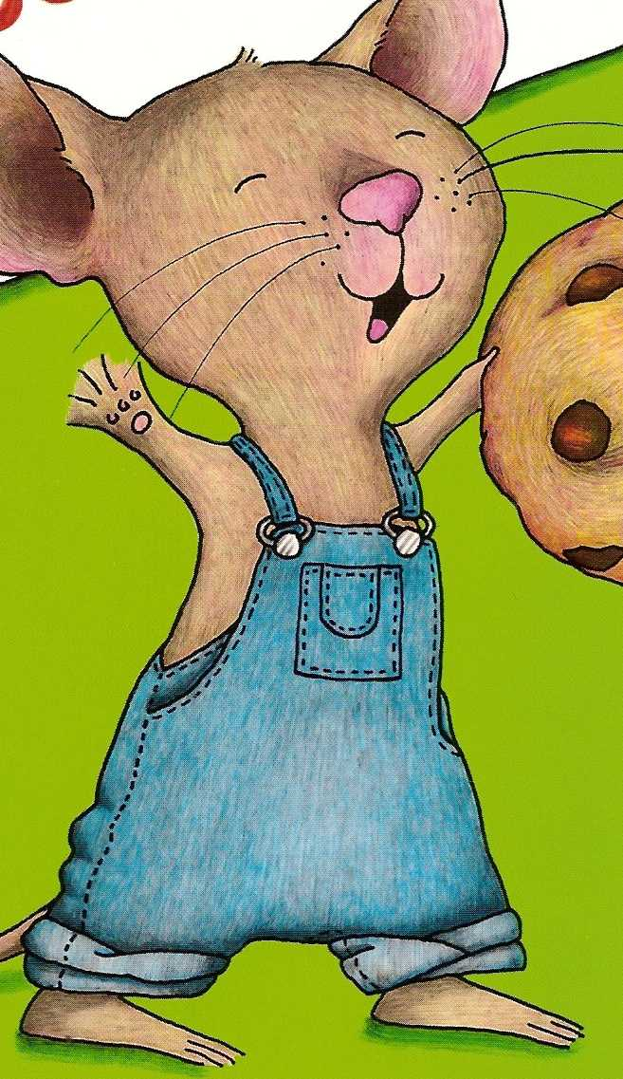 Each student will receive one of these. They will write down their predictions on the overalls and their names on the head. The teacher might want to write down if they had a correct prediction or not on the back. The teacher will keep a record of these in a journal for each student. At the end of the week, you will be able to see their progress with predictions. ** Pictures taken from If You Give a Mouse a Cookie by Laura Numeroff Tuesday/Day 2 1st Grade Language Arts 2 Hour block Content Standards for Learners - Acquires vocabulary by listening to literature, participating in discussions, and reading self-selected texts. - Makes predictions about texts. - Answers questions about text. (English Language Development Standard) Pre-Teaching: Standards-Based Instructional Goals: - Make predictions before reading and check predictions after reading. - Learn meanings of new vocabulary. - Answer questions after reading the text through prompting. Assessment: The students will read If You Take a Mouse to School by Laura Numeroff. They will focus on pre-selected vocabulary words and patterns of the book. This will lead to them predicting throughout the story. I will assess the students by writing their predictions on individual mice and placing them on the board. Then, they will find their predictions and see if they came true. Students will also take turns opening lunchbox words from a bag. Each lunchbox will have a vocabulary word on it. Students will pronounce the word and then look for it in the text. As a group, students will create a definition for the word and place it in their vocabulary box. Student Grouping: The students are placed in their guided reading groups of four. The ELLs will all be on similar levels, thus allowing them to work well together. Learning Activities: - Place students in small group setting. - Welcome the students back. Ask who can remind you what book they read yesterday? - Have students open their Vocabulary Boxes and define their new words. - See if they can use the words in a sentence. - Display the cover of today’s text: If You Take a Mouse to School by Laura Numeroff. - Ask students what they think this book might be about. Have they seen this mouse before? - Explain to students that we have several articles that we are going to use to help us today. We have Mouse Predictors and Lunchbox Words. - Show the students the Mouse Predictor. Ask them to remind you what we use the Mouse Predictor for. - Explain to students that after we look through the book, they will write down their predictions on their Mouse Predictor. We will hang the Mouse Predictors up and see if they come true after reading the text. - Next, show the students the Lunchbox Words. Explain that there are five new vocabulary words from the text that we will be looking at. - After we read the text, we will create our own definitions for the words. - Open the book to the first page. Read aloud, “If you take a mouse to school, he’ll ask for your lunchbox”. Ask students if they have heard something similar. Prompt them by remind them about the book they read yesterday. - Read aloud, “The he’ll need to wash up. You’ll have to take him to the bathroom. Once he’s nice and clean, he’ll be ready for his lunch.” Ask students if they think they know what will happen afterwards. - Ask students how they think the book will end. - Distribute Mouse Predictors to each student. Have them write (or you can write) down what they think will happen in this book. If this is their first time predicting, let them know that the answer does not have to be right. A prediction is just a guess. - After the students use their Mouse Predictors, hang them on the board or somewhere where they can be seen. - Show students their Lunchbox Bag. Have them take turns pulling out lunchboxes until all Lunchbox Words have been read aloud. (lunchbox, sandwich, bathroom, notebook, and pencil). - Tell students that these are their Lunchbox Words. As they read, when they find a Lunchbox Word, place the lunchbox inside the book to mark the place. After reading, we will define the word. - Make sure you say each word aloud and have the students repeat it after you. - Distribute copies of the book. - Have students silently read to the page where the mouse is building blocks. - When they reach that point, have students retell what has happened so far. Ask them if they can guess what might happen next. Does this book remind them of another? - Have students finish reading silently or whispering to himself or herself. - After students have finished, have them retrieve their Mouse Predictors one at a time and tell whether their prediction came true. - Collect these predictions to keep a record of how their prediction progress is coming throughout the week. - Have students show you where they put their Lunchbox Words. Ask them to help you define the words. As you define them, have students write the definition on the back. - Ask the students if they have heard or seen these words before (not in the book). - Explain to the students that we are using vocabulary words that they will see in school, so this will help them understand more words. - When all the words have been defined, have students put them in their Vocabulary Box. - Last, reread the story aloud, inviting the students to take turns reading aloud if they want to. IF they want, they can read aloud with you. - Thank them and remind them that tomorrow we will read a book that they might recognize from today, so they should make sure to keep their Lunchbox Words close. Materials and Resources - 4 copies of If You Take a Mouse to School by Laura Numeroff - plenty of Mouse Predictors - 4 sets of Lunchbox Words (enough for each student to have a set) - 4 Vocabulary Boxes Lunchbox Word 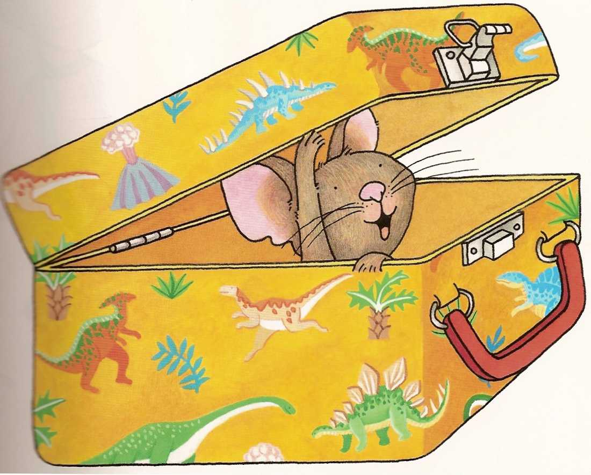 On each lunchbox, the teacher will write the Lunchbox Word. This book has five words: lunchbox, sandwich, bathroom, notebook, and pencil. The students will write their definitions on the back and store in their vocabulary box. Mouse Predictor 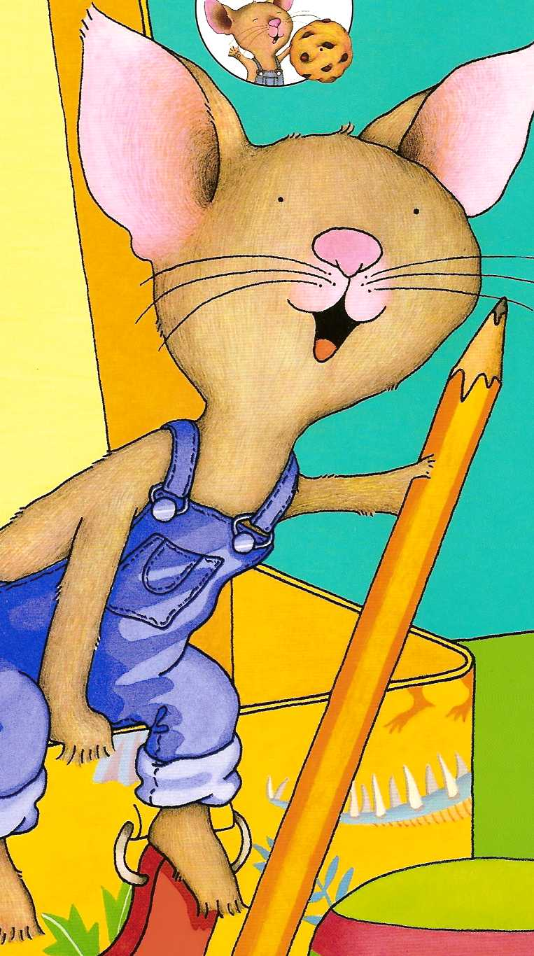 The students will write their predictions down on this. Make sure to notice it is the same mouse as the previous book, but with a pencil so we know that he is going to school! The teacher might want to write down if they had a correct prediction or not on the back. The teacher will keep a record of these in a journal for each student. At the end of the week, you will be able to see their progress with predictions. ** Pictures taken from If You Take a Mouse to School by Laura Numeroff Wednesday/Day 3 1st Grade Language Arts 2 Hour block Content Standards for Learners - Acquires vocabulary by listening to literature, participating in discussions, and reading self-selected texts. - Makes predictions about texts. - Answers questions about text. (English Language Development Standard) Pre-Teaching: Standards-Based Instructional Goals: - Make predictions before reading and check predictions after reading. - Learn meanings of new vocabulary. - Answer questions after reading the text through prompting. Assessment: The students will read If You Give a Moose a Muffin by Laura Numeroff. They will focus on pre-selected vocabulary words and patterns of the book. This will lead to them predicting throughout the story. I will assess the students by writing their predictions on an individual moose and placing them on the board. Then, they will find their predictions and see if they came true. Students will also take turns opening muffin words from a bag. Each muffin will have a vocabulary word on it. Students will pronounce the word and then look for it in the text. As a group, students will create a definition for the word and place it in their vocabulary box. Student Grouping: The students are placed in their guided reading groups of four. The ELLs will all be on similar levels, thus allowing them to work well together. Learning Activities: - Place students in small group setting. - Welcome the students back. Ask who can remind you what book they read yesterday? - Have students open their Vocabulary Boxes and define their new words. - See if they can use the words in a sentence. - Display the cover of today’s text: If You Give a Moose a Muffin by Laura Numeroff. - Ask students what they think this book might be about. Does this sentence structure seem familiar? - Point out to the students that all the books we have read so far are by the same author. Does this mean anything? Does this give them a clue about the structure of the books? - Explain to students that we have several articles that we are going to use to help us today. We have Moose Predictors and MuffinWords. - Show the students the Moose Predictor. Remind students that this is not a mouse, but do they think we use it in the same why? - Explain to students that after we look through the book, they will write down their predictions on their Moose Predictor. We will hang the Moose Predictors up and see if they come true after reading the text. - Next, show the students the Muffin Words. Explain that there are five new vocabulary words from the text that we will be looking at. - After we read the text, we will create our own definitions for the words. - Open the book to the first page and read aloud, “If you give a moose a muffin, he’ll want some jam to go with it.” Ask students what jam is. - Read aloud, “So, he’ll ask for some old socks. He’ll make sock puppets.” Ask the students if they have ever made sock puppets. - Ask the students what other objects the moose might ask for. Prompt them to explain why they chose these objects. - When they are reading, encourage them to use their Vocabulary boxes because there might be a word from a previous text in the book. - After you have examined all the pictures, close the book. - Distribute Moose Predictors to each student. Have them write (or you can write) down what they think will happen in this book. If this is their first time predicting, let them know that the answer does not have to be right. A prediction is just a guess. - After the students use their Moose Predictors, hang them on the board or somewhere where they can be seen. - Show students their Muffin Bag. Have them take turns pulling out muffins until all Muffin Words have been read aloud. (lunchbox, sandwich, bathroom, notebook, and pencil). - Tell students that these are their Muffin Words. As they read, when they find a Muffin Word, place the muffin inside the book to mark the place. After reading, we will define the word. - Make sure you say each word aloud and have the students repeat it after you. - Distribute copies of the book. - Have students silently read to the page where the moose asks for socks. - When they reach that point, have students retell what has happened so far. Ask them if they can guess what might happen next. Does this book remind them of another? - Have students finish reading silently or whispering to himself or herself. - After students have finished, have them retrieve their Moose Predictors one at a time and tell whether their prediction came true. - Collect these predictions to keep a record of how their prediction progress is coming throughout the week. - Have students show you where they put their Muffin Words. Ask them to help you define the words. As you define them, have students write the definition on the back. - Ask the students if they have heard or seen these words before (not in the book). - Explain to the students that we are using vocabulary words that they will see in school, so this will help them understand more words. - When all the words have been defined, have students put them in their Vocabulary Box. - Read aloud the book again to the students. - Tell the students that we are going to do a retelling and you will write down what they say. - Have students work together to create a retelling of the book. Make sure to record their story. Write down who said what so that you can keep notes on their progress. - When they have finished, read their retelling back to them. - Thank them and remind them that tomorrow we will read a book that they might recognize from today, so they should make sure to keep their Muffin Words close. Materials and Resources - 4 copies of If You Give a Moose a Muffin by Laura Numeroff - plenty of Moose Predictors - 4 sets of Muffin Words (enough for each student to have a set) - 4 Vocabulary Boxes Muffin Words 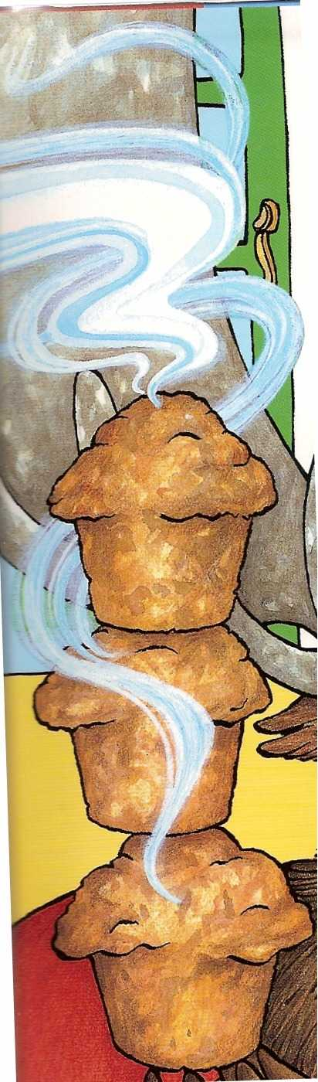 On each muffin, the teacher will write the Muffin Word. This book has five words: muffin sweater, sockets, puppets, and paint. The students will write their definitions on the back and store in their vocabulary box. Moose Predictor 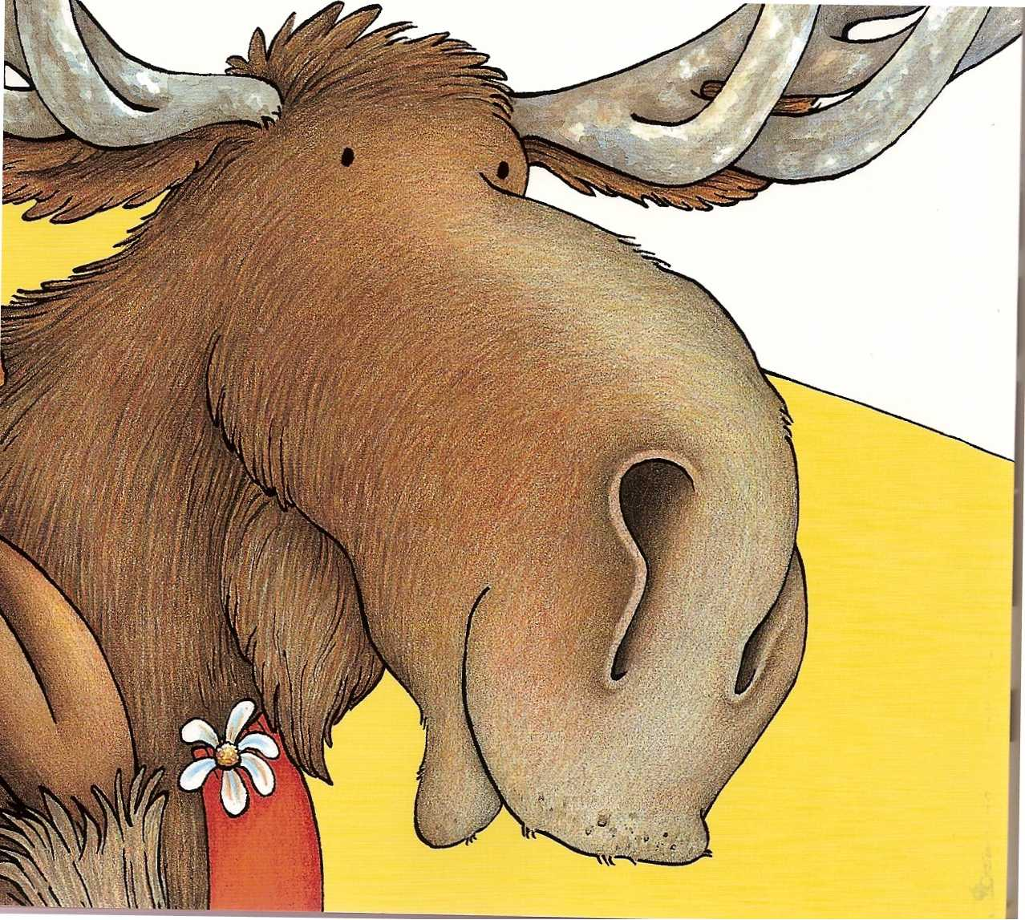 The students will write their predictions down on this. Make sure to note that it is not a mouse, but a moose, which is the main character of the book. The teacher might want to write down if they had a correct prediction or not on the back. The teacher will keep a record of these in a journal for each student. At the end of the week, you will be able to see their progress with predictions. ** Pictures taken from If You Give a Moose a Muffin by Laura Numeroff Thursday/Day 4 1st Grade Language Arts 2 Hour block Content Standards for Learners - Acquires vocabulary by listening to literature, participating in discussions, and reading self-selected texts. - Makes predictions about texts. - Answers questions about text. (English Language Development Standard) Pre-Teaching: Standards-Based Instructional Goals: - Make predictions before reading and check predictions after reading. - Learn meanings of new vocabulary. - Answer questions after reading the text through prompting. Assessment: The students will read If You Give a Pig a Pancake Laura Numeroff. They will focus on pre-selected vocabulary words and patterns of the book. This will lead to them predicting throughout the story. I will assess the students by writing their predictions on individual pigs and placing them on the board. Then, they will find their predictions and see if they came true. Students will also take turns opening pancake words from a bag. Each pancake will have a vocabulary word on it. Students will pronounce the word and then look for it in the text. As a group, students will create a definition for the word and place it in their vocabulary box. Student Grouping: The students are placed in their guided reading groups of four. The ELLs will all be on similar levels, thus allowing them to work well together. Learning Activities: - Place students in small group setting. - Welcome the students back. Ask who can remind you what book they read yesterday? - As a warm-up activity, we are going to compare and contrast the three books that we have read so far. - Draw a Venn Diagram on the board with three circles. - Have the students do a quick retelling of the books so far. If they need help, remind them to use their Vocabulary Boxes. - Work on each circle and write down things that are unique to that book. - In the circles that overlap, write down things that are the same. This activity might take a while, but will be beneficial to the students. - When you are finished, ask the students what they have noticed about the books that we have read so far. Encourage them to look at the Venn Diagram and the books, if they want. - Ask the students to predict what today’s book will be like. Give them a clue that it is about a pig! - Display the cover of today’s text: If You Give a Pig a Pancake by Laura Numeroff. - Ask students what they think this book might be about. - Explain to students that we have several articles that we are going to use to help us today. We have Pig Predictors and Pancake Words. Ask the students what they notice about our predictors. Prompt them to answer that they are in the form of the main character each time. - Show the students the Pig Predictor. How do we predict? - Explain to students that after we look through the book, they will write down their predictions on their Pig Predictor. We will hang the Pig Predictors up and see if they come true after reading the text. - Next, show the students the Pancake Words. Explain that there are five new vocabulary words from the text that we will be looking at. - After we read the text, we will create our own definitions for the words. - Open the book and read aloud, “If you give a pig a pancake, she’ll want some syrup to go with it.” Ask students if they like syrup with their pancakes. Maybe they use butter? - Ask students if they think the pig will be messy. Are pigs usually messy? - Read aloud, “On the way, she’ll see the tree in your backyard. She’ll want to build a tree house.” Ask students if they know what a tree house is. Have they ever built one? Was it hard? - When they are reading, encourage them to use their Vocabulary boxes because there might be a word from a previous text in the book. - After you have examined all the pictures, close the book. - Distribute Pig Predictors to each student. Have them write (or you can write) down what they think will happen in this book. If this is their first time predicting, let them know that the answer does not have to be right. A prediction is just a guess. - After the students use their Pig Predictors, hang them on the board or somewhere where they can be seen. - Show each student their Pancake Bag. Have them take turns pulling out pancakes until all Pancake Words have been read aloud. (pancake, sticky, syrup, glue, and camera). - Tell students that these are their Pancake Words. As they read, when they find a Pancake Word, place the pancake inside the book to mark the place. After reading, we will define the word. - Make sure you say each word aloud and have the students repeat it after you. - Distribute copies of the book. - Have students silently read to the page where the pig sees the picture. - When they reach that point, have students retell what has happened so far. Ask them if they can guess what might happen next. Does this book remind them of another? - Have students finish reading silently or whispering to himself or herself. - After students have finished, have them retrieve their Pig Predictors one at a time and tell whether their prediction came true. - Collect these predictions to keep a record of how their prediction progress is coming throughout the week. - Facilitate a discussion among the students about the book. Did they like it? What parts did they like or dislike. - Have students show you where they put their Pancake Words. Ask them to help you define the words. As you define them, have students write the definition on the back. - Ask the students if they have heard or seen these words before (not in the book). - Explain to the students that we are using vocabulary words that they will see in school, so this will help them understand more words. - When all the words have been defined, have students put them in their Vocabulary Box. - Ask the students which book was their favorite and why. - Explain to students that we are going to create our own “If You Give A…” book based on our favorite characters. - Have the students pull out their Vocabulary Box and spread their words out. - Each student will contribute a sentence using a vocabulary word. - As the teacher, act as the scribe. - When the book is finished, make copies for all of the students. - Remind students that tomorrow we will wrap up the unit with special activities and a book. Materials and Resources - 4 copies of If You Give a Pig a Pancake by Laura Numeroff - plenty of Pig Predictors - 4 sets of Pancake Words (enough for each student to have a set) - 4 Vocabulary Boxes Pancake Words  On each pancake, the teacher will write the Pancake Word. This book has five words: pancake, sticky, syrup, glue, and camera. The students will write their definitions on the back and store in their vocabulary box. Pig Predictor 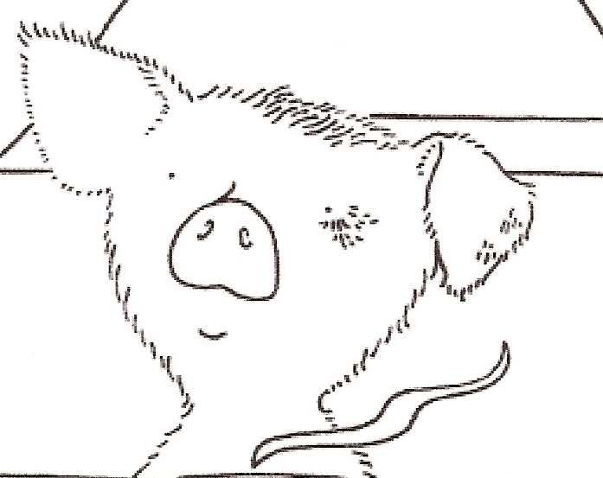 The students will write their predictions down on this. Make sure to note that it is a pig because the pig is our main character. The teacher might want to write down if they had a correct prediction or not on the back. The teacher will keep a record of these in a journal for each student. At the end of the week, you will be able to see their progress with predictions. ** Pictures taken from If you Give a Pig a Pancake by Laura Numeroff Friday/Day 5 1st Grade Language Arts 2 Hour bloc Content Standards for Learners - Acquires vocabulary by listening to literature, participating in discussions, and reading self-selected texts. - Makes predictions about texts. - Answers questions about text. (English Language Development Standard) Pre-Teaching: Standards-Based Instructional Goals: - Make predictions before reading and check predictions after reading. - Learn meanings of new vocabulary. - Answer questions after reading the text through prompting. Assessment: The students will read Cookies: Bite-Size Life Lessons by Amy Krouse Rosenthal. They will focus on pre-selected vocabulary words and patterns of the book. Student Grouping: The students are placed in their guided reading groups of four. The ELLs will all be on similar levels, thus allowing them to work well together. Learning Activities: - Welcome the students to the last day of the unit. - Show them the cover of the book we will be working with today, Cookies: Bite-Size Life Lessons by Amy Krouse Rosenthal. - Ask the students what they see on the cover. Do they see things that we have been discussing this week? - Have the students open up their vocabulary boxes. - Hold a discussion about the words that we have been learning this week. Did they see those words or hear them outside the classroom? Was it helpful to learn words that they would use in every-day speech? - Explain to students that the book today talks about making cookies, but teaches us some very important words (cooperate, patient, proud, modest, respect, trustworthy, fair, unfair, compassionate, greedy, generous, pessimistic, optimistic, polite, honest, courageous, envy, loyal, open-minded, regret, content, and wise. - These are all new words that are difficult concepts to understand, yet will be easier to learn because of the underlying cookie theme. - Show students the bite-size words. - Read each word aloud and have them repeat the word after you. - Ask the students if they know what any of these words mean. If they do, write down their answers on a piece of paper. - Preview the book with them. Read the first page, “Cooperate means, how about you add the chips while I stir?” Point out that the word cooperate is in bold. Explain that means that is the main word. - Ask the students about the picture. Can they think of another example of cooperate? - Repeat this process with each bolded word until you finish the book. - Distribute the books to the students. Have them read the book silently or whispering softly. If they wish, use their bite-size cookies to mark pages where the words appear. - When the students finish, ask their opinions on the book. Did they like it? What did it remind them of? Prompt them to answer making cookies. - Ask students what other books that we read this week discussed cookies. - Use the bite-size cookies and write definitions on the backs that are student-created. - Read the book aloud and invite students to take turns reading with you. - Remind students that these words are concepts, thus harder to understand. - When finished with the book, ask the students to recall the different books we read this week. - Ask students what items you can eat were discussed. (Cookies, sandwich, pancakes, muffins) - Surprise students and tell them that we are going to be making these special treats. There are four treats and four students, so each student will get to make their treat. - Explain that we are following a recipe like in the book that we just read. - Distribute mixes to each child and guide them through reading the recipes and planning their treats. - After they are finished, each student will read their book aloud to the group. - Remind students that they can always use their vocabulary boxes by themselves. It is important to make their own note cards. They can do this with teacher aid. Materials and Resources - 4 copies of Cookies: Bite-Size Life Lessons by Amy Krouse Rosenthal - 4 Vocabulary Boxes - Muffin Mix - Cookie Mix - Pancake Mix - Sandwich things Bite-Size Words Each word of wisdom will be written on these bite-size cookies. Rationale/Connections I created my lesson plans based on a need for guided reading strategies with English Language Learners. This rationale and connections paper will explain why I created the lesson plans the way I did, show an understanding of professional knowledge, and provide implications for my profession. A lot of literature was read in order to prepare for this project. I felt that most of the information provided was very practical. My lesson plans were created based on the readings that I did. Guided reading is actually an easy process once it is practiced. I think that I prepared my lessons with a lot of time and thought. When choosing the books for the unit, I thought about fun books that had a common theme. I geared the lessons for first grade, yet wanted something that was not too young. I realized that Laura Numeroff’s books were perfect for working with ELLs. There is not an abundance of text, yet there are rich vocabulary words and great themes throughout it. My first graders had read If You Give a Pig a Pancake and they loved it and thought it was a hilarious book. Most of them were ELLs, so I knew that these books were at an appropriate grade level. I lucked into the closing book for the unit. Concepts are difficult to teach, especially to ELLs. Cookies: Bite-Size Life Lessons was a book that I discovered at Davis Kidd. I realized that it took a unique approach to learning life lessons. Not only was the book structured like a recipe, but also it had the underlying cookie theme that was also present in my unit. I would highly recommend using this book when teaching ELLs because of the simplicity of text and the rich pictures and content. Guided reading was not a concept that I was familiar with until I came to Peabody. After taking classes with Dr. Vicki Risko, I was given the opportunity to practice guided reading during my practicum. My comfort level progressed the more I used guided reading. At the end of the practicum, I felt like I had done a good job working with my students. The lesson plan format that I used with this project is the same that I used in Dr. Risko’s classes. I used this format because it became very easy and almost second nature. Lastly, some might question the cooking activity on the final day. I feel that following a recipe is a great way for ELLs to learn to follow directions. It was also nice for them to be able to choose a book and make the “characters” come to life. I felt that this allowed them ownership of their reading. It is not realistic to expect the students to learn all twenty new vocabulary words in one week. However, the students may have heard some of the words before and will continue to hear those words used in and out of the classroom. As a teacher, when choosing vocabulary words for ELLs, there must be some sort of connection. By having words that would appear in their everyday lives, the teacher is providing more opportunities to practice those words. In addition, the vocabulary box is something that can be used in all classes, not just language arts. The students now understand how to create their vocabulary cards. This habit should be carried over into all subjects. My idea behind this was to introduce them to a fun and new way to learn words, without it seeming like too much work. By using cookies, muffins, etc. I provided them with a visual clue to the word as well. This is a huge benefit for ELLs since I previously mentioned how important the use of realia is in the classroom. The standards were chosen from Metro Nashville Public Schools First Grade. I also made sure to look up the English Language Learner expectations. The objectives were based on what first graders should be doing and what ELLs should be capable of accomplishing. When working with ELLs, I needed to make sure that I was sticking to the curriculum while providing the support that they required as well. The assessments that I planned were rather informal. I would not create formal assessments until after the students learned the guided reading methods. By collecting the students’ predictions, the teacher is able to see their progress over all five days. Any student-created items can also be stored in a file for future reference. When thinking back on the literature that I read, I realized that the books for teachers were the most helpful. They were very clear and explained systematically how to do guided reading. The information on vocabulary was not specifically designed for ELLs, but I found that most vocabulary instruction for ELLs is similar to working with struggling readers. The theory behind guided reading was very applicable to actual practice. Oftentimes, it is hard for me to bridge theory and practice, but with guided reading, it was very accessible. When creating this project I drew upon a lot of information from my courses required for ELL certification. I graduated from undergrad with that certification, but had not had the opportunity to apply it to guided reading. This project allowed me to create something that would bridge my two knowledge bases: teaching English language learners and reading instruction. I am very excited to try out these lessons in the classroom; possibly this will happen through a class that I am taking this semester with Dr. Youb Kim. This project provided many implications for reading education. The first is that there needs to be more research done on guided reading and English Language Learners. Once the research is done, someone needs to write a book for teachers. Truly, the most influential part of the project was using the materials that teachers use to create lesson plans. It just made me further realize how hard it is to bridge together two seemingly unrelated topics (guided reading and ELLs). I say seemingly unrelated because in my mind there is no question that they are related. This country is moving in a direction that will require more teachers of ELLs. I feel that reading specialists will bear a bit of the burden. There may not be enough money or qualified teachers in a district to provide services to all ELLs. In Miami-Dade County, most teachers hold ELL certification out of necessity. Here in Nashville, I have not noticed as many teachers with certification. I think that often the reading specialists are providing services to the ELLs. As a future reading specialist, I need to be aware of the strategies that are most beneficial to ELLs. I have previously mentioned that ELL strategies are similar to struggling readers. It thus becomes a natural connection to work with ELLs and struggling readers using the same techniques. The reality of this project is that there is always room for improvement. As more and more strategies become common, the better the materials teachers have to work with. I think that this project could even be expanded into a full thematic unit for the general classroom with additional resources, however, that was not the purpose of this project. The intent of this project was to provide examples of doing guided reading instruction with English Language Learners, with a focus on vocabulary. That is what was done.

