Running Head: SAFETY BEHAVIORS AND HYPOCHONDRIASIS

The Effects of Safety Behaviors on Health Anxiety:
Conceptualizing Hypochondriasis as an Anxiety Disorder
Erin N. Etzel
Thesis completed in partial fulfillment
of the requirements of the
Honors Program in Psychological Sciences

Under the Direction of Dr. Bunmi Olatunji
Vanderbilt University
April 3, 2009

Approved Date
_____________________________ _______________

Abstract
Research in the anxiety disorders has shown that safety behaviors function to maintain pathological anxiety by preventing the disconfirmation of inaccurate threat beliefs. The present study examined if such safety behaviors might also contribute to the development and exacerbation of symptoms of health anxiety. The present study tested this notion in a sample of students that were randomized to a safety-behavior (n = 30) or a control (n = 30) condition. After a week-long baseline period, participants in the safety-behavior condition spent 1 week engaging in a clinically representative array of health-related safety behaviors on a daily basis, followed by a second baseline period. Participants in the control condition were instructed to monitor their normal use of safety behaviors. Subsequent to the manipulation, participants in the safety behavior manipulation evidenced statistically significant increases in health anxiety, contamination fear, disgust sensitivity, and cognitive and avoidant responses to three health-related behavioral avoidance tasks compared to those in the control condition. However, anxiety and depressive symptoms remained stable and did not differ between the two groups. These findings suggest that health-related safety behaviors may cause an increase in health anxiety and related processes. The implications of these findings for a cognitive-behavioral model of hypochondriasis are discussed.

The Effects of Safety Behaviors on Health Anxiety:

Conceptualizing Hypochondriasis as an Anxiety Disorder
What is hypochondriasis (severe health-focused anxiety)?
Hypochondriasis is characterized by the preoccupation that one has, or is imminently developing, a serious medical condition. This preoccupation interferes with the individual’s daily functioning and persists even after reassurance of good health from medical professionals (Abramowitz, 2005). Indeed, the relationship between patients with hypochondriasis and primary care doctors is often stressed by unnecessary requests for additional tests and procedures as a means of reassurance (Abramowitz, 2005). The misinterpretation of bodily functions, minor physical abnormalities, or vague and ambiguous physical sensations fuels this preoccupation and explains its current classification as a somatoform disorder in the DSM-IV (American Psychiatric Association, 2000). According to the DSM-IV, the prevalence of hypochondriasis in the general population is 1% - 5%. However, within the population of primary care outpatients, estimates of the prevalence of hypochondriasis range from 2% - 7%. In fact, somatic symptoms are the root cause of over half of outpatient doctor’s visits, but only about half of those symptoms presented are found to have a purely physical cause (Khan, Khan, Harezlak, Tu, & Kroenke, 2003).
Examination of cultural influences suggests that a higher prevalence of hypochondriasis may be observed among African-Americans even when controlling for other sociodemographic variables (Barsky, Wyshak, Klerman, & Latham, 1990). A review of the literature on somatoform disorders found that women were typically more likely to present with somatic symptoms, but whether this presentation necessitates a diagnosis of hypochondriasis is unclear because of overlap with other diagnostic categories (Creed & Barsky, 2004). In fact, these findings suggest that, unlike other somatoform disorders, hypochondriasis does not appear to have a gender bias (Creed & Barsky, 2004). However, women are inclined to use medical services more frequently, which may be indicative of more psychological distress (Kroenke & Spitzer, 1998).
According to Salkovskis and colleagues (1986), distress resulting from health anxiety symptoms and disturbing thoughts about the origins of those symptoms combine to resemble features of obsessive-compulsive disorder (OCD). However, repeated attempts to seek reassurance from medical personnel compound the problem by providing temporary relief and eventually, a prolonged state of anxiety. Unfortunately, the overuse of medical services only serves to reinforce anxiety about health among patients with hypochondriasis (Abramowitz & Deacon, 2004). Accordingly, hypochondriasis can be a chronic, stable condition that often causes long-term disability (Abramowitz, 2005). This chronicity has led to considerations of hypochondriasis as a personality trait (American Psychiatric Association, 2000). Indeed, hypochondriasis can be diagnosed at any age, but is usually diagnosed in early adulthood. The onset of hypochondriasis may emerge secondary to severe reactions to the death or severe illness of a loved one or just simply a conscious decision to be more proactive about one’s health (Abramowitz & Deacon, 2004).
Impact of Hypochondriasis
Hypochondriasis greatly impacts individual quality of life (Barsky, 1996). For example, hypochondriasis interferes with daily activities and places additional stress on interpersonal relationships with family and friends. Relationships with medical professionals are also strained as these patients are often reluctant to approach their problems as anything other than organic (Abramowitz, 2005). Fear of illness becomes central to the individual’s self-image, which may manifest in poor insight such that individuals with hypochondriasis cannot recognize that their health concerns are unreasonable (American Psychiatric Association, 2000).
Hypochondriasis also leads to an economic burden due to excessive utilization of primary care resources including unnecessary medical tests and procedures. Patients who often present with somatic symptoms observed in hypochondriasis make more visits to their doctor, have more hospital stays, and incur higher health care costs (Barsky, Ettner, Horsky, & Bates, 2001). Indeed, Barsky et al. found that patients scoring at or above the 86th percentile on a self-report measure of somatization and health anxiety had average outpatient costs of approximately $1,500 compared with about $863 for those who scored below that level. In a more recent study, Barsky, Orav, and Bates (2005) found that, in one year, somatizing patients incurred total health care costs about $2,700 greater per patient than those of non-somatizing patients. Based on that figure, the researchers estimate that the cumulative cost of care for these patients nationwide is approximately $250 billion dollars annually. Such a dramatic expense in an era of managed care highlights the need for more sophisticated ways of conceptualizing the etiology and treatment of hypochondriasis.
Traditional Models of Hypochondriasis
Traditionally, hypochondriacal concerns have been viewed as a dimension of personality linked to neuroticism and negative affectivity (Noyes, 1999). Psychiatrists have prescribed selective serotonin reuptake inhibitors in order to manage hypochondriacal symptoms, but this treatment strategy often does not result in long lasting symptom relief (Abramowitz, Whiteside, & Schwartz, 2002). A psychodynamic framework suggests that unconscious motivations and “attention-seeking” are the impetus behind hypochondriasis, maintaining that patients remain preoccupied with illness and persistently seek reassurance of good health because of the secondary gain associated with these behaviors (Barsky & Klerman, 1983). If one is sick, that individual is excused from normal daily functioning and will receive sympathy. Such a model views the hypochondriacal patient’s anxiety as the manifestation of unmet interpersonal or physiological needs (McCranie, 1979). According to McCranie’s model, the patient seeks out a diagnosis to justify his or her shortcomings and embraces the idea of a medical cure. This diagnosis temporarily serves to defend the patient’s ego against his or her low self-esteem (Barsky & Klerman, 1983). But, when the benefits of a cure prove to be short-lived, the patient endures the diagnostic cycle once again.
Other psychodynamic interpretations of hypochondriasis suggest that fears of one’s own body and internal disease cues manifest themselves as fear of death (Starcevic, 2005). The hypochondriac’s search for reassurance that he or she is ill seems to function similarly to the Freudian concept of Thanatos, the death drive. In this way, the hypochondriacal obsession with disease and death compels the sufferer to look for symptoms that may ultimately lead to his or her own death, just as Freud believed Thanatos triggered self-destructive behavior in humans. This fixation on the end of life may actually have its roots in the early stages of life. Noyes and colleagues (2002) found that patients with hypochondriasis reported significantly more traumatic experiences during childhood and were more likely to have had substance-abusing parents. These findings also indicate that childhood experience of serious illness and exposure to serious illness or death may foster a sense of increased susceptibility to illness. However, Freudian psychoanalysis would suggest that parental tendencies toward overprotection might actually reinforce the sick role from a young age and lead to unresolved conflicts and hypochondriasis later in life (Noyes et al., 2002). Yet another psychodynamic interpretation argues that hypochondriasis is the result of repressed anger and a means of blaming others for his or her suffering (Brown & Vaillant, 1981). The treatment that derives from this model recommends recognizing the patient’s somatosensory experience as a real entity to help build a therapeutic relationship; however, these psychodynamic explanations of separate features of hypochondriasis do not easily lend themselves to a systematic and standardized treatment.
Contemporary Cognitive-Behavioral Models of Hypochondriasis
Parallels between hypochondriasis and OCD and panic disorder have initiated conceptualizations of hypochondriasis as an anxiety disorder (Abramowitz, Olatunji, & Deacon, 2007). Given that empirically supported cognitive-behavioral models of anxiety disorders are well established, translating such a model to hypochondriasis could greatly advance our understanding of this complex disorder (Abramowitz et al., 2002). In terms of a possible link to OCD, 34% of patients who met criteria for OCD report health-related obsessions (Abramowitz, Brigidi, & Foa, 1999) suggesting some symptom overlap with hypochondriasis. Persons with a primary diagnosis of hypochondriasis have been found to exhibit obsessive-compulsive traits and, in fact, a cross-sectional family study found that approximately 10% of hypochondriacs in the sample presented with comorbid OCD (Greeven, van Balkom, van Rood, van Oppen, & Spinhoven, 2006). In hypochondriasis, intrusiveness/undesirability of thoughts about having a disease may be functionally similar to obsessions in OCD and the excessive need for reassurance may parallel compulsive rituals in OCD (Abramowitz, 2005; Abramowitz et al., 1999).
The excessive vigilance for bodily sensations that is central to etiological models of panic disorder (Schmidt, Lerew, & Trakowski, 1997) can also be observed in hypochondriasis where body vigilance can lead to illness attributions of unusual bodily sensations (Olatunji, Deacon, Abramowitz, & Valentiner, 2007). Catastrophic misinterpretations of bodily sensations as signals of severe illness in hypochondriasis may also contribute to the fear of physical sensations (Olatunji, Wolitzky-Taylor, Elwood, Connolly, Gonzales, & Armstrong, in press). In panic disorder, spontaneous panic attacks increase fear of arousal sensations, leading to increased vigilance to these arousal sensations and increased perception of arousal sensations, which, in turn, causes increased anxiety and additional arousal sensations, thereby perpetuating the cycle (Schmidt et al., 1997). As depicted in Figure 1, a similar cycle may exist in hypochondriasis. According to Abramowitz, Deacon, and Valentiner (2007), individuals with hypochondriasis may interpret normal bodily functions (i.e., gastric fluctuations) as catastrophic (i.e., stomach cancer) leading to excessive anxiety about health and the need for reassurance.
Treatment using the Cognitive-Behavioral Model
If the symptom patterns present in hypochondriasis are similar to those in some anxiety disorders, then perhaps the same treatment model most effectively used to treat anxiety disorders can also benefit hypochondriasis patients. Cognitive-behavioral therapy (CBT) techniques may benefit hypochondriacal patients in the same way that they serve to treat irrational thoughts in anxious patients. CBT may function by employing response prevention to curtail paradoxical safety behaviors and provide a means of challenging irrational beliefs and establishing more constructive beliefs (Abramowitz & Deacon, 2004). Exposure interventions that help patients confront situations, physical sensations, and thoughts that are frequently and needlessly avoided and feared may also combat avoidance behaviors in hypochondriasis (Abramowitz, 2005).
Studies examining the efficacy of CBT for hypochondriasis have produced very promising results. For example, Visser and Bouman (2001) found that exposure in vivo plus response prevention and cognitive therapy was efficacious in the treatment of hypochondriasis compared to no treatment. Buwalda, Bouman, and van Duijn (2006) also found CBT and a problem-solving educational approach to be equally as effective in the treatment of hypochondriacal symptoms. A more recent study found that a CBT intervention given in a secondary care setting was efficacious, relative to a control group, in reducing health anxiety symptoms and requests for medical consultations compared to a control condition (Seivewright et al., 2008). The cognitive-behavioral model of hypochondriasis, based largely on functional similarities with the anxiety disorders, seems to have facilitated a more effective treatment strategy. However, the mechanisms of change in CBT for hypochondriasis are yet to be fully elucidated. Examination of specific individual difference variables that may contribute to the development of hypochondriasis may prove to be helpful in this regard.
Individual Difference Traits and Hypochondriasis
A growing body of research suggests that individual differences in disgust sensitivity have been implicated in the development and maintenance of hypochondriasis. The propensity to experience disgust, often referred to as disgust sensitivity, may improve one’s evolutionary fitness by encouraging the avoidance of germs and contaminated objects. In this way, disgust sensitivity and contamination fear may both be linked to health anxiety via a disease avoidance mechanism (Oaten, Stevenson, & Case, 2009). Consistent with this notion, Thorpe, Patel, and Simonds (2003) found that disgust sensitivity scores were significantly correlated with health anxiety scores. Furthermore, disgust sensitivity was the most robust predictor of hand washing frequency compared to health anxiety, general anxiety, and fear of death, whereas health anxiety was the best predictor of the affective response to hand washing. Davey and Bond (2006) also found that the strong relationship between disgust sensitivity and health anxiety remains even after controlling for levels of trait anxiety. It is important to note, however, that the relationship between disgust sensitivity and health anxiety may be bidirectional (Oaten et al., 2009). Although disgust sensitivity may be conceptualized as a risk factor for the development of hypochondriasis (Olatunji, in press), a history of illness may also be a risk factor for the development of disgust sensitivity and contamination fear.
Catastrophic appraisals of physical sensations are often cited as a trigger for panic attacks in panic disorder (Schmidt, Joiner, Staab, & Williams, 2003). Similarly, this fear of bodily sensations, or anxiety sensitivity, may also predispose an individual to interpret more generalized sensations as physical symptoms of an illness (Olatunji et al., in press). Indeed, several studies have investigated the relationship between anxiety sensitivity and hypochondriasis. For example, Watt and Stewart (2000) observed that anxiety sensitivity may increase one’s risk of developing hypochondriacal concerns during young adulthood if one’s social learning experience as a child involved sensitivities to both arousal-related and non-arousal-related bodily sensations. Consistent with these findings, Stewart, Sherry, Watt, Grant, and Hadjistavropoulos (2008) found a significantly positive correlation between anxiety sensitivity, particularly for physical concerns, and elevated preoccupation with somatic symptoms in a nonclinical sample. The link between anxiety sensitivity and hypochondriacal concerns has also been found in clinical samples. For instance, Otto, Pollack, Sachs, and Rosenbaum (1992) found that anxiety sensitivity was significantly positively correlated with several indicators of health anxiety among patients with panic disorder even when controlling for anxiety and depressive symptoms. An extension of this work found that anxiety sensitivity significantly predicted illness concerns among patients with major depression (Otto, Demopulos, McLean, Pollack, & Fava, 1998). Anxiety sensitivity in hypochondriasis may motivate efforts to avoid harm and obtain certainty. According to the cognitive behavioral model, safety behaviors are often employed in this regard.

Safety Behaviors as Core Mechanism in Hypochondriasis
Safety behaviors, defined as actions used to perceive and subsequently avoid specific threats (Salkovskis, 1991), provide a means of short-term relief from the anxiety-inducing stimulus, but, in time, serve to perpetuate and reinforce anxiety and its associated avoidance (Rachman, Radomsky, & Shafran, 2008). For example, a recent study found that participants high in contamination fear that engaged in safety behaviors evidenced statistically significant increases in threat overestimation, contamination fear, and avoidance (Deacon & Maack, 2008). This finding suggests that the systematic engagement in safety behaviors may be causal in the development of some anxiety-based conditions. Similarly, safety behaviors in hypochondriasis may cause a misattribution of safety such that the non-occurrence of a feared catastrophe (e.g., illness) may be erroneously attributed to a safety behavior (e.g., excessive medical evaluations). Safety behaviors in hypochondriasis such as body checking, seeking evidence of good health from doctors, from relatives and friends, or from Internet medical advice resources (“cyberchondria”) becomes habitual because of the instant reduction of distress that it produces (Abramowitz, 2005). Examination of the role of safety behaviors in the development of hypochondriasis may have important implications for treatment. Indeed, safety behaviors have been described as detrimental to the therapeutic process (Rachman et al., 2008). For example, one study found that the use of safety behaviors in patients with claustrophobic fear during exposure therapy interfered with between-trial fear reduction and, thus, was detrimental to treatment outcome (Sloan & Telch, 2002).
As depicted in Figure 1, safety behaviors have been theorized to be a key component of contemporary cognitive-behavioral models of health anxiety (Tang et al., 2007). However, the validity of this component of the model has not been extensively evaluated. Accordingly, the present study experimentally investigated the role of safety behaviors in the development of health anxiety symptoms. It was predicted that participants asked to engage in frequent use of health-related safety behaviors, compared to a control condition, would show a statistically significant increase in health anxiety. It was also predicted that participants in the safety behavior condition would demonstrate increased disgust sensitivity and contamination fear, as both of these variables are related to health anxiety by way of a disease avoidance mechanism. Thus, it was also predicted that participants in the safety behavior condition, compared to controls, would exhibit more avoidant behavior on a health-related behavioral avoidance task (BAT) and more physiological arousal. As evidence of specificity, no differences between the two groups were expected with regards to general anxiety and depressive symptoms.
Methods
Participants
Sixty-one volunteer participants, drawn from the undergraduate subject pool, were consented and randomized into 2 groups. One participant was withdrawn from the study due to hospitalization during the third week of participation. One group, the control group, was observed and instructed to do what they would normally do in their everyday lives throughout the 3-week study period. The experimental group, or the safety behavior manipulation group, was instructed to complete a 3-week manipulation, consisting of multiple phases as detailed below. The mean age of the control group (19.20 years; S.D. = 1.00) was not significantly different from the mean age of the safety behavior group (19.47 years; S.D. = 1.22). Gender was equally distributed across conditions as the control group was 73.3% female and the safety behavior group was 80.0% female. The sample was predominantly Caucasian (84.7%) with no significant differences in ethnic distribution between conditions (χ² = 1.063, p = 0.90). The sample was also similar in general health status at baseline, as determined by responses to a subset of items selected from the Short-Form Health Survey [SFHS; F(1, 58) = 1.46, p = .23].
Measures
General Health Status
The general health perceptions subscale of the Short-Form Health Survey (SFHS; McHorney, Ware, & Raczek, 1993) is a four item measure of perceptions about general health status. The subscale had good internal consistency with an alpha coefficient of .83.
Health Anxiety
The Short Health Anxiety Inventory (SHAI; Salkovskis, Rimes, Warwick, & Clark, 2002) contains 18 items that assess health anxiety independently of physical health status. Items assess worry about health, awareness of bodily sensations or changes, and feared consequences of having an illness on a scale from 0 to 3.
The Whiteley Index (WI; Pilowsky, 1967) is a widely used 14 item measure of hypochondriacal worries and beliefs. The WI assesses disease fear, disease conviction, and bodily preoccupation on a scale of 0, “not at all” to 4, “a great deal” (Conradt, Cavanagh, Franklin, & Rief, 2006.)
Disgust-Relevant Processes
The Disgust Scale-Revised (DS-R; Haidt et al., 1994; modified by Olatunji, Williams, Tolin, et al., 2007) Contamination disgust subscale is a 5 item self-report scale assessing contamination disgust sensitivity. The subscale had fair internal consistency with an alpha coefficient of .65.
The Padua Inventory (PI; Burns, Keortge, Formea, & Sternberger, 1996) contamination fear subscale consists of ten items assessing contamination concerns. Items are scored on a 5-point scale ranging from 0, "Not at all" to 4, "Very much."
Negative Affect
The Anxiety Sensitivity Index (ASI-3; Taylor et al., 2007) is an 18-item questionnaire assessing fear of anxiety sensations and beliefs that the sensations are potentially harmful across dimensions of Physical Concerns, Mental Incapacitation, and Social Concerns on a scale from 0, “very little” to 4, “very much.”
The Beck Anxiety Inventory (BAI; Beck, Epstein, Brown, & Steer, 1988) assesses 21 common symptoms of clinical anxiety (e.g., sweating, fear of losing control) on a scale of 0, “not at all” to 3, “severe”.
The Center for Epidemiologic Studies Depression Scale (CES-D; Radloff, 1977) is a 20 item measure of depressive symptomatology. The items of the scale assess symptoms on a scale of 0, “rarely or none of the time” to 3, “most or all of the time”.
Assessment of Health-Related Safety Behaviors
Health Behavior Checklist (HBC). Participants were instructed to complete a health behavior checklist at the end of each day during the 3-week study period. Respondents noted whether or not they performed each of 34 health-related safety behaviors that day by indicating ‘‘Yes’’ or ‘‘No.’’ Table 1 presents each health-related safety behavior on the checklist. The checklist also asked participants to rate how often concerns about their health entered their mind each day. Total scores were derived by calculating the average number of ‘‘Yes’’ responses on each completed checklist per day during a given study phase.

Assessment of Health-Related Behavioral Avoidance
Behavioral Avoidance Tasks (BATs). Participants completed three BATs that consisted of a series of steps as detailed below and in Appendix I, after which participants were asked to rate the anxiety and disgust levels they experienced from 0, “none at all,” to 10, “intense.” For purposes of analysis, four indices were calculated for each BAT: (1) avoidance, measured by the number of steps the participant refused to complete; (2) anxiety, determined by the average anxiety rating for each completed step; (c) disgust, assessed by the average disgust rating for each completed step; and (d) illness likelihood, determined by the participant’s estimation of likelihood of contracting an illness from the task.
Assessment of Physiological Responding
Systolic-Diastolic Blood Pressure and Heart Rate. Participants’ physiological responding was assessed with a WrisTech Blood Pressure Monitor. The monitor uses an oscillometric measurement method. Its measurement range is 0-280 mm Hg for pressure and 40-199 beats/minute for pulse. Pressure accuracy is within + 3 mm Hg and pulse accuracy is within + 5%.
Study Design
The present study utilized an ABA design consisting of multiple phases.
Phase One: Introductory Measures. Participants completed a battery of seven measures including the SHAI, WI, DS-R contamination subscale, PI contamination fear subscale, ASI-3, BAI, and CES-D. They were also given a survey about their health status to complete and participated in the three BATs. After completing the BATs, the participant’s blood pressure and heart rate were measured and recorded.
Phase Two: Baseline. For the first week, participants were instructed to monitor their normal frequency of health-related safety behaviors using an HBC, which they were to complete at the end of each day. Beginning with the first day of the baseline phase and continuing through the end of the three-week study, participants received daily e-mail reminders to complete their HBC each night in order to ensure compliance with the manipulation.
Phase Three: Safety Behavior Phase. After the one week monitoring period, participants were randomized to an experimental group or a control group. Again, both groups completed the seven study measures, three BATs, and blood pressure and heart rate measurements. Next, the experimental group was instructed to engage in frequent, daily health-related safety behaviors and the control group was instructed to continue to do what they would normally do on a day to day basis. This phase continued for one week and during this time, participants monitored their use of safety behaviors by completing the HBC at the end of each day.
Phase Four: Return to Baseline. Participants returned to the lab and completed the same seven measures, three BATs, and blood pressure and heart rate measurements. Participants in both groups were asked to once again engage in their normal frequency of health-related safety behaviors for the final week of the study.
Procedure
Individuals who expressed interest in participating in the study arranged a 45-minute meeting with a research assistant. During this meeting, the experimenter explained the purpose of the study and obtained informed consent. Participants were then informed about their responsibilities, which included reporting for three additional 30-minute appointments in the lab over the following three weeks that entailed completing five questionnaires and completing three BATs, completing a paper-and-pencil checklist on a daily basis, and spending the second week of the study actively engaging in a variety of health-related safety behaviors, if assigned to the experimental condition (see Table 1). Participants were informed of their right to terminate their involvement in the study at any time without penalty.
During the initial 45-minute meeting, consenting participants spent approximately 15-20 minutes completing the study questionnaires and participants were asked to participate in three BATs presented in a random order. These tasks, each of which consisted of five independent steps (touch bag containing item, open bag containing item, touch item, touch lips with hand used to touch item, touch lips with item), included (1) exposure to a tissue supposedly used by someone who has the common cold, (2) exposure to an oral thermometer supposedly used to measure the temperature of someone with the flu, and (3) exposure to a plastic water bottle from which a student infected with mononucleosis supposedly drank. Participants were informed that these behavioral tasks test their ability to approach certain objects and proceed as far as they can, but that they are not tests of courage and that they are free to refuse all or any part of the BATs. At each session, participants’ blood pressures and heart rates were measured and recorded immediately following the BATs.
Following the initial lab assessment as described above, participants spent one week (the “baseline” week) recording on a daily basis their use of specific behaviors related to health (e.g., hand washing, taking body temperature, body scanning and checking, avoiding touching dirty objects) and their preoccupation with thoughts of health anxiety on the HBC. To increase compliance with this task over the three-week study period, participants received daily reminder e-mails regarding completion of the HBC. Participants were instructed to engage in their normal health-related behaviors during the baseline week. Immediately following the baseline week, participants returned to the lab for a 30-minute appointment and repeated the same self-report, behavioral, and physiological measures they completed during their initial lab appointment.
After the second lab assessment following the baseline week, participants spent a second week (the “experimental manipulation” week) recording their daily use of health behaviors and preoccupation with health concerns. During the experimental week, however, participants in the experimental group were asked to engage daily in a variety of health-related safety behaviors (see Table 1). To assist participants in this endeavor, they were given a large plastic bag containing 2 trial-size bottles of Germ-X hand sanitizer to be carried with them at all times, a container of Clorox surface disinfectant wipes, and 7 tongue depressors to check their throats for inflammation each day of the week as listed on the HBC. Participants were instructed to use the anti-bacterial Clorox wipes to disinfect certain objects at home that might be particularly likely to harbor germs. Participants were also encouraged to avoid touching anything they thought might be contaminated by germs and to disinfect their hands immediately when contact was unavoidable. The control group engaged in their normal levels of health behavior use. Immediately following the experimental week, participants returned to the lab for a 30-minute appointment and completed the same assessments.
Participants then spent a third and final week (the “return to baseline” week) recording their daily use of health-related behaviors and preoccupation with health concerns. Participants were instructed to engage in the same level of health-related behaviors they engaged in during the initial baseline week (i.e., their normal health-related behaviors). Immediately following the return to baseline week, participants again returned to the lab for a final 30-minute appointment and completed assessment measures identical to those at prior sessions. In addition, participants were asked a brief series of open-ended questions about the study, including questions addressing their adherence with prescribed health-related behaviors, whether they perceived that engaging in health-related behaviors had an effect on their health anxiety, and possible explanations for this effect if it was evident. Participants were provided with their SONA credits following the fourth and final assessment and their participation was terminated at this time.
Results
Correlations among study measures
As shown in Table 2, measures of contamination disgust sensitivity, contamination fear, and negative affect were highly correlated with measures of health anxiety at baseline for the entire sample (p’s < .05). Of the measures of negative affect, anxiety sensitivity appeared to have the strongest correlation with measures of health anxiety. As shown in Table 3, disgust and anxiety responding to the BATs were significantly correlated (p < .001). BAT Illness Likelihood was also significantly correlated with anxiety responding on the BATs (p < .05). Importantly, baseline SHAI total scores were significantly negatively correlated with number of steps taken on average on the BATs (r = -.35, p < .05). This finding suggests that the BATs are adequate behavioral measures of health concerns. Table 4 presents correlations on the physiological measures where systolic and diastolic blood pressures were significantly correlated at baseline (p < .001).
Safety behavior manipulation check
To examine changes in health-related safety behavior usage as a result of the experimental manipulation, a 3 (assessment time point) x 2 (safety behavior condition) mixed ANOVA was conducted on weekly scores on the health behavior checklist (HBC). The analyses yielded significant main effects of time point [F(2, 104) = 100.99, p < .001, partial η² of .66] and condition, [F(1, 52) = 73.62, p < .001, partial η² = .59]. These main effects were qualified by a significant time point X condition interaction [F(2, 104) = 106.96, p < .001, partial η² = .673]. Subsequent analyses examining this interaction revealed no significant difference between the two groups in frequency of safety behaviors during the first week of the study (baseline phase; t = -0.99, p > .30). However, there was a significant difference in frequency during both the second and third weeks (study manipulation phase, t = -11.46, p < .001; return to baseline phase, t = -4.78, p < .001). Participants in the control group reported engaging in an average of 4.14 (S.D. = 2.51), 3.79 (S.D = 2.38), and 3.51 (S.D. = 2.39) health-related safety behaviors during the three weeks of the study, respectively. However, as expected, participants in the safety behavior group reported an average of 5.04 (S.D = 2.19), 17.14 (S.D. = 4.73), and 7.99 (S.D. = 4.34) safety behaviors, respectively.
Effects of safety behaviors on health anxiety
A series of 4 (assessment time point) x 2 (safety behavior condition) mixed ANOVAs examining the effects of the health-related safety behavior manipulation on self-report and behavioral measures of health anxiety was conducted. These results are summarized here and in Tables 5 and 6.
Self-reported health anxiety. A significant main effect of condition was found on SHAI scores [F(1, 58) = 4.01, p < .05, partial η² = .07], indicating higher health anxiety among the safety behavior manipulation group. Although no main effect of time was found [F(3, 174) = 1.32 , p = .27 , partial η² = .02], the main effect of condition was qualified by a significant time point X safety behavior group interaction [F(3, 174) = 4.01, p < .01, partial η² = .07]. SHAI scores at the first two time points were not significantly different across groups (t = 1.71, p = .09 at time 1; t = -1.09, p = .28 at time 2). However, as hypothesized, Figure 2 shows that SHAI scores were significantly higher in the safety behavior group post-manipulation (time 3) compared to controls after the second week of the study, (t = -2.89, p < .01). Following the return to baseline phase, only a marginal difference in SHAI scores was found between the two conditions, (t = -1.91, p = .06).
Similar analyses on the WI reveal no main effect of time [F(3, 174) = 1.40, p = .24, partial η² = .02], or safety behavior condition [F(1, 58) = 2.07, p = .16, partial η² = .03]. However, there was a significant time point X safety behavior condition interaction [F(3, 174) = 2.94, p < .05, partial η² = .05]. While there were no significant differences in WI scores across groups at time 1 or time 2 (t = -.89, p = .38; t = -.55, p = .59, respectively), those in the safety behavior group reported more anxiety about health than the control group after the safety behavior manipulation (t = -1.94, p = .06). This group difference was also marginally maintained after the return to baseline phase (t = -1.86, p = .07).
Behavioral assessment of health anxiety. The mixed ANOVA failed to reveal a main effect of time [F(3, 174) = 0.42, p > .70, partial η² = .01] or safety behavior condition [F(1, 58) = 3.40, p = .07, partial η² = .06] on the number of steps completed. However, a significant time point X condition interaction was found [F(3, 174) = 4.28, p < .01, partial η² = .07]. As depicted in Figure 3 (a), the number of steps completed at time 1 or time 2 was not significantly different across groups (t = 1.18, p = .24; t = 1.56, p = .12, respectively). But, as predicted, the difference in number of steps completed across groups was significantly different after the safety behavior manipulation phase with the safety behavior group completing fewer steps than the control group, (t = 1.98, p = .05). This significant difference was maintained even after the return to baseline phase (t = 2.47, p = .02).
Emotional responses during behavioral assessment. A significant main effect of time was observed in both self-report ratings of anxiety [F(3, 171) = 5.28, p < .01, partial η² = .09] and disgust [F(3, 171) = 3.30, p < .05, partial η² = .06] induced by the BAT. There was also a significant main effect of safety behavior condition in self-report ratings of BAT-induced disgust [F(1, 57) = 6.39, p < .05, partial η² = .10], but this effect was not observed in the anxiety ratings [F(1, 57) = 1.48, p = .23, partial η² = .03]. As shown in Figure 3 (a), a significant interaction between time point and condition was not found for anxiety [F(3, 171) = 1.21, p = .31, partial η² = .02] or disgust [F(3, 171) = 1.36, p = .26, partial η² = .02].
Appraisals during behavioral assessment. There were no observed main effects of time point or condition on participant ratings of the likelihood of contracting illness from the BAT [F(3, 168) = 1.35, p = .26, partial η² = .02; F(1, 56) = .14, p = .71, partial η² = .003, respectively], but there was a significant interaction between time point and condition [F(3, 56) = 3.15, p < .05, partial η² = .05]. As expected, Figure 3 (a) shows that ratings of the likelihood of contracting illness increase post-manipulation (at time 3) only in the safety behavior group; however, this difference did not reach significance [t = .99, p = .33 at time 1; t = .06, p = .96 at time 2; t = -.84, p = .40 at time 3; t = -.49, p = .63 at time 4]. Indeed, Figure 3 (b) shows in the safety behavior group, ratings of the likelihood of contracting illness from the BAT showed a marked increase after the safety behavior manipulation compared to ratings of anxiety and disgust for the BAT. Furthermore, this pattern was not observed in the control group.
Effects of safety behaviors on disgust-related variables
4 (time point) x 2 (condition) mixed ANOVAs yielded a significant main effect of assessment time point for the contamination fear subscale of the PI [F(3, 174) = 3.28, p < .05, partial η² = .05] and the DS-R contamination subscale [F(3, 174) = 3.25, p < .05, partial η² = .05]. No main effect of safety behavior condition was observed for either index [F(1, 58) = 1.27, p = .26, partial η² = .02 for the PI subscale; F(1, 58) = .81, p = .37, partial η² = .01 for the DS-R subscale]. However, there was a significant interaction between time point and safety behavior condition observed for both the PI contamination fear subscale [F(3, 174) = 4.31, p < .01, partial η² = .07] and the DS-R contamination subscale [F(3, 174) = 5.82, p < .001, partial η² = .09]. As shown in Figure 4, differences in the PI contamination fear subscale scores across groups at time 1 and time 2 were not significant (t = -.20, p = .84 at time 1; t = -.76, p = .45 at time 2). But, as hypothesized, the safety behavior group reported marginally significant higher levels of contamination fear than the control group after the safety behavior manipulation (t = -1.94, p = .06). Following the return to baseline phase, there was no significant difference in PI CF subscale scores across the two conditions (t = -1.38, p = .17). Differences in DS-R subscale scores across groups were not significant at times 1 and 2 (t = .29, p = .77 at time 1; t = -.60, p = .55 at time 2). But, the difference across groups also approached statistical significance at time 3 (t = -1.95, p = .06 at time 3) with the safety behavior group reporting more contamination disgust sensitivity (see Figure 4). At the return to baseline phase, there was no significant difference in DS-R contamination subscale scores across the two conditions (t = -1.29, p = .20 at time 4).
Effects of safety behaviors on negative affect
To examine the specificity of the health-related safety behavior manipulation, we examined changes in anxiety and depressive symptoms throughout the various study phases. Mixed ANOVAs yielded a significant main effect of assessment time point for the BAI [F(3, 174) = 3.52, p < .05, partial η² = .06] and CES-D [F(3, 174) = 3.69, p < .05, partial η² = .06]. These analyses also yielded a significant main effect of safety behavior condition for the BAI [F(3, 174) = 5.78, p < .05, partial η² = .09] and CES-D [F(3, 174) = 6.15, p < .05, partial η² = .10]. However, Figure 5 shows that no interaction between time point and condition was observed for these scales [F(3, 174) = 1.15, p = .33, partial η² = .02 for the BAI; F(3, 174) = .60, p = .61, partial η² = .01 for the CES-D]. Figure 5 shows that a 4 (time point) X 2 (condition) ANOVA on ASI-3 scores also revealed no main effects of time [F(3, 174) = .53, p = .67, partial η² = .01] or condition [F(1, 58) = 1.11, p = .30, partial η² = .02] and no time point X condition interaction [F(3, 174) = 1.80, p = .15, partial η² = .03].
Effects of safety behaviors on physiological responses
We also examined changes in systolic blood pressure (SBP), diastolic blood pressure (DBP), and heart rate (HR; in beats per minute) over time in both groups. As shown in Figure 7, a series of 4 (time point) X 2 (condition) mixed ANOVAs was conducted on these physiological data, which yielded no significant main effect of time on SBP [F(3, 168) = 2.65, p = .051, partial η² = .05] or on HR [also F(3, 168) = 2.65, p =.051, partial η² = .05]. However, a significant main effect of time was found on DBP [F(3, 168) = 6.45, p < .001, partial η² = .10]. No main effect of safety behavior condition was found on SBP [F(1, 56) = 2.30, p = .14, partial η² = .04], DBP [F(1, 56) = .03, p = .87, partial η² = .00], or HR [F(1, 56) = .63, p = .43, partial η² = .01]. Additionally, no significant time point X condition interactions were observed for these data [F(3, 168) = 1.15, p = .33, partial η² = .02 for SBP; F(3, 168) = .12, p = .95, partial η² = .002 for DBP; F(3, 168) = 1.85, p = .14, partial η² = .03 for HR]. These results can be found in Table 7.
Responses to the safety behavior manipulation
Compared to controls, participants in the safety behavior manipulation condition reported that thoughts about their health entered their minds more often during the manipulation phase of the study (week 2; t = -4.45, p < .001). This difference was also nearly significant during the return to baseline phase (week 3; t = -1.95, p = .056), indicating that effects of the manipulation may have lingered into the final phase of the study. Differences in the frequency of these thoughts across groups were not significant during the first week of the study (t = -.68, p = .50). Participants in the safety behavior group reporting at least a slight increase in level of health anxiety (n = 28, 93.0%) offered various qualitative responses as to why their anxiety level may have been affected by the manipulation (e.g. “I am usually not as health-conscious,” “It made me more conscious of germs and hand washing,” “It made me more attuned to bodily changes”).
At the final laboratory session, participants were also asked to rate their level of compliance with their daily recording and/or performance of health-related safety behaviors from 0 to 10 (0 = not at all, 10 = completely). Both groups were generally compliant, but there was a significant difference in compliance rating (t = 2.20, p < .05) such that participants in the safety behavior condition were slightly less compliant (M = 6.93, S.D. = 1.76 compared to M = 7.93, S.D. = 1.76 in the control group). This difference is likely explained by the more demanding and time-intensive homework tasks assigned to the safety behavior group.
Discussion
The present study investigated the effects of safety behaviors on anxiety about one’s health. As hypothesized, after one week of increasing the frequency of health-related safety behavior usage, participants evidenced statistically significant increases in health anxiety, disgust and contamination fear symptoms, and estimation of illness likelihood. However, anxiety and depressive symptoms remained stable after the manipulation phase suggesting some degree of specificity in response to the health-related safety behavioral manipulation. Generally, our findings indicate that excessive and systematic engagement in health-related safety behaviors may play a role in the development of the emotional, cognitive, and behavioral components of health anxiety. As depicted in Figure 1, safety behaviors may confer risk for the development of health anxiety by preventing acquisition of disconfirmatory evidence and toleration of uncertainty.
The magnitude of the effects of the safety behavior manipulation on health anxiety was not large; however, a number of outcome variables followed the expected pattern. In both groups, self-report ratings of anxiety, disgust, and illness likelihood in response to the BATs decreased slightly between time 1 and time 2, likely indicating that participants habituated to the task upon repeated exposure. Interestingly, health anxiety levels in the safety behavior group remained somewhat elevated compared to the control group after the return to baseline phase. This suggests that the effects of safety behaviors may be robust and long lasting. In fact, nearly all participants in the safety behavior group noted increased health anxiety at the conclusion of the study and anecdotal evidence suggests that this increase was due to increased awareness about their surroundings and personal hygiene habits. Accordingly, engagement in safety behaviors may increase vigilance for internal and external signs of illness probability. This is consistent with prior work showing health-related vigilance significantly predicts use of medical services (Abramowitz et al., 2007).
The present finding that excessive use of safety behaviors may play a role in the development of health anxiety may have important implications for the validity of recent conceptualizations of hypochondriasis as an anxiety disorder (Olatunji, Deacon, & Abramowitz, in press). In panic disorder, for example, body vigilance results in selective attention to physical sensations (i.e., heart rate). Such an internal focus on arousal-related sensations leads, in time, to heightened perception of these sensations and a greater likelihood of catastrophic appraisals (Schmidt et al., 1997). Safety behaviors in panic disorder reduce distress and reinforce the belief that danger has been averted. In hypochondriasis, this feedback loop is similar (see Figure 1), as bodily sensations are more readily detected, patients may misinterpret such sensations as signs of a deadly illness. Safety behaviors are then used to reduce anxiety about health. Unfortunately, the use of safety behaviors does not allow for the disconfirmation of dysfunctional beliefs about health.
In the present study, a feeling of increased vulnerability to illness was also evidenced in the safety behavior group, who rated their likelihood of contracting illness from the BAT higher than controls. Thus, the safety behavior manipulation may have amplified perceptions of risk. In the case of health anxiety, threatening external stimuli include objects that are viewed as a source of contamination. The safety behavior manipulation also involved avoidance of potentially contaminated objects, such as raw meat, money, or public door handles. These objects represent core threat-relevant stimuli for patients with contamination-based OCD. Thus, the safety behavior manipulation may have generated concern about the consequences of direct contact with these objects (i.e. illness) due to a fear of contamination (Deacon & Maack, 2008). Indeed, health anxiety levels at baseline were significantly correlated with contamination fear and disgust sensitivity. The robust association between these constructs may be largely explained by a higher-order disease-avoidance mechanism (Oaten et al., 2009) that may account for the effectiveness of the safety behavior manipulation.
The consequences of safety behavior usage may be most prominent in clinically anxious patients; however, our findings suggest that the presence of these behaviors in the daily routines of generally healthy individuals may serve to produce, and subsequently, maintain symptoms of health anxiety. Although the effects of usage of safety behaviors on physiological responding was not observed in the present study, likely due to measurement error, such effects were observed in self-report and behavioral outcomes. These findings may have important implications for facilitating the effectiveness of contemporary CBT. More specifically, these findings suggest that directly targeting safety behaviors during treatment may reduce hypochondriacal tendencies and associated symptoms. Indeed, such a targeted treatment approach may substantially reduce excessive utilization of primary care resources and other medical resources, which often causes physicians to consider hypochondriacs as “problem patients.”
Although the present study has many strengths, including a repeated measures experimental design and multimodal assessment of health anxiety concerns, inferences based on the findings must be considered in the context of several limitations. For example, ensuring participant compliance with the manipulation outside of the lab setting was challenging. Although daily e-mail reminders were sent to participants to engage in and record use of health-related safety behaviors, it is impossible to know what participants were doing outside of the laboratory. Furthermore, the influence of demand characteristics on subjects in the safety behavior group cannot be ruled out. The nature of the BATs used in the present study may also be an important limitation. Participants in both groups did complete fewer than 10 out of the possible 15 steps of the tasks, with subjects in the safety behavior manipulation group completing fewer steps than controls after the manipulation. Although this finding suggests that the BAT may have some validity, the tasks did not elicit high levels of anxiety or disgust. Future research may benefit from the development of more aversive health-related BATs.

References
Abramowitz, J. S. (2005). Hypochondriasis: Conceptualization, treatment, and relationship with obsessive-compulsive disorder. Annals of Clinical Psychiatry, 17, 211-217.
Abramowitz, J. S., Brigidi, B. D., & Foa, E. B. (1999). Health concerns in patients with obsessive-compulsive disorder. Journal of Anxiety Disorders, 13, 529-539.
Abramowitz, J. S., & Deacon, B. J. (2004). Severe health anxiety: Why it persists and how to treat it. Comprehensive Therapy, 30, 44-49.
Abramowitz, J. S., Deacon, B. J., & Valentiner, D. P. (2007). The Short Health Anxiety Inventory: Psychometric properties and construct validity in a non-clinical sample. Cognitive Therapy and Research, 31, 871-883.
Abramowitz, J. S., Olatunji, B. O., & Deacon, B. J. (2007). Health anxiety, hypochondriasis, and the anxiety disorders. Behavior Therapy, 38, 86-94.
Abramowitz, J. S., Whiteside, S. P., & Schwartz, S. A. (2002). A contemporary conceptual model of hypochondriasis. Mayo Clinic Proceedings, 77, 1323-1330.
American Psychiatric Association. (2000). Diagnostic and statistical manual of mental disorders (4th ed. text revision). Washington, D.C.: Author.
Barsky, A. J. (1996). Hypochondriasis: Medical management and psychiatric treatment. Psychosomatics, 37, 48-56.
Barsky, A. J., Ettner, S. L., Horsky, J., & Bates, D.W. (2001). Resource utilization of patients with hypochondriacal health anxiety and somatization. Medical Care, 39(7), 705-715.
Barsky, A. J., & Klerman, G. L. (1983). Overview: Hypochondriasis, bodily complaints, and somatic styles. American Journal of Psychiatry, 140(3), 273-283.
Barsky, A. J., Orav, E. J., & Bates, D.W. (2005). Somatization increases medical utilization and costs independent of psychiatric and medical comorbidity. Archives of General Psychiatry, 62, 903-910.
Barsky, A. J., Wyshak, G., Klerman, G. L., & Latham, K. S. (1990). The prevalence of hypochondriasis in medical outpatients. Social Psychiatry and Psychiatric Epidemiology, 25, 89-94.
Beck, A. T., Epstein, N., Brown, G., & Steer, R. (1988). An inventory for measuring clinical anxiety: psychometric properties. Journal of Consulting and Clinical Psychology, 56, 893-897.
Brown, H. N., & Vaillant, G. E. (1981). Hypochondriasis. Archives of International Medicine, 141, 723-726.
Burns, G. L., Keortge, S. G., Formea, G. M., & Sternberger, L. G. (1996). Revision of the Padua inventory of obsessive compulsive disorder symptoms: Distinctiveness between worry, obsessions, and compulsions. Behaviour Research and Therapy, 34, 163-173.
Buwalda, F. M., Bouman, T. K., & van Duijn, M. A. (2006). Psychoeducation for hypochondriasis: A comparison of a cognitive-behavioural approach and a problem-solving approach. Behaviour Research and Therapy, 45, 887-899.
Conradt, M., Cavanagh, M., Franklin, J., & Rief, W. (2006). Dimensionality of the Whiteley Index: Assessment of hypochondriasis in an Australian sample of primary care patients. Journal of Psychosomatic Research, 60, 137-143.
Creed, F., & Barsky, A. (2004). A systematic review of the epidemiology of somatisation disorder and hypochondriasis. Journal of Psychosomatic Research, 56, 391-408.
Davey, G. C. L. & Bond, N. (2006). Using controlled comparisons in disgust psychopathology research: The case of disgust, hypochondriasis and health anxiety. Journal of Behavior Therapy and Experimental Psychiatry, 37, 4-15.
Deacon, B. J., & Maack, D. J. (2008). The effects of safety behaviors on the fear of contamination: An experimental investigation. Behaviour Research and Therapy, 46, 537-547.
Greeven, A., van Balkom, A. J. L. M, van Rood, Y. R., van Oppen, P., & Spinhoven, P. (2006). The boundary between hypochondriasis and obsessive-compulsive disorder: A cross-sectional study from the Netherlands. Journal of Clinical Psychiatry, 67, 1682-1689.
Haidt, J., McCauley, C., & Rozin, P. (1994). Individual differences in sensitivity to disgust: A scale sampling seven domains of disgust elicitors. Personality and Individual Differences, 16(5), 701-713.
Khan, A. A., Khan, A., Harezlak, J., Tu, W., & Kroenke, K. (2003). Somatic symptoms in primary care: etiology and outcome. Psychosomatics, 44, 471-478.
Kroenke, K., & Spitzer, R. L. (1998). Gender differences in the reporting of physical and somatoform symptoms. Psychosomatic Medicine, 60, 150-155.
McCranie, E. J. (1979). Hypochondriacal neurosis. Psychosomatics, 20(1), 11-15.
McHorney, C. A., Ware, J. E., & Raczek, A. E. (1993). The Medical Outcomes Study 36-Item Short-Form Health Survey (SF-36): II. psychometric and clinical tests of validity in measuring physical and mental health constructs. Medical Care, 31, 247–263.
Noyes, R. (1999). The relationship of hypochondriasis to anxiety disorders. General Hospital Psychiatry, 21, 8-17.
Noyes, R., Stuart, S., Langbehn, D. R., Happel, R. L., Longley, S. L., & Yagla, S. J. (2002). Childhood antecedents of hypochondriasis. Psychosomatics, 43(4), 282-289.
Oaten, M., Stevenson, R. J., & Case, T. I. (2009). Disgust as a disease-avoidance mechanism. Psychological Bulletin, 135(2), 303-321.
Olatunji, B. O. (in press). Incremental specificity of disgust propensity and sensitivity in the prediction of health anxiety dimensions. Journal of Behavior Therapy and Experimental Psychiatry.
Olatunji, B. O., Deacon, B. J., & Abramowitz, J. S. (in press). Is hypochondriasis an anxiety disorder? British Journal of Psychiatry.
Olatunji, B. O., Deacon, B. J., Abramowitz, J. S., & Valentiner, D. P. (2007). Body vigilance in nonclinical and anxiety disorder samples: Structure, correlates, and prediction of health concerns. Behavior Therapy, 38, 392-401.
Olatunji, B. O., Williams, N. L., Tolin, D. F., Sawchuk, C. N., Abramowitz, J. S., Lohr, J. M., & Elwood, L. (2007). The Disgust Scale: Item analysis, factor structure, and suggestions for refinement. Psychological Assessment, 19, 281-297.
Olatunji, B. O., Wolitzky-Taylor. K., Elwood, L., Connolly, K., Gonzales, B., & Armstrong, T. (in press). Anxiety sensitivity and health anxiety in a nonclinical sample: Specificity and prospective relations with clinical stress. Cognitive Therapy and Research.
Otto, M. W., Demopulos, C. M., McLean, N. E., Pollack, M. H., & Fava, M. (1998). Additional findings on the association between anxiety sensitivity and hypochondriacal concerns: Examination of patients with major depression. Journal of Anxiety Disorders, 12, 225-232.
Otto, M. W., Pollack, M. H., Sachs, G. S., & Rosenbaum, J. F. (1992). Hypochondriacal concerns, anxiety sensitivity, and panic disorder. Journal of Anxiety Disorders, 6, 93-104.
Pilowsky, I. (1967). Dimensions of hypochondriasis. British Journal of Psychiatry, 113, 89-93.
Rachman, S., Radomsky, A. S., & Shafran, R. (2008). Safety behaviour: A reconsideration. Behaviour Research and Therapy, 46, 163-173.
Radloff, L. S. (1977). The CES-D Scale: A self-report depression scale for research in the general population. Applied Psychological Measurement, 1(3), 385-401.
Salkovskis, P. M. (1991). The importance of behaviour in the maintenance of anxiety and panic: A cognitive account. Behavioural Psychotherapy, Special issue: The changing face of behavioural psychotherapy, 19, 6–19.
Salkovskis, P. M., Rimes, K. A., Warwick, H. M., & Clark, D. M. (2002). The health anxiety inventory: Development and validation of scales for the measurement of health anxiety and hypochondriasis. Psychological Medicine, 32, 843-853.
Salkovskis, P. M., & Warwick, H. M. (1986). Morbid preoccupations, health anxiety and reassurance: a cognitive-behavioural approach to hypochondriasis. Behaviour Research and Therapy, 24(5), 597-602.
Schmidt, N. B., Joiner, T. E., Jr., Staab, J. P., & Williams, F. M. (2003). Health perceptions and anxiety sensitivity in patients with panic disorder. Journal of Psychopathology and Behavioral Assessment, 25(3), 139-145.
Schmidt, N. B., Lerew, D. R., & Trakowski, J. H. (1997). Body vigilance in panic disorder: Evaluating attention to bodily perturbations. Journal of Consulting and Clinical Psychology, 65, 214-220.
Seivewright, H., Green, J., Salkovskis, P., Barrett, B., Nur, U., & Tyrer, P. (2008). Cognitive–behavioural therapy for health anxiety in a genitourinary medicine clinic: randomized controlled trial. The British Journal of Psychiatry, 193, 332-337.
Sloan, T., & Telch, M. J. (2002). The effects of safety-seeking behavior and guided threat reappraisal on fear reduction during exposure: an experimental investigation. Behaviour Research and Therapy, 20, 235-251.
Starcevic, V. (2005). Fear of death in hypochondriasis: Bodily threat and its treatment implications. Journal of Contemporary Psychotherapy, 35(3), 227-237.
Stewart, S. H., Sherry, S. B., Watt, M. C., Grant, V. V., & Hadjistavropoulos, H. D. (2008). Psychometric evaluation of the Multidimensional Inventory of Hypochondriacal Traits: Factor structure and relationship to anxiety sensitivity. Journal of Cognitive Psychotherapy, 22(2), 97-114.
Tang, N.K.Y., Salkovskis, P.M., Poplavskaya, E., Wright, K.J., Hanna, M., & Hesten, J. (2007). Increased use of safety-seeking behaviors in chronic back pain patients with high health anxiety. Behaviour Research and Therapy, 45, 2821-2835.
Taylor, S., Zvolensky, M. J., Cox, B. J., Deacon, B., Heimberg, R. G., Ledley, D. R., et al. (2007). Robust dimensions of anxiety sensitivity: Development and initial validation of the Anxiety Sensitivity Index-3. Psychological Assessment, 19, 176-188.
Thorpe, S. J., Patel, S. P., & Simonds, L. M. (2003). The relationship between disgust sensitivity, anxiety and obsessions. Behaviour Research and Therapy, 41, 1397-1409.
Visser, S., & Bouman, T. K. (2001). The treatment of hypochondriasis: exposure plus response prevention vs. cognitive therapy. Behaviour Research and Therapy, 39, 423-442.
Watt, M. C., & Stewart, S. H. (2000). Anxiety sensitivity mediates the relationships between childhood learning experiences and elevated hypochondriacal concerns in young adulthood. Journal of Psychosomatic Research, 49, 107-118.

Table 1.
Suggested health-related behaviors to be used each day during the safety behavior manipulation.

1. Carrying anti-bacterial hand sanitizer with you throughout the day.
2. Cleaning and disinfecting surfaces in your home with antibacterial wipes.
3. Washing or disinfecting your hands each time before eating.
4. Washing or disinfecting your hands each time after eating.
5. Washing or disinfecting your hands each time after handling raw meat.
6. Washing or disinfecting your hands after using workout equipment.
7. Avoid touching public door handles or stairway railings.
8. If you did touch public door handles or stairway railings, always washing or disinfecting your hands afterwards.
9. Avoid touching money.
10. If you did touch money, always washing or disinfecting your hands afterwards.
11. Avoid touching foods that might have pesticides on them (e.g., unwashed produce).
12. If you did touch foods that might have pesticides on them, always washing or disinfecting your hands afterwards.
13. Eating organic or health foods.
14. Drinking eight 8 oz. glasses of water.
15. Asking your family, friends, or doctor if something about your body (inside or out) is abnormal.
16. Females: Doing a breast self-exam. / Males: Doing a testicular self-exam.
17. Taking 2 or more showers daily.
18. If you did take 2 or more showers today, making sure they lasted for 20 minutes or more.
19. Asking for medical advice from family, friends, or doctor.
20. Taking an aspirin tablet.
21. Taking a daily multivitamin.
22. Taking 2 pain reliever tablets at first onset of a headache.
23. Making a phone call or visit to a doctor.
24. Using WebMD or other health-related Internet resources to look up health information.
25. Checking your body in the mirror for moles, freckles, bumps, blemishes, etc.
26. Weighing yourself at least once.
27. Exercising for more than one hour
28. Checking your lymph nodes by palpation (touch).
29. Examining your urine for blood.
30. Examining your mucus for blood or signs of infection (thick mucus with yellow or greenish color).
31. Checking your throat by repeatedly swallowing.
32. Using a tongue depressor to check for throat inflammation.
33. Taking your body temperature.
34. Monitoring your pulse rate—radial (wrist) / carotid (neck).

Table 2.

 | SHAI | WI | PI CF | DS-R C | BAI | CES-D | ASI-3 | Cronbach’s α
SHAI | --- | .83*** | .41** | .17 | .53*** | .46*** | .67*** | .84
WI |  | --- | .35** | .09 | .49** | .35** | .68*** | .74
PI CF |  |  | --- | .38** | .54** | .53** | .67*** | .88
DS-R C |  |  |  | --- | .03 | .16 | .29* | .65
BAI |  |  |  |  | --- | .60*** | .62*** | .87
CES-D |  |  |  |  |  | --- | .54*** | .89
ASI-3 |  |  |  |  |  |  | --- | .88
Correlations between self-report measures of health anxiety, disgust-related variables, and negative affect at time 1 and internal consistency.
Notes: SHAI = Short Health Anxiety Inventory; WI = Whiteley Index; PI CF = Padua Inventory contamination fear subscale; DS-R C = Disgust Scale-Revised contamination subscale; BAI = Beck Anxiety Inventory; CES-D = Center for Epidemiological Studies—Depression scale; ASI = Anxiety Sensitivity Index-3. *p < .05; **p < .01; ***p < .001.

Table 3.

Correlations between behavioral assessment data at time 1.

 | BAT Number of Steps | BAT Anxiety | BAT Disgust | BAT Illness Likelihood
BAT Number of Steps | --- | -.003 | -.06 | .18
BAT Anxiety |  | --- | .77** | .27*
BAT Disgust |  |  | --- | .21
BAT Illness Likelihood |  |  |  | ---
Note: BAT = behavioral avoidance task. *p < .05; **p < .001.

Table 4.

Correlations between psychophysiological variables at time 1.

 | Systolic BP | Diastolic BP | Heart Rate
Systolic BP | --- | .54* | .25
Diastolic BP |  | --- | .20
Heart Rate |  |  | ---
Note: BP = blood pressure. *p < .001.

Table 5.

Descriptive statistics for the self-report measures at each assessment time point and F-tests of main effects of time, safety behavior condition, and their interaction.

Variable | Time 1 |  | Time 2 |  | Time 3 |  | Time 4 |  | Main Effect  of Time  F(3, 174) | Main Effect of SB Condition  F(1, 58) | Time X Condition Interaction  F(3, 174)
 | Control | SB | Control | SB | Control | SB | Control | SB | Main Effect  of Time  F(3, 174) | Main Effect of SB Condition  F(1, 58) | Time X Condition Interaction  F(3, 174)
SHAI  M  S.D. | 13.37  6.35 | 16.03  5.69 | 13.20  6.76 | 15.03  6.30 | 11.80  6.00 | 16.50  6.30 | 12.40  5.83 | 15.37  6.18 | 1.32 | 4.01* | 4.01**
WI  M  S.D. | 3.50  2.47 | 4.13  3.03 | 3.20  2.99 | 3.60  2.67 | 3.03  2.93 | 4.53  3.05 | 3.03  3.06 | 4.50  3.04 | 1.40 | 2.07 | 2.94*
PI CF subscale  M  S.D. | 9.70  7.36 | 10.07  7.02 | 9.10  6.16 | 10.37  6.82 | 9.27  6.48 | 12.70  7.24 | 9.30  7.62 | 12.10  8.09 | 3.28* | 1.27 | 4.31**
DS-R C subscale  M  S.D. | 7.83  4.08 | 7.53  3.93 | 7.23  3.84 | 7.80  3.52 | 7.20  3.33 | 8.97  3.64 | 7.60  3.60 | 8.87  4.02 | 3.25* | 0.81 | 5.82***
BAI  M  S.D. | 9.07  5.23 | 12.80  8.64 | 7.60  5.63 | 10.60  7.37 | 7.37  5.95 | 12.87  10.90 | 6.60  11.20 | 11.20  8.43 | 3.52* | 5.78* | 1.15
CES-D  M  S.D. | 12.43  8.86 | 15.43  8.01 | 9.93  7.08 | 14.00  6.86 | 9.53  5.93 | 14.53  10.32 | 8.70  6.62 | 13.67  7.83 | 3.69* | 6.15* | 0.06
ASI  M  S.D. | 15.47  9.47 | 16.73  11.91 | 14.53  8.83 | 16.13  11.26 | 12.87  8.09 | 17.43  11.25 | 13.87  8.89 | 17.07  13.29 | 0.53 | 1.11 | 1.80
Notes: SB = safety behavior manipulation condition; SHAI = Short Health Anxiety Inventory; WI = Whiteley Index; PI CF subscale = Padua Inventory contamination fear subscale; DS-R C = Disgust Scale-Revised contamination subscale; BAI = Beck Anxiety Inventory; CES-D = Center for Epidemiological Studies Depression scale; ASI = Anxiety Sensitivity Index. *p < .05; **p < .01; ***p < .001.
Table 6.

Variable | Time 1 |  | Time 2 |  | Time 3 |  | Time 4 |  | Main Effect  of Time  F(3, 174) | Main Effect of SB Condition  F(1, 58) | Time X Condition Interaction  F(3, 174)
 | Control | SB | Control | SB | Control | SB | Control | SB | Main Effect  of Time  F(3, 174) | Main Effect of SB Condition  F(1, 58) | Time X Condition Interaction  F(3, 174)
BAT Number of Steps  M  S.D. | 8.90  3.55 | 7.90  3.00 | 8.93  3.54 | 7.60  3.06 | 9.13  3.59 | 7.43  3.02 | 9.27  3.35 | 7.20  3.12 | 0.42 | 3.40 | 4.28**
BAT Anxiety  M  S.D. | 1.12  0.94 | 1.27  1.09 | 0.83  0.76 | 1.01  1.07 | 0.80  0.83 | 1.20  1.15 | 0.68  0.77 | 1.08  1.09 | 5.28** | 1.48 | 1.21
BAT Disgust  M  S.D. | 1.05  1.14 | 1.60  1.42 | 0.88  0.89 | 1.43  1.18 | 0.74  0.82 | 1.52  1.26 | 0.64  0.75 | 1.47  1.31 | 3.30* | 6.39* | 2.19
BAT Likelihood  of Illness  M  S.D. | 2.62  3.05 | 2.00  2.12 | 1.93  2.02 | 1.90  2.68 | 1.83  2.19 | 2.76  3.33 | 1.62  1.84 | 1.84  2.60 | 1.35 | 0.14 | 3.15*
Descriptive statistics for the behavioral avoidance task performance and ratings and F-tests of main effects of time, safety behavior condition, and their interaction.

Notes: SB = safety behavior manipulation group; BAT = behavioral avoidance task; *p < .05; **p < .01; ***p < .001.

Table 7.

Descriptive statistics for the psychophysiological measures at each assessment time point and F-tests of main effects of time, safety behavior condition, and their interaction.

Notes: SB = safety behavior manipulation condition; BP = blood pressure; bpm = beats per minute; *p < .05; **p < .01; ***p < .001.
Variable | Time 1 |  | Time 2 |  | Time 3 |  | Time 4 |  | Main Effect  of Time  F(3, 168) | Main Effect of SB Condition  F(1, 56) | Time X Condition Interaction  F(3, 168)
 | Control | SB | Control | SB | Control | SB | Control | SB | Main Effect  of Time  F(3, 168) | Main Effect of SB Condition  F(1, 56) | Time X Condition Interaction  F(3, 168)
Systolic BP  M  S.D. | 135.55  24.24 | 124.07  20.45 | 124.93  19.63 | 123.62  22.85 | 127.00  19.76 | 120.00  20.86 | 126.21  18.29 | 119.69  20.68 | 2.65 | 2.30 | 1.15
Diastolic BP  M  S.D. | 77.45  9.13 | 78.17  12.52 | 75.17  10.73 | 74.28  14.63 | 73.03  11.27 | 72.52  12.00 | 71.86  9.92 | 70.97  13.99 | 6.45*** | 0.25 | 0.12
Heart Rate (bpm)  M  S.D. | 73.93  13.13 | 76.59  12.93 | 79.28  17.94 | 76.93  15.84 | 79.07  18.31 | 82.28  13.33 | 74.34  14.02 | 81.00  14.94 | 2.65 | 0.63 | 1.85

Figure Captions
Figure 1. Cognitive-behavioral model of hypochondriasis (Abramowitz, Deacon, & Valentiner, 2007).
Figure 2. Self-report measures of health anxiety at each assessment time point for the control and safety behavior conditions. Note: SHAI = Short Health Anxiety Inventory.
Figure 3 (a) Average BAT responses by condition; (b) Comparison of ratings of the likelihood of contracting illness, anxiety, and disgust from the BAT by condition. Note: BAT = behavioral avoidance task.
Figure 4. Measures of disgust-related variables at each assessment time point for the control and safety behavior conditions. Note: CF = contamination fear.
Figure 5. Measures of anxiety and depressive symptoms at each assessment time point for the control and safety behavior conditions. Note: CES-Depression = Center for Epidemiological Studies Depression scale.
Figure 6. Anxiety Sensitivity Index-3 at each assessment time point for the control and safety behavior conditions.
Figure 7. Psychophysiological measures at each assessment time point for the control and safety behavior conditions. Note: BP = blood pressure.
Dysfunctional Illness Beliefs
hurt = harm, intolerance of uncertainty, overestimating
the likelihood and severity of having an illness
Body Vigilance
Perception of
Bodily Symptoms
Catastrophic Cognitions
about Illness
Anxiety and Uncertainty
Safety-Seeking Behaviors
selective attention
to threat
misinterpretation of
ambiguous symptoms
activates illness fear
motivation to prevent
harm and attain certainty
prevents acquisition of
disconfirmatory evidence
and toleration of uncertainty
increased likelihood of
noticing benign sensations

Figure 1.
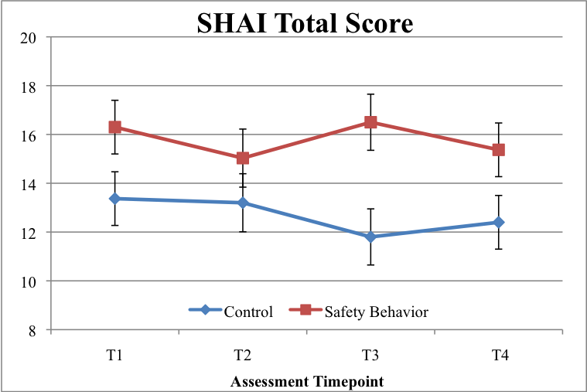

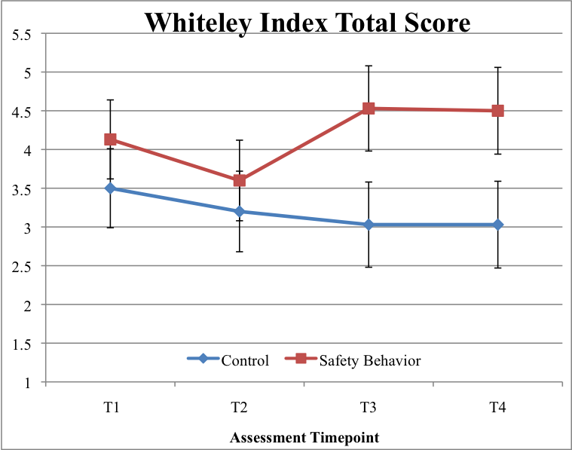

Figure 2.

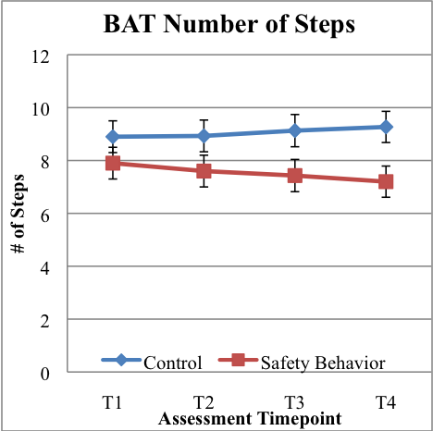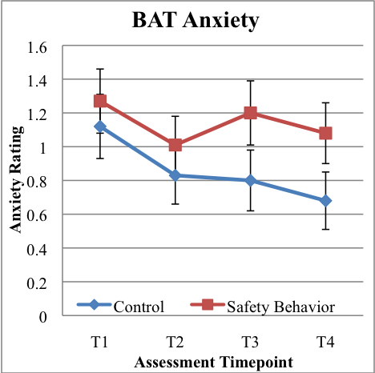

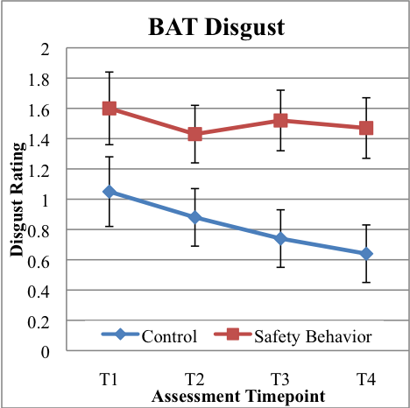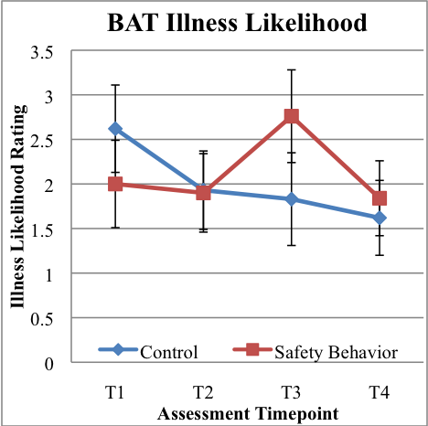

Figure 3 (a).

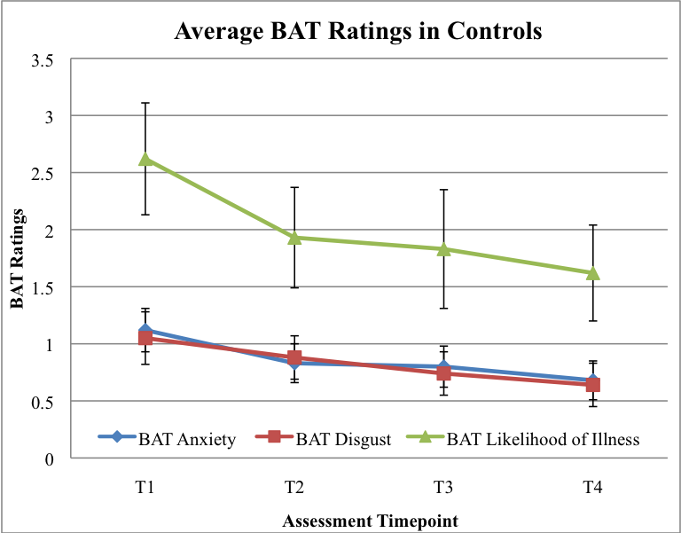
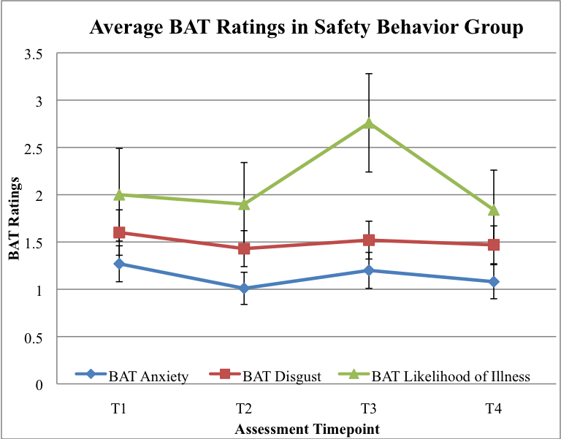

Figure 3 (b).
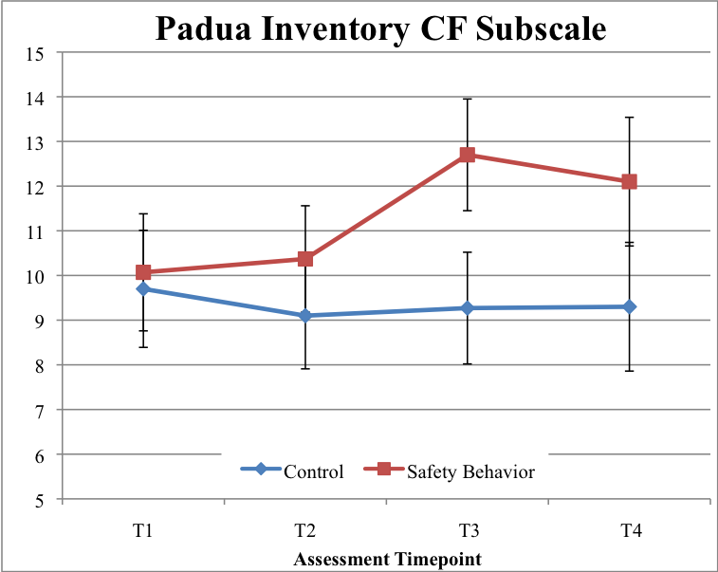
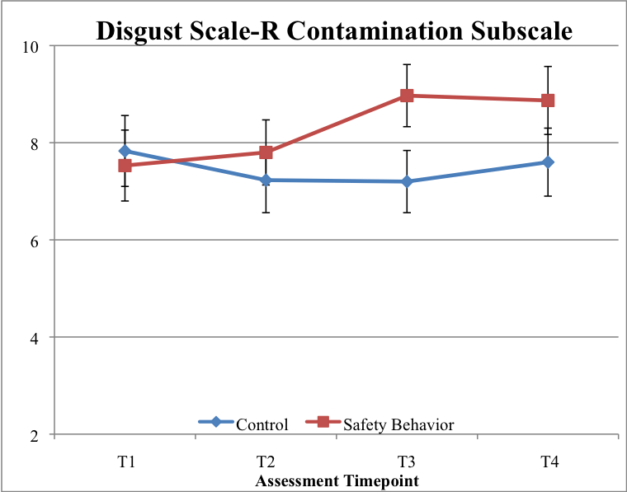

Figure 4.
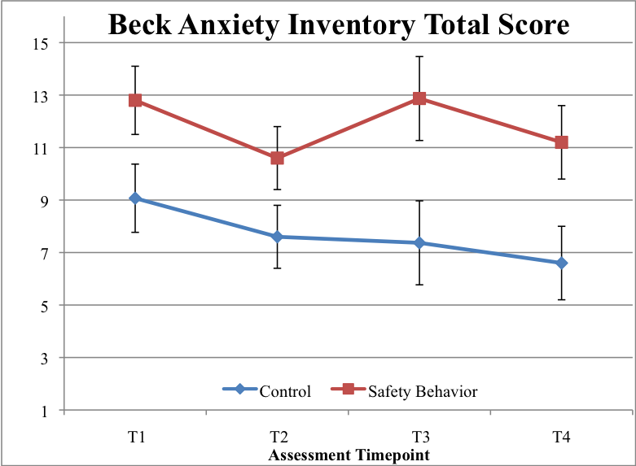
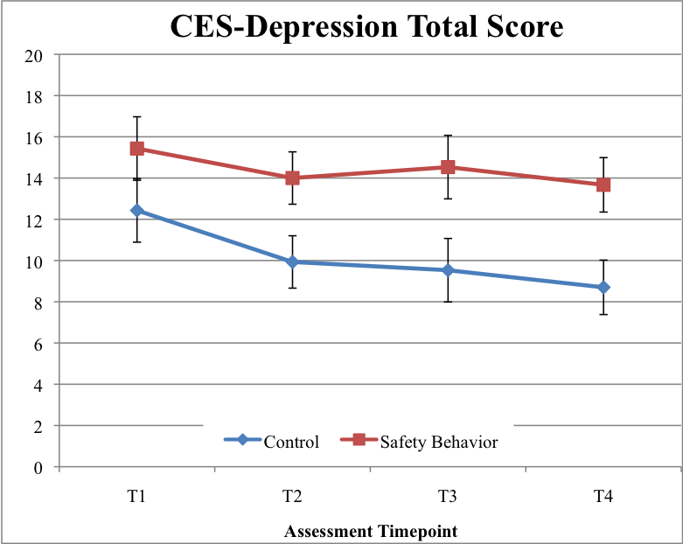

Figure 5.
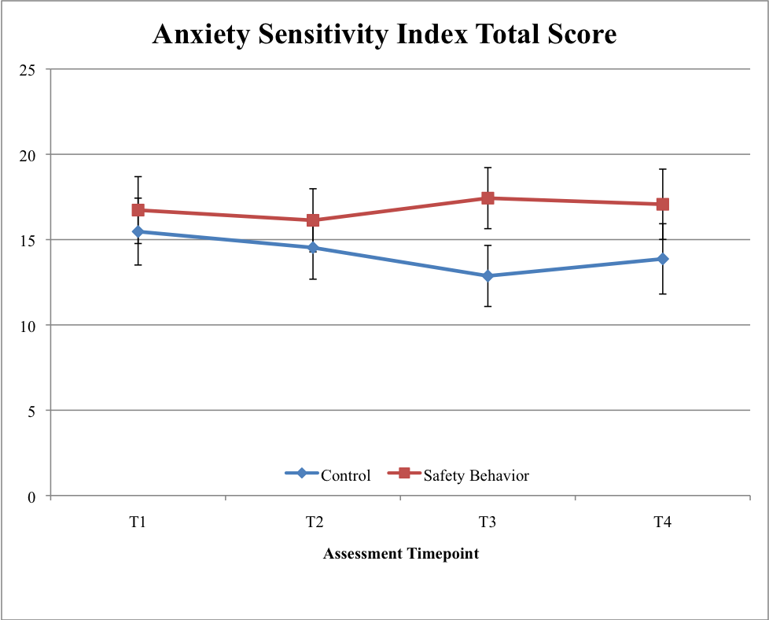

Figure 6.
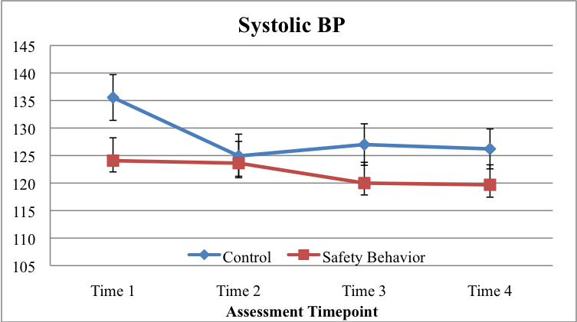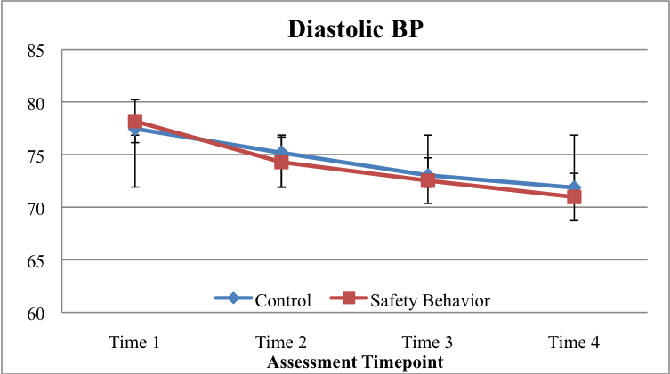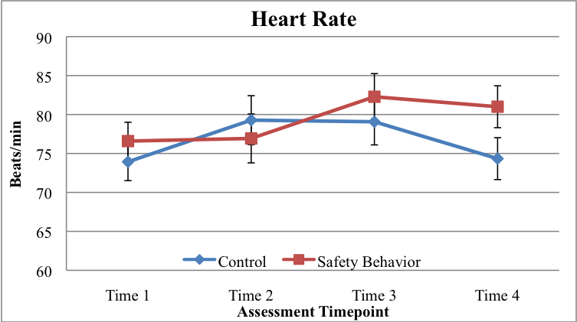

Figure 7.
Appendix A
General Health Perceptions subscale from the Short-form Health Survey

- Please circle the number that best describes whether each of the following statements is true or false for you. (Circle one number on each line.)

Definitely Mostly Not Mostly Definitely
True True Sure False False

I am somewhat ill. 1 2 3 4 5

I am healthy. 5 4 3 2 1

My health is excellent. 5 4 3 2 1

I have been feeling bad. 1 2 3 4 5

Note: Total score is computed so that a higher score indicates better general health perceptions, so the point values for each response have been changed accordingly. Taken from the Medical Outcomes Study (McHorney, Ware, & Raczek, 1993).

Appendix B

Short Health Anxiety Inventory
Please read each group of statements carefully and then select the one which best describes your feelings, over the past six months. Identify the statement by circling the letter next to it, i.e. if you think that statement (a) is correct, circle statement (a); it may be that more than one statement applies, in which case, please circle any that are applicable.

- (0) I do not worry about my health.
(1) I occasionally worry about my health.
(2) I spend much of my time worrying about my health.
(3) I spend most of my time worrying about my health.

- (0) I notice aches/pains less than most other people (of my age).
- (1) I notice aches/pains as much as most other people (of my age).
- (2) I notice aches/pains more than most other people (of my age).
(3) I am aware of aches/pains in my body all the time.

- (0) As a rule I am not aware of bodily sensations or changes.
(1) Sometimes I am aware of bodily sensations or changes.
- (2) I am often aware of bodily sensations or changes.
(3) I am constantly aware of bodily sensations or changes.

- (0) Resisting thoughts of illness is never a problem.
(1) Most of the time I can resist thoughts of illness.
(2) I try to resist thoughts of illness but am often unable to do so.
(3) Thoughts of illness are so strong that I no longer even try to resist them.

- (0) As a rule I am not afraid that I have a serious illness.
(1) I am sometimes afraid that I have a serious illness.
- (2) I am often afraid that I have a serious illness.
(3) I am always afraid that I have a serious illness.

- (0) I do not have images (mental pictures) of myself being ill.
(1) I occasionally have images of myself being ill.
(2) I frequently have images of myself being ill.
(3) I constantly have images of myself being ill.

- (0) I do not have any difficulty taking my mind off thoughts about my health.
(1) I sometimes have difficulty taking my mind off thoughts about my health.
(2) I often have difficulty taking my mind off thoughts about my health.
(3) Nothing can take my mind off thoughts about my health.

- (0) I am lastingly relieved if my doctor tells me there is nothing wrong.
(1) I am initially relieved but the worries sometimes return later.
(2) I am initially relieved but the worries always return later.
(3) I am not relieved if my doctor tells me there is nothing wrong.

- (0) If I hear about an illness I never think I have it myself.
(1) If I hear about an illness I sometimes think I have it myself.
- (2) If I hear about an illness I often think I have it myself.
- (3) If I hear about an illness I always think I have it myself.

- (0) If I have a bodily sensation or change I rarely wonder what it means.
(1) If I have a bodily sensation or change I often wonder what it means.
- (2) If I have a bodily sensation or change I always wonder what it means.
(3) If I have a bodily sensation or change I must know what it means.

- (0) I usually feel at very low risk for developing a serious illness.
(1) I usually feel at fairly low risk for developing a serious illness.
(2) I usually feel at moderate risk for developing a serious illness.
(3) I usually feel at high risk for developing a serious illness.

- (0) I never think I have a serious illness.
(1) I sometimes think I have a serious illness.
(2) I often think I have a serious illness.
(3) I usually think that I am seriously ill.

- (0) If I notice an unexplained body sensation I don’t find it difficult to think about other things.
(1) If I notice an unexplained body sensation I sometimes find it difficult to think about other things.
(2) If I notice an unexplained body sensation I often find it difficult to think about other things.
(3) If I notice an unexplained body sensation I always find it difficult to think about other things.

- (0) My family/friends would say I do not worry enough about my health.
(1) My family/friends would say I have a normal attitude about my health.
- (2) My family/friends would say I worry too much about my health.
(3) My family/friends would say I am a hypochondriac.

For the following questions, please think about what it might be like if you had a serious illness of a type which particularly concerns you (such as heart disease, cancer, multiple sclerosis and so on). Obviously you cannot know for definite what it would be like; please give your best estimate of what you think might happen, basing your estimate on what you know about yourself and serious illness in general.

- (0) If I had a serious illness I would still be able to enjoy things in my life quite a lot.
(1) If I had a serious illness I would still be able to enjoy things in my life a little.
(2) If I had a serious illness I would be almost completely unable to enjoy things in my life.
(3) If I had a serious illness I would be completely unable to enjoy life at all.

- (0) If I developed a serious illness there is a good chance that modern medicine would be able to cure me.
(1) If I developed a serious illness there is a moderate chance that modern medicine would be able to cure me.
(2) If I developed a serious illness there is a very small chance that modern medicine would be able to cure me.
(3) If I developed a serious illness there is no chance that modern medicine would be able to cure me.

- (0) A serious illness would ruin some aspects of my life.
(1) A serious illness would ruin many aspects of my life.
- (2) A serious illness would ruin almost every aspect of my life.
(3) A serious illness would ruin every aspect of my life.

- (0) If I had a serious illness I would not feel that I had lost my dignity.
(1) If I had a serious illness I would feel that I had lost a little of my dignity.
- (2) If I had a serious illness I would feel that I had lost quite a lot of my dignity.
- (3) If I had a serious illness I would feel that I had totally lost my dignity.
Appendix C
WI (Whiteley Index)
Indicate your answer to the following questions about your health by
circling values 0 to 4, where 0 means “Not at all” and 4 means “A great deal.”
1. Do you often worry about the possibility that you have a serious illness? | 0 | 1 | 2 | 3 | 4
2. Are you bothered by many aches and pains? | 0 | 1 | 2 | 3 | 4
3. Do you find that you are often aware of various things happening  in your body? | 0 | 1 | 2 | 3 | 4
4. Do you worry a lot about your health? | 0 | 1 | 2 | 3 | 4
5. Do you often have the symptoms of a very serious illness? | 0 | 1 | 2 | 3 | 4
6. If a disease is brought to your attention (through the radio, television, newspaper or someone you know) do you worry about getting it yourself? | 0 | 1 | 2 | 3 | 4
7. If you feel ill and someone tells you that you are looking better, do you become annoyed? | 0 | 1 | 2 | 3 | 4
8. Do you find you are bothered by many different symptoms? | 0 | 1 | 2 | 3 | 4
9. It is easy for you to forget about yourself and think about all sorts of other of other things? | 0 | 1 | 2 | 3 | 4
10. It is hard for you to believe the doctor when she or he tell you there is nothing for you to worry about? | 0 | 1 | 2 | 3 | 4
11. You often get the feeling that other people do not take your illness seriously enough. | 0 | 1 | 2 | 3 | 4
12. Do you think that you worry about your health more than  most people you know. | 0 | 1 | 2 | 3 | 4
13. Do you think there is something seriously wrong with your body? | 0 | 1 | 2 | 3 | 4
14. Are you afraid of illness? | 0 | 1 | 2 | 3 | 4

Appendix D
DS-R contamination subscale
Please indicate how much you agree with each of the following statements, or how true it is about you. Please write a number (0-4) to indicate your answer:
0 = Strongly disagree (very untrue about me)
1 = Mildly disagree (somewhat untrue about me)
2 = Neither agree nor disagree
3 = Mildly agree (somewhat true about me)
4 = Strongly agree (very true about me)
____1. I never let any part of my body touch the toilet seat in public restrooms.
____2. I probably would not go to my favorite restaurant if I found out that the cook had a cold.

How disgusting would you find each of the following experiences? Please write a
number (0-4) to indicate your answer:
0 = Not disgusting at all
1 = Slightly disgusting
2 = Moderately disgusting
3 = Very disgusting
4 = Extremely disgusting
____3. You take a sip of soda, and then realize that you drank from the glass that an
acquaintance of yours had been drinking from.
____4. A friend offers you a piece of chocolate shaped like dog-doo.
____5. As part of a sex education class, you are required to inflate a new unlubricated
condom, using your mouth.

Appendix E
Padua Inventory contamination fear subscale
INSTRUCTIONS: The following statements refer to thoughts and behaviors which may occur to everyone in everyday life. For each statement, choose the reply which best seems to fit you and the degree of disturbance which such thoughts or behaviors may create. Rate your replies as follows:

0 = not at all
1 = a little
2 = quite a bit
3 = a lot
4 = very much

_____ 1. I feel my hands are dirty when I touch money
_____ 2. I think even the slightest contact with bodily secretions (perspiration, saliva, urine, etc.) may contaminate my clothes of somehow harm me.
_____ 3. I find it difficult to touch an object when I know it has been touched by strangers or by certain people.
_____ 4. I find it difficult to touch garbage or touch dirty things.
_____ 5. I avoid using public toilets because I am afraid of disease and contamination.
_____ 6. I avoid using public telephones because I am afraid of contagion and disease.
_____ 7. I wash my hands more often and longer than necessary.
_____ 8. I sometimes have to wash or clean myself simply because I think I may be dirty or “contaminated.”
_____ 9. If I touch something I think is “contaminated,” I immediately have to wash or clean myself.
_____ 10. If an animal touches me, I feel dirty and immediately have to wash myself or change clothing.

Appendix F
Anxiety Sensitivity Index-3
Please circle the number that best corresponds to how much you agree with each item. If any items concern something that you have never experienced (e.g., fainting in public) answer on the basis of how you think you might feel if you had such an experience. Otherwise, answer all items on the basis of your own experience. Be careful to circle only one number for each item and please answer all items.

 | Very  Little | A little | Some | Much | Very much
1. It is important for me not to appear nervous. | 0 | 1 | 2 | 3 | 4
2. When I cannot keep my mind on a task, I worry that I might be going crazy. | 0 | 1 | 2 | 3 | 4
3. It scares me when my heart beats rapidly. | 0 | 1 | 2 | 3 | 4
4. When my stomach is upset, I worry that I might be seriously ill. | 0 | 1 | 2 | 3 | 4
5. It scares me when I am unable to keep my mind on a task. | 0 | 1 | 2 | 3 | 4
6. When I tremble in the presence of others, I fear what people might think of me. | 0 | 1 | 2 | 3 | 4
7. When my chest feels tight, I get scared that I won’t be able to breathe properly. | 0 | 1 | 2 | 3 | 4
8. When I feel pain in my chest, I worry that I am going to have a heart attack. | 0 | 1 | 2 | 3 | 4
9. I worry that other people will notice my anxiety. | 0 | 1 | 2 | 3 | 4
10. When I feel “spacey” or spaced out I worry that I may be mentally ill. | 0 | 1 | 2 | 3 | 4
11. It scares me when I blush in front of people. | 0 | 1 | 2 | 3 | 4
12. When I notice my heart skipping a beat, I worry that there is something seriously wrong with me. | 0 | 1 | 2 | 3. | 4
13. When I begin to sweat in a social situation, I fear people will think negatively of me. | 0 | 1 | 2 | 3 | 4
14. When my thoughts seem to speed up, I worry that I might be going crazy. | 0 | 1 | 2 | 3 | 4
15. When my throat feels tight, I worry that I could choke to death. | 0 | 1 | 2 | 3 | 4
16. When I have trouble thinking clearly, I worry that there is something wrong with me. | 0 | 1 | 2 | 3 | 4
17. I think it would be horrible for me to faint in public. | 0 | 1 | 2 | 3 | 4
18. When my mind goes blank, I worry there is something terribly wrong with me. | 0 | 1 | 2 | 3 | 4

Appendix G
Beck Anxiety Inventory
Below is a list of common symptoms of anxiety. Please read each item in the list carefully. Indicate how much you have been bothered by each symptom during the PAST WEEK, INCLUDING TODAY by circling the number in the corresponding space in the column next to each symptom.
 | Not at all | Mildly  It did not bother me much | Moderately  It was very unpleasant, but I could stand it. | Severely  I could barely stand it.
1. Numbness or tingling. | 0 | 1 | 2 | 3
2. Feeling hot. | 0 | 1 | 2 | 3
3. Wobbliness in legs. | 0 | 1 | 2 | 3
4. Unable to relax. | 0 | 1 | 2 | 3
5. Fear of the worst happening. | 0 | 1 | 2 | 3
6. Dizzy or lightheaded. | 0 | 1 | 2 | 3
7. Heart pounding or racing. | 0 | 1 | 2 | 3
8. Unsteady. | 0 | 1 | 2 | 3
9. Terrified. | 0 | 1 | 2 | 3
10. Nervous. | 0 | 1 | 2 | 3
11. Feelings of choking. | 0 | 1 | 2 | 3
12. Hands trembling. | 0 | 1 | 2 | 3
13. Shaky. | 0 | 1 | 2 | 3
14. Fear of losing control. | 0 | 1 | 2 | 3
15. Difficulty breathing. | 0 | 1 | 2 | 3
16. Fear of dying. | 0 | 1 | 2 | 3
17. Scared. | 0 | 1 | 2 | 3
18. Indigestion or discomfort in  abdomen. | 0 | 1 | 2 | 3
19. Faint. | 0 | 1 | 2 | 3
20. Face flushed. | 0 | 1 | 2 | 3
21. Sweating (not due to heat). | 0 | 1 | 2 | 3

Appendix H
Center for Epidemiologic Studies Depression Scale

AGE_____ GENDER ______

RACE (circle one) Caucasian, Hispanic/Latino, African American, Asian, other

INSTRUCTIONS: Indicate how often you have felt the following way during the past week. Rate your replies as follows:

0 = none of the time (< 1 day); 1 = some (1-2 days); 2 = occasionally (3-4 days); 3 = most of the time (> 5 days)

_____ 1. I was bothered by things that usually don’t bother me.
_____ 2. I did not feel like eating; my appetite was poor.
_____ 3. I felt that I could not shake off the blues even with help from my family or friends.
_____ 4. I felt I was just as good as other people.
_____ 5. I had trouble keeping my mind on what I was doing.
_____ 6. I felt depressed.
_____ 7. I felt that everything I did was an effort.
_____ 8. I felt hopeful about the future.
_____ 9. I thought my life had been a failure.
_____ 10. I felt fearful.
_____ 11. My sleep was restless.
_____ 12. I was happy.
_____ 13. I talked less than usual.
_____ 14. I felt lonely.
_____ 15. People were unfriendly.
_____ 16. I enjoyed life.
_____ 17. I had crying spells.
_____ 18. I felt sad.
_____ 19. I felt that people dislike me.
_____ 20. I could not get “going.”

Appendix I
Behavioral Avoidance Tasks
There will be three tasks:
Task 1) touching a Kleenex (common cold)
Task 2) touching an oral thermometer (influenza)
Task 3) touching a water bottle (mononucleosis)
The three items will be in zip lock bags clearly labeled with the corresponding illness. For task 1, participants will be told that someone with the common cold coughed on the Kleenex, for task 2 they will be told that the thermometer was used to measure the temperature of someone with the flu, and for task 3 they will be told that with a mononucleosis patient drank from the water bottle. Each task will have 5 steps:
Step 1-touch bag (yes/no)
Step 2-open bag (yes/no)
Step 3-touch item (yes/no)
Step 4-touch lips with hand used to touch item (yes/no)
Step 5-touch lips with item (yes/no)
After each step, Anxiety and Disgust levels are assessed (0-100).

