**The Distribution of Ejected Stars around a Super Massive Black Hole Binary Due to Three-Body Scattering**

Amanda Benson

Undergraduate Senior Honors Thesis

Advisor Dr. Kelly Holley-Bockelmann

Shortly after a galaxy merger, the supermassive black holes from each galaxy are thought to form a binary at the center of the galaxy merger remnant. Since a substantial fraction of the scattered stars are ejected with enough energy to escape the host galaxy, three-body encounters with a supermassive binary black hole are a viable mechanism to generate hypervelocity stars. We investigate the 3-d spatial and kinematic distribution of the stars that are scattered by interacting with a supermassive binary black hole. We simulate each three body encounter explicitly, including gravitational radiation, until the stellar interloper has either been ejected or has merged with a black hole. We discuss how the anisotropic distribution could aid us in the search for binary black holes and hypervelocity stars.

1. **Introduction**

Supermassive binary black holes (SMBBHs) are one expected consequence of galactic mergers. Each individual galaxy is assumed to contain a supermassive black hole (SMBH) at its center (e.g. Kormendy & Richstone, 1995). During a merger, dynamical friction, meaning a deceleration of the objects due to the gravitational forces of those objects that they are moving through (Binney & Tremaine, 1987), causes these black holes to sink towards the center where they will eventually become bound to each other. The binary’s separation will shrink through interactions with stars in the nearby vicinity. However, this means of ‘hardening’ the binary becomes ineffective once the binary reaches a certain separation because distant stars perturb the binary’s center of mass but not its semi-major axis. (Begelman et al. 1980) At this point the binary begins to ‘harden’ via three body interactions (see figures 1 for an illustration of the full process and figure 2 for an illustration of a three body interaction).

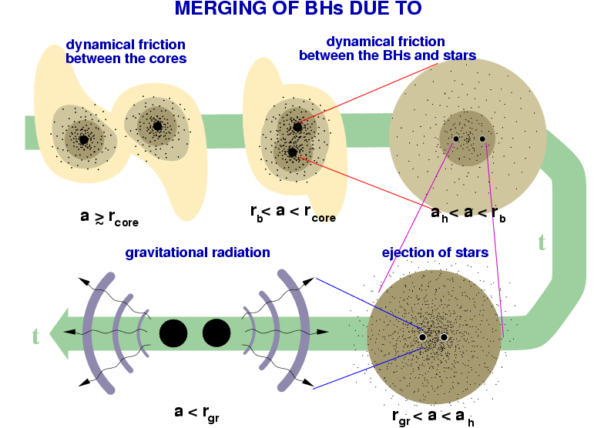

Figure 1: The steps by which a SMBBH is created and hardened as detailed above. (<http://www.mpifr-bonn.mpg.de/staff/chzier/interest_merger.html>)

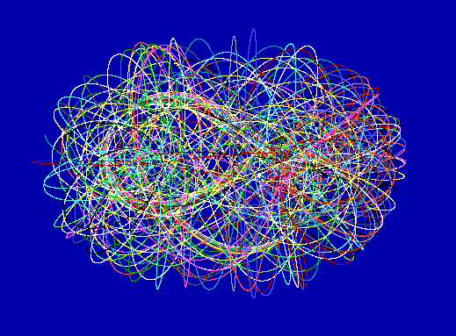

Figure 2: Illustration of the chaos of the three body problem. Notice that the orbit is very random. Our interactions are similar in nature, as shown in §3.1 (<http://sprott.physics.wisc.edu/fractals/chaos/threebod.gif>).

While there are a number of different definitions of a ‘hard’ binary, one of the most straightforward is known as “Heggie’s Law” (Heggie, 1975) which states that interactions with a hard binary tend to harden, meaning shrink, the binary more. When stars interact with a hard binary, there is an exchange of both energy and angular momentum. This causes the binary to shrink and can cause one of the bodies to be ejected from the system at very high velocities. This concept was first shown in Hills (1988) when simulations of stellar binaries and massive black hole intruders showed one component being ejected at velocities ~1000 km/s due to the breakup of the binary. The same result can be achieved when low angular momentum stars pass near or through a binary black hole (BBH). After one or more encounters (see figure 3 for an explanation of a single encounter) with the binary, most stars will gain enough energy and angular momentum to be expelled from the system. (e.g. Sesana et al., 2006) Those stars ejected at velocities of ~1000 km/s are known as hypervelocity stars (HVSs). The first discovery of such a star was reported by Brown et al. (2005). This star, which is known as SDSS J090745.0+024507 and had a velocity of 709 km/s, was found leaving the Milky Way galaxy,

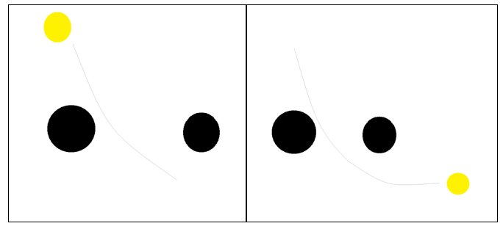

Figure 3: One encounter of a star (yellow) with the SMBBH (both black components). Left: Before the encounter. The star is entering the system and will travel between the two black holes (light gray line shows the trajectory). Right: After the encounter. The star has traveled through the binary, removing energy and angular momentum from the binary as it travels. This has caused the binary to harder, meaning that the two black holes have come closer together.

Eventually the binary will become hard enough for gravitational wave radiation to take energy away from the system (see figure 1). This will eventually cause it to merge, with the timescale of a merger for a circular orbit being

Tc(a0) = a04/(4β) (1)

β = (64/5)(G3m1m2(m1+m2)/c5). (Peters, 1964)

In equation 1, a0 is the initial semi-major axis of the binary, m1 and m2 are the masses of the binary components (m1>m2), and G is the gravitational constant, which in our calculations is equal to 4π2 AU3/yr2M⊙ (AU which is an astronomical unit, or ~1.5*108 km).

We investigate three body scattering encounters between a SMBBH and single stars. This type of scattering has been investigated in the past. For example, Yu & Tremaine (2003), while not actually simulating the system, studied three body scattering between a BBH and a single star using a BBH of total mass 3.5 * 106 M⊙. Specifically, they assumed that one component of their BBH was the black hole at the Galactic center, Sagittarius A*, and calculated the rate of ejections of HVSs that would be produced through three body scattering. Another example, which is more like ours since it uses actual simulations, is Sesana et al. (2006, part 1), where they modeled three-body interactions between a massive BBH and single stars with a mass ratio of mstar/Mbinary~10-7. Specifically, they studied the kinematics of HVSs produced by three body interactions with a massive BBH and found that most HVSs are ejected on nearly radial orbits. The subpopulation of HVSs that their simulations created was initially very flat within the plane of the BBH, but became more isotropic as the binary hardened. Our work investigates a much higher mass regime for our SMBBH, with mstar/Mbinary on the order of 10-9, which is consistent with recent findings of SMBHs with masses on the order of 109 M⊙ (e.g. Gebhardt & Thomas, 2009, who determined the central black hole mass of M87 to be ~6.4*109 M⊙).

We simulate each encounter, including the effects of gravitational radiation, and look at the distribution of the stars that are ejected from the system. We attempt to find a characteristic distribution of these stars, which would be beneficial in a few ways. For one, it would allow us to determine characteristics of the binary itself from the characteristics of the stars. If the stellar ejecta were aligned with the SMBBH orbital plane then we could infer the existence and orientation of a SMBBH at the center of a galaxy without deep, high resolution observations. We may also be able to infer the mass ratio, since the exchange of angular momentum and energy needed to eject stars from the system is dependent upon the masses of the three bodies. We discuss how other characteristics of the system, including energy exchanges, angular momentum exchanges, etc, affect that distribution.

The set up of this paper will be as follows. In §2 we discuss our simulations, background work, and the code. In §3 we discuss our findings up to the present. In §4 we discuss work that will continued in the future on this project, including any issues we have found with our current work mentioned in §3. Finally, we summarize our work up to this point in §5.

1. **Methods**

*2.1) Initial Conditions and Integrations*

Our system is created and evolved using the code “It’s a Binary Life” (*iabl.c*), by Kayhan Gultekin. We begin by supplying initial conditions for the binary’s semi-major axis, a, its eccentricity, e, the relative velocity of the star to the binary at infinity, v∞, and the masses of the two black holes and the star, M0, M1, and M2 respectively (M0 > M1). Using a random number generator, *Iabl* generates initial positions and velocities for the three system components as well as impact parameters for the system. It then evolves the SMBBH through a series of encounters with the stars, although the code is limited by the assumption that the initial distribution of the encounters is either isotropic in three dimensions.

The integration is done using an eighth order Runge-Kutta integrator with HNBody. *Iabl* passes the initial conditions and the time needed for integration:

t0 = √(a3/GM)[e(sinhFi+sinhFf)-(Fi+Ff)] (2)

where a and e are the semi-major axis and eccentricity of the star’s hyperbolic orbit and

F = cosh-1[(1/e)(1+(r/a))] (Goldstein et al. 2002; Richardson et al. 1998). (3)

The integration can be stopped in one of a few ways. The first is a merger of the SMBBH via gravitational waves. Assuming that neither black hole has merged with a star the SMBBH will eventually merge via gravitational wave radiation, where the timescale for this merger is that in equation 1. Assuming that no merger has occurred, the second way for the integration to stop is if the encounter has finished, meaning that the star has merged with one of the black holes or the star has traveled outside a distance of 30a0 from the system. (Gultekin, 2006)

The integration step size of the code is set to allow for energy conservation on the order of ΔE/Einit ~ 10-9when the system is only interacting via Newtonian mechanics, see Figure 4.

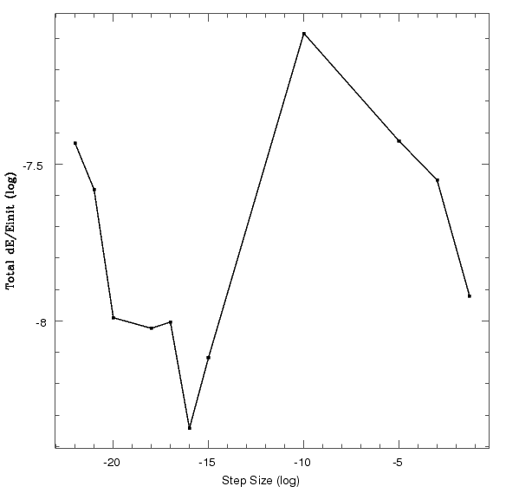

Figure 4: Energy conservation of the system as compared to the code’s integration step size. Our step size was chosen to ensure that the energy conservation of the system remains at ~10-9. In the future we hope to be able to obtain energy conservation on the order of 10-12.

*2.2) Background Work*

The original purpose of *iabl* was to study the growth of intermediate mass black holes using gravitational waves (Gultekin, 2006). Since this is not what we were using it for, prior to our actual scattering experiments it was necessary for us to familiarize ourselves with the code and its outputs.

We began by confirming that our first test runs came from the same distribution as those of the code’s original project (see Gultekin, 2006). We chose to look at and recreate the data for masses 100 M⊙, 10 M⊙, and 10 M⊙ (M0,M1, M2) with an initial semi-major axis of 10 AU (~1.5*108 km), and an initial eccentricity of 0. Figure 5 shows our distribution (2a), Dr. Gultekin’s distribution (2b), and a comparison of the two using a Kolmogorov-Smirnov test (K-S test). The two histograms (2a and 2b) are not identical, as the amount of encounters run and the exact sequence of encounters are not identical, however the peak is around the same semi-major axis, log a of -1, and the characteristics of the tails on either side are the same. The K-S test confirmed that the two distributions had a >99% chance of being the same.

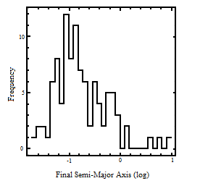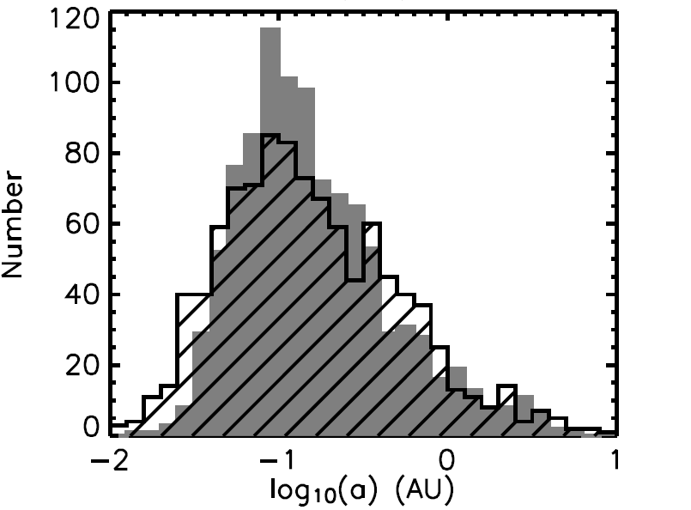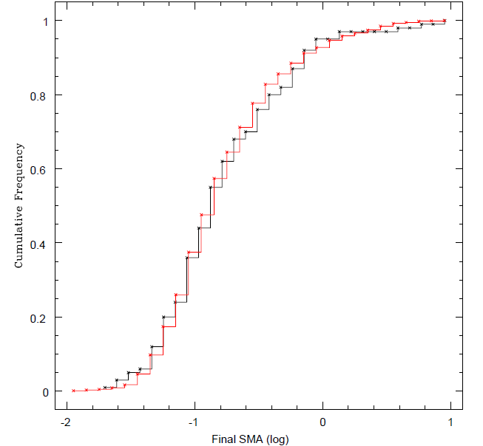

Figure 5: This test was performed using Newtonian interactions for a mass ratio of 100:10:10. 5a (upper left) is our 100 sequence run, 5b (upper right) is the original with the solid section as Newtonian, and 5c (bottom) is the K-S test results.

*2.3) Scattering Experiments*

Our system consists of a SMBBH with masses M1and M2, where M1 = 108 M⊙ and M2 = 107⊙, and a series of single stars, each with a mass of 1 M⊙ and interacting with the binary one at a time. The initial conditions used to generate the initial positions and velocities are as follows: a = 100 AU, e = 0.0, and v∞ = 2.1094502 AU/yr. The small semi-major axis was chosen to ensure that the binary is hard to begin with so that each encounter causes the binary to lose energy and angular momentum. Our simulation also includes gravitational radiation, which without stellar interference would cause the binary to merge in approximately 8.5*104 years (see equation 1). The code can approximate the three body system as a two body system when the interloper star is far from the system, this approximation speeds up the actual integration process. However we prefer to look at actual three body encounters. We output the initial conditions for each encounter. After the integration for each encounter is finished the code outputs the final positions and velocities for each encounter. For each encounter, the code also outputs how many stars are left from the original distribution. Using that number we determine whether the encounter permanently ejected the star from the system or if it eventually returned for another interaction.

For each permanently ejected encounter, we use the final conditions to calculate the star’s angle with respect to the binary as follows.

θbf=arctan(zbf/rbf) (4)

θsf=arctan(zsf/rsf)

θs-b= -θbf+ θsf



Figure 6: Angles of the binary and the star with respect to the x-y plane, θbf and θsf, and the angle between the binary and the star as calculated by equations 4.

1. **Analysis and Results**

*3.1) Orbits*

At the time of this writing we have simulated 168 sequences of encounters, meaning multiple encounters (see figure 2) run until two of the bodies have merged. This provided us with 8150 encounters where a star was ejected from the system. We currently have many more runs going and will continue to run these in the future.

After running our simulations, we investigated the orbits of some of these ejected encounters. Figure 7 shows some examples, in order decreasing by the energy exchange of the encounter (top left to bottom right).

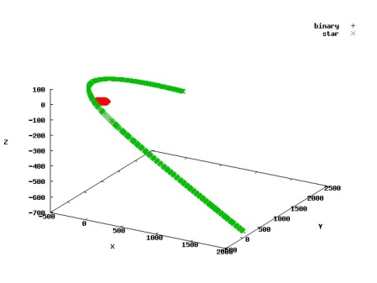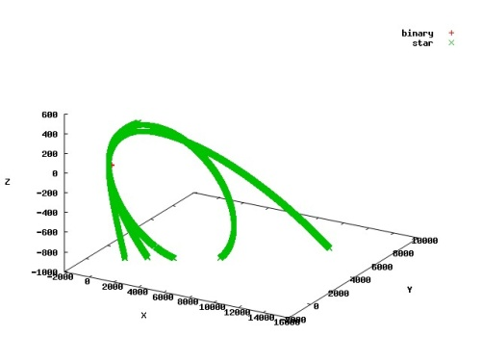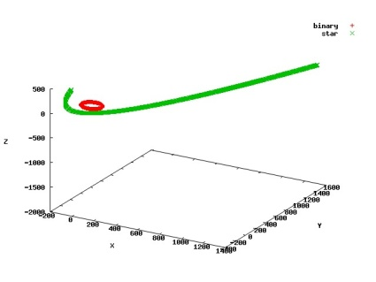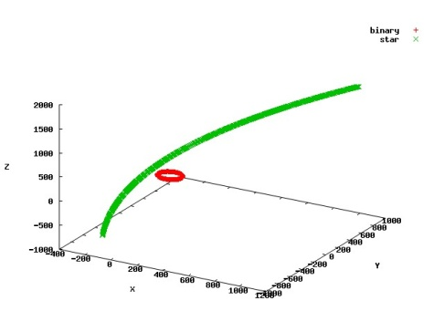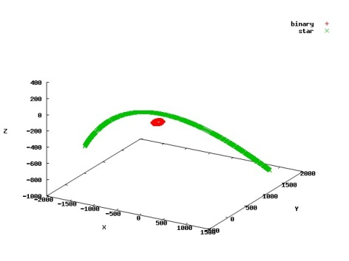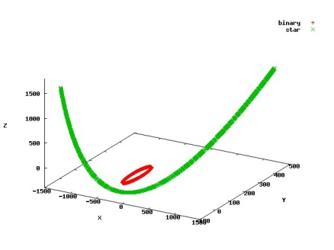

Figure 7: Orbits of single encounters. Each star is ejected from the system at the end of this encounter. Green is the star and red is the secondary binary component. With the exception of the top left, most of these do not appear to interact much, however the star often goes through more than one encounter before being ejected, so the orbits shown are only the last part of that process. The top left is the best example of a random three body interaction, such as the illustrated one in figure 2. The ejection angles with respect to the binary (as discussed in the next section) for these orbits are as follows: Top (left to right): 41.10° below the binary, 8.69° below the binary, and 71.28° above the binary. Bottom (left to right): 44.22° above the binary, 17.95° below the binary, and 19.28° below the binary.

*3.2) Ejection Angles*

We determined the ejection angle for each of the 8150 encounters mention above. Figure 8 shows the distribution of these ejection angles.

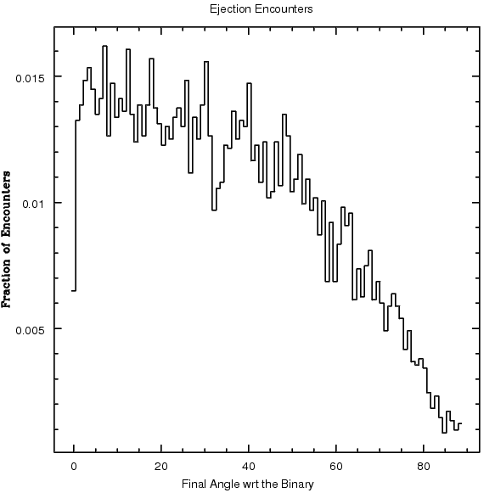

Figure 8: Distribution of the angle with respect to the binary at which each star is ejected from the system.

It is clear from figure 8 that the majority of the stars are ejected at angles close to the plane of the binary (specifically, the percentages of stars ejected at the following angles with respect to the binary are as follows: 15.83% within 10°, 31.44% within 20°, 46.04% within 30°, 59.85 within 40°, 73.29% within 50°, 84.04% within 60°, 92.69% within 70°, and 98.32% within 80°, see figure 9).

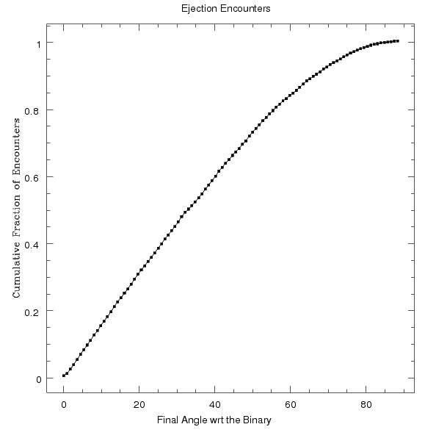

Figure 9: Cumulative frequency of the final angle with respect to the binary at which the star is ejected from the system. More than 50% of the stars are being ejected within 40° of the plane of the binary.

Figures 10 and 11 show the two dimensional distribution of the bodies after the encounters. Although there are stars being ejected at all angles between 0° and 90° of the binary, the stripes allow the shape of flattening to be better defined. Due to the large number of data points and a lack of depth on these two dimensional figures, overplotting makes it difficult to actually see which of the bands are most populated, especially in the figure on the left. However, the right side of figure 10 and figure 11 represent ~60% of the ejected stars and shows the clear beginnings of a torus shape around the plane of the SMBBH.

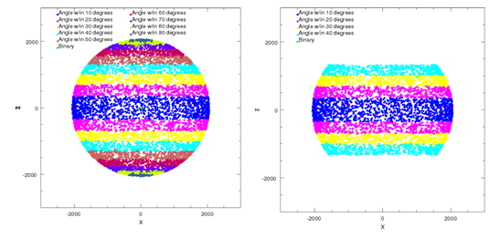

Figure 10: X vs. Z of the stars after they have been ejected from the system. The different colors represent the angle with respect to the binary at which the star has been ejected from the system. Although difficult to see the, binary is located at the center of the figure and this view point is looking at its plane edge on. Left; All of the stars that have been ejected from the system. Right: Those stars that were ejected within 40° of the binary. These represent ~60% of all stars that have been ejected from the system. In both figures there is a clear torus shape indicated by the colored stripes.

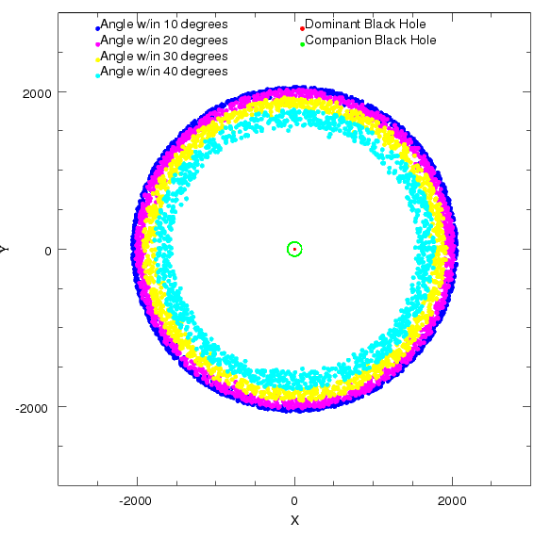

Figure 11: XY positions of those stars that were ejected within 40° of the binary, same as the right side of figure 10. This is looking at the binary face on.

As mentioned in §2.1, an encounter is considered to be complete when the star reaches 30a0 from the binary. Because of this, the stars have a set boundary, indicated by the sphere. Were we to evolve the stars past this point, it is likely that the spherical shape would disappear and be replaced by more of a bowtie shape (although we have yet to prove this, see §4).

*3.3) Energy Relationship*

As explained in §1, each encounter results in an exchange of energy. We looked at how this exchange relates to the ejection angle of the stars.

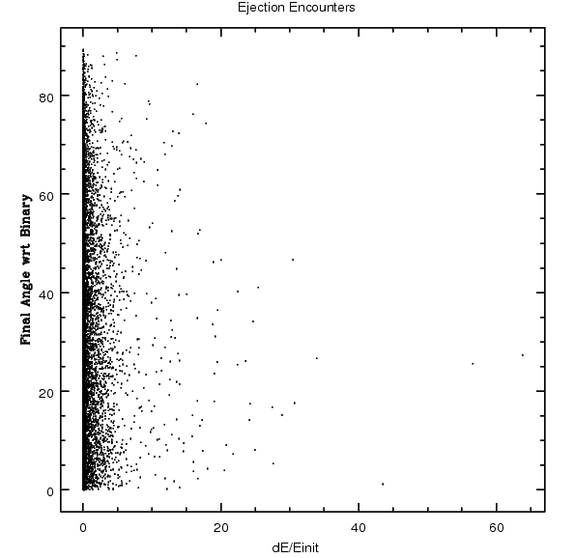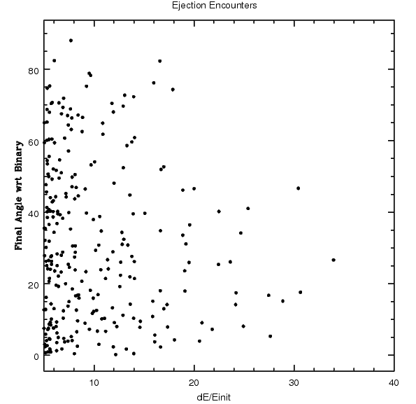

Figure 12: Change in energy, scaled by the initial energy, of the star after each encounter compared to its final ejection angle with respect to the binary. 12a) (left) all data points. 12b) (right) zoomed in on the less compact spread of dE/Einit.

From figure 12, one can see that there is a relationship between the energy exchange and the ejection angle. Those encounters where the change in energy is higher tend to be ejected closer to the plane of the binary. This is slightly clearer in 12b, where the spread of points has a better defined appearance. As one can see, there is a definite trend in which those encounters with a larger change in energy are ejected closer to the plane of the binary. Specifically, they seem to be preferentially ejected within 40° of the binary. Figure 13 shows more clearly the range of change in energies.

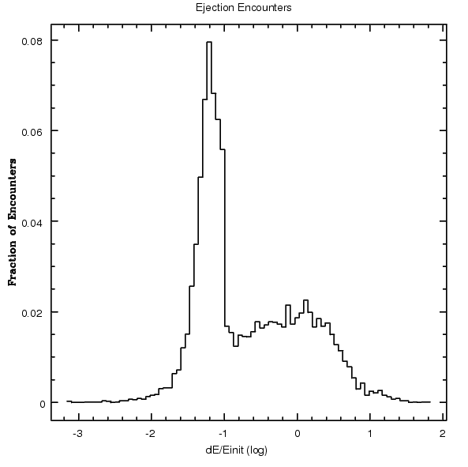

Figure 13: Distribution of the dE/Einit of the stars after each encounter. It is clear that the majority of our encounters result in an energy change in the low range of ~.03-.1. We hope to have more higher energy change encounters in the future in order to confirm a relationship between energy exchange and ejection angles.

Figure 14 shows the relationship between the change in energy and the ejection angle in a slightly different manner. Both energy exchange regimes show a tendency for the stars to be ejected close to the plane of the binary. We hypothesize that the higher energy exchange encounters will be more preferentially ejected closer to the plane of the binary than lower energy exchange encounters, although this is not reflected in our current data set. This could be due in part to the small number of high energy exchange encounters in this data set. In the future we hope to find many more of these encounters so that we can explore different energy ranges.

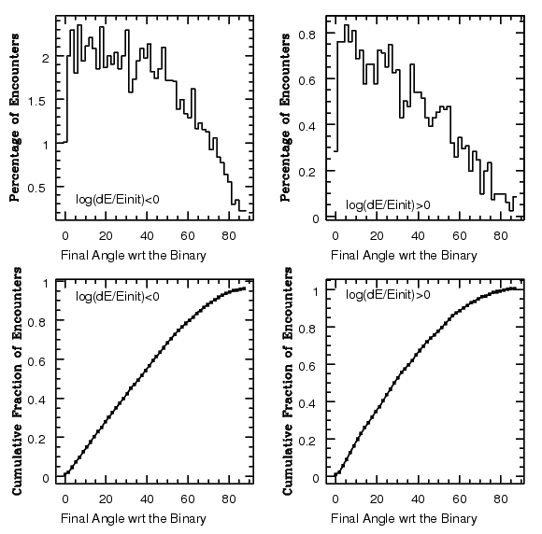

Figure 14: Distribution of the ejection angles of the star in terms of their change in energy. Top: The percentages are of the total distribution, although the encounters shown are only those of the specific energy. Bottom: The cumulative frequency of each final angle, within the specified energy range, with respect to the binary. These two plots seem to show that there is not much of a difference in the preferred ejection angles between lower energy exchange encounters and higher energy encounters. However, we do not currently have enough high energy exchange encounters to make a conclusive statement one way or the other.

*3.4) Angular Momentum*

Similarly, we also looked for a relationship between the ejection angle and the system’s exchange of angular momentum.

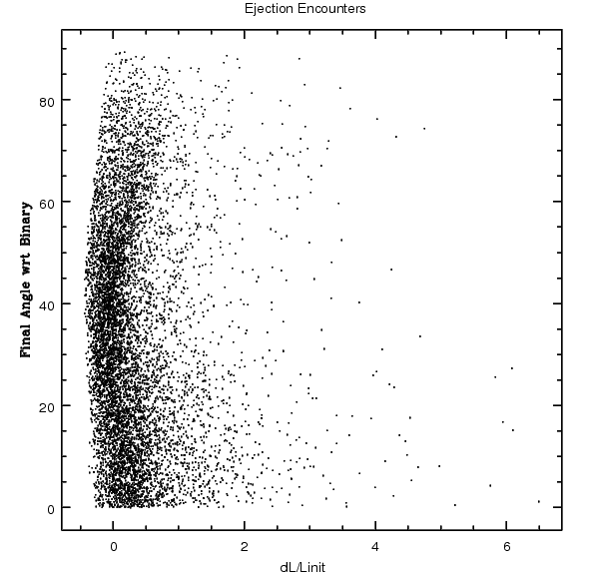

Figure 15: Change in angular momentum, scaled by the initial angular momentum, of the star after each encounter compared to its final ejection angle with respect to the binary. While the relationship between the angular momentum exchange and the ejection angle is not as well defined as that of the energy change and the ejection angle, there is still a clear tendency for the stars with a greater change in angular momentum to be preferentially ejected closer to the plane of the binary.

As figure 15 shows, there is a similar relationship between the angular momentum exchange and the ejection angle as that of the energy exchange and the ejection angle. While this relationship does not appear to be quite as obvious, there is still a visible tendency for larger angular momentum changes to eject the stars with smaller angles outside of the plane of the binary. Specifically, those with the highest change in angular momentum tend to be ejected within ~30° of the binary.

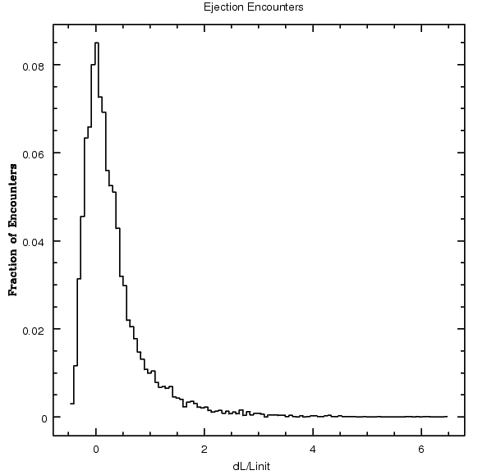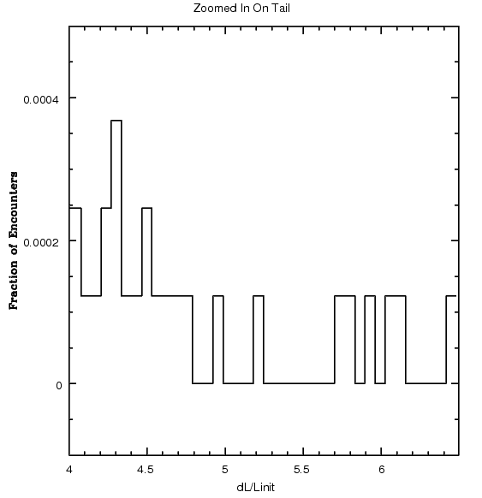

Figure 16: Distribution of the dL/Linit of the stars after each encounter. Left: All ejection encounters. Right: Zoomed in on the tail from dL/Linit >4. In the figure on the left this tail appears to be almost flat, however the right figure shows that there are encounters with exchanges of angular momentum in those higher amounts, they are just very rare and make up a fairly insignificant portion of the data set.

As shown in figure 16, the majority of encounters had a dL/Linit of slightly negative to approximately 2. Figure 16 also shows is that the majority of encounters are ejected after an exchange of close to or often more than 100% of the initial angular momentum.

**4) Future Work**

While our results are promising, there are still a number of things that we will continue to work on in the future. Tasks for the future include the following:

1. Continue to analyze the distributions seen in figures 9 and 10 in order to determine what the actual three dimensional distribution would look like. At the time of this writing we have been unable to determine a way to plot the positions in three dimensions in a way that allows for the viewer to see the actual depth of the stars. In order to determine what observers would actually see we will need to find a way to distinguish the distance of a star from the viewer so that not all stars along the same line of sight appear to be in the same area.
2. Continue running more sequences in order to get more ejection encounters and data. As mentioned in §3.1, we currently only have 8150 encounters worth of data. In order to come to a more conclusive result we will need a lot more data, particularly at higher energy exchanges.
3. Inputting initial conditions for the stars from a file. As detailed in §2.1, the stars current initial distribution is isotropic and therefore is not necessarily what one would find in the real universe (*iabl* does allow for the initial conditions to be generated from a file). For our purpose, we would need to adapt the code to read in an anisotropic distribution from an N-Body simulation.
4. Evolve the stars after the encounter. As mentioned in §2.1 and §3.2, the encounters conclude when the star has moved a distance of 30a0 from the binary. By inputting the final scattered star phase space into an N-Body simulation we would be able to evolve them and see how the scattered distribution changes over time. This would also allow us to see what the distribution of these stars would look like at a point in a galaxy where they could actually be observed.

**5) Summary**

We have performed three-body scattering experiments of a SMBBH and a series of stars in order to study the distribution of the stars once they are ejected from the system. The stars are taken from an isotropic distribution and sent towards the SMBBH one at a time where they can gain both energy and angular momentum. Eventually they are expelled from the system. Specifically, we looked at the angle with respect to the plane of the binary at which the stars are ejected from the system. We also looked at how that angle might be related to the exchange of energy and angular momentum.

From our experiments we determined that a majority of these stars are scattered within 40° of the plane of the binary. While lower energy exchanges tend to produce a wide variety of scattering angles, those exchanges with higher energy exchanges tend to scatter the stars closer to the plane of the binary. The same is true for angular momentum exchanges, although this relationship does not appear to be as strong from our current data. Both of these statements will need more evidence to confirm the correlations. Follow up work will both add to these results as well as attempt to make new discoveries in more realistic environments.

**6) References and Acknowledgements**

**References**

Begelman, MC., Blandford, R.D., & Rees, M.J. 1980, Massive black hole binaries in active galactic nuclei, Nature 287, 307-309.

Binney, James, and Scott Tremaine. "Dynamical Friction." *Galactic Dynamics*. Princeton, N.J.: Princeton UP, 1987. 422.

Brown, W. R., Geller, M. J., Kenyon, S. J., & Kurtz, M. J. 2005, ApJ, 622, L33

Karl Gebhardt and Jens Thomas 2009 ApJ **700** 1690 doi: [10.1088/0004-637X/700/2/1690](http://dx.doi.org/10.1088/0004-637X/700/2/1690)

Gultekin, Kayhan 2006, Growing intermediate-mass black holes with gravitational waves, PhD Thesis, Proquest Dissertations And Theses 2006. Section 0117, Part 0606 126 pages; [Ph.D. dissertation].United States -- Maryland: University of Maryland, College Park; 2006. Publication Number: AAT 3222352. Source: DAI-B 67/06, Dec 2006

Heggie, D. C. 1975, MNRAS, 173, 729

Hills, J. G. 1988, Nature, 331, 687

Hills, J. G. 1983, The effect of low-velocity, low-mass intruders (collisionless gas) on the dynamical evolution of a binary system, Astronomical Journal (ISSN 0004-6256), vol. 88, Aug. 1983, p. 1269-1283.

Kormendy, John, [Richstone, Douglas](http://adsabs.harvard.edu/cgi-bin/author_form?author=Richstone,+D&fullauthor=Richstone,%20Douglas&charset=UTF-8&db_key=AST), [1995ARA&A..33..581K](http://adsabs.harvard.edu/abs/1995ARA%26A..33..581K)

Peters, P. C. 1964, Phys. Rev. B, 136, 1224

Quinlan, G. D. 1996, NewA, 1, 35

S[esana, Alberto](http://adsabs.harvard.edu/cgi-bin/author_form?author=Sesana,+A&fullauthor=Sesana,%20Alberto&charset=UTF-8&db_key=AST); [Haardt, Francesco](http://adsabs.harvard.edu/cgi-bin/author_form?author=Haardt,+F&fullauthor=Haardt,%20Francesco&charset=UTF-8&db_key=AST); [Madau, Piero](http://adsabs.harvard.edu/cgi-bin/author_form?author=Madau,+P&fullauthor=Madau,%20Piero&charset=UTF-8&db_key=AST), [2006ApJ...651..392S](http://adsabs.harvard.edu/abs/2006ApJ...651..392S)

Yu, Q., & Tremaine, S. 2003, ApJ, 599, 1129

Zier, Christian. "Research Interest: Black Hole Merger Due to Ejection of Stars." *Max-Planck-Institut Fur Radioastronomie, Bonn - Max-Planck-Institut FÃ¼r Radioastronomie*. Web. 14 Apr. 2010. <http://www.mpifr-bonn.mpg.de/staff/chzier/interest_merger.html>.

**Acknowledgements**

Dr. Kelly Holley-Bockelmann

Dr. Andreas Berlind

Dr. Keivan Stassun

Dr. Tom Weiler

Dr. Kayhan Gultekin

The Vanderbilt University Astronomy Department

My family and friends

Thank you all for your part in making this work possible.

**7) Analysis Codes**

While the code used to simulate the scattering experiments was borrowed, all analysis of data outputted by *iabl* was done independently using scripts written by Amanda Benson. Figures 4, 5a, 5c, 8, 9, 10, 11, 12, 13, 14, 15, and 16 were generated using the SM (supermongo) plotting package with all also macros written by Benson. Figures 3 and 6 were generated using Paint. Figure 7 was generated using an IDL script, written by Manodeep Sinha, and Gnuplot.

The following are some of the analysis scripts that I wrote and used with a brief description of their importance.

Commands used to create our system

We chose to hardwire our system initial conditions, mentioned in §2.3, into the code by adjusting the following lines in iabl.h:

#define DOGRBINEVOL_DEFAULT 1 (turns on gravitational radiation)

#define STARTA_DEFAULT 100.0 (sets initial semi-major axis)

#define STARTE_DEFAULT 0.0 (sets initial eccentricity)

#define MASSD_DEFAULT 1.0e8 (sets mass of the dominant black hole)

#define MASSC_DEFAULT 1.0e7 (sets mass of the companion black hole)

#define MASSI_DEFAULT 1.0 (sets mass of the stars)

#define AINIT_DEFAULT 100.0 (same as STARTA_DEFAULT)

#define EINIT_DEFAULT 0.0 (same as STARTE_DEFAULT)

#define DO_TWO_BODY_APPROX_DEFAULT 0 (turns off two body approximation)

Perl scripts to separate data of ejected stars from that of other stars

1)

#!/usr/bin/perl -w

open(FILE, "<gchistory.dat");

open(OUTFILE, ">ejectlines.dat");

$f="gchistory.dat";

$c=`wc -l < $f`;

$nbhsinit=1000;

@lines=<FILE>;

my $lines;

$LINESINIT=$lines[0];

@valuesinit = split(" ", $LINESINIT);

my $valuesinit;

$nbhsinitial=$valuesinit[8];

if ($nbhsinitial < $nbhsinit) {

printf(OUTFILE "1\n");

}

for ($i=0; $i<$c-2; $i+=1) {

$LINES=$lines[$i];

$LINES2=$lines[$i+1];

@values = split(" ", $LINES);

@values2 = split(" ", $LINES2);

my $values;

$nbhsorig=$values[8];

my $values2;

$nbhsnew=$values2[8];

if ($nbhsnew < $nbhsorig) {

$j=$i+2;

printf(OUTFILE "$j\n");

}

}

close(OUTFILE);

close(FILE);

2)

#!/usr/bin/perl -w

open FILE , '<' , "ejectlines.dat" || die "$!";

open (INITFILE,"<initcond.dat");

open (FINFILE, "<finalcond.dat");

@initlines=<INITFILE>;

my $initlines;

@finlines=<FINFILE>;

my $finlines;

open(INITOUTFILE, ">initelines.dat");

open(FINOUTFILE, ">finelines.dat");

$c=`wc -l < ejectlines.dat`;

@lines=<FILE>;

my $lines;

for ($i=0; $i<$c; $i+=1) {

$number=$lines[$i];

$n=$number-1;

print (INITOUTFILE "$initlines[$n]");

print (FINOUTFILE "$finlines[$n]");

}

close INITOUTFILE;

close FINOUTFILE;

close FILE;

SM macro to determine the initial and final angles of the stars with respect to the binary (see figure 4)

data initelines.dat

read {ix0 2 iy0 3 iz0 4 ix1 9 iy1 10 iz1 11 ix2 16 iy2 17 iz2 18}

data finelines.dat

read {fx0 2 fy0 3 fz0 4 fx1 9 fy1 10 fz1 11 fx2 16 fy2 17 fz2 18}

set ir1=sqrt((ix1**2)+(iy1**2))

set izb=-iz1

set it1=izb/ir1

set iang1=ATAN(it1)

set ir2=sqrt((ix2**2)+(iy2**2))

set it2=iz2/ir2

set iang2=ATAN(it2)

set iang=iang1+iang2

set fr1=sqrt((fx1**2)+(fy1**2))

set fzb=-fz1

set ft1=fzb/fr1

set fang1=ATAN(ft1)

set fr2=sqrt((fx2**2)+(fy2**2))

set ft2=fz2/fr2

set fang2=ATAN(ft2)

set fang=fang1+fang2

set dfang=(fang*(180/PI)

set change=(fang-iang)*(180/PI)

print finalangle.dat '%7.5f\n' {dfang}

print changeangle.dat '%7.5f\n' {change}

SM macro to relate the angular momentum exchange to the stars’ ejection angles

dev postencap angmom.ps

data initelines.dat

read {ix2 16 iy2 17 iz2 18 ivx2 19 ivy2 20 ivz2 21}

data finelines.dat

read {fx2 16 fy2 17 fz2 18 fvx2 19 fvy2 20 fvz2 21}

####Initial Angular Momentum####

###X###

set Lxi=ix2*ivx2

###Y###

set Lyi=iy2*ivy2

###Z###

set Lzi=iz2*ivz2

###total###

set Li=sqrt((Lxi**2)+(Lyi**2)+(Lzi**2))

####Final Angular Momentum####

###X###

set Lxf=fx2*fvx2

###Y###

set Lyf=fy2*fvy2

###Z###

set Lzf=fz2*fvz2

###total###

set Lf=sqrt((Lxf**2)+(Lyf**2)+(Lzf**2))

set dL=Lf-Li

set ratio=dL/Li

data all.dat

read ang 1

set angs = abs(ang)

ctype black

ptype 0 0

limits ratio angs

lweight 2

box

lweight 3

points ratio angs

lweight 2

xlabel dL/Linit

ylabel Final Angle wrt Binary

toplabel Ejection Encounters

hardcopy

SM macro to relate the energy exchange to the stars’ ejection angles

dev postencap energy.ps

data initelines.dat

read {ivx 19 ivy 20 ivz 21}

data finelines.dat

read {fvx 19 fvy 20 fvz 21}

set ei = .5*((ivx**2)+(ivy**2)+(ivz**2))

set ef = .5*((fvx**2)+(fvy**2)+(fvz**2))

set de = (ef-ei)/ei

data all.dat

read angles 1

set ang=abs(angles)

ctype black

ptype 1 0

lweight 2

limits de ang

box

lweight 3

points de ang

lweight 2

xlabel dE/Einit

ylabel Final Angle wrt Binary

toplabel Ejection Encounters

hardcopy

Script used to run *iabl* on ACCRE

#!/bin/sh

#PBS -M amanda.l.benson@vanderbilt.edu

#PBS -m bae

#PBS -l nodes=1:ppn=1:x86

#PBS -l pmem=1000mb

#PBS -l mem=10000mb

#PBS -l walltime=72:00:00

#PBS -o out.test

#PBS -j oe

echo $PBS_NODEFILE

cd $PBS_O_WORKDIR

#mpirun -v -np 32 iabl

./iabl

# - end of script