Model, Meet, and Mimic:
How to Use Children’s Literature with ELLs in the Elementary Classroom
Lindsay M. Ranew
Peabody College at Vanderbilt University

Abstract
In this paper, I discuss a solution to teaching in lower elementary using mandated basal readers. I propose that by supplementing them with children’s literature through a variety of ways, the students and the teacher will be less bored with the material and more excited about learning to read and write. Also, children’s literature provides a more diverse supply of material, stories, and anecdotes particular to certain students’ backgrounds (culturally relevant texts). These teaching tools are particularly helpful for English Language Learners, that is, students who are learning the English language. The most effective instructional methods that I found include the following: 1) Read-alouds: a teacher reads a book aloud to his or her students and models good thinking out loud for them, promoting metacognition; the students are free to interact, answer questions, and perform other comprehension strategies, such as predicting, summarizing, etc.; 2) Literature circles: students meet together (with or without a teacher guide, depending on the ability and experience levels) to discuss a text on a deeper level than just listening to the teacher read and answering questions about a text; and finally, 3) Mentor texts: studying works of certain authors to teach students particular aspects of writing by allowing them to mimic the author’s style, vocabulary, structure, etc. ELLs do benefit widely from these three teaching strategies, and the things learned are also very helpful across the board for all students in a classroom. ELLs (as well as other students) learn vocabulary and language in meaningful contexts, practice their new language (through reading, writing, listening, and speaking), communication, and group skills with their peers, and get to practice their reading and writing using texts that are familiar to them. I also briefly discuss text selection for working with multicultural students and/or topics—why it is important and how to accomplish it. Key terms: English Language Learners, Children’s Literature, Read-alouds, Literature Circles, Mentor Texts, Text Selection
Introduction
In many elementary classrooms today, teachers, whether by direction from their administration or their own personal choice, are teaching reading to their students using a basal reading program. Others, however, feel that a literature-based program is better tapered to fit their students’ needs in the reading process. This debate usually ends somewhere in the middle with a compromise which allows for children’s literature to be used to supplement the core reading program usually already in place. In the diverse classrooms of today, is this the best way to ensure there is learning by all students? One present, prevalent, diverse group is English Language Learners, students learning the English language. “ELLs are a highly heterogeneous and complex group of students, with diverse gifts, educational needs, backgrounds, languages, and goals” (NCTE, 2008). So how should teachers best incorporate children’s literature into the lower elementary classroom (Kindergarten through third grade) to ensure growth amongst each and every one of today’s diverse students?
Even after much research and finding out about best practices and how they benefit a wide range of students, most teachers still are not ready to accomplish this new goal of using children’s literature in their classrooms because they hit another huge obstacle: text selection. While carefully picking out books to read in any class for any student is important, it is crucial that teachers match appropriate texts with ELLs to ensure that effective learning occurs.
I began by looking at the latest research regarding basal readers, using children’s literature in the classrooms, and methods to implement it in the classroom; I also spent time interviewing teachers and educational professors for their first-hand experience. I then researched specifically at how each of the things I found was helpful for ELLs. Finally, I researched text selection in regards to ELLs, and why it is so imperative in the classroom. What I discovered is that we first must take a look at what children’s literature is and why it’s important to use to before being able to determine how it can best be used for all students, specifically ELLs.
Basal Reading Programs and Children’s Literature
Basal reading is defined as “instruction that develops reading skills through the use of a series of reading materials which are designed in sequential steps for successive levels of achievement”(Glossary of Education, 2010). These programs are scientifically based and usually include instruction in each of the following components of literacy: vocabulary, phonemic awareness, phonics, fluency, and comprehension. It views reading as step-by-step instruction, piecing together all of the skills in a mechanical process. Usually, however, teachers are dissatisfied with these programs; while they do teach specific skills and are helpful for learning the basics of reading, the text used is often weak because it is written specifically for skill mastery (Basal Reading Programs, 2010). It also assumes that each student has the same background knowledge and interests and will read the text the exact same way. This is not the case for many students, especially ELLs who usually come from a culture very different from the United States. While some textbooks now include suggestions for teaching ELLs, most are not written with a multicultural mindset. Beyond that, textbooks are often boring and do not allow students to create connections with the text (Goerss, 1994). This leaves most teachers looking for quality text to use in the classroom. But where is quality text found?
It is found in children’s literature. Children’s literature does not have one solid definition, but it more or less includes all appropriate texts read by and selected for use with children. There are many benefits to using children’s literature in the classroom. These trade books (books intended for the general public), can allow learning to be more authentic, giving students practical growth in reading with lessons that can be tied to the outside world. So much of school is focused on learning information. While students read literature, they can connect more personally to the information and it may have a stronger impact in the long run (Klassen, 2009). Children’s literature also introduces students to a variety of genres and authors (Goerss, 1994). If studying a particular topic, the basal reader (whether it be reading, science, math, etc.) may only give one story in relation to it, while trade books specifically related to that topic may be endless in number. Using children’s literature keeps the focus less on how a student learns to read and more on the specific reader’s context and purposes for reading (Center for the Expansion of Language and Thinking, 1998). It may also encourage curiosity in learning more about a particular topic. Students are free to read books on their own level and still stay on the same topic as the rest of the class. They can also continue to read books they love if they are interested in a particular author or genre. Stories in children’s literature are so much more genuine and life-like to students, whether they are fiction or non-fiction. It is also important to note that just because a book is for children, it may not be children’s literature. Teachers must make sure that the text is high quality material. Books and stories stay with us the rest of our lives.
Because children are most impressionable between the ages of six and twelve and are usually influenced for life through children’s books, some teachers go beyond reading to incorporate children’s literature in every subject. Dr. Emily Mulhollen, Professor of Education at Mississippi College, says she believes that “Children's literature should be woven through all content areas. Children's literature is available for the content areas and it is oftentimes much more appealing than textbooks, more life-like, and more interesting! Text sets should be created for the content you cover at your grade level” (Mulhollen, 2010). In science and mathematics, for example, using literature to present the material of often-difficult concepts in a narrative form can lead to better understanding by the students. Ultimately, the information is put into a meaningful context (Sackes, Trundle, & Flevares, 2009). Long time second-grade teacher at Northside Elementary in Clinton, Mississippi, Melissa Renacker, says that she fell in love with integrating children’s literature in all aspects of instruction. She comments, “Why teach those reading skills in isolation when you can teach it using literature where it is in context and makes more sense?” (Renacker, 2010).
Taking into account the strong points of both basal reading programs and the importance of children’s literature across the curriculum, we must now move on to figure out how to best execute it in the classroom. Once that is established, we will look at how each practice benefits English Language Learners.
MODEL: Read-Alouds
In elementary classrooms, many teachers utilize children’s literature by performing read-alouds, a practice where the teacher reads aloud a book to her students. Some teachers use them simply to “introduce the joy of reading and the art of listening” (Fisher, Flood, Lapp, & Frey, 2004). Read-alouds help to build background knowledge, allow teachers to model reading strategies for their students, and help oral language development. “Through modeling reading strategies, students can broaden vocabulary, develop better comprehension (through questioning), and [be motivated] to learn” (Renacker, 2010). How does a read-aloud differ in instruction from just reading any book out loud to your class? I believe the strongest, most important step of a read-aloud is the planning and preparation beforehand. While it is possible to “wing it”, a thoughtful, well-prepared guide can help the reading evolve from a passive activity to an active one. See Figure 1 for an example of an interactive read aloud planner (provided in EDUC 3390 at Vanderbilt University by Dr. Debbie Rowe).
During a read aloud, a teacher will first introduce the book that he or she is going to read. For younger children, this may be a picture book that is easy, predictable, decodable, or focused on a particular concept. The teacher may also wish to model concepts about print by asking where to begin reading, recognizing book directions, letter-sound correspondence, and tracking print while reading (Zucker, Ward, & Justice, 2009). For older children, this may be a chapter book. Sometimes it includes a picture walk, initiating necessary background knowledge, and allowing the students to make predictions.
Next, the teacher offers vocabulary support. This includes introducing five to ten unfamiliar vocabulary words up front and then explaining in short, simple definitions what the words mean as they are approached in the text. Often a teacher will offer a meaningful connection to help the child better understand the word (Kindle, 2010).
As the teacher reads, he or she is free to stop at any time to model reading strategies. This may be in the form of a think aloud, where the teacher says aloud exactly what he or she is thinking so that students are able to see the steps they need to take in their own thinking. It can help to promote metacognition while reading. He or she may also just make comments about what they think is happening, reviewing what they know, and even guessing what will happen next. It is very important that the teacher not over-do it; commentary should never take away from the story (Laminack & Wadsworth, 2006).
After reading, students may be asked to retell the story or summarize the important points. Sometimes sequencing is used. Students are also encouraged to use the vocabulary words in their own sentences. Most importantly, teachers usually ask many “why” questions to allow the children to make inferences about the text. Follow-up probing questions are then used to dig a little deeper(McGee & Schickedanz, 2007). If at all possible, the teacher and students will read-aloud the book two to three times, reviewing what was previously learned and discussed, gradually giving the students more responsibility in terms of discussing the vocabulary and text.
There are many important factors in a read-aloud to promote learning. The text should be one that the teacher is excited to read, that the students will find interesting, and that can be beneficial in teaching or supporting a subject in the classroom. The teacher’s voice must be used in such a way to bring the story and its characters to life. This may include different voices, pitches, volumes, animation, expression, and speeds. Beyond all that, the teacher must effectively model fluent reading (Fisher, Flood, Lapp, & Frey, 2004).
More recently, research has shown that tweaking this practice slightly to more involve the students, called an interactive read-aloud, is more effective. In an interactive read-aloud, students do not passively listen to a book, but are actively involved by making predictions, answering questions, summarizing, retelling, etc. throughout the reading(McGee & Schickedanz, 2007). Sophisticated picture books (which include “stories in which readers must infer characters’ motivations and thoughts and connect them to actions” [McGee & Schickedanz, 2007]) are more often suggested to use because of their extensive vocabulary and usefulness in helping build oral comprehension, rather than picture books with lots of repetition, rhyming, and predictable text. With these higher order texts, students can be more involved in discussion, ultimately leading to better comprehension and learning.
Teachers can use read-alouds in any subject. In their book Learning Under the Influence of Language and Literature, Laminack and Wadsworth developed a curriculum across the subjects to include up to six read-alouds a day (2006). They suggest that teachers create a small text collection for each subject planned and prepare the questions and selected vocabulary ahead of time. Books in each collection should be organized from simple to complex. After reading a book, the conversation should progress toward the intended subject matter for the lesson. In this way, the students’ learning is not in the typical lecture format, and they may learn more and maybe even enjoy it more. From these discussions, teacher can opt to redirect their students to literature discussion circles (which will be discussed later). The teacher may also wish to record information on a graphic organizer that can be used throughout the remaining lessons as a reminder of what has been discussed. The authors also include a list of texts they suggest as examples for each of the following subjects: language arts, science, math, and social studies.
Read-alouds benefit ELLs the best by providing meaningful and interactive ways to learn new vocabulary words, which is what many struggle with in the youngest grades (Silverman, 2007). As teachers and children discuss, manipulate, spell, see, hear, and read these new terms, they participate in effective vocabulary instruction. Picture books used in read-alouds provide the visual aid needed for ELLs to understand unfamiliar words or concepts; the think-aloud piece and questioning done by the teacher in the reading time allows for direct instruction and review of those same words.
In short, children’s literature can be used in the classroom through read-alouds to introduce information, develop skills, teach new vocabulary words and concepts, and produce discussion about a text. Teachers can assess to see if their students are learning and understanding the text and its content by observing or taking quick, anecdotal notes. Read-alouds can be used throughout the entire curriculum, helping to assign familiar meaning to otherwise difficult concepts.
MEET: Literature Circles
A second way that some teachers implement children’s literature into the elementary classroom is through literature circles. While these are most often used with upper elementary, there are certainly many ways to involve even first and second graders. There are also different approaches to literature circles, giving roles to students and not using roles. We will discuss both.
In a literature circle, a small group of students who have read the same text get together to discuss it in depth. In younger grades, the teacher may lead this, while older students may gradually take full responsibility for discussion. In the discussion, the students respond to what they have read. Teachers may help get things started by offering a conversation topic, but the focus should be on student response and ultimately be completely guided by student questions. Others are free to add their own comments on what was said, allowing the talk to move deeper and ultimately for comprehension to grow. “The goal is to engage in the kind of discussions that make the students want to come back for more—the kind of discussion in which students learn about life, themselves, and the power of reading great books” (McIntyre, 2007). While there is no specific way that a literature circle should go each time, keep in mind that they are just one piece of a literacy program and should not stand alone. They should be flexible and fluid because they may change over time depending on the text, the purposes for reading, and the students involved (Noe, 2009). As one teacher mentioned, "They morph. Like the shifty characters in the Animorph series, our organization for literature circles has to remain flexible, ready to evolve into a structure that will match students' most immediate needs and interests” (Dyer, Lovedahl, & Conley, 2000).
The read-aloud mentioned before is the perfect way to introduce a text. If it is a picture book for younger students, the teacher can read it aloud and then move the students into literature circles for further discussion. With older students and a chapter book, the teacher may read the chapter aloud each day or just give a review and introduction, allowing the students to read it together before they discuss it. Usually teachers add some kind of extension activity after the group discussion, such as a writing prompt or art project (Noe, 2009).
It is important to note that most students may have never done a group discussion without a teacher before and may have no idea where to begin. Before beginning literature circles in a classroom, the teacher must model extensively what they are to look like, starting with introducing some form of guidelines for discussion. As the teacher reads, she should allow the students to write down on sticky notes questions they may have, vocabulary words they may not understand, or just something in particular that they want to discuss(Gilbert, 2000). This practice can carry over into their own personal reading habits and can greatly help an otherwise lacking discussion. Some teachers also like to provide pre-printed bookmarks for their students that have space specifically for those things instead of writing them on sticky notes. See Figure 2 for a sample bookmark form (Gilbert, 2000). Let the students know that there is a general pattern in literature circles for how things are to be done, but that their own experiences may be unique. Questions may be sparse and comments few at first, so teachers can encourage their students to ask follow-up questions and use connector phrases (Maloch, Green, Tuyay, Dixon, & Floriani, 2004). Once the students are comfortable in their new structures, however, literature circles can be quite exciting and fun for the students and learning will take place.
What does a literature circle specifically look like for students? At the beginning of the year, the teacher and students read and discuss a text in a whole group setting, which helps to set up the structure for literature circles. Once establishing a protocol, a class can then move on to literature circles. The teacher may have the class all read the same book or break the groups up according to reading levels. Groups can also be made based upon interest. If so, allow the students to choose which book they would like to study together. This works well for students with different reading levels, allowing them all to study the same topic but using a book that best fits their needs. Teachers need to make sure that the books are about the same length so that they will finish around the same time. These groups, generally with four to six students, then begin to read their book. Some teachers create a rotation schedule, where they meet with one group at a time while the others read, discuss their books, and record what they learn in their journals. A progress chart may also be on the board or in the room so that the students can remember all that they need to accomplish. Based upon the length of the book and the choice of extension activity, these groups can last up to three or four weeks(Noe, 2009).
How do teachers use assessment in a literature circle setting? First of all, because the teacher acts as a guide throughout this process, she is free to observe the groups as they work. She may take notes on each student’s participation, preparation, behavior, and even do a quick analysis on their reading. See Figure 3 for an example of a teacher’s documentation form (Gilbert, 2000). Some teachers may wish to collect students’ journals or worksheets that show what they have learned along the way. It can be something that helps them think through things or summarize what they know already. See Figure 4 for an example of a student reflection sheet (Dyer, Lovedahl, & Conley, 2000). At the end of the book, teachers may also allow the students to complete a self-assessment. This can show the students what they may need to work on more next time or what they are doing well in literature circles. See Figure 5 for an example of a student self-assessment form for use in literature circles(Gilbert, 2000). Harvey Daniels agrees with these ideas and even suggests that teachers collect all of those things and create student literature group portfolios. The evidence is now documentation and can therefore produce a grade. “Of course, the best assessment of all, the one that really matters is this: after doing literature circles, do young people want to read more books? Measure that” (Daniels, 2003).
Some teachers feel more comfortable giving each student in the group a particular role while reading. This helps to set a task for the readers, which may allow them greater focus or provide something for them to specifically discuss. In his book, Literature Circles: Voice and Choice in the Student-Centered Classroom, Harvey Daniels outlines several roles for students that help to guide them as they read: Discussion Director, Literary Luminary, Illustrator, Connector, Summarizer, and Vocabulary Enricher (Daniels, Literature Circles: Voice and Choice in the Student-Centered Classroom, 2002). The Discussion Director looks at the passage being read, selects at least five questions or topics that he/she thinks might be interesting to discuss, and helps to guide the conversation along. The Literary Luminary selects a few sections of text that they think the group members may like to hear aloud. “The idea is to help the students remember some interesting, powerful, funny, puzzling, or important sections of the text”(Briggs, 2010). The Illustrator draws a picture about the reading, shares it with the group, gets their opinions on what they think it means, and then shares his/her own connections with it. The Summarizer prepares a quick summary of what happened in the text read, which may include key events, high points, and a general overall picture of the assigned reading. Finally, the Vocabulary Enricher finds unfamiliar or confusing words and looks up the definitions to share with the group. These roles can change from meeting to meeting to allow the students an opportunity to practice with each. Some teachers modify this practice and create their own roles for students. Some include a student who makes connections with the text and self, another text, or the world; some have a predictor; others a synthesizer who puts all the pieces together. Whatever you may choose, it is important to make sure that each student knows what is required of him or her so that they can complete their task well. It may even be helpful when teaching how to conduct a literature circle that each student complete every role once so that they know how it should be done.
Other teachers, however, do not like to use roles because they feel that it restricts the students from moving into a deeper discussion of the book (Candler, 2010). Some say that the students are bound by their particular role, focusing so much on looking for what they need that they miss out on other important things or at the very worst, the whole story! If a student has trouble putting their thoughts into words, their answers could be lessened in quality. Still, others feel that the role sheets given to aid students feel too much like worksheets. When students see another “worksheet”, they may just look at it as something to get done as quickly as possible so they can talk to their friends, rather than using it as a tool to aid in a deeper discussion of the text (Daniels, Literature Circles: Voice and Choice in the Student-Centered Classroom, 2002). The advice is to be careful in using the role sheets, especially as the students mature and the groups become more second nature in the classroom. While they can be helpful in facilitating and guiding conversation, too much focus on them can seem like busywork and actually detract from a deeper level of learning by the students. As students become more familiar with roles, they can learn to read the whole text for what it is and pick out pieces that they want to discuss, based on their assigned role.
Some of the best benefits of using literature circles with ELLs are to promote literacy and build confidence in students (Carrison, 2005). As students discuss texts, ELLs are given an opportunity to practice their new language in real and meaningful contexts, both by listening and speaking. Also, these students are given a space to share their stories as all the group members learn to explore the world around them. Because the students are in a small group, ELLs are more likely to speak up and ask for clarification or venture out to give an answer; this may not happen in a large group because of a lack of self-confidence or fear of failure (Carrison, 2005). .
Basically, children’s literature can be used in the classroom through literature circles to help students develop a deeper understanding of both the meaning and structure of a text by responding in student-led discussions.
MIMIC: Mentor Texts
A third way that some teachers incorporate children’s literature into the elementary classroom is by using it as mentor texts for students’ writing. A mentor text is simply a single book or other work of an author that teachers study with their students as a model, usually for writing. We return to them again and again to teach students what they may not yet be able to do on their own (Dorfman & Cappelli, 2007). Mentor texts can also scaffold student work. They give ideas to students about what to write and encourage them to take risks. “Writing is a craft, and one of the best ways to learn a craft is to imitate the masters” (Freeman, 1997). A quick note here is that mentor texts differ from touchstone texts, although they can be one in the same; touchstone texts include a few works widely known and loved in a classroom, which are used to spark conversation and ideas.
What kinds of books should be used as mentor texts? Teachers should use children’s books that they know inside and out, backwards and forwards. They should be texts frequently used in a classroom to point out literary structures and forms, personal connections, and pictures. They must be books “we know well and love deeply” (Dorfman & Cappelli, 2007). From this, the teacher picks out the author’s strong points and unique style, such as repetition, imagery, language, or patterns. Then, they see how it best meets the needs of their students in connection with the curriculum. It is very important to find a good balance between the genres, mixing in fiction, non-fiction, poetry, etc.
How do you use mentor texts in the classroom? The teacher first introduces the book with a read-aloud. Once a student has read the book, they are then able to see it through the author’s eyes. Picture books work well because they can be read and re-read multiple times throughout a school year. One example tells of how a boy didn’t like all of the “chicken words” in Barn Savers by Linda Oatman High (Dorfman & Cappelli, 2007). Because the story took place on a farm and the author was very immersed in that culture, she included many animal and farm terms not familiar to the little boy. Once the teacher compared it to something her students knew, such as writing with sports talk, they students were able to understand how to write with their own “cultural” languages.
Mentor texts can easily fit into a school’s unique curriculum by incorporating them into a writer’s workshop, which usually includes a mini-lesson, time to practice writing, and a share time. Mentor texts can be used in the mini-lesson to highlight a feature of writing that the teacher specifically wants the students to focus on in their practice.
The first job of a mentor text, however, is to allow the students to make personal connections with the story. Once they understand that they have similar stories to texts and that they can share them, their love of reading can turn into a love of writing. Teachers should openly encourage responses while reading. Beyond this, teachers need to give students a way to organize all of their writing ideas, such as writing ideas on sticky notes and placing them in a journal. A lot of stories will bring up memories and emotions students have experienced. Keeping track of these can be a great resource when it comes time to write. “Only by hearing good literature can a child come to realize what it is and to understand what writing has to offer him—an opportunity to describe, define, and perhaps understand his world” (Gay, 1976).
Once reading a story, the class can then create a list of the specific things the author has written about, i.e. their writing territories. Student can move on to create their own lists, detailing things that they love or are important to them. From this, students can see what they want the focus of their writing to be and ultimately what they want the point to be. The teacher can then show the students how to write about small bits of time, often moment by moment, using the mentor text as an example. Details are very important to writing, as well as correctly placed dialogue. Teachers must be sure to share with the student their thoughts and helpful hints, whether it be before writing, during, or after (Dorfman & Cappelli, 2007).
Reading mentor texts can also help children see how time develops throughout a story. Many struggle with where to begin and end their writing. Using a storyboard, a teacher can work with the students to map out the mentor text, showing how some stories cover months and weeks, while others may span a few short minutes. Students will begin to understand the flow of a story and hopefully translate it into how they can start and end their own writing and fill in all of the blanks in between (Dorfman & Cappelli, 2007).
Students often need to be scaffolded as they write, to be supported while they finish their work (Dorfman & Cappelli, 2007). Children’s literature provides great scaffolding for young writers. In many texts, such as Brown Bear, Brown Bear, What Do You See? by Bill Martin, Jr. (illustrated by Eric Carle), the repetitive structures pattern an easy way for students to begin to write. Words can be adapted and changed, leaving the main structure as a vivid guideline for young writers. Older writers can use texts such as The Important Book by Margaret Wise Brown to mimic the paragraph structures. Utilizing the alphabet and numbers are also easy ways to get kids writing. Finally, getting students involved in letter writing or journaling about particular characters from mentor texts can get them writing a lot without specifically thinking about form and structure.
Mentor texts can also help to point out important parts of writing, such as the choice of vocabulary, point of view, figurative language, and syntax. “Young writers must…see the skill modeled. They have to hear what the skill sounds like…they need time to practice the skill and share what they have written” (Dierking & Anderson-McElveen, 1998). In a writer’s workshop, the teacher can read a story and have the students copy down the structure that the author used. For example, in her book The Whales’ Song, Dyan Sheldon names a noun, tells about three actions it does in a row, and links each of them with and. Students can practice by writing their own sentences, picking a noun and writing three things it does, linking them with the word and. Another example is reading a book like Perfect Pancakes by William Wise and having the students work together in a shared writing to create the step-by-step the directions for making pancakes. From this, students can move into their own independent writing and write step-by-step directions for another process they are familiar with (Kates, 2010).
Several of these sources include specific examples of how to bring children’s literature into the classroom, including which books to use and what to do with them. Dorfman and Cappelli’s book, Mentor Texts: Teaching Writing Through Children’s Literature, K-6, also gives excellent examples of stories that teachers may use to highlight specific parts of an author’s work. A list is compiled in the back of the text, along with examples throughout the whole book. They also include “Your Turn” lesson plans to walk the teacher through the various aspects of teaching writing about specific literary elements using mentor texts. Schwedt and DeLong also created a presentation that walks through each genre of children’s literature and suggests books to use for each along with writing prompts to accompany them (Schwedt & DeLong, 2007). Carol Hurst’s website also has tons of ideas of what books to use in the classroom and how to integrate them across the curriculum. She also includes book reviews and professional development ideas (Hurst & Otis, 2010).
Using mentor texts is helpful for ELLs because it basically lays out the structure of what is being learned. They are free to choose their own author, which provides a sense of freedom and choice. As these students learn new language and oftentimes story structure, they are able to utilize these mentor texts to guide them along as they work to create their own works. Because mentor texts often include works across the genres, ELLs are exposed to many kinds of writing and reading, and their knowledge bases can be expanded. Also, most mentor texts in lower elementary school are picture books, so again, the illustrations can be very helpful in determining text or sometimes even structure.
Children’s literature can be used in the elementary classroom as mentor texts to provide scaffolding and quality examples of text structure and components to children as they venture into their own, new world of the writing process. Teachers can assess it using writing rubrics, writing conferences, observations, and by taking anecdotal notes.
Text Selection
Beyond implementing these new strategies, the most crucial piece of the puzzle involves selecting the right texts for a classroom. Above all else, a teacher must know the students in his or her classroom, including their backgrounds, cultures, languages, interests, and some general idea of their experiences. Text selection is important because all children need an opportunity to learn about their own cultures, so that cultural sensitivity and understanding can grow in them as they experience new cultures for the first time (Gay, 2010). Cross-cultural understanding will deepen as students gain valuable background information, because all students are definitely not afforded the same opportunities and lifestyles. When teachers choose books that do match a student’s schema, they will be able to construct meaning easier as they link personal connections to the text (Gay, 2010). Text selection is especially important for ELLs—with familiar background knowledge, events may be easier to picture and ideas easier to understand. Also, students may make higher quality miscues and have better retellings (Freeman, 2004).
Making transparent unfamiliar concepts, words, and ideas is most important in allowing ELLs the privilege of reading. Bridging the gap between experience and/or knowledge and texts is crucial in making meaning from a text; it is part of the transactional theory by Louise Rosenblatt.
Summer Edward, a Master’s student in the Reading, Writing, Literacy program at the University of Pennsylvania, wrote a list on k12reader.com that gives the top ten helpful hints when selecting texts to use in a multicultural classroom with ELLs:
1. The book avoids offensive expressions, negative attitudes, or stereotypical representation.
2. The author of the book is from the culture being depicted.
3. The events, situations, and objects depicted are historically accurate.
4. The book exemplifies good storytelling.
5. The book avoids any suggestions that there is a single cause or simple answer to the socio-historical dilemmas of the culture being represented.
6. The story includes words and phrases from the culture being depicted.
7. The book is explicit and precise about the cultural roots of the group being depicted.
8. The book does not set different cultures or groups in opposition to each other.
9. The story accurately reflects the values inherent to the culture being depicted.
10. The story acknowledges the diversity of experiences within a particular cultural group (Edward, 2010).
While not everyone may agree with each and every one of these tips, they do prove to be very useful in determining which books work best in a classroom to cut out stereotyping, biases, and mediocrity. Using culturally relevant books in a classroom, that is, books that relate to a student’s culture and background knowledge, are key in teaching them to read proficiently because it does build on what they already know. A text that is culturally relevant for one student may not be for another; this depends on the situation in which each student exists. For example, a book written about a child coming to America from Mexico may be culturally relevant for the student who did the same; however, it would not be culturally relevant to another Hispanic student in the same class. As students become more engaged in texts that are real to their lives, they will read more as their skills develop (Ebe, 2010).
Some may also wonder if it’s always best to use “correct” books in a classroom. Gay and Milner argue that the answer is no. “Multicultural literature and trade books are valuable content resources for culturally responsive teaching even if they are not always bias-free and culturally reaffirming for different ethnic groups” (Gay, 2010). Milner adds, “While cultural conflicts are inevitable in a range of social contexts in education, the ability of teachers to recognize those conflicts as learning opportunities is a promising component of developing knowledge to teach all students well. It is largely teachers’ responsibility to bridge, work through, and eventually transcend cultural conflicts in order to get to the heart of the content/subject matter they are teaching” (2010). It is ultimately the teacher’s responsibility to choose the texts and then to be able to teach them effectively, no matter the barriers that may be faced. Teachers should often prepare for the worst and hope for the best.
An article by Vardell, Hadaway, and Young also provided several considerations for selecting texts for use with English Language Learners (2006). The content needs to be familiar so that the knowledge base is similar. The language should be fairly easy, repetitive, or predictable so that the new vocabulary and words do not trip up the reader, but instead help to grow their new language. There also needs to be an abundance of illustrations, because many times when content or vocabulary is not understood, students rely on picture cues to help them figure it out.
Conclusion
There are multiple ways that children’s literature can be brought into an elementary classroom. Using it in read-alouds, literature circles, and as mentor texts are just a few of the most practical ways to incorporate it into a pre-existing curriculum or program. Children’s books are loved by all, and because they are written for children, many students should not have much trouble understanding the content in them; if they do, hopefully the teacher is intelligent enough to further explain. Read-alouds are helpful for al students because they can provide a personal connection as an introduction to a perhaps difficult concept. While reading or listening to these texts, students begin to respond to the material, hopefully leading them to think deeper about it, above just the text level. Once these connections and responses form, teachers can move the students into literature circles, where they can continue their conversations about the text as a group. From here, the students’ literacy can continue to develop as they use the text they have been working with all along or a brand new text to scaffold their own writing. Above and beyond these things, children’s literature is useful for talking about social issues and helping with English language learners. They are able to learn new vocabulary words and practice language through meaningful contexts, make connections with their own cultures as well as build new schema about others, and use pre-existing texts as structures upon which to build their new language and knowledge in their reading, speaking, listening, and writing. ELLs can gain a sense of self-confidence and accomplishment as they learn language, and they can develop lasting relationships with their peers through conversations and informal peer tutoring. Not only is children’s literature engaging and fun, but it can also be the perfect underlying source to teaching all about literacy in elementary classrooms without having to practice specific skills from a textbook day after day. It allows for a wide spectrum of diverse learners to all learn together and to have fun doing so. C.S. Lewis said it best: “Literature adds to reality, it does not simply describe it. It enriches the necessary competencies that daily life requires and provides; and in this respect, it irrigates the deserts that our lives have already become” (2010).

Interactive Read Aloud Planner
Book Title:

Book Introduction:

Teacher Think Aloud/Modeling of how you understand the story:
I think…

Vocabulary and support (short definitions/gesture/illustration)
1.

2.

3.

4.

5.

6.

7.

8.

9.

10.

Questions:
Predictions; Connections to Life experiences; Why?; What would happen if…?”

Figure 1: Interactive Read Aloud Planner

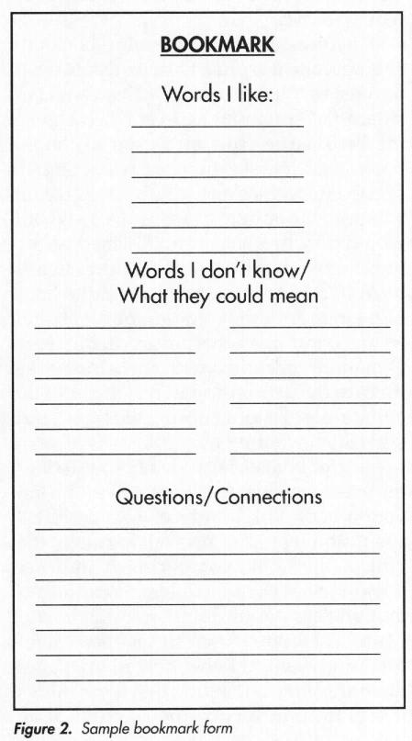

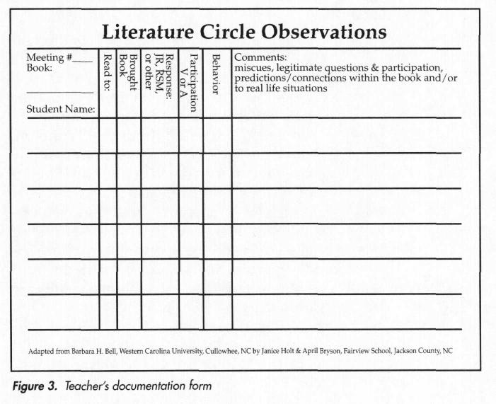
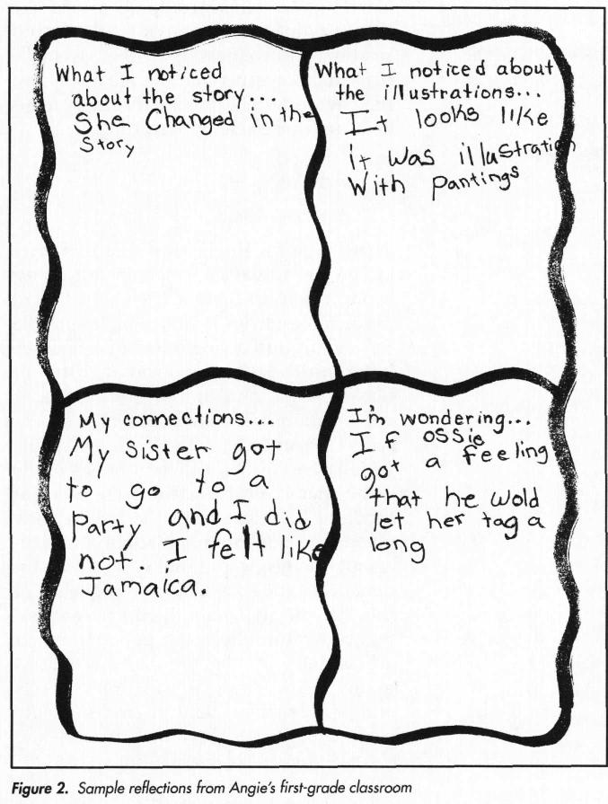
Figure 4. Sample Reflections Sheet.
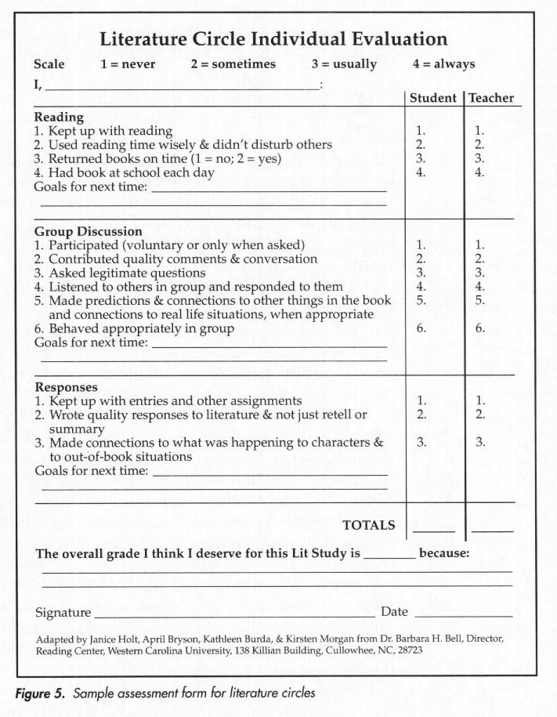

References
Basal Reading Programs. (2010). Retrieved October 23, 2010 from Information, news, & reviews: http://www.readingprograms.info/basal.html
Briggs, S. R. (2010). Using Literature Circles to Increase Reading Comprehension in Third Grade Elementary Students. Dominican University of California, School of Education and Counseling Psychology , San Rafael.
Candler, L. (2010, October 15). Literature Circle Models. Retrieved October 25, 2010, from Teaching Resources: http://www.lauracandler.com/strategies/litcirclemodels.php
Carrison, C., & Ernst-Slavit, G. (2005). From Silence to a Whisper to Active Participation: Using Literature Circles with ELL Students. ReadingHorizons , 46 (2), 93-113.
Center for the Expansion of Language and Thinking. (1998). Basal Reading Programs, Literature-Based Reading Programs, and Literature Programs. Retrieved October 23, 2010 from Center for the Expansion of Language and Thinking: http://www.celtlink.org/index.php?option=com_content&view=article&id=54:basal- reading-programs-literature-based-reading-programs-and-literature- programs&catid=34:fact-sheets&Itemid=57
Daniels, H. (2003). How can you grade literature circles?. Voices from the Middle, 11 (1), 52- 53.
Daniels, H. (2002). Literature Circles: Voice and Choice in the Student-Centered Classroom. York, Maine: Stenhouse Publishers.
Delaney, E. J. (Director). (2010). The Library of the Early Mind [Motion Picture].
Dierking, C. C., & Anderson-McElveen, S. (1998). Teaching Writing Skills With Children's Literature. Maupin House Publishing.
Dorfman, L. R., & Cappelli, R. (2007). Mentor Texts: Teaching Writing Through Children's Literature K-6. Portland, Maine: Stenhouse Publishers.
Dyer, J., Lovedahl, A., & Conley, T. (2000). Talking about books right from the start: Literature study in first, second, and third grade. Primary Voices K-6 , 9 (1), 27-33.
Ebe, A. (2010). Culturally Relevant Texts and Reading Assessment for English Language Learners. Reading Horizons, Sep/Oct 2010; 50, 3, 193.
Edward, S. (2010, November 1). Ten Tips for Selecting Multicultural Books for Reading Instruction. Retrieved May 11, 2011, from K12 Reader: Reading Instruction Resources for Teachers and Parents: http://www.k12reader.com/ten-tips-for-selecting-multicultural- books-for-reading-instruction/
Fisher, D., Flood, J., Lapp, D., & Frey, N. (2004). Interactive read-alouds: Is there a common set of implementation practices? The Reading Teacher, 58 (1), 8-17.
Freeman, M. (1997). Listen to This: Developing an Ear for Expository. Maupin House Publishing.
Freeman, Y., & Freeman, D. (2004, ). Connecting students to culturally relevant texts. Talking Points, April/May.
Gay, C. (1976). Reading Aloud and Learning to Write. The Elementary School Journal, 77, 87- 93.
Gay, G. (2010). Culturally Responsive Teaching: Theory, Research, and Practice. New York: Teachers College Press.
Gilbert, L. (2000). Getting started: Using literature circles in the classroom. Primary Voices K-6, 9 (1), 9-15.
Glossary of Education. (2010). Retrieved October 23, 2010 from Education.com: http://www.education.com/definition/basal-reading/
Goerss, B. (1994). Incorporating Children's Literature into the Content Reading Classroom. Paper, College Reading Association, New Orleans.
Hurst, C. O., & Otis, R. (2010). Curriculum Areas. Retrieved October 25, 2010, from Carol Hurst's Children's Literature Site: http://www.carolhurst.com/index.html
Kates, T. (2010). Using Children's Literature to Teach Writing: Perfect Pancakes . Retrieved October 25, 2010, from A to Z Teacher Stuff: http://www.atozteacherstuff.com/pages/494.shtml
Kindle, K. (2010). Vocabulary Development During Read-Alouds: Examining the Instructional Sequence. Literacy, Teaching and Learning , 14 ((1/2)), 65-88.
Klassen, B. (2009, June 26). Good Books Matter: How to Choose and Use Children's Literature to Help Students Grow as Readers. CM : an Electronic Reviewing Journal of Canadian Materials for Young People , 15 (22), p. 1.
Laminack, L. L., & Wadsworth, R. M. (2006). Reading Aloud Across the Curriculum: How to Build Bridges in Language Arts, Math, Science, and Social Studies. Portsmouth, NH: Heinemann.
Lewis, C. (2010). Literature quotes. Retrieved June 14, 2011, from Thinkexist.com: http://thinkexist.com/quotations/literature/
Maloch, B., Green, J., Tuyay, S., Dixon, C., & Floriani, A. (2004). One Teacher's Journey: Transitioning into Literature Discussion Groups. Language Arts , 81 (4), 312-322.
McGee, L. M., & Schickedanz, J. A. (2007). Repeated Interactive Read-Alouds in Preschool and Kindergarten. Reading Teacher , 60 (8), 742-751.
McIntyre, E. (2007). Story discussion in the primary grades: Balancing authenticity and explicit teaching. The Reading Teacher , 60 (7).
Milner, H. R. (2010). Start Where You are, but Don’t Stay There. Cambridge, MA: Harvard Education Press
Mulhollen, D. E. (2010, October 11). Incorporating Children's Literature in the Classroom. (L. Ranew, Interviewer) Madison, MS.
National Council of Teachers of English. (2008). English language learners: A policy research brief produced by the national council of teachers of English. http://www.ncte.org/library/NCTEFiles/Resources/PolicyResearch/ELLResearchBrief.pd f
Noe, K. L. (2009). Literature Circles Resource Center. Retrieved October 24, 2010, from Literature Circles Resource Center: http://www.litcircles.org/index.html
Renacker, M. (2010, October 13). Incorporating Children's Literature in the Classroom. (L. Ranew, Interviewer) Clinton, MS.
Sackes, M., Trundle, K., & Flevares, L. (2009). Using Children's Literature to Teach Standard- Based Science Concepts in Early Years. Early Childhood Education Journal , 36 (5), 415-422.
Schwedt, R., & DeLong, J. A. (2007). Using Children’s Literature to Teach Writing. Liberty University. Lynchburg: Faculty Publications and Presentations.
Silverman, R. D. (2007). Vocabulary Development of English-Language and English-Only Learners in Kindergarten. The Elementary School Journal , 107 (4), 365-383.
Vardell, S. M., Hadaway, N. L., & Young, T. A. (2006). Matching books and readers: Selecting literature for English learners. The Reading Teacher , 59 (8), 734-741.
Zucker, T. A., Ward, A. E., & Justice, L. M. (2009). Print Referencing During Read-Alouds: A Technique for Increasing Emergent Readers’ Print Knowledge. The Reading Teacher , 63 (1), 62-72.

