RUNNING HEAD: GENDER AND VICTIMIZATION HISTORY

THE IMPACT OF CHILDREN’S GENDER AND VICTIMIZATION HISTORY ON SELF-COGNITION AND PERCEIVED MEANNESS

Alessandra M. Camino

Honors Thesis
Submitted to the Faculty of the
Undergraduate Psychology Honors Department of Vanderbilt University
for the fulfillment of the requirements
for a honor degree of

PSYCHOLOGY HONORS

May, 2014
Nashville, Tennessee

Approved:

Professor David A. Cole

ACKNOWLEDGEMENTS

This project would not have been possible without the support, instruction, and endless guidance of Dr. David A. Cole. I am extremely thankful to have him as an advisor. I would also like to thank Keneisha Sinclair-McBride, without whom I would never have been able to produce a final product. I am also grateful to Megan Saylor for being a wonderful instructor and moral support pillar throughout these past two years. Lastly I would like to acknowledge my fellow students in the Cole lab and our participants for their help with this project.

ABSTRACT

This study examined gender differences in self-cognitions and perceived meanness following exposure to audio recordings of peer victimization. A second goal of the study was to examine the interaction between victimization experiences and gender on perceived meanness and resultant self-cognitions after listening to peer victimization scenarios ranging from mild to severe victimization. A total of 571 third through sixth graders participated in this cross-sectional study. Results revealed: (a) main effect for victimization, peer victimization experiences are associated with greater negative self-cognitions after listening to the peer victimization scenarios and greater perceived meanness of the scenarios (b) girls have greater negative cognitions after listening to the scenarios and think the scenarios are meaner than do boys and (c) there is no interaction between victimization and gender on perceived meanness and negative self-cognitions. Implications and future research are discussed.

THE IMPACT OF CHILDREN’S GENDER AND VICTIMIZATION HISTORY ON SELF-COGNITION AND PERCEIVED MEANNESS
Does gender impact response to peer victimization? Peer victimization affects children both socially and psychologically (Harter, 1985, & Ostrov, 2007). Victimization can influence how people view themselves and their capabilities. These effects are especially impactful during childhood and adolescence as these are times when self-concept is developing (Harter, 1985).
There are at least two main types of peer victimization (Ostrov, 2007). The first is overt/physical victimization; this involves actual or threatened physical attack on the victim. The second type of victimization is covert/relational victimization; this involves “behavior designed to damage peer relationships, friendships, and social acceptance, often by excluding the victim from peer activities, withdrawing friendships, or spreading rumors” (Hawker & Boulton, 2000). Covert/relational victimization has been found to predict increases in negative cognitions and decreases in positive cognitions over time (Sinclair, Cole, Dukewich, Felton, Weitlauf, &Maxwell, 2012). If children are socially excluded or gossiped about, they may begin to harbor negative beliefs about themselves. This relationship may predispose children to depression (Cambron, Acitelli, & Pettit, 2009).
The current study has two goals. The first goal is twofold. I aim to examine (a) gender differences in self-cognitions following audio recordings of peer victimization and (b) gender differences in perceived meanness of peer victimization from the same audio scenarios. Another goal of this study is to examine the interaction between victimization experiences and gender on perceived meanness and resultant self-cognitions after listening to peer victimization scenarios ranging from mild to severe victimization.
Aaron Beck’s concept of negative automatic thoughts helps explain how peer victimization experiences can affect self-cognition. Negative automatic cognitions are thoughts that people have spontaneously about themselves; these thoughts can be ideas about themselves, the world, and the future (Beck, Freeman, Davis, 2004). Such negative core beliefs (e. g., I am vulnerable, bad, helpless) can be triggered by negative event and can lead the individual to see the situation through a point of view consistent with this core belief. This process reinforces these negative thoughts about themselves and others. An example of this concept is if an individual has the core beliefs about being unintelligent and then performs badly on an exam, he or she will start to think automatic negative thoughts reflecting their core beliefs, for example, “My teacher thinks I’m stupid. She shouldn’t judge me, but I really must have a worse IQ then the rest of my class” (Beck, Freeman, Davis, 2004).
The negative thoughts a person has during the important time of childhood identity formation play a critical role in the development of self-concept and overall self-worth. If one is constantly having these negative ideas or feelings about oneself and the world, then they are likely to develop a lower sense of self-worth and self-concept. An example of how negative automatic thoughts interact with peer victimization and effect the child’s self-concept can be seen thought relational victimization. If a child is constantly being excluded from groups, the child may start to have thoughts like “No one will ever love me,” provoked by the situation of not being included. Furthermore, if this child has a history of victimization, they will have more established core beliefs that they are “not cool, not worth it,” increasing the level of negative thoughts and affecting the child self-concept (Beck, 1987; Beck, 2005; & Beck, et al. 2004)
Both males and females are exposed to victimization, though the amount and type of victimization does vary by gender. Girls experience more relational peer victimization than boys do (Cole, Maxwell, Dukewich, & Yosick, 2010; Sinclair et al., 2012). Girls are not only more likely to experience the type of victimization that has a greater effect on self-concept, they may also be more adapted to view peer affiliation as an important part of life. This is related to Susan Taylor’s (Taylor, Lewis, Gruenewald, Gurung, and Updegraff, 2000) concept of “Tend-and-Befriend.” Like the concept of the fight-or-flight response to a stressor, tend-and-befriend is a stress-elicited behavioral pattern, meaning that if a stressor or a dangerous situation arises, females respond by taking care of or affiliating with others. This response appears to have developed from the need to maximize the survival of self and offspring. Evolutionarily, women have found strength and positive outcomes from tending and befriending. Tend-and-befriend may be oxytocin mediated and moderated by sex hormones and endogenous opioid peptide mechanisms (Taylor, 2006). The tend-and-befriend concept suggests that social groups may be more important to females than they are to males.
Women have been found to define themselves in terms of their relationships more often than men have (Acitelli, Rogers, & Knee, 1999) and to place higher importance and value on the interpersonal, or social domain, basing their self-worth on their interpersonal relationships. The concept of interpersonal contingent self-esteem theory (Cambron, Acitelli, & Pettit, 2009) also helps explain why the importance placed on social groups by women may predispose them to depression. Contingent self-esteem is the extent to which one’s self-esteem is dependent on a domain (Deci & Ryan, 1995). If someone is receiving negative feedback or experiences failure in a particularly important domain, it will negatively affect the person’s overall wellbeing. Research also suggests that girls are more likely than boys to experience negative events in their relationships with others. The combination of greater social stress and interpersonal-contingent self-esteem could put females at higher risk for depressive symptoms (Cambron, et al. 2009). Research has shown that depressed individuals engage in certain behavioral and cognitive patterns that will have interpersonal consequences that keep them in depression (Hammen, 1991; Nolen-Hoeksema, 2000). Other reactions to interpersonal stress include excessive reassurance seeking, negative feedback seeking, and rumination. (Cambron et al., 2009). Girls tend to ruminate more often than boys, and research has shown a positive correlation between rumination and depressive symptoms (Lyubomisrsky & Nolen-Hoeksema, 1995).
The goal of this research is to investigate the differences between males and females’ self-cognition and perceived meanness. Based on the tend-and-befriend and interpersonal contingent self-esteem, I hypothesize that in response to the BYB study, girls will endorse more negative self-cognitions compared to boys and that girls will rate victimization scenarios as being meaner than do boys. This study will also explore whether there is an interaction between gender and one’s history of experiencing victimization. I hypothesis that those who have a longer history of prior victimization will endorse more negative self-cognitions and perceive scenarios as meaner and that this relation will be stronger for girls than boys.

Methods
Participants
Participants were in 3rd through 6th grade and were recruited from five schools in Davidson County. Grades 3 and 4 were gathered from three elementary schools and grades 5 and 6 were from two middle schools. Consent forms were issued to the students, their parents and teachers; 1083 students were given consent forms. Students were informed that the study was examining how kids get along. A total of 571 students participated in the study. As a group participants were 55.87% female and had an average age of 10.89 years (SD=1.20). The group was ethnically diverse, proportionately representing the school populations from which they came: 69.88% Caucasian, 33.10% African American, 7.36% Hispanic or Mexican-American, 5.60% Asian or Asian American, and 2.03% other.
Measures
Peer Victimization. To measure peer victimization we used a self-report called Way Kids Are (WKA). Our self-report was a twenty five-item questionnaire designed to assess covert/relational and overt/physical victimization we had used and validated in an earlier study (Cole, Maxwell, Dukewich, & Yosick, 2010). The measure expands on the items used by Kochenderfer-Ladd and Ladd (2001) to reﬂect a broader range of victimization experiences. Items were also reworded for somewhat older children. The question stem was ‘‘Does anyone in your class ever....’’ Asking questions that ranged to include 5 types of victimization: physical, relational, property, cyber, and verbal. The WKA asked how often these types of victimizations occurred both in the current year and in the previous year. Items are answered on a 4-point Likert scale (Never, Rarely, Sometimes, A lot). Some examples of questions on the WKA are “called you names,” “put lies about you on the Internet,” and “hurt you physically.” Cronbach’s alpha was .853 for verbal victimization, .852 for physical victimization, .846 for relational, .837 for property victimization, .836 for cyber victimization.
Self-Cognitions. The measure of self-cognitions used in this study is from the Behind Your Back (BYB) measure. The BYB is a measure made of audio recordings of peer victimization scenarios and self-report questions on responses to the scenarios. The peer victimization scenarios were conversations between two people, where the two people were talking about a third person. Participants were told to imagine that they were this third person. These conversations ranged from being mild to being harsh about the third person. Each participant listened to the audio-recorded conversation and then completed questions about each scenario. Four versions of the BYB measure were constructed: two girl versions and two boy versions. All versions included the same questions but the orders of the questions were rearranged to control for possible response patterns. The only other difference between the four BYB protocols was that in the girl versions, two females spoke in the peer victimization scenario, while the boys heard two males speaking. The BYB measures self-cognitions through the use of cognitive over-reactions listed after each scenario. These negative self-cognitions include statements that make strong negative inferences about oneself or one’s future. For this study, the self-cognition questions were divided into two subscales, self-cognitions following the harsh scenarios and self-cognitions for the mild. The self-cognitions were also analyzed as a whole. Some examples of these types of questions are, “Something is really wrong with me” and “There’s nothing to like about me.” The Cronbach’s alpha for the self-cognition for the harsh subscale was .951, and it was .903 for the mild.
Perceived Meanness. The BYB also assessed perceived meanness and asked how mean the participant felt the conversation was. These sets of questions were repeated 21 times for each of the conversations. For this study, the meanness questions were divided into two subscales, perceived meanness following the harsh scenarios and perceived meanness for the mild. We also examined perceived meanness for all the scenarios combined. The Cronbach alpha for the harsh subscale was .913, and for the mild scenarios it was .871.
Procedure
Students were informed that the study was looking at how kids get along, and were given consent forms to take home to be signed by a guardian. We offered a $100 donation to each classroom if 90% of the class returned consent forms signed, regardless of whether permission was granted or not. We made sure that all the participants knew that they could decide to not do the study or stop at any time. Students who wished to participate and who had parental consent were administered the BYB by members of the research team. During regular school hours, lab members went to the school and, in small groups, had students complete the questionnaires. The lab members were available to answer any questions the students had. After the completion of the questionnaires, students put on headphones and listened to the BYB. They were told to imagine they were overhearing the conversation and to imagine that each four-sentence conversation was about them. After each conversation they completed the 3 sets of questions before moving on to the next conversation. After the students finished with the study they were given a snack and a pencil as a treat.

Results
Overview
I addressed both of the goals of this study with a series of multiple regression analyses with one of six dependent variables: SELFCOG_ALL (self-cognition for all the scenarios), SELFCOG_Harsh (self-cognitions for the harsh scenarios), SELFCOG_MILD (self-cognitions for mild scenarios), MEAN_ALL (perceived meanness for all scenarios), MEAN_HARSH (perceived meanness of harsh scenarios), and MEAN_MILD (perceived meanness of mild scenarios). Table 1 contains correlations among all study variables, and Table 2 contains all the means and standard deviations for each variable and interaction use.

Correlation Table | 1 | 2 | 3 | 4 | 5 | 6 | 7 | 8 | 9 | 10 | 11 | 12 | 13 | 14
1) Total Victimization | 1.0
2) Verbal Victimization | .805 | 1.0
3) Physical Victimization | .771 | .583 | 1.0
4) Social Victimization | -.344 | -.299 | -.304 | 1.0
5) Relational Victimization | .855 | .648 | .528 | -.339 | 1.0
6) Property Victimization | .781 | .431 | .546 | -.288 | .585 | 1.0
7) Cyber Victimization | .568 | .260 | .223 | -.025 | .369 | .462 | 1.0
8)SELFCOG_ALL | .302 | .278 | .244 | -.141 | .250 | .202 | .111 | 1.0
9) SELFCOG_HARSH | .259 | .259 | .206 | -.079 | .212 | .159 | .096 | .955 | 1.0
10) SELFCOG_MILD | .313 | .276 | .249 | -.176 | .259 | .226 | .119 | .924 | .788 | 1.0
11) MEAN_ALL | .158 | .128 | .118 | -.091 | .139 | .142 | .074 | .403 | .292 | .520 | 1.0
12) MEAN_HARSH | .087 | .150 | .057 | .043 | .125 | -.007 | -.022 | .330 | .368 | .258 | .469 | 1.0
13) MEAN_MILD | .156 | .119 | .117 | -.097 | .134 | .146 | .082 | .389 | .270 | .517 | .995 | .398 | 1.0
14) Gender | .012 | -.016 | .204 | -.077 | -.112 | .063 | -.031 | -.164 | -.168 | -.142 | -.242 | -.251 | -.224 | 1.0
Table 1

Table 2
Means and Standard deviations

Variables | Mean | Std. Deviation
Gender (male) | 0.44 | 0.49
Total Victimization | 21.73 | 17.92
Verbal Victimization | 6.65 | 5.41
Physical Victimization | 3.55 | 4.43
Social Victimization | 22.84 | 5.75
Relational Victimization | 6.78 | 5.72
Property Victimization | 2.85 | 4.15
Cyber Victimization | 1.85 | 3.59

Goal 1
The first half of goal 1 was to examine gender differences in self-cognition. To test this hypothesis, I ran a family of multiple regression models. Three different dependent variables (DV) were conducted independently with the independent variable of gender and the seven variables of victimization. When looking at the DV of SELFCOG_ALL, gender and each individual type of victimization resulted in seven significant p values (See Table 3). When SELFCOG_HARSH, stories variable, or the mean of the self-cognitions for the harsh stories, was used as the DV gender and all victimization variables were significant (See Table 4). When the third DV dealing with self-cognitions, SELFCOG_MILD (mean of the cognitions for the mild BYB stories) was tested, gender and all types of peer victimizations produced significant p value results (See Table 5). The information produced by the regression analyses was used to generate figures to see the comparison for girls and boys. Eighteen of these figures involved, looked at self-cognition, using the three DV SELFCOG_ALL, SELFCOG_HARSH, and SELFCOGN_MILD and gender for each of the six types of victimization (Total Victimization, Verbal Victimization, Physical Victimization, Relational Victimization, Property Victimization, and Cyber Victimization). As depicted in Figures 1, 2, and 3, there was a main effect for gender, girls overall had lower self-cognitions than boys.
The second half of goal 1 was to examine gender differences on levels of perceived meanness. To achieve this goal, I conducted a family of multiple regression using three different dependent variables dealing with perceived meanness: MEAN_ALL (perceived meanness for all BYB stories), MEAN_HARSH (mean of the perceived meanness for the harsh BYB stories), and MEAN_MILD (mean of the perceived meanness for the mild BYB stories). When regression was used using the DV of MEAN_ALL, gender and each peer victimization values were significant (See Table 6). Secondly, the DV was changed to MEAN_HARSH, which resulted in all gender and victimization variables to have a significant p value (See Table 7). The third DV, MEAN_MILD, was run resulting in gender and all victimizations to be significant (See Table 8). The information gathered from the regression analyses was used to create eighteen figures showing the difference between boys and girls (See Figures 4, 5, and 6). The eighteen figures involved, looked at perceived meanness, using the three DV MEAN_ALL, MEAN_HARSH, and MEAN_MILD, and gender for each of the six types of victimization (Total Victimization, Verbal Victimization, Physical Victimization, Relational Victimization, Property Victimization, and Cyber Victimization). As depicted in Figures 4, 5, and 6, there was a main effect for victimization, those who have a greater history of victimization rated the scenarios as more mean.

Table 3
Predictor | Intercept | Unst. B | SE(B) | B | t | p
DV: SELFCOG_ALL
Gender | 2.483 | -0.343 | 0.087 | -0.164 | -3.958 | 0.00
Gender | 2.091 | -0.352 | -0.084 | -0.17 | -4.215 | 0.00
Total Victimization |  | 0.017 | 0.002 | 0.304 | 7.546 | 0.00
Gender | 2.1017 | -0.189 | 0.131 | -0.091 | -1.443 | 0.15
Victimization Total |  | 0.021 | 0.003 | 0.363 | 6.653 | 0.00
Gender X Victimization |  | -0.007 | 0.005 | -0.119 | -1.618 | 0.11
Gender | 2.104 | -0.315 | 0.086 | -0.15 | -3.664 | 0.00
Verbal Victimization |  | 0.053 | 0.008 | 0.275 | 6.712 | 0.00
Gender | 2.034 | -0.164 | 0.136 | -0.078 | -1.211 | 0.23
Verbal Victimization |  | 0.063 | 0.011 | 0.329 | 5.938 | 0.00
Gender X Verbal Victimization |  | -0.023 | 0.016 | -0.107 | -1.438 | 0.15
Gender | 2.283 | -0.473 | 0.087 | -0.228 | -5.439 | 0.00
Physical Victimization |  | 0.068 | 0.01 | 0.29 | 6.938 | 0.00
Gender | 2.258 | -0.418 | 0.111 | -0.201 | -3.757 | 0.00
Physical Victimization |  | 0.077 | 0.015 | 0.33 | 5.087 | 0.00
Gender X Physical Victimization |  | -0.016 | 0.2 | -0.061 | -0.791 | 0.43
Gender | 3.095 | -0.357 | 0.088 | -0.171 | -4.046 | 0.00
Social Victimization |  | -0.028 | 0.008 | -0.155 | -3.658 | 0.00
Gender | 2.913 | 0.074 | 0.362 | 0.036 | 0.205 | 0.84
Social Victimization |  | -0.02 | 0.01 | -0.111 | -2.016 | 0.04
Gender X Social Victimization |  | -0.019 | 0.015 | -0.214 | -1.229 | 0.22
Gender | 2.154 | -0.294 | 0.087 | -0.142 | -3.381 | 0.00
Relational Victimization |  | 0.042 | 0.008 | 0.234 | 5.588 | 0.00
Gender | 2.095 | -0.17 | 0.133 | -0.082 | -1.277 | 0.20
Relational Victimization |  | 0.05 | 0.01 | 0.279 | 5.029 | 0.00
Gender X Relational Victimization |  | -0.019 | 0.015 | -0.088 | -1.237 | 0.22
Gender | 2.316 | -0.35 | 0.87 | -0.169 | -4.025 | 0.00
Property Victimization |  | 0.053 | 0.01 | 0.213 | 5.081 | 0.00
Gender | 2.294 | -0.302 | 0.106 | -0.146 | -2.857 | 0.00
Property Victimization |  | 0.061 | 0.015 | 0.246 | 4.172 | 0.00
Gender X Property Victimization |  | -0.017 | 0.021 | -0.053 | -0.8 | 0.42
Gender | 2.421 | -0.35 | 0.088 | -0.168 | -3.998 | 0.00
Cyber Victimization |  | 0.03 | 0.012 | 0.106 | 2.52 | 0.01
Gender | 2.378 | -0.261 | 0.098 | -0.125 | -2.666 | 0.01
Cyber Victimization |  | 0.053 | 0.016 | 0.183 | 3.221 | 0.00
Gender X Cyber Victimization |  | -0.049 | 0.024 | -0.121 | -2.009 | 0.05

Table 4
Predictor | Intercept | Unst. B | SE(B) | B | t | p
DV: SELFCOG_HARSH
Gender | 76.672 | -8.143 | 1.177 | -0.281 | -6.916 | 0.00
Gender | 73.883 | -8.341 | 1.177 | -0.289 | -7.085 | 0.00
Total Victimization |  | 0.123 | 0.033 | 0.154 | 3.768 | 0.00
Gender | 74.003 | -3.871 | 1.116 | -0.228 | -3.468 | 0.00
Victimization Total |  | 0.213 | 0.088 | 0.137 | 2.425 | 0.02
Gender X Victimization |  | -0.045 | 0.131 | -0.026 | -0.343 | 0.73
Gender | 73.871 | -8.081 | 1.184 | -0.281 | -6.823 | 0.00
Verbal Victimization |  | 0.402 | 0.108 | 0.153 | 3.718 | 0.00
Gender | 74.038 | -3.871 | 1.116 | -0.228 | -3.468 | 0.00
Verbal Victimization |  | 0.213 | 0.088 | 0.137 | 0.137 | 0.02
Gender X Verbal Victimization |  | -0.045 | 0.131 | 0.026 | -0.026 | 0.73
Gender | 74.785 | -8.987 | 1.216 | -0.313 | -7.39 | 0.00
Physical Victimization |  | 0.568 | 0.137 | 0.175 | 4.133 | 0.00
Gender | 75.365 | -5.391 | 0.919 | -0.319 | -5.868 | 0.00
Physical Victimization |  | 0.21 | 0.124 | 0.11 | 1.687 | 0.09
Gender X Physical Victimization |  | 0.21 | 0.165 | 0.098 | 1.273 | 0.20
Gender | 80.717 | -8.204 | 1.211 | -0.284 | -6.777 | 0.00
Social Victimization |  | -0.184 | 0.106 | -0.072 | -1.727 | 0.09
Gender | 79.448 | -4.086 | 2.984 | -0.24 | -1.369 | 0.17
Social Victimization |  | -0.163 | 0.082 | -0.109 | -1.998 | 0.05
Gender X Social Victimization |  | -0.006 | 0.127 | -0.008 | -0.046 | 0.96
Gender | 74.313 | -8.015 | 1.202 | -0.279 | -6.669 | 0.00
Relational Victimization |  | 0.313 | 0.104 | 0.125 | 3.003 | 0.00
Gender | 74.551 | -4.208 | 1.085 | -0.25 | -3.878 | 0.00
Relational Victimization |  | 0.148 | 0.082 | 0.101 | 1.801 | 0.07
Gender X Relational Victimization |  | 0.037 | 0.125 | 0.021 | 0.297 | 0.77
Gender | 75.441 | -7.995 | 1.194 | -0.28 | -6.694 | 0.00
Property Victimization |  | 0.373 | 0.146 | 0.107 | 2.557 | 0.01
Gender | 75.452 | -3.933 | 0.863 | -0.232 | -4.557 | 0.00
Property Victimization |  | 0.353 | 0.119 | 0.17 | 2.965 | 0.00
Gender X Property Victimization |  | -0.066 | 0.174 | -0.025 | -0.378 | 0.71
Gender | 76.351 | -7.994 | 1.186 | -0.28 | -6.74 | 0.00
Cyber Victimization |  | 0.13 | 0.166 | 0.032 | 0.782 | 0.44
Gender | 75.884 | -3.627 | 0.793 | -0.213 | -4.571 | 0.00
Cyber Victimization |  | 0.268 | 0.132 | 0.113 | 2.025 | 0.04
Gender X Cyber Victimization |  | -0.259 | 0.198 | -0.077 | -1.304 | 0.19

Table 5
Predictor | Intercept | Unst. B | SE(B) | B | t | p
DV: SELFCOG_MILD
Gender | 50.04 | -4.207 | 0.685 | -0.251 | -6.139 | 0.00
Gender | 49.113 | -4.241 | 0.695 | -0.253 | -6.098 | 0.00
Total Victimization |  | 0.041 | 0.019 | 0.089 | 2.134 | 0.03
Gender | 49.288 | -4.631 | 1.091 | -0.277 | -4.247 | 0.00
Victimization Total |  | 0.033 | 0.026 | 0.071 | 1.27 | 0.20
Gender X Victimization |  | 0.18 | 0.039 | 0.035 | 0.465 | 0.64
Gender | 48.533 | -3.917 | 0.688 | -0.237 | -5.694 | 0.00
Verbal Victimization |  | 0.219 | 0.063 | 0.145 | 3.48 | 0.00
Gender | 48.91 | -4.057 | 1.096 | -0.239 | -3.704 | 0.00
Verbal Victimization |  | 0.078 | 0.026 | 0.165 | 2.979 | 0.00
Gender X Verbal Victimization |  | -0.006 | 0.039 | -0.012 | -0.165 | 0.87
Gender | 49.395 | -4.403 | 0.722 | -0.263 | -6.099 | 0.00
Physical Victimization |  | 0.206 | 0.082 | 0.109 | 2.524 | 0.01
Gender | 49.803 | -5.312 | 0.921 | -0.317 | -5.767 | 0.00
Physical Victimization |  | 0.057 | 0.124 | 0.03 | 0.458 | 0.65
Gender X Physical Victimization |  | 0.261 | 0.165 | 0.124 | 1.586 | 0.11
Gender | 49.17 | -4.039 | 0.704 | -0.242 | -5.738 | 0.00
Social Victimization |  | 0.033 | 0.062 | 0.023 | 0.542 | 0.59
Gender | 47.576 | -0.254 | 2.931 | -0.015 | -0.086 | 0.93
Social Victimization |  | 0.102 | 0.08 | 0.07 | 1.269 | 0.21
Gender X Social Victimization |  | -0.166 | 0.125 | -0.235 | -1.331 | 0.18
Gender | 49.032 | -4.17 | 0.71 | -0.248 | -5.872 | 0.00
Relational Victimization |  | 0.142 | 0.062 | 0.097 | 2.3 | 0.02
Gender | 49.121 | -4.354 | 1.083 | -0.259 | -4.02 | 0.00
Relational Victimization |  | 0.13 | 0.082 | 0.089 | 1.58 | 0.12
Gender X Relational Victimization |  | 0.028 | 0.125 | 0.016 | 0.225 | 0.82
Gender | 49.945 | -4.025 | 0.701 | -0.243 | -5.745 | 0.00
Property Victimization |  | 0.015 | 0.086 | 0.007 | 0.172 | 0.86
Gender | 50.052 | -4.275 | 0.855 | -0.258 | -5.002 | 0.00
Property Victimization |  | -0.026 | 0.118 | -0.013 | -0.225 | 0.82
Gender X Property Victimization |  | 0.088 | 0.172 | 0.034 | 0.511 | 0.61
Gender | 50.145 | -4.09 | 0.689 | -0.248 | -5.939 | 0.00
Cyber Victimization |  | -0.07 | 0.095 | -0.031 | -0.738 | 0.46
Gender | 49.8 | -3.373 | 0.768 | -0.205 | -4.393 | 0.00
Cyber Victimization |  | 0.108 | 0.128 | 0.047 | 0.841 | 0.40
Gender X Cyber Victimization |  | -0.399 | 0.191 | -0.123 | -2.084 | 0.04

Table 6
Predictor | Intercept | Unst. B | SE(B) | B | t | p
DV: MEAN_ALL
Gender | 26.61 | -4.053 | 0.743 | -0.224 | -5.455 | 0.00
Gender | 24.824 | -4.138 | 0.74 | -0.232 | -5.593 | 0.00
Total Victimization |  | 0.079 | 0.021 | 0.158 | 3.809 | 0.00
Gender | 24.741 | -3.952 | 1.16 | -0.221 | -3.407 | 0.00
Victimization Total |  | 0.082 | 0.028 | 0.165 | 2.963 | 0.00
Gender X Victimization |  | -0.009 | 0.041 | -0.016 | -0.208 | 0.84
Gender | 25.28 | -4.132 | 0.752 | -0.23 | -5.493 | 0.00
Verbal Victimization |  | 0.188 | 0.069 | 0.115 | 2.733 | 0.01
Gender | 25.068 | -3.669 | 1.183 | -0.205 | -3.101 | 0.00
Verbal Victimization |  | 0.22 | 0.093 | 0.134 | 2.364 | 0.02
Gender X Verbal Victimization |  | -0.07 | 0.138 | -0.038 | -0.508 | 0.61
Gender | 25.432 | -4.63 | 0.761 | -0.26 | -6.081 | 0.00
Physical Victimization |  | 0.34 | 0.086 | 0.169 | 3.941 | 0.00
Gender | 25.703 | -5.232 | 0.972 | -0.294 | -5.383 | 0.00
Physical Victimization |  | 0.24 | 0.132 | 0.119 | 1.821 | 0.07
Gender X Physical Victimization |  | 0.174 | 0.174 | 0.078 | 0.997 | 0.32
Gender | 30.757 | -4.165 | 0.756 | -0.232 | -5.506 | 0.00
Social Victimization |  | -0.184 | 0.066 | -0.117 | -2.772 | 0.01
Gender | 30.946 | -4.608 | 3.166 | -0.257 | -1.456 | 0.15
Social Victimization |  | -0.192 | 0.087 | -0.122 | -2.21 | 0.03
Gender X Social Victimization |  | 0.019 | 0.135 | 0.026 | 0.144 | 0.89
Gender | 25.267 | -3.866 | 0.752 | -0.218 | -5.14 | 0.00
Relational Victimization |  | 0.169 | 0.065 | 0.11 | 2.579 | 0.01
Gender | 25.394 | -4.131 | 1.147 | -0.233 | -3.601 | 0.00
Relational Victimization |  | 0.151 | 0.087 | 0.098 | 1.737 | 0.08
Gender X Relational Victimization |  | 0.04 | 0.132 | 0.022 | 0.306 | 0.76
Gender | 25.508 | -4.045 | 0.749 | -0.227 | -5.403 | 0.00
Property Victimization |  | 0.345 | 0.092 | 0.158 | 3.771 | 0.00
Gender | 25.433 | -3.871 | 0.912 | -0.217 | -4.244 | 0.00
Property Victimization |  | 0.374 | 0.126 | 0.172 | 2.972 | 0.00
Gender X Property Victimization |  | -0.062 | 0.184 | -0.022 | -0.335 | 0.74
Gender | 26.215 | -3.993 | 0.752 | -0.222 | -5.312 | 0.00
Cyber Victimization |  | 0.182 | 0.104 | 0.073 | 1.743 | 0.08
Gender | 26.035 | -3.621 | 0.84 | -0.202 | -4.309 | 0.00
Cyber Victimization |  | 0.274 | 0.14 | 0.11 | 1.957 | 0.05
Gender X Cyber Victimization |  | -0.207 | 0.21 | -0.059 | -0.988 | 0.32

Table 7
Predictor | Intercept | Unst. B | SE(B) | B | t | p
DV: MEAN_HARSH
Gender | 31.174 | -4.697 | 1.169 | -0.168 | -4.018 | 0.00
Gender | 26.702 | -4.774 | 1.142 | -0.172 | -4.182 | 0.00
Total Victimization |  | 0.201 | 0.032 | 0.26 | 6.335 | 0.00
Gender | 25.636 | -2.383 | 1.785 | -0.086 | -1.335 | 0.18
Victimization Total |  | 0.251 | 0.043 | 0.325 | 5.877 | 0.00
Gender X Victimization |  | -0.111 | 0.064 | -0.129 | -1.741 | 0.08
Gender | 26.567 | -4.359 | 1.162 | -0.156 | -3.751 | 0.00
Verbal Victimization |  | 0.652 | 0.106 | 0.255 | 6.155 | 0.00
Gender | 25.605 | -2.262 | 1.821 | -0.081 | -1.242 | 0.22
Verbal Victimization |  | 0.796 | 0.143 | 0.312 | 5.571 | 0.00
Gender X Verbal Victimization |  | -0.318 | 0.213 | -0.111 | -1.495 | 0.14
Gender | 28.935 | -6.198 | 1.194 | -0.221 | -5.191 | 0.00
Physical Victimization |  | 0.792 | 0.135 | 0.25 | 5.87 | 0.00
Gender | 28.593 | -5.43 | 1.527 | -0.194 | -3.556 | 0.00
Physical Victimization |  | 0.917 | 0.206 | 0.29 | 4.456 | 0.00
Gender X Physical Victimization |  | -0.22 | 0.273 | -0.062 | -0.807 | 0.42
Gender | 36.044 | -4.797 | 1.191 | -0.173 | -4.028 | 0.00
Social Victimization |  | -0.227 | 0.104 | -0.093 | -2.181 | 0.03
Gender | 34.287 | -0.607 | 4.956 | -0.022 | -0.122 | 0.90
Social Victimization |  | -0.151 | 0.135 | -0.062 | -1.119 | 0.26
Gender X Social Victimization |  | -0.184 | 0.212 | -0.156 | -0.871 | 0.38
Gender | 27.596 | -4.208 | 1.185 | -0.151 | -3.552 | 0.00
Relational Victimization |  | 0.47 | 0.103 | 0.195 | 4.575 | 0.00
Gender | 26.465 | -1.854 | 1.8 | -0.067 | -1.03 | 0.30
Relational Victimization |  | 0.626 | 0.136 | 0.259 | 4.594 | 0.00
Gender X Relational Victimization |  | -0.359 | 0.207 | -0.124 | -1.734 | 0.08
Gender | 29.413 | -4.775 | 1.18 | -0.172 | -4.046 | 0.00
Property Victimization |  | 0.575 | 0.144 | 0.169 | 3.986 | 0.00
Gender | 29.053 | -3.931 | 1.44 | -0.142 | -2.73 | 0.01
Property Victimization |  | 0.713 | 0.198 | 0.21 | 3.607 | 0.00
Gender X Property Victimization |  | -0.296 | 0.289 | -0.068 | -1.023 | 0.31
Gender | 30.521 | -4.899 | 1.179 | -0.176 | -4.157 | 0.00
Cyber Victimization |  | 0.346 | 0.163 | 0.09 | 2.118 | 0.04
Gender | 29.943 | -3.697 | 1.315 | -0.133 | -2.813 | 0.01
Cyber Victimization |  | 0.643 | 0.219 | 0.167 | 2.943 | 0.00
Gender X Cyber Victimization |  | -0.668 | 0.327 | -0.122 | -2.04 | 0.04

Table 8
Predictor | Intercept | Unst. B | SE(B) | B | t | p
DV: MEAN_MILD
Gender | 20.969 | -2.683 | 0.751 | -0.149 | -3.571 | 0.00
Gender | 17.706 | -2.823 | 0.721 | -0.159 | -3.916 | 0.00
Total Victimization |  | 0.148 | 0.02 | 0.299 | 7.364 | 0.00
Gender | 17.052 | -1.361 | 1.128 | -0.077 | -1.206 | 0.23
Victimization Total |  | 0.179 | 0.027 | 0.36 | 6.601 | 0.00
Gender X Victimization |  | -0.068 | 0.04 | -0.124 | -1.683 | 0.09
Gender | 17.881 | -2.537 | 0.745 | -0.141 | -3.405 | 0.00
Verbal Victimization |  | 0.446 | 0.068 | 0.27 | 6.54 | 0.00
Gender | 17.3 | -1.272 | 1.171 | -0.071 | -1.087 | 0.28
Verbal Victimization |  | 0.532 | 0.092 | 0.323 | 5.79 | 0.00
Gender X Verbal Victimization |  | -0.192 | 0.137 | -0.104 | -1.4 | 0.16
Gender | 19.303 | -3.715 | 0.745 | -0.211 | -4.987 | 0.00
Physical Victimization |  | 0.557 | 0.084 | 0.279 | 6.598 | 0.00
Gender | 19.07 | -3.196 | 0.953 | -0.181 | -3.356 | 0.00
Physical Victimization |  | 0.642 | 0.129 | 0.322 | 4.98 | 0.00
Gender X Physical Victimization |  | -0.149 | 0.171 | -0.067 | -0.875 | 0.38
Gender | 27.248 | -2.87 | 0.758 | -0.16 | -3.784 | 0.00
Social Victimization |  | -0.28 | 0.066 | -0.179 | -4.219 | 0.02
Gender | 25.273 | 1.814 | 3.158 | 0.101 | 0.574 | 0.57
Social Victimization |  | -0.196 | 0.086 | -0.125 | -2.259 | 0.02
Gender X Social Victimization |  | -0.206 | 0.135 | -0.27 | -1.528 | 0.13
Gender | 18.333 | -2.387 | 0.742 | -0.136 | -3.215 | 0.00
Relational Victimization |  | 0.342 | 0.065 | 0.224 | 5.298 | 0.00
Gender | 18.056 | -1.813 | 1.133 | -0.103 | -1.601 | 0.11
Relational Victimization |  | 0.38 | 0.086 | 0.249 | 4.426 | 0.00
Gender X Relational Victimization |  | -0.087 | 0.13 | -0.048 | -0.671 | 0.50
Gender | 19.508 | -2.771 | 0.75 | -0.155 | -3.696 | 0.00
Property Victimization |  | 0.491 | 0.092 | 0.225 | 5.345 | 0.00
Gender | 19.355 | -2.416 | 0.913 | -0.135 | -2.645 | 0.01
Property Victimization |  | 0.549 | 0.126 | 0.251 | 4.355 | 0.00
Gender X Property Victimization |  | -0.125 | 0.184 | -0.045 | -0.68 | 0.50
Gender | 20.51 | -2.738 | 0.759 | -0.153 | -3.609 | 0.00
Cyber Victimization |  | 0.248 | 0.105 | 0.099 | 2.351 | 0.02
Gender | 20.018 | -1.724 | 0.843 | -0.096 | -2.044 | 0.04
Cyber Victimization |  | 0.501 | 0.141 | 0.201 | 3.557 | 0.00
Gender X Cyber Victimization |  | -0.567 | 0.211 | -0.161 | -2.691 | 0.01

Goal 2
The second goal of this study was to examine the interaction between victimization experiences and gender on perceived meanness and resultant self-cognitions. An extensive series of multiple regressions was performed using the six DV of SELFCOG_ALL, SELFCOG_HARSH (mean of the cognitions for the harsh stories), SELFCOG_MILD (mean of the cognitions for mild stories), MEAN_ALL (perceived meanness for all BYB), MEAN_HARSH (mean of the perceived meanness of harsh stories), and MEAN_MILD (mean of the perceived meanness of mild stories) and all interaction variables listed on Table 2 (See Tables 3, 4, 5, 6, 7, and 8). Out of all thirty-six regressions performed only four resulted in significant p values, SELFCOG_ALL and the interaction of gender and cyber victimization (B = -0.129, p = .05) and SELFCOG_HARSH and the interaction of gender and cyber victimization (B = -0.123, p = .04). Two perceived meanness regressions resulted in significant interactions. MEAN_HARSH with gender and cyber victimization (B = -.122, p = .04) and MEAN_MILD mean with gender and cyber victimization (B = -0.161, p = .01). Since so many regressions were conducted it is expected to see a few of these results caused by Type 1 error.
The information produced by the regression analyses was used to generate figures to illustrate the interactions. Eighteen of these figures involved, looked at self-cognition, using the three DV SELFCOG_ALL, SELFCOG_HARSH, and SELFCOG_MILD, and gender for each of the six types of victimization (Total Victimization, Verbal Victimization, Physical Victimization, Relational Victimization, Property Victimization, and Cyber Victimization), while the other eighteen figures looked at perceived meanness, using the three DV MEAN_ALL, MEAN_HARSH, MEAN_MILD, and gender for each of the six types of victimization. Depicted in Figures 1, 2, 3, 4, 5, and 6.

Figure 1

Interactions using DV SELFCOG_ALL

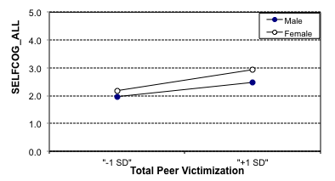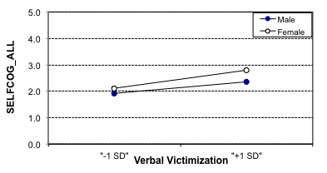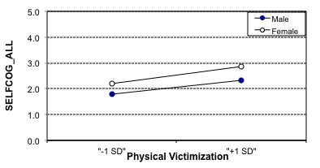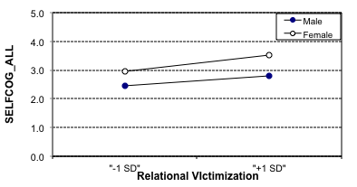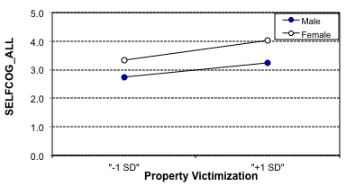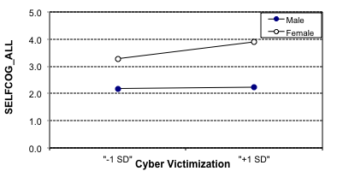

Figure 2

Interactions using DV SELFCOG_HARSH

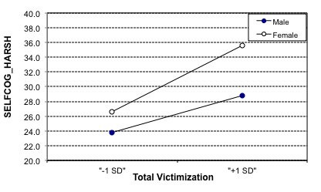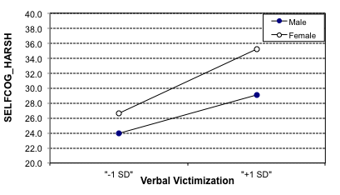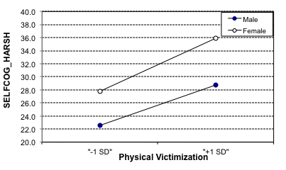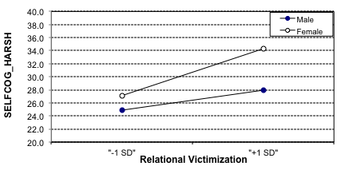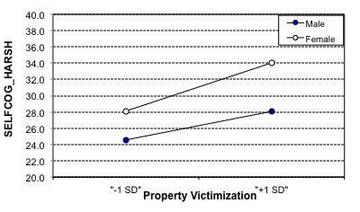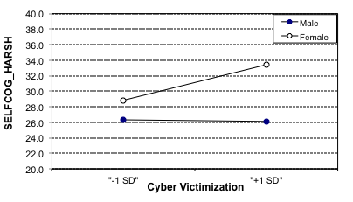

Figure 3

Interactions using DV SELFCOG_MILD

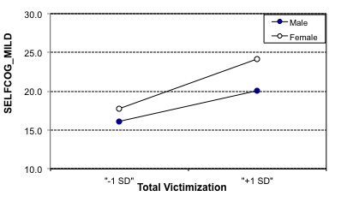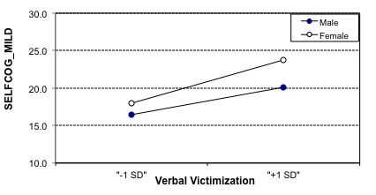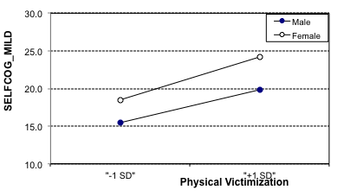
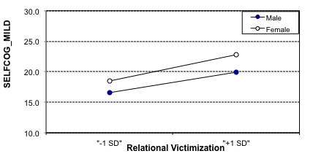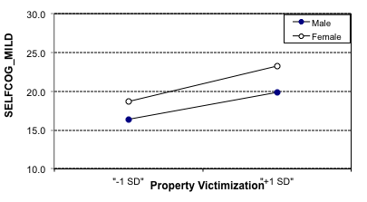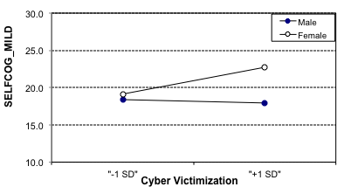

Figure 4

Interactions using DV MEAN_ALL

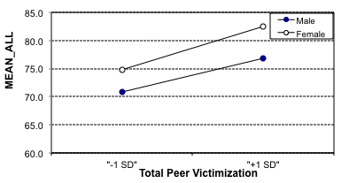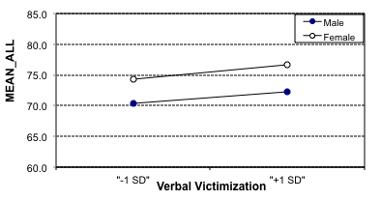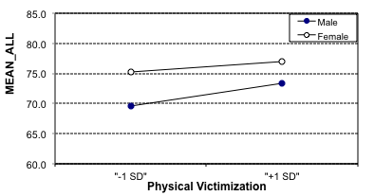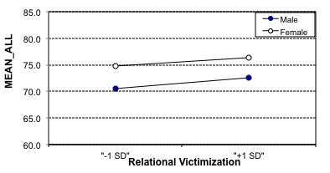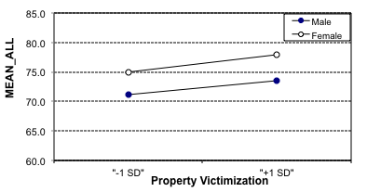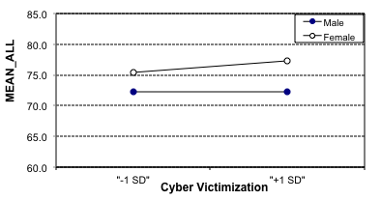

Figure 5

Interactions using DV MEAN_HARSH

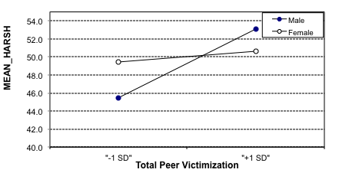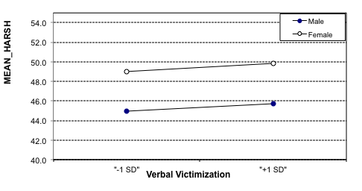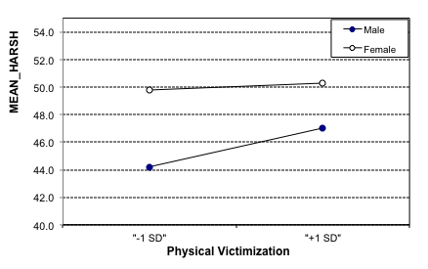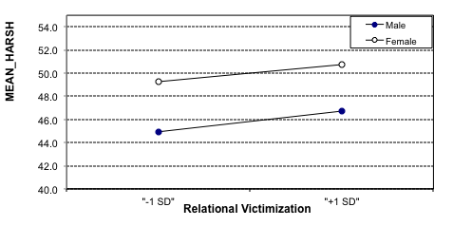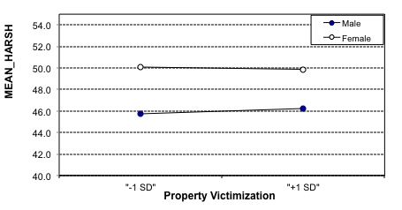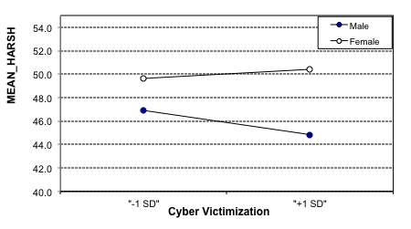

Figure 6

Interactions using DV MEAN_MILD

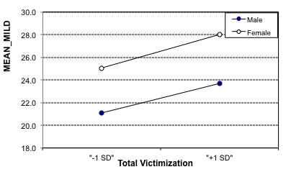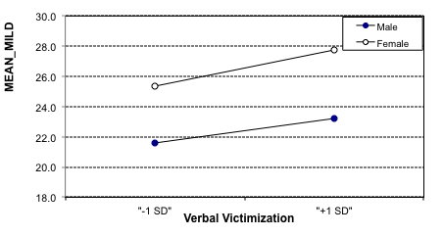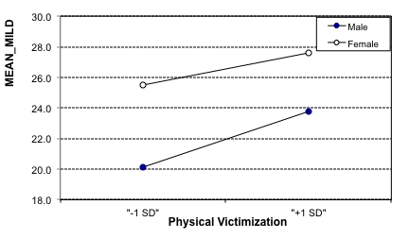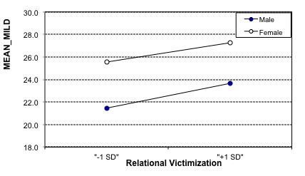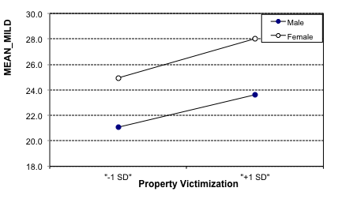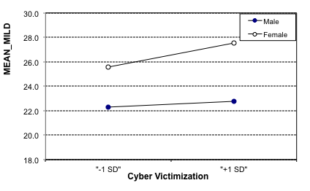

Discussion
Three major findings emerged from the current study. The first finding suggested that peer victimization has a negative impact on both boys’ and girls’ self-cognition, but girls will have an overall lower self-cognition. The second finding was that one’s history of peer victimization influence both girls’ and boys’ perceived meanness of peer victimization scenarios, but girls will overall rate the scenarios as meaner. The third finding was that there is little evidence that peer victimization experiences interact with gender to impact self-cognitions and perceived meanness following victimization scenarios. Each of the results is elaborated below.
First, the data supported the hypothesis that girls would have more negative self-cognitions than boys in response to analog experiences of peer victimization. Results showed that relational peer victimization had an influence on both girls and boys, but girls would have lower self-cognitions. These findings are consistent with previous research suggesting that girls value social acceptance more than boys; however boys are not immune to the negative affects of victimization. Aaron Beck’s research on negative automatic thoughts made the claim that when an individual receives negative feedback it can impact and lower their self-cognitions. The outcomes from this study support this research, as well as, Taylor’s “Tend-and-Befriend” theory. The findings of this study suggest that girls place higher value on other’s views, and therefore let peer victimization change their self-cognitive more.
The second result from the data analyses indicated that both boys and girls who have a history of peer victimization experiences tend to perceive peer victimization situations to be meaner than do people without or with less peer victimization histories. Girls would still rate scenarios as meaner than boys, but those with victimization history would also rate them as meaner. This finding could be explained by the “Tend-and-Befriend” concept and Cambron’s Interpersonal contingent self-esteem theory. The “Tend-and-Befriend” theory is based on the idea that throughout history girls have had to put more value on social groups for survival. Therefore, girls feel the want to develop social relationships and they become more emotionally impacted when relational peer victimization takes place. This is similar to Cambron’s theory, which is if someone is receiving negative feedback or experiences failure in a particularly important social domain, it will negatively impact the person’s overall sense of wellbeing.
The third finding was that there were overall no interactions, apart from four interactions resulting in significant p values, which are most likely due to type 1 error. Four of the thirty-six interactions resulted in being significant, SELFCOG_ALL and the interaction of gender and cyber victimization, SELFCOG_MILD and the interaction of gender and cyber victimization, MEAN_HARSH with gender and cyber victimization, and MEAN_MILD with gender and cyber victimization. From conducting thirty-six analyses it is expected to get about four significant results due to error. These points should not be over analyzed but we consider them results from type 1 error.
Using the DV of MEAN_HARSH and total victimization, the boys started having a lower level of perceived meanness than the girls, but after the BYB scenarios boys had higher levels of perceived meanness than those of girls. The effect on girls still increased but not as steeply or high as that of boys. This was not significant mostly like due to type 1 error, since no other situation produced similar results and these two seem to go in opposite directions. Overall, this study suggested that for both boys and girls, peer victimization history will cause boys and girls to have lower self-cognitions and higher perceived meanness but that overall girls will have lower self-cognitions and higher levels of perceived meanness. they view relational peer victimization situations, but girls view the situations as meaner than boys will.
Implications and Future Research
The findings from this study can be used to play a role in how interventions could be performed for children who are victims of bullying. The results from this study suggested that boys would also benefit from also having interventions dealing with relational victimization. It would be best if the interventions were equally focused on both boys and girls. This study showed that several types of victimization, including relational, still impacts boys’ as well as girls’. Therefore, boys also need interventions that deal with relational victimization. This being said new methods for counseling could be developed specifically aimed at boys dealing with relational victimization and their impacts.
There are several weaknesses to the current study that suggest avenues for future research. First, this was a cross-sectional study; future research should run this study and collect data from a longitudinal study. It would also be beneficial to gather more participants in the future when examining these research questions. Cyber victimization is a fairly new type of victimization that has surfaced over the past few years. There is not a aot of research on cyber victimization at this point, but due to some of the findings in this study more time and effort should be placed in studying this newer type of bullying.

REFERENCES
Acitelli, L. K., Rogers, S., & Knee, C. R. (1999). The role of identity in the link between relationship thinking and relationship satisfaction. Journal of Social and Personal Relationships, 16, 591-618.
Beck, A. T, (1987). Cognitive models of depression. Journal of cognitive psychotherapy: An international Quarterly, I, 5-37.
Beck, A. T., Freeman, A., & Davis, D. D., (2004). Cognitive therapy of personality disorders. Psychiartic Rehabilitation Journal, 29, 82-83.
Cambron, M. J., Acitelli, L. K., & Pettit, J. W. (2009). Explaining gender differences in depression: an interpersonal contingent self-esteem perspective. Springer Science + Business Media, 61, 751-761.
Cole, D. A., Maxwell, M. A., Dukewich, T. L., & Yosick, R. (2010). Targeted peer victimization and the construction of positive and negative self-cognitions: Connections to depressive symptoms in children. Journal of Clinical Child and Adolescent Psychology, 39, 421-445.
Deci, E. L., & Ryan, R. M. (1995). Human autonomy: the basis for true self-esteem. In M. H. Kennis (ED.), Efficacy, agent, and self-esteem, pp. 31-49. New York, NY: Plenum
Hammen, C. (1991) Generation of stress in the course of unipolar depression. Journal of Abnormal Psychology, 100, 555-561.
Harter, S. (1985). The perceived competence scale for children. Child Development, 53, 87-97.
Harter, S. (1999). A model of the causes, correlates, and consequences of global self-worth. In S. Harter (Ed.), The construction of the self: A developmental perspective. New York, NY, US: Guilford.
Hawker, D. S. J., & Boulton, M. J. (2000). Twenty years’ research on peer victimization and psyhosocial maladjustment: A meta-analytic review of cross-sectional studies. Journals of Child Psychology and Psychiatry, 41, 441-455.
Kochenderfer-Ladd, B., & Wardrop, J. L. (2001). Chronicity and Instability of Children’s Peer Victimization Experiences as Predictors of Loneliness and Social Satisfaction Trjectories. Child Development, 72, 134-151.
Lyubomirsky, S., & Nolen-Hoeksema, S. (1995). Effects of self-focused rumination on negative thinking and interpersonal problem solving. Journal of Personality and Social Psychology, 69, 176-190.
Nolen-Hoeksema, S. (2000). Further evidence for the role of psycho-social factors in depression chronicity. Clinical Psychology: Science and Practice, 7, 224-227.
Ostroc, J. M. (2007). Form of aggression and peer victimization during childhood: A short-term longitudinal study. Journal of Abnormal Child Psychology, 36, 311-322.
Schniering, C. A., & Rapee, R.M. (2002). Development and validation of a measure of children’s automatic thoughts: the children’s automatic thoughts scale. Behaviour Research and Therapy, 50, 1091-1109.
Sinclair, K. R., Cole, D. R., Dukewich, T., Felton, J., Weitlauf, A. S., Maxwell, M. M., Tilghman-Osborne, C., & Jacky, A. (2012). Impact of physical and relational peer victimization on depressive cognitions in children and adolescents. Journal of Clinical Child & Adolescent Psychology, 0, 1-14.
Taylor, S. E., Cousino, L., Lewis, B. P., Gruenewalk, T. L., Gurung, R. A. R., & Updegraff, J. A. (2000). Biobehavior responses to stress in females: Tend-and-befriend, not fight or flight. Psychological Review, 107, 411-429.
Taylor, S. E. (2006). Tend and Befriend: Biobehavioral bases of affiliation under stress. Current Direction in Psychological Science, 15, 273-277.

