A Closer Look at Enhanced EBooks: Compatible Versus Distracting Games
Julia Hrobon
Under the supervision of Georgene Troseth
Vanderbilt University

Abstract
The current literature on eBooks contains conflicting results for enhanced eBooks containing games and hot spots as effective reading tools for children. This study investigated different types of interactivity within enhanced eBooks to understand how the relation of the games embedded in eBooks to the story line may affect how much the child learns from the story. The study also involved observation of the different co-reading styles of parents and children as an exploratory analysis. The results indicate that interactivity within the enhanced eBooks neither helped nor hurt children’s ability to learn new words from the story and to remember the story content. It was also found that all of the eBooks elicited content-related co-reading, but enhanced eBooks elicited more non-content-related co-reading. Implications of the findings are discussed.
A Closer Look at Enhanced EBooks: Compatible Versus Distracting Games
It is commonly accepted that reading books to young children is important for their development (Scarborough & Dobrich, 1994). For example, children enter school at various levels of book and reading knowledge, and studies have found that these differences predict children’s academic achievement in the early school years and beyond (Scarborough & Dobrich, 1994). Children’s attitudes toward reading can also have an effect on their future academic achievement (Scarborough & Dobrich, 1994). These results indicate that it is important to find a way to make book reading an enjoyable experience for children to improve their chances at succeeding academically.
One potential way to make reading a more positive experience for children is to have them read stories through electronic books, otherwise known as eBooks. EBooks are electronic versions of print books that can be read on devices ranging from computers to Smartphones to tablets. EBooks may offer many features to enhance a child’s reading experience that a print book cannot, such as audio, highlighting text, a dictionary, and games. Thus, it is possible that eBooks may make the reading experience more enjoyable for children while improving their reading skills. But how effective are eBooks as tools to foster children’s reading development? Although it may seem like an easy question to answer, there is inconsistency in the results on the effectiveness of eBooks. Some studies demonstrate the benefits of eBooks, but others find serious issues with these new reading devices.
Vaala and Takeuchi (2012) found that parents select eBooks over print books in different contexts, preferring to co-read eBooks when traveling or commuting with their children and to provide the child with narrated eBooks when they are too busy to co-read with him/her. In other words, eBooks provide children with the ability to read when they otherwise may not have had the opportunity.
EBooks not only show their benefits in certain contexts, but also with different populations of people. Kindergarten children from low socioeconomic status (LSES) backgrounds achieve greater progress in word reading, concepts about print, and phonological awareness when co-reading an eBook with adult instruction than either reading an eBook independently or co-reading a print book with adult instruction (Segal-Drori, Korat, Shamir, & Klein, 2010). When comparing LSES and MSES (middle socioeconomic status) kindergarten children in four different types of eBook – reading groups (“Read Story Only”, “Read with [embedded] Dictionary”, “Read and Play [the story’s games]”, and regular kindergarten program) Korat and Shamir (2008) found not only that children improved their emergent literacy levels most in the “Read with Dictionary” and “Read and Play” groups, but also that the LSES children’s scores improved more than those of their MSES counterparts. Educational eBooks have also been found to improve phonological awareness and concepts about print with preschool-aged children who are at risk for learning disabilities (Shamir & Shlafer, 2011) and to improve vocabulary acquisition with kindergarten children who have recently immigrated to a country that does not speak their native language (Segers & Verhoeven, 2002). The reason why eBooks are more beneficial than print books for these groups of children (when read alone, without adult input) may be because eBooks can provide multiple ways to help children understand difficult words or the content of the story, whereas print books (when read without adult help) are limited in this capability (Shamir & Shlafer, 2011).
Of similar interest is how eBooks can benefit young children who are acquiring reading skills normally. Studies have found that eBooks that contain audio can enhance 3-to-6-year-old children’s phonological awareness and their awareness of letter sounds and word onsets (Chera & Wood, 2003). When eBooks have a computerized dictionary, they also improve pre-kindergarten and kindergarten children’s understanding of word meaning (Korat & Shamir, 2012). In this study, the dictionary function allowed children to click on the difficult words on the page, which would cause the words to be clearly pronounced by a narrator with a picture supporting the word’s meaning displayed near the difficult word. This electronic dictionary support provided children with a much deeper understanding of what the word meant (Korat & Shamir, 2012). Additionally, in a case study of one parent reading either an eBook in a CD-ROM format, an eBook in a video clip format, or a print book with her two young children, the parent and her young children conversed more with the print book than the eBook, but the conversations with the print book focused more on the illustrations, while those for the eBooks focused more on the storyline (Kim & Anderson, 2008). In addition, the parent and her young children exhibited more “immediate talk” (more concrete, less cognitively demanding) while reading the print book and more “non-immediate talk” (more abstract, more cognitively demanding) while reading either eBook format. This shows that, although parents and their children talk more while reading a print book, the conversations that occur while reading an eBook have more potential to enhance children’s language, literacy, and cognitive development. Children also show much higher levels of engagement when reading an eBook compared to a print book (Chiong, Ree, & Takeuchi, 2012). The fact that eBooks demonstrate both an ability to engage children in reading and benefits to literary development shows great potential for eBooks as a reading device.
Although many studies have found eBooks to be just as good as print books, if not more so, as a way for children to read, other studies have not found this to be the case. After observing kindergarten children and their mothers co-reading eBooks and print books, Korat and Or (2010) reported that mothers initiated more story elaboration with print books than eBooks. This could imply that mothers are more competent at co-reading print books than eBooks, which might hurt the effectiveness of eBooks, or that mothers (and fathers) feel that eBooks supply all the information that the child needs, without elaboration. Mothers also seem to perceive eBooks as secondary reading tools behind print books, meaning they are more likely to read a print book with their child than an eBook (Vaala & Takeuchi, 2012). For this reason, parents may not feel the need to put in the effort to be effective co-readers with eBooks.
Effective co-reading may be a problem with eBooks, but a second issue seems to be the eBooks themselves. When a parent and his/her preschool-aged child co-read a print book and an eBook, Worden, Kee, and Ingle (1987) found more conversation between parent and child with the print book, as well as more labeling and pointing. By comparing children who are read print books to children who read an eBook either with or without playing the games that are associated with the eBook, de Jong and Bus (2002) found that the children in the print book group read the book more times during a time restraint than the children in either eBook group. The difference was greatest between print book and eBook without game restrictions (in which children spent more time playing the games). De Jong et al. theorized that the difference in the amount of reading is what helped the children in the print book condition to know more of the story’s content than the children in the eBook conditions. The fact that the children who read the eBook without game restrictions did so poorly compared to the other conditions may show that children became more interested in the games than the story content, which hindered their understanding of the story.
Chiong, Ree, and Takeuchi (2012) found issues with a particular type of eBook. They videotaped parents and their three-to-six-year-old children co-reading a print book and one of two different types of eBooks: basic eBooks and enhanced eBooks. A basic eBook is essentially a print book in a digital format with a few extra features such as a dictionary or highlighting text. In contrast, an enhanced eBook has more interactive multimedia options such as games and animations. Chiong et al. (2012) found that basic eBooks are very similar to print books in terms of being effective reading tools, but found enhanced eBooks to be less effective for book reading. In their study, print books and basic eBooks produced similar high levels of content-related actions (such as labeling and pointing) and low levels of non-content-related actions (such as pushing hands away), whereas enhanced eBooks elicited fewer content-related actions and more non-content-related actions. The enhanced eBook also reduced children’s recall of narrative details, possibly because they were more focused on the games than the narrative aspect of the story.
Why is there a discrepancy in study results regarding whether eBooks are actually a good book reading format? In some studies, the researchers did not control for different styles of co-reading (Segal-Drori, Korat, Shamir, & Klein, 2010). Korat and Or (2010) and Chiong, Ree, and Takeuchi (2012) have both reported that parents co-read differently with eBooks compared to print books, making it difficult to determine whether differences in outcome result from the parent or the eBook. Another possibility is that in some of the studies children read the eBook in pairs (Underwood & Underwood, 1998; Korat & Shamir, 2012) while, in other studies, the children read the eBook independently (Chera & Wood, 2003; de Jong & Bus, 2002; de Jong & Bus, 2004; Korat & Shamir, 2008; Segers & Verhoeven, 2002). This may make it more complicated to determine the effectiveness of eBooks because the presence of a second child may serve either as a support for or a distraction from learning. One final possibility that is not often discussed in the literature is that researchers to date may have only looked at the most extreme types of enhanced eBook with multiple hot spots and distracting games. In other words, all enhanced eBooks might not be bad, but rather, some are not designed to promote literacy development.
Some of the benefits that have been found with eBooks, such as providing multiple ways to help a child fully understand a word or the content of the story, cannot be achieved with audio or highlighted text alone. Therefore, the next important step is to distinguish not between basic and enhanced eBooks, but between helpful and distracting enhancements or interactivity in eBooks – specifically, games and hot spots that are compatible with the story versus those that distract the child from the story. Would children still struggle with reading comprehension and vocabulary acquisition or gain a better understanding of the reading and difficult words with an enhanced eBook that had interactivity that was compatible with the story rather than distracting? My prediction is that children’s reading comprehension and vocabulary acquisition will be strong for eBooks with compatible games and weak for eBooks with distracting games.
Methods
Participants
The sample consisted of 29 monolingual English-speaking kindergarten children (4 years 3 months to 5 years 11 months, M = 5 years 0 months, 14 girls and 15 boys), each accompanied by one of their parents. This age group was chosen because many other studies of eBooks used participants around this age (Clarfield & Stoner, 2005; de Jong & Bus, 2002; de Jong & Bus, 2004; Korat & Or, 2010; Korat & Shamir, 2008; Korat & Shamir, 2012; Labbo & Kuhn, 2000; Segal-Drori, Korat, Shamir, & Klein, 2010; Segers & Verhoeven, 2002; Shamir & Shlafer, 2011; Verhallen, Bus, & de Jong, 2006). These children were recruited through Tennessee state birth records, which are public information; through the Kennedy Center’s web-based Studyfinder; by flyers posted around campus; and by email through a campus-wide listserv. Participants were typically developing with no developmental disabilities or delays. Children were excluded from the study if they had any hearing loss (e.g., due to ear infections), had any major health problems during the first year of life (e.g., prematurity or being held in the NICU for two weeks or more after birth), and/or had any current major illnesses. Prior experience with iPads and/or eBooks was not a requirement to participate in the study.
Materials
The assigned eBook was presented on an iPad. The parent and child either read the story Parker Penguin – an eBook with compatible games – (Nosy Crow Ltd., 2012) or When I Grow Up – an eBook with distracting games – (HarperCollins Publishers, 2012). See Figure 1 for screen capture pictures from each book. Both are enhanced eBooks with games/activities embedded within the story. The stories are comparable in many regards: they have similar reading difficulty (age range 6-8 for Parker Penguin, 4-8 for When I Grow Up), number of words (about 831 words for Parker Penguin and 822 for When I Grow Up), and story length (9.5 minutes for Parker Penguin – assuming reader plays games and presses hot spots until page repeats itself – and 11.5 minutes for When I Grow Up – assuming reader plays every game once). In other ways, they are very different. The activities in Parker Penguin are designed to emphasize story content about the penguin life cycle. For instance, children are instructed to tip the screen to help Parker slide down the ice into the sea to catch his dinner, and to pull Parker’s baby down feathers off so his adult feathers can grow. In contrast, the games in When I Grown Up are much less central to the story. They may relate to some of the professions the main character aspires to be when he grows up (e.g., help the main character be a gorilla masseuse by massaging the gorilla or be a snail trainer by racing snails), but clicking on the games brings the reader to an entirely new screen and these games have multiple levels that the child can play rather than returning to the story content.
To determine whether or not the games enhance learning from each story or make it more difficult, basic versions of the eBooks were created. These basic eBooks consisted of screen shots of the eBook assembled into eBook form using iBooks Author software (Apple Inc., 2013). Additional text from the disabled games and hot spots was added to some of the screenshots to equate the content of the basic and enhanced form of each eBook. To equate the presence of story narration, a voice recording performed by the experimenter was included in the basic eBooks. It is nearly impossible to find two eBooks that are perfectly comparable, so results found with each of these basic eBooks were used as a baseline for results obtained with the corresponding enhanced counterpart.
During the pre- and post-test, the experimenter used lab-made flashcards to determine the child’s current level of story vocabulary knowledge (pre-test) and his/her story vocabulary acquisition from the eBook (post-test). These flashcards consisted of two-to-three different pictures placed next to each other (see Appendix A). The experimenter asked the child to point to one of the pictures (e.g., “Which picture shows a growler? Can you point to the picture of the growler?”). Once the child selected one of the pictures, the experimenter then asked why he/she picked that picture to account for potential guessing. The flashcards tested words from the story children read, and words from the other story, which they did not read. The pre- and post- test used the same words. The pictures on each flashcard appeared in a different configuration on a second set of cards, and the flashcards (and words) themselves were presented in a counterbalanced order to minimize the likelihood that children merely memorized their previous responses. This means that children either got set A for their pre-test and set B for their post-test, or the reverse. These two tests helped the experimenter determine which vocabulary words from the story the child already knew and if the child was able to learn any words from the story they read. The coding sheet for Form A of the vocabulary test can be found in Appendix B.
In addition to the flashcards, the post-test consisted of a reading comprehension test and a general, standardized vocabulary test called the Peabody Picture Vocabulary Test (PPVT — Dunn & Dunn, 2007). The experimenter asked each child 10 reading comprehension questions and the child responded orally (See Appendices C and D). These questions included multiple choice (allowing the child to choose between two answers) and open ended (asking the child to answer the question in his/her own words). The PPVT consists of a set of pages, each of which contains four pictures. The child had to point to the picture that represented the word the experimenter said vocally. This test determined the child’s general vocabulary ability, which might affect the participants’ pre- and post-test vocabulary scores and learning of new words.
Finally, parents were asked to fill out a survey to determine the child’s electronic media usage. This survey was e-mailed to the family and was to be completed before they came to participate in the study.
Design
A between-subjects design was used for this study. The children were randomly assigned to one of four conditions, each of which read a different eBook: (a) enhanced compatible Parker Penguin, (b) basic Parker Penguin, (c) enhanced distracting When I Grow Up, or (d) basic When I Grow Up. Gender, age, and order of flashcard sets were roughly balanced across conditions. The independent variable was which book the child was assigned to read with his or her parent, and the dependent variables were the child’s reading comprehension and vocabulary acquisition scores from the post-test.
Procedure
The main experimenter carried out the two-day experiment with the help of other undergraduate students who recorded the entire experiment. Before the experiment began, the undergraduate assistant would explain the purpose of the study to the parent and give him/her a consent form to sign. The undergraduate assistant would then demonstrate to the parent how to work the eBook they were about to read and teach them how to play the games if necessary. The parent was then asked to leave the room to keep him or her from knowing of the vocabulary words on which the child would be tested and to prevent the child from trying to obtain answers/confirmation from the parent.
The experimenter began by sitting at a small table across from the child to perform the pre-test. The experimenter held up the flashcards one at a time and asked the child to point to the matching picture. Once the child labeled the object (or failed to do so after a period of time), the experimenter asked the child why he/she selected that object and then scored both responses (whether they picked the correct picture and their explanation for their selection). The child was videotaped from two angles to record his/her looking and pointing response and the pictures on the flashcards. Only the child, experimenter, and research assistant were in the room at this time.
Once the pre-test was completed, the parent came into the room and sat on the couch with the child. The experimenter opened the app for them and handed the iPad to the parent. The parent was then instructed to read the story with their child as they would normally. In the case of the enhanced eBooks, the parent was also encouraged to make as much use of the interactivity/games as they could. They were reminded to use the narration for the app, but they could expand on that narration as much as they felt comfortable. The experimenter then sat in the back of the room out of the child’s eyesight. After the completion of the story, the experimenter asked the parent and child to read the story a second time. There was a video camera that faced the parent and child to record the interactions between the two for later coding.
About 2-3 days later (maximum = 3 days), the child and parent returned to the lab for the final portion of the study. They were asked to co-read the same story for a third time in the same setting as on the first day.
Next, the child and experimenter sat at the same small table that they did for the pre-test. There was a video camera facing the child to record his/her responses to the questions for later coding, and another behind the child recording the pictures on the flashcards. The post-test consisted of three parts: the vocabulary test, the reading comprehension test, and the PPVT. The undergraduate assistant scored the lengthy PPVT as it was presented, ensuring speedy administration, given that this test seemed to quickly bore the participants.
Coding
The main experimenter scored the story vocabulary pre- and post-test and the reading comprehension during the session. Children received a 1 for each correct picture choice and a 0 for an incorrect choice. A second coder scored 100% of the available videotapes from children’s sessions. One test was not coded at all because the video camera had malfunctioned, and three tests were partially coded because the camera cut off before the testing ended. These four participants were dropped from reliability coding but their results recorded by the main experimenter were used for all other analyses. For the story comprehension measure, children received a 1 for each correct response and a 0 for an incorrect response. A second coder scored 100% of the videotapes from children’s sessions.
Analyses using Krippendorff’s alpha (Hayes & Krippendorff, 2007) indicated high intercoder reliability in children’s vocabulary scores on the pre- and post-test (1.000) and their reading comprehension scores (0.950). As a follow-up for the story vocabulary test, once the child selected one of the pictures, the researcher asked why he/she picked that picture to try to identify potential guessing. This measure was not able to be reliably coded, and was not further analyzed.
Videotapes of parents and children interacting with each other while reading the eBook together (otherwise known as “co-reading”) were coded by breaking the conversations into content-related and non-content-related exchanges. Content-related exchanges are any set of remarks that are in some way related to the story content until the topic changed, while non-content-related exchanges are any set of remarks that are not related to the story content in any way. These two categories were then divided further. The categories that fell into content-related exchanges included: parent labeling object/defining word (“A masseuse is a person who gives massages”), parent or child prompting other with questions related to the text (“What do you think is going to happen next?”), parent asking child to discuss the book from his/her own experiences (“What do you want to be when you grow up?”), and parent or child commenting about the story (“Oh look, the penguin is going to meet a mate”). The categories that fell into non-content-related exchanges included: parent or child telling other to turn the page or press the narration button, pointing out games/hot spots (“Press here to play this game”), other labeling/pointing that is irrelevant to the story line (“That penguin has long eyelashes”), and off-topic conversation (“What are we doing after this?”). The coders did not achieve adequately high intercoder reliability in the amount of content- and non-content-related conversations (0.026). Given the exploratory nature of the co-reading data, the results from the primary coder are used below for data analysis.
Results
Paired sample t-tests were used to investigate whether children knew more words from their assigned eBook compared to words from the other eBook, both before and after the three readings. First, I looked at vocabulary pre-test scores to determine which of the 8 tested words from each story the child already knew before reading. The results demonstrated that before they read the stories, children did not know more vocabulary words from their assigned book (M = 4.48, SD = 1.617) than from the other book (M = 3.83, SD = 1.365; t(28) = 1.881, p = 0.070, d = 0.434). This suggests that the vocabulary words taken from both stories are comparable in difficulty. Next, I compared the words they knew at the post-test that either came from the story they read or the other story. The children knew significantly more words from the story they had read (M = 5.03, SD = 1.679) than from the other story (M = 4.03, SD = 1.426; t(28) = 2.559, p = 0.016, d = 0.642). Thus, the explanation for the increase in children’s story vocabulary score from the book they read cannot be merely that children were more comfortable with the testing situation on the second day.
My main hypothesis was that children who read an eBook with games and animations that were compatible to the story would learn more compared to baseline (reading a basic, non-functional Ebook) than children would who read an eBook with games/animations that were a distraction from the story (compared to reading a basic version of that story). As a result, I did a one-way ANOVA to see if there was a significant change in vocabulary from the story they had read depending on which of the four eBooks they were assigned to read. The results revealed no significant condition difference in the number of vocabulary words learned from the story they read (F(3, 25) = 1.025, p = 0.399). This suggests that children were able to learn vocabulary words from any of our eBooks, regardless of the type of interactivity or whether it had interactivity at all. A graph of the results of vocabulary words learned from the Parker Penguin basic and enhanced compatible versions can be found in Figure 2 and from the When I Grown Up basic and enhanced distracting versions in Figure 3. There were no significant condition difference in pre-post-test change for the story not read (F(3, 25) = 0.162, p = 0.921), indicating that the children’s different reading experiences in the lab on day 1 did not make one group more comfortable and successful in the testing situation.
To clarify whether the number of words the children learned from the story for each condition could be explained by either their general vocabulary knowledge (standardized PPVT test score) or by how many of the words from both books they already knew (i.e., ceiling effect), each factor was controlled for separately using a UNIANOVA. For the children who read the two versions of the Parker Penguin book, neither the PPVT (F(1, 8) = 0.160) nor the total pre-test score (F(1, 13) = 5.418) influenced how many words a child learned from either version of the story: enhanced compatible (M = 0.800, SD = 0.837) and basic compatible (M = 0.286, SD = 2.628). For those who read the two versions of the When I Grow Up book, the PPVT (F(1, 11) = 0.001) and the total pre-test score (F(1, 12) = 0.090) again had no significant effect on how many words a child learned from either distracting story: enhanced distracting (M = 0.857, SD = 0.900) and basic distracting (M = 0.200, SD = 1.095). In looking at individual change in vocabulary scores, some children scored worse on the vocabulary test on the second day compared to the first day (3 in basic compatible condition, 2 in basic distracting condition).
Besides looking at story vocabulary, I investigated how interactivity affects the child’s story comprehension. I ran separate independent samples t-tests for reading comprehension scores for children assigned Parker Penguin, with or without the story-compatible games, and for children assigned When I Grow Up, with or without distracting games. The results indicate no significant difference in children’s story comprehension after reading a story three times with or without games for the compatible (t(13) = 0.337, p = 0.742) or the distracting (t(8.248) = -0.608, p = 0.559) games. This suggests that having the games neither hurt nor helped the children remember the story content. A graph depicting the results of the reading comprehension test per condition can be found in Figure 4.
To investigate whether the eBook condition affected the amount of content- and non-content-related exchanges between parent and child, I ran independent samples t-tests for the two Parker Penguin conditions and the two When I Grow Up conditions. The results indicate significantly more non-content-related exchanges for the version of Parker Penguin with compatible games (M = 20.833, SD = 12.384) compared to the basic version (M = 6.000, SD = 3.899), t(5.981) = -2.799, p = 0.031, d = -1.615). These types of exchanges for the enhanced compatible eBook frequently revolved around the parent explaining to the child how to play the games or press the hot spots. In terms of the content-related exchanges, I found no significant difference in overall content-related exchanges between the basic compatible (M = 48.167, SD = 33.102) and the enhanced compatible (M = 21.833, SD = 19.385; t(10) = 1.681, p = 0.124, d = 0.971) versions of Parker Penguin. However, this comparison revealed a large effect size, meaning the lack of significance may be due to the small sample size. Additionally, when looking at individual types of content-related exchanges, there were significantly more exchanges in which the parent or child prompted the other with questions related to the text for the basic Parker eBook (M = 12.667, SD = 7.789) than the version of Parker with enhanced compatible games (M = 3.571, SD = 3.457; t(11) = 2.800, p = 0.017, d = 0.602). A graph depicting the differences in content-related and non-content-related exchanges between compatible stories can be found in Figure 5.
I then did the same comparison with the When I Grow Up story and once again found significantly more non-content-related conversation when reading the enhanced book with distracting games (M = 44.60, SD = 38.991) compared to the basic book (M = 9.14, SD = 6.203; t(10) = -2.410, p = 0.037, d = -1.270) and no significant difference for the content-related conversation between the enhanced book (M = 23.40, SD = 23.362) and the basic book (M = 42.71, SD = 38.431; t(10) = 1.044, p = 0.321, d = 0.607), although this comparison revealed a moderate effect size, meaning the lack of significance may be due to the small sample size. Similar to the compatible stories, the number of non-content-related exchanges in the enhanced distracting book frequently revolved around discussing how to play the games. A graph depicting the differences in content-related and non-content-related exchanges between distracting stories can be found in Figure 6.
One potential reason for the significant increase in non-content-related exchanges for both of the enhanced eBooks compared to their basic counterparts is the embedded games that create more opportunities for the parent and child to discuss non-content-related aspects of the book, especially if the games do not pertain to the story content. To investigate whether the enhanced eBooks created more non-content-related exchanges than their basic counterparts during parts of the story that did not include games/hot spots, I ran an independent samples t-test for the version of each story with and without the embedded games. For When I Grow Up, I found no significant difference between the amount of non-content-related exchanges (outside of discussing the distracting games/hot spots) in the enhanced story (M = 12.000, SD = 7.969) and the basic story (M = 9.143, SD = 6.203; t(10) = -0.701, p = 0.499, d = 0.400). For Parker Penguin, I also found no significant difference between the total amount of non-content-related exchanges (minus discussing the compatible games/hot spots) in the enhanced story (M = 7.667, SD = 6.186) and the basic story (M = 6.000, SD = 3.899; t(10) = -0.558, p = 0.589, d = 0.322). This suggests that much of the difference in non-content-related exchanges between the enhanced and basic stories is due to conversations surrounding the games and hot spots that are found in the enhanced stories but not the basic ones. However, as noted above, no significant difference was found between the enhanced stories and their basic counterparts in terms of content-related conversation. This implies that, although most of the non-content-related conversation surrounded the games and hot spots, this focus did not detract the parents and children from content-related conversation as well.
Discussion
In the research reported here, I investigated how the quality of the games embedded in interactive eBooks affects how much a child learns from the story, i.e., how many new words a child learns from reading the story, and how much the child remembers about the story. I also examined how the quality of the parent’s and child’s co-reading played a role in what the child learned. The results indicated that the interactivity in these enhanced eBooks did not affect how many new words a child learned and how much the child remembered. Additionally, the enhanced eBooks elicited more non-content-related exchanges due to their games and hot spots, but these interactive aspects of the stories did not take away from the amount of content-related exchanges between the parent and child.
I had predicted that children would learn more vocabulary words from the enhanced compatible story than they would from its basic counterpart, and that they would learn less vocabulary words from the enhanced distracting story than they would from its basic counterpart. There are several potential reasons why my hypothesis was not supported. First, the fact that the children learned just as many vocabulary words from their assigned eBook in all conditions may be attributed to the fact that not enough vocabulary words were tested (8 words per story) to find a significant change in vocabulary words learned, since children already knew an average of 4 of the tested words coming into the study. Another potential reason for this finding is that the pre-test and post-test looked too similar. Some children asked at the beginning of the post-test whether this was the same test they did on the first day, suggesting they recognized the pictures on the cards. As a result, some children may have selected the pictures on the post-test flashcards based on what they had chosen last time rather than what they currently believe the correct answer is. However, it is also possible that the compatible activities in the Parker Penguin book did not make the words taught by the story more memorable, and the games in When I Grow Up did not distract children from learning the story vocabulary.
Similar to vocabulary acquisition, I had predicted that children who read the enhanced compatible story would remember more from the story than those who read its basic counterpart, and that those who read the enhanced distracting story would remember less from the story than those who read its basic counterpart, but this was not the case. The reason for this finding could be as simple as the children being able to remember story content regardless of format. This would fit with the findings of Ackermann and Goldsmith (2011), whose study compared how well college students performed on a test when they studied using either a textbook or eBook while given either a limited amount of time to study for the test or no time constraint. Their results indicated that the students performed the same on the test regardless of whether they read the print book or eBook when put under a time constraint. The time restrictions in the present study could be attributed to the requirement of reading the eBook a certain number of times. In fact, the consistency in how many times each child and parent read the book together may contribute to the similar reading comprehension scores across conditions. In the study by de Jong and Bus (2002), the results indicated that children who read the print book heard the story more times during the sessions than the children who read the eBook with game restrictions, who in turn heard the story more times during the sessions than the children who read the eBook without game restrictions. They also found that the more times the child heard the story, the better they did on reading comprehension. This could imply that children need to hear a story a certain number of times in order to remember the story content. In the current study, the children in all conditions ended up hearing the story an equivalent number of times, which may explain why learning was equivalent across conditions.
Although time restraints and story repetition may be potential factors in children’s success in remembering the story, another could be how the reading comprehension test was conducted. Studies have found that when a child is asked to retell the story (rather than be asked to orally respond to questions about the story), children who read the eBook provided a better recollection of the story than those who read the print book (de Jong and Bus, 2004). A child in a case study who read a more “considerate” (compatible) story and a more “inconsiderate” (distracting) story created a more cohesive retelling of the story for the considerate story and a more fragmented retelling for the inconsiderate story (Labbo and Kuhn, 2000). This may suggest that retelling a story requires a deeper understanding of the story content than orally responding to specific questions, which only requires the child to know fragmented pieces of the story. As a result, the data I collected may not portray differences in reading comprehension scores between the different conditions because the test did not require a deep enough understanding of the story content.
In terms of the co-reading, the types of exchanges that occurred between the parent and child while reading the eBook did not affect how many words the child learned from the story or how much he/she remembered from the story. This result is surprising because it would seem logical that the more content-related exchanges that occurred during the readings (e.g., defining new words and asking questions about the story), the more new words the child would learn from the story and the better the child would remember the story. In contrast, it would seem that the more non-content-related exchanges that took place between parent and child while reading the stories (e.g., more focus on the games or off-topic situations), the less emphasis there would be on new words and the story content, causing the child to learn fewer words and remember less from the story.
There are multiple potential reasons for these findings. The first relates to the issue with the story vocabulary tests themselves. If there were problems with the tests, any differences in learning that co-reading would normally bring about would not appear in the results. In a similar light, co-reading may not have an effect on the reading comprehension scores because the test did not require the child to have a full understanding of the story. Quality co-reading may not be necessary to remember fragments of a story. In addition, given that the average score on the reading comprehension test is relatively high (about 7.4 out of 10, on average), it could be that the effects of co-reading were not demonstrated because the test was too easy (that is, due to a ceiling effect).
However, it is important to note that, although both enhanced stories elicited more non-content-related exchanges than their basic counterparts, there was no difference in the amount of content-related exchanges between the basic and enhanced stories. This could potentially be due to one of two reasons. The first is that only content-related exchanges demonstrated an effect on what children learn from the story. This would mean that the large amount of non-content-related exchanges in the enhanced eBooks were not detrimental to the children’s learning from the story because the children had the same amount of content-related exchanges with their parents across conditions. This conclusion seems unlikely due to studies that have found both content-related and non-content-related conversations to affect children’s learning from the story (Chiong, Ree, & Takeuchi, 2012). A second alternative explanation rests on the large amount of variability in all four conditions for content-related exchanges (SD = 33.102 for compatible stories, SD = 23.362 for distracting stories). This suggests that parents in our sample read the eBooks with their children in individualistic ways that were not changed by the presence of enhancements (games). For this reason, differences in content-related exchanges did not vary by condition so as to differentially affect children’s learning from the story.
Some limitations of this study should be considered for future studies. It was very difficult to find the right eBooks for this type of study. At the time of this writing, there is no known catalog system that provides enough information about different eBook apps to determine their quality without purchasing the app. I could not find an app on the market with high-quality story content that contained modes for games that were compatible (e.g., perhaps highlighting and a dictionary, for instance) and distracting (e.g., exciting “bells and whistles” that are fun but extraneous to the story). This meant I had to find two separate eBooks that had to be as comparable as possible except for the type of games (a nearly impossible task). As a result, a better decision for the future would be to work with an app designer to create a customized app to fit the study’s needs. In terms of this study, that would mean one enhanced eBook with both compatible and distracting games, allowing all participants to read the same story but play only the compatible or distracting games within the story.
A second limitation is the unreliability between first and second coder in coding videotapes of parent-child co-reading. Although I used the results of the first coder for exploratory analysis, it could be that she did not accurately code the exchanges between the parent and child during the readings. For the future, it would be important to get reliable data on the co-reading measures to be able to rely on analyses of the connection between co-reading and learning. Finally, a larger sample size would produce a fairer test of the hypotheses. In future studies, the sample size should be larger to ensure the results better represent the population as a whole and thus allow the results to be more generalizable.
In future studies, it would be interesting to use one eBook with both compatible and distracting games to see if controlling for differences in the stories other than the interactivity provides different results than the present study. Reading comprehension should be studied by asking the child to retell the story in his/her own words to get a better sense of how the quality of the interactivity affects how much the child remembers from the story. The vocabulary testing should also be changed to prevent children from basing their answers on the answers they remember providing at the pre-test. One potential improvement would be to use different pictures to represent the vocabulary words between pre-test and post-test. Finally, in future studies, researchers should consider should how different types of co-reading could affect how much a child learns from the story by manipulating the co-reading itself (e.g., training parents on effective co-reading versus poor co-reading versus no co-reading).
The conclusion from the current study is that interactivity in general neither hurt nor helped children in their ability to learn from the stories they read. The enhanced stories elicited more non-content-related exchanges than their basic counterparts, but all books elicited similar amount of content-related exchanges, and both types of co-reading styles did not appear to affect how much the child learned from the stories used here.
These results are the first step into looking at how to study the question of whether the quality of the interactivity within enhanced eBooks affects how much a child learns from the story, as well as how co-reading (elicited by the type of eBook read), can affect the child’s learning. The results of this study emphasize the need to control for differences in eBooks and to either control for or manipulate co-reading of the story between parent and child.
References
Ackerman, R., & Goldsmith, M. (2011). Metacognitive regulation of text learning: On screen versus on paper. Journal of Experimental Psychology: Applied, 17(1), 18-32. doi: 10.1037/a0022086
Chera, P., & Wood, C. (2003). Animated multimedia ‘talking books’ can promote phonological awareness in children beginning to read. Learning and Instruction, 13(1), 33-52. doi: 10.1016/s0959-4752(01)00035-4
Chiong, C., Ree, J., & Takeuchi, L. (2012). QuickReport: Print Books vs. E-books. Retrieved from http://www.joanganzcooneycenter.org/publication/quickreport-print-books-vs-e-books/
de Jong, M. T., & Bus, A. G. (2002). Quality of book-reading matters for emergent readers: An experiment with the same book in a regular or electronic format. Journal of Educational Psychology, 94(1), 145-155. doi: http://dx.doi.org/10.1037/0022-0663.94.1.145
HarperCollins Publishers (2012) Al Yankovic: When I grow up (Version 1.2) [Mobile Application Software]. Retrieved from http://itunes.apple.com
Hayes, A. F., & Krippendorff, K. (2007). Answering the call for a standard reliability measure for coding data. Communication Methods and Measures, 1, 77-89.
iBooks Author (Version 2.1.1) [Computer Software]. Cupertino, CA: Apple Inc.
Kim, J.E., & Anderson, J. (2008). Mother-child shared reading with print and digital texts. Journal of Early Childhood Literacy, 8(2), 213-245. doi: http://dx.doi.org/10.1177/1468798408091855
Korat, O., & Or, T. (2010). How new technology influences parent-child interaction: The case of e-book reading. First Language, 30(2), 139-154. doi: 10.1177/0142723709359242
Korat, O., & Shamir, A. (2008). The educational electronic book as a tool for supporting children’s emergent literacy in low versus middle SES groups. Computers & Education, 50(1), 110-124. doi: 10.1016/j.compedu.2006.04.002
Korat, O., & Shamir, A. (2012). Direct and indirect teaching: Using e-books for supporting vocabulary, word reading, and story comprehension for young children. J. Educational Computing Research, 46(2), 135-152. doi: 10.2190/EC.46.2.b
Nosy Crow Limited (2012). Rounds: Parker Penguin (Version 1.0.3) [Mobile Application Software]. Retrieved from http://itunes.apple.com
Scarborough, H. S., & Dobrich, W. (1994). On the efficacy of reading to preschoolers. Developmental Review, 14, 245–302. doi: 10.1006/drev.1994.1010
Segal-Drori, O., Korat, O., Shamir, A., & Klein, P.S. (2010). Reading electronic and printed books with and without adult instruction: Effects on emergent reading. Reading and Writing, 23(8), 913-930. doi: 10.1007/s11145-009-9182-x
Segers, E., & Verhoeven, L. (2002). Multimedia support of early literacy learning. Computers &amp; Education, 39(3), 207-221. doi: 10.1016/s0360-1315(02)00034-9
Shamir, A., & Shlafer, I. (2011). E-books effectiveness in promoting phonological awareness and concept about print: A comparison between children at risk for learning disabilities and typically developing kindergarteners. Computers & Education, 57(3), 1989-1997. doi: 10.1016/j.compedu.2011.05.001
Siegenthaler, E., Wurtz, P., Bergamin, P., & Groner, R. (2011). Comparing reading processes on e-ink displays and print. Displays, 32(5), 268-273. doi: 10.1016/j.displa.2011.05.005
Vaala, S., & Takeuchi, L. (2012). Parent Co-Reading Survey. Retrieved from http://joanganzcooneycenter.org/Reports-36.html
Worden, P.E., Kee, D.W., & Ingle, M.J. (1987). Parental teaching strategies with preschoolers: A comparison of mothers and fathers within different alphabet tasks. Contemporary Educational Psychology, 12(2), 95-109. doi: 10.1016/S0361-476X(87)80043-7

Figure Captions

Figure 1. Screenshots from the compatible and distracting stories. The images on the left come from the compatible story (“Parker Penguin”) and the ones on the right come from the distracting story (“When I Grow Up”). In each column, the picture on top is the title page, the middle picture is an example of a typical page within the story, and the bottom picture is an example of a game from the story.
Figure 2. Mean number of vocabulary words children learned from the basic compatible story versus the enhanced compatible story.
Figure 3. Mean number of vocabulary words children learned from the basic distracting story versus the enhanced distracting story.
Figure 4. Reading comprehension scores by condition.
Figure 5. Content-related and non-content-related exchanges for the compatible stories. Non-content-related exchanges: p < .05x.
Figure 6. Content-related and non-content-related exchanges for the distracting stories. Non-content-related exchange. : p < .5x.

Figure 1

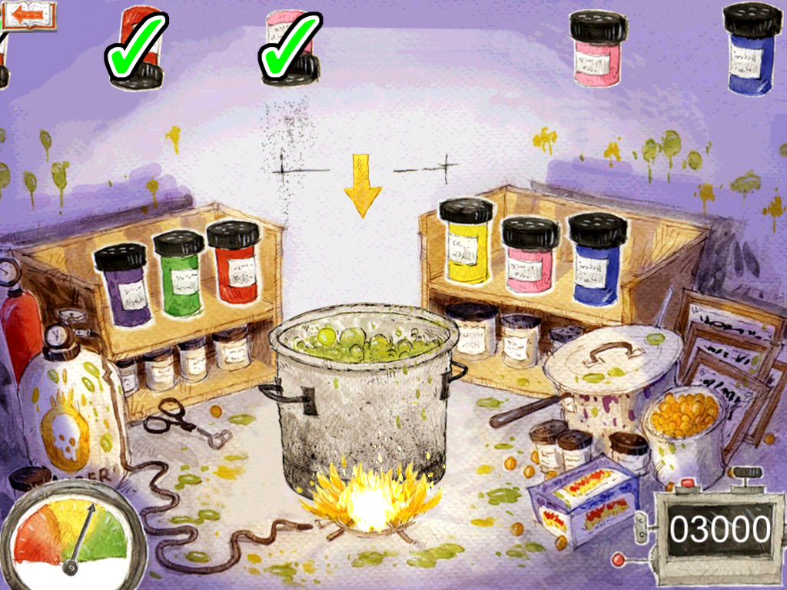
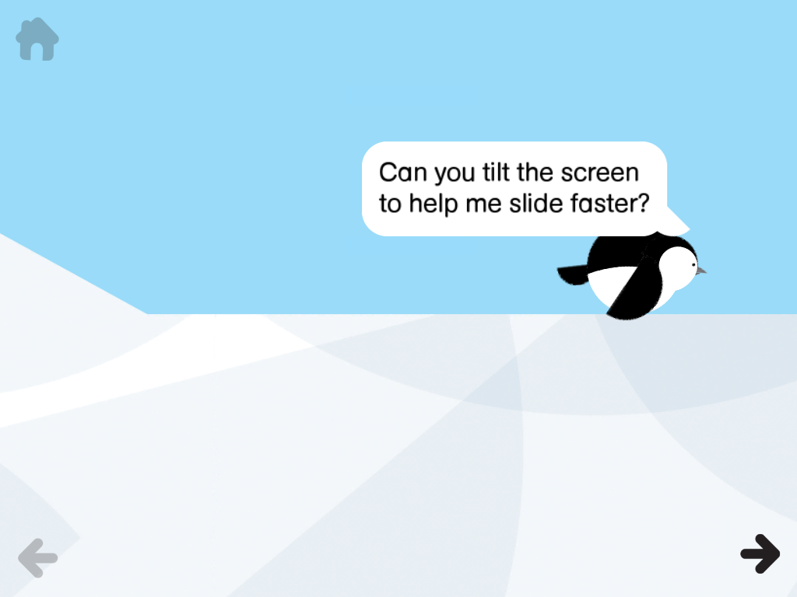
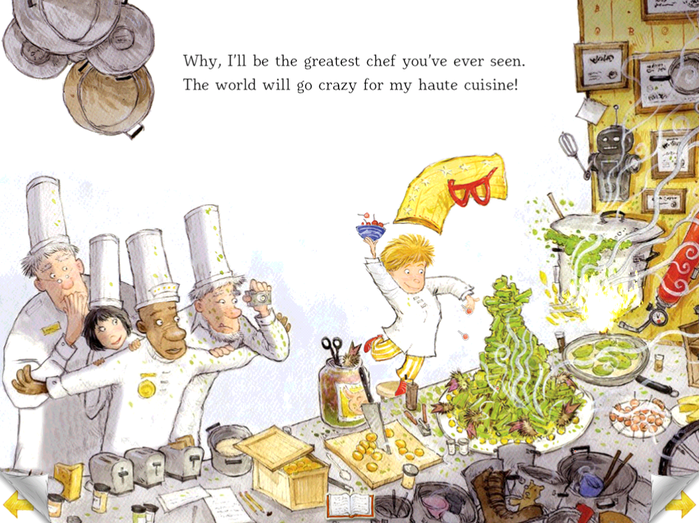
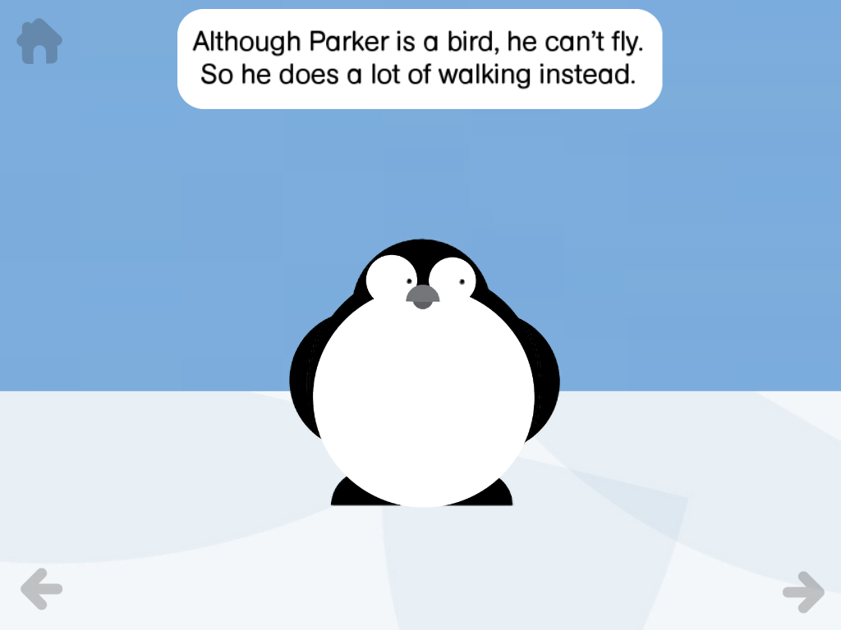
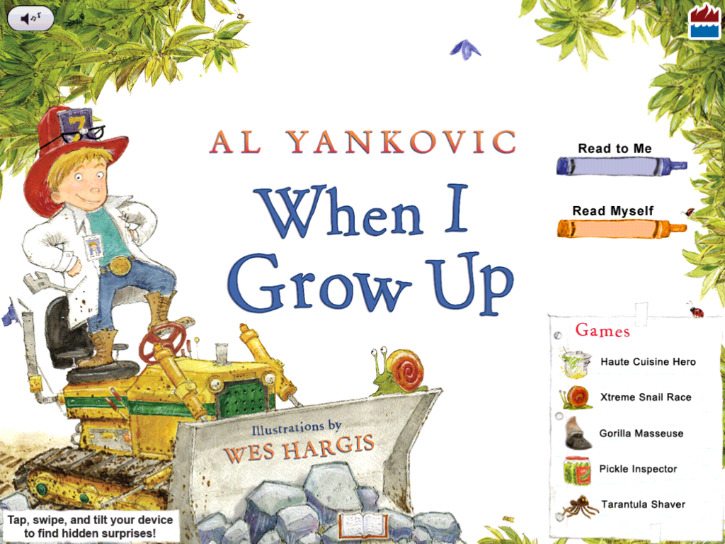
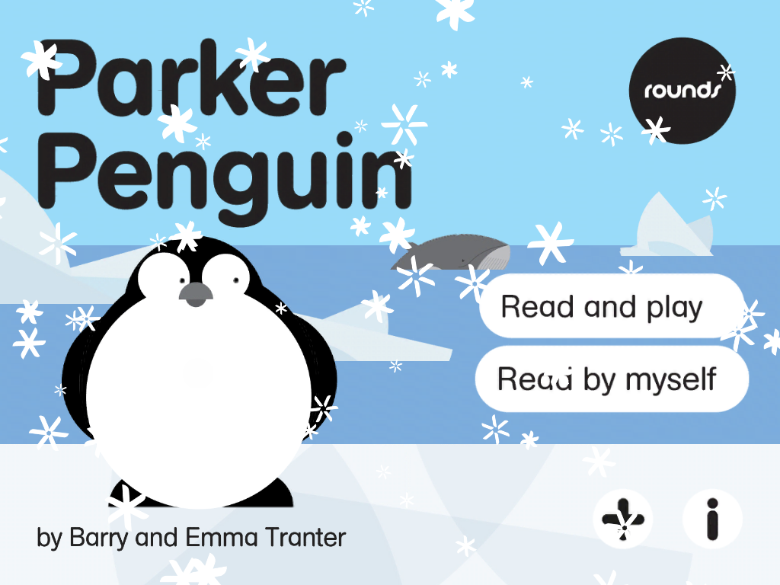
Figure 2

Figure 3
Figure 4
Figure 5

Figure 6

Appendix A
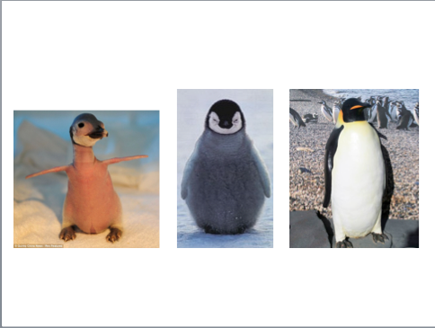
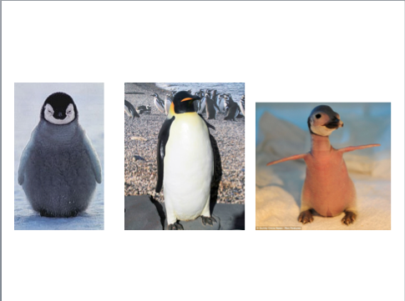
Appendix B
Form A vocabulary word from distracting story: professions
Form B vocabulary word from distracting story: professions
Form A vocabulary word from compatible story: down
Form B vocabulary word from compatible story: down

Appendix C
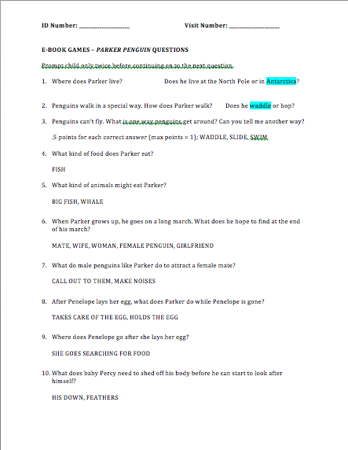

Appendix D
