A Literacy Coach’s Role in Professional Learning Communities in Elementary Schools
Capstone, Summer 2016
Vanderbilt University
Stevie Reilly

Abstract

Effective professional development for teachers has been a controversial topic in education for many years. Schools beg to answer the question: how do we continue to educate teachers so that student learning will increase? Oftentimes, professional development is a one-day event; information is delivered through direct instruction by a presenter and teachers leave with binders that end up collecting dust on a bookshelf. As educators sift through the policy changes and expectations of Common Core to increase student achievement and learning, the need for continuing growth and learning amongst teachers is crucial to meet these demands. This capstone seeks to answer the question: is there a way to provide teachers with an ongoing learning experience, specifically for literacy instruction? This paper, which is grounded in an extensive review of research literature, will explore the definition of a Professional Learning Community (PLC), the rationale for PLCs and why they are superior to traditional professional development approaches in respect to increasing student learning, a principal’s essential role in creating a conducive environment for successful PLCs, the literacy coach as a facilitator of literacy PLCs in an elementary (K-4) setting, and what research says about how the literacy coach can effectively implement the PLC model in an elementary setting.

Introduction

What is a PLC (professional learning community)? Who leads them? Are they important in elementary schools? Can a literacy coach make a difference to facilitate literacy PLCs? How does the literacy coach do this? As a future literacy coach, these questions were paramount to understanding an integral aspect of a literacy coach’s role: coaching teachers. The purpose of this essay is to explore the definition and rationale of a professional learning community (PLC), the role of the principal to support this community, the literacy coach as a facilitator for literacy PLCs, and why a literacy coach leading the literacy PLC is essential to facilitate student learning.
Definition of a Professional Learning Community

Is a professional learning community (PLC) simply professional development for teachers? The short answer is no. According to Dufour (2004, p.6), “the term has been used so ubiquitously that it is in danger of losing all meaning.” I would argue that schools need to have certain characteristics to be considered a true professional learning community; “a school does not become a PLC by enrolling in a program, renaming existing practices, taking the PLC pledge, or learning the secret PLC handshake” (Dufour, 2007, p.4). So the question is: what are the characteristics that encapsulate a true PLC? Vescio, Ross, and Adams, (2008) sum up the concept succinctly and state “at its core, the concept of a PLC rests on the premise of improving student learning by improving teacher practice;” therefore, the goal of a PLC is to create a community amongst teachers, a team in which teachers and staff members work together for a common goal: improving student learning. This model does not create a shorter route to improving schools. It is not a strict curriculum that can be followed, but a “framework” that will change a school through hard work and dedication of all staff members to change a culture (Dufour, 2007).
Hord and Sommers (2008) provide five distinct areas that need to be present for a true PLC to exist: (1) shared beliefs, values and vision, (2) collective learning and its application, (3) supportive and shared leadership, (4) supportive conditions, and (5) shared personal practice. These components allow for a day to day environment of learning and collaboration; it is not just an after school meeting, but a culture among the members of the school.
The first component is shared beliefs, values and vision. Teachers, administrators, and staff members need to be in agreement of the school’s mission and vision; this should be a collaborative effort and not simply a directive by the principal (DuFour and Eaker, 2005; Hord, 2009).
The second component is collective learning and its application. Schools are moving away from the traditional direct instruction workshop approach of professional development as research shows constructive, meaningful, and classroom applicable strategies are desired by teachers (Garet, Porter, Desimone, Birman, & Suk Yoon, 2001). This approach allows for teachers to collaborate among their grade level and/or team to analyze data and use research based approaches to enhance student learning (Schmoker, 2004).
The third component is supportive and shared leadership. Staff, administrators, and teachers should work together to make decisions regarding their school and teaching and learning opportunities (Hall & Hord, 2006). DuFour (2004, p.3) states that “despite compelling evidence indicating that working collaboratively represents best practice, teachers in many schools continue working in isolation.” This notion needs to be addressed by administration in order to promote a culture of collaboration, decision making, and learning amongst staff members (DuFour, 2004).
The fourth component is supportive conditions. Time to meet during the school day and year is crucial for the PLC environment (DuFour, 2004). This time will allow for discussion as well as an opportunity to build trust and respect among colleagues. An opportunity to engage in positive interactions among staff members is significant in the role of the PLC (Vescio et al, 2008).
The fifth and final component is shared personal practice. This provides teachers with a space to share successes and failures; this allows for a collaborative approach to learn from each other. Teachers observing each other can facilitate this process and provide an open dialogue; this will also promote trust and build relationships among colleagues.
Huffman and Hipp (2010) confirmed the importance of the five characteristics of PLC’s by developing an assessment in 2003, and now a revised edition in 2010, to provide evidence of the importance of each of the five components listed above that were implemented in schools.
A definition of a PLC cannot be summed up into a few words; it is a culture that cannot be achieved over night. Although this notion can be disheartening or feel overwhelming, a PLC environment can be achieved by working together collaboratively with school staff to create a community of learners. The goal is to increase teacher knowledge so that student learning will increase; the results of a PLC should show in student data. If teaching practices are changed for the better, then student learning should increase (Vescio et al, 2008). The principal is often the pivotal facilitator in this process; however, teachers and staff also play a vital role. As we move forward, I will stress the importance of the role of that the literacy coach can play in facilitating the development of a PLC community within the context of literacy culture in an elementary setting. For the purposes of this paper, the PLC will focus on creating cohesiveness among a grade level team in an elementary school.
Rationale for PLC’s
Schools are moving further away from traditional professional development that is focused on giving teachers extra facts that they typically already know and is moving toward a culture of learning and growth in teachers and students (Vescio, et al, 2008). In a review of research regarding PLC’s effects on student learning, it showed that when teachers became more centered on student learning and collaboration increased, students also benefited and test scores increased (Vescio, et. al, 2008). On the other hand, critics scrutinized PLC’s “as sites of learning provide some appearance of professional autonomy when in fact the learning content is largely pre-determined” (Servage, 2009). Professional development topics may be pre-determined ins some schools that say they are operating as a PLC, but I would argue that if this is occurring, a true PLC format is not in place and DuFour’s (2004) fear of the term being misused is evident. In this respect, traditional professional development of providing teachers with “skills and knowledge necessary to be ‘better’ educators” is primary rather than resting in the fact that teachers are trained and do have knowledge and recognizing that PLC’s enhance teaching practices to increase student learning (Vescio, et. al 2008, p. 88). Avalos (2011) agreed and found in a review of studies that the “power of teacher co-learning emerges very strongly” (p. 17). The power of PLC’s lies in the fact that teachers and administrators are brought together to engage in conversations surrounding student learning and achievement rather than working in isolation thus increasing student learning and enhancing teaching practices” (Hord & Sommers, 2008).
A Principal’s Role in PLC’s
Now that the definition and components of a PLC have been unpacked, a principal’s role in a PLC needs to be addressed. The principal ultimately creates the culture of a PLC environment; “strong principals are crucial to the creation of learning communities (DuFour & Eaker, 2005, p.3; Thompson, Gregg, & Niska, 2004). In order for a true PLC to exist, the components above are needed along with strong support and guidance from the administrator. Traditional roles of principals may need to be reevaluated as an “autocratic approach is incongruent with the assumptions of the professional learning community” (DuFour and Eaker, 2005, p. 4). On the one hand, principals do need to be the leader of the school and provide guidance to teachers, but on the other hand, in order for teachers to feel comfortable in an environment of the PLC, a principal will need to “take the lead in creating a trusting atmosphere among teachers and restructuring schools as PLCs to provide support for teachers’ collective learning and application, all of which will finally contribute to the improvement of teachers’ collective efficacy on instructional strategies” (Lee, Zhang, & Yin, 2011, p.829).
DuFour and Eaker (2005) reiterate the importance of principals implementing the five components of PLCs. They state that principals should “lead through a shared vision and values rather than rules and procedures” to reinforce creating a vision and culture together with teachers (Dufour & Eaker, 2005, p.5). Principals are encouraged to include faculty members in decision making and empowering staff members to have a voice and act on what they feel could be beneficial for the school. They also need to provide the staff with “information, training, and parameters they need to make good decision” (Dufour & Eaker, 2005, p. 7). Modeling behavior that is congruent with the values and vision of the school will work to establish credibility of the principal and being results oriented will provide teachers with accountability while still supporting their needs (Dufour & Eaker, 2005, p.16)

Literacy Coach as a Facilitator of literacy PLC’s
Creating a culture of PLCs takes time and hard work; a principal can utilize a literacy coach to aid in the facilitation of creating a PLC community within the context of literacy instruction. Typically, a literacy coach is certified with a reading specialist certificate for kindergarten-twelfth grade. In addition, the literacy coach must be a classroom teacher for at least three years before stepping into the role as a literacy coach. For further clarification on the responsibilities of a coach, Galloway (2014) suggests four roles that the literacy coach typically balances: managerial, teacher oriented, data oriented, and student oriented. The role that we are focusing on is teacher oriented: specifically, the literacy coach facilitating PLCs within the school. A literacy coach’s specialized knowledge by obtaining a master’s degree in literacy, previous years teaching students in classrooms, time spent coaching teachers, and collaborative relationships provide teachers with embedded professional development as student test scores are being scrutinized and teaching practices evaluated (L’Allier, Piper, & Bean, 2010). According to Bean, Belcastro, Draper, Jackson, Jenkins, Vandermolen, et al. (2008), schools where literacy coaches spent the majority of their time coaching and training teachers showed significant increases in test scores for first and second graders than a school that teachers were not mentored or trained by the literacy coach. With the qualifications of a literacy coach, facilitation of PLCs can be more effectively implemented than with simply allowing teachers to lead. Although certified elementary teachers have a wealth of knowledge, the literacy coach provides an additional specialty with best reading practices.
Developing areas in which staff need additional collaboration and discussion to enhance student learning can be a daunting task. Without a facilitator to hone in on a particular area across a grade level, teacher opinions could vary drastically in regard to topics. The literacy coach can aid teachers in developing a plan for professional growth to support overall school needs as well as individual teacher needs based on data and conversations with the teachers (Wald & Castleberry, 2000). As an unbiased third party, the literacy coach provides a mediator to a grade level team without the pressure of the team feeling as if they are being evaluated or monitored. The principal’s demanding schedule and daily tasks often make it cumbersome for them to assist teachers in working through group dynamics and being a mediator during PLC meetings (Dooner, Mandzuk, & Cliftonn, 2008). The literacy coach is typically a neutral party to aid the grade level team to “work together to develop curriculum and assessment strategies; engage in the ongoing cycle of inquiry, reflection dialogue, action, analysis, and adjustments in order to improve results; and give one another feedback as they practice new skills” (DuFour & Eaker, 1998, p. 273). The literacy coach is able to push the group forward by asking strategic questions and being a sounding board for how to move forward which causes teacher and student growth (Venables, 2011).
Another aspect of a literacy coach’s role is implementing a “coaching cycle”, which includes modeling and observing literacy lessons in classrooms as a support to teachers. Through this experience, literacy coaches are able to have an understanding as to how literacy is being instructed across the grade level and across the entire elementary school. Avalos (2008) states “in many classrooms teaching continues to be a solitary activity. Therefore, to move from co-learning through talk to co-learning through observation and feedback is necessary as well as effective” (p. 18). Because of this knowledge, coaches are able to see the big picture of literacy instruction in the elementary school. The ability to focus on an overall area of a grade level’s concerns allows the coach to “help personnel become more individually and collectively effective in helping all students achieve the intended results of their education” (DuFour & Eaker, 1998, p. 276). Because of a literacy coach’s role and schedule, being aware of literacy instruction in the school is possible; principals or fellow teachers simply do not have the time or resources to engage in observations on a day to day basis.
The strict schedules of elementary teachers do not always allow for an opportunity to delve into the latest research to find out exactly what literacy strategies are beneficial for certain student skills needing to be mastered. Teacher expectations such as lesson planning, data management, RtII, and parent communication rarely allow teachers the time that would be necessary to read, research, and implement new research practices in the classroom. A literacy coach provides teachers with a resource equipped with latest reading strategies and the ability to have a conversation with a literacy expert.
Literacy coaches counter the inherent shortcomings of brief professional development workshops with ongoing job embedded consultation regarding literacy instruction. The coach provides a resource; a physical person that the teachers build a relationship with and is available to provide support to teachers as they navigate how to work collaboratively in a PLC environment (Venables, 2011). In order for this relationship to thrive, building trust with the literacy coach is essential for teachers to respect and feel comfortable with sharing successes and struggles with the literacy coach (Lee, Zhang, & Yin, 2011). A literacy coach is an expert in his or her content area and able to provide insight when teachers are looking at data and an overall, unbiased view of teaching practices and strategies in literacy instruction. Additionally, the literacy coach’s oversight of the entirety of the elementary school provides a more comprehensive and unified evaluation of assessment, needs, areas for improvement, and fostering professional growth.

How Literacy Coaches can facilitate PLC’s
Literacy coaches are a valuable resource to teachers regarding literacy instruction, but how do they support facilitating a PLC? We are going to look at some practical ways in regards to how to implement literacy PLC’s and support the overall culture of a PLC that principals initiate. The overall goal of the PLC, again, is to increase student learning (Vescio, Ross, & Adams, 2008). To create an environment that encourage this to happen, the literacy coach needs to be mindful of how to create a literacy culture among grade level teams. This typically takes time and effort by all parties that are involved (DuFour, 2007).
Before delving into literacy strategies and instructional practices, a foundation needs to be built among the grade level team and the literacy coach. Joyce and Showers’ (1995) research recognizes the importance of teachers building trust in the group before trying to have professional conversations regarding best teaching practices. Venables (2011) identifies three specific benefits of team building activities to increase collaboration and make a grade level team cohesive. First, team building activities that allow the teachers to work together and complete a task in which all parties’ participation is essential (Darling-Hammond, 1999). Second, they allow for the teachers to have fun, and third, they are “often metaphorical in symbolizing the interpersonal dynamics of PLCs” (Venables, 2011, p. 24). An example she provides entitled “Traffic Jam” (Appendix A) involves all parties to exchange places while following a set of rules. The activities provide a fun, low pressure situation that introduces the concept of problem solving with one another; thus promoting a culture collaboration to translate into problem solving of future academic issues. Furthermore, Venables (2011) purports trust is fostered and enhanced among fellow teachers and group facilitator due to the establishment of a non threatening environment. The focus of the groups is on teacher development and group cohesion, rather then the installation of authority for the literacy coach (Venables, 2011). In addition, it is important for the literacy coach to realize that this group is not about the coach, but about the teachers. The teachers are in the classroom daily and bring valuable knowledge and experiences to the PLC session (Bean, 2004). Therefore, the literacy coach’s efficacy is bolstered by vigilant monitoring of the role of a “catalyst for good and important change” and need to “see themselves less as managers of people and more as conduits for making their PLCs an effective, collective entity that happens to be made up of individual teachers” (Venables, 2011, p. 110; Kelly, 1999). Literacy coaches need to possess conversational skills such as: listening, setting aside judgement, questioning, observing, staying open, and recognizing the goal of the PLC (Hord & Sommers 2008). In order to build mutual trust and respect with teachers, it is crucial for the literacy coach to garner a set of skills that will allow for conversations to happen within the context of the PLC (Hollins1, McIntyre, Debose, Hollins, & Towner, 2004).
Establishing group norms (Venables, 2011, Wald & Castleberry, 2000; Stanley & Moore, 2011) is paramount for a robust PLC environment. Group norms are “agreements suggested by the group that have been approved by everyone” (Stanley & Moore, 2011, p. 14). Stanley and Moore (2011) postulate the differentiation of norms from rules allows for the installation of a non-judgmental environment, thus freeing teachers from direct and indirect fears of “being caught doing something wrong” (Stanley & Moore, 2011, p. 14). Additionally, group norms provision of a non punitive environment, provides expectations for the group to function in a collaborative manner with mutual respect (Stanley & Moore, 2011). Additional evidence-based resources have been developed to target specific goals of the PLC prior to the establishing of group norms. “Compass points” (Appendix B), an activity developed by the National School Reform Faculty, assists teachers in identifying their preferences when working in a group. In addition, the “Peeves & Traits Protocol” (Appendix C) developed by Venables (2011) permits teachers to take working in groups one step further by allowing the group to explore things that bother them and identify significant personality traits pertinent to group dynamics. Following the activities, the literacy coach analyzes the ideas provided by the teachers. The group will then utilize the data to establish a cohesive set of group norms. It is imperative for the literacy coach to remind the group of the norms and not let them fade into the background as the school year unfolds (Venables, 2011). One way to do this is to have one person from the team read the norms in the beginning of the PLC meeting to remind all of the members of the expectations they agreed upon in the beginning of the year.
Another aspect to establish with the PLC is consistency and time for collaboration (Darling Hammond, 1999). Scott, Cortina, and Carlisle (2012) found that teachers preferred coaches who consistently had meetings on a regular basis than those who had sporadic meetings. DuFour and Eaker (2005) contended essential factors for success were that timely collobaration occur during traditional school hours in the academic year and that the purpose be made explicitly clear to participants. The adherence to Dufour and Eaker’s (2005) suggestions provide adequate allowance of scheduling time for teachers, therefore a hypothetical reduction of the inherent stressors of constant adjustment of one’s work schedule. These components will increase community among the teachers and collaboration across the grade level to support the learning environment (D’Ardenne, Barnes, Hightower, Lamason, Mason, Patterson, Stephens, Wilson, Smith & Erickson, 2013; Hord 2009).
Dietz (2008) acknowledges three types of frameworks for the PLC model. The first, action research, involves teachers studying assessment strategies in order to show student growth. The second, school reform, involves a leadership team that will look at the entire school to analyze data, provide professional development according to the data, give an action plan to teachers, and then monitor the results. The final framework, professional development for instruction priorities, is when a grade level team analyzes data and works together in an inquiry setting to analyze instructional techniques to enhance teaching practices and student progress (Dietz, 2008; Hord 2009). For the purposes of this paper, we will look further at the third type of framework and discuss how to implement this type of PLC in a literacy setting.
Teachers are more excited about professional development when they have an ability to create their own plan rather than have an administrator construct their learning goals (Colbert, Brown, Choi, & Thomas, 2008). In order for a literacy coach to effectively facilitate this, Wald and Castelberry (2000) suggest a “collaborative learning process” framework. The process is cyclical and interactive, but consists of five stages: 1) define, 2) explore, 3) experiment, 4) reflect, 5) share. These components will assist the literacy coach in creating consistent framework for PLC meetings and also provide an inquiry setting to look closely at literacy instruction.
The first stage, define, consists of 4 categories. The first step is to “create shared meaning about the topic and specific terms” (Dietz, 2008, p. 47). After utilizing data to find a trend that needs to be addressed, the group will choose a topic to explore (Dietz, 2008). The group will work together to discuss what the topic means from each person’s perspective (Dietz, 2008). After that, the group will “further define topic of study” (Dietz, 2008, p. 47; Hipp & Huffman, 2010). The group will further investigate the meaning of their topic and formulate a question that addresses the topic of study (Dietz, 2008).
In the second stage, explore, teachers will “develop a game plan, identify current practices and underlying assumptions, explore new ideas and underlying assumptions, and refine their questions” (Dietz, 2008, p. 50-51). The second stage is a time for teachers to reflect on what they are currently doing in the classroom regarding a particular literacy strategy and then looking ahead to see what they can change to enhance student learning. In order to accomplish this task, the group will need to look at student and teacher work (Venables, 2011; Hipp & Huffman, 2010). Student work can be in the form of written responses, formative assessments, summative assessments, or even classwork. Teacher work can be in the form of assessments, unit plans, or lesson plans. It is logical for teachers to want to bring their best work; however, the literacy coach should encourage teachers to bring all samples so that the group can collaboratively construct the best way to teach a strategy (Venables, 2011; Hipp & Huffman, 2010).
Stage three, experiment, allows teachers to “design action based on the question and a set of assumptions and observe and document results” (Dietz, 2008, p 51-52). During this stage, teachers will implement the strategies they are discussing in the PLC environment and take notes on successes and failures. This should be a time to look at and dissect formative assessments to ensure that they are directly anchored in the school’s standards (Venables, 2011). This leads into stage four, reflect, where teachers will analyze what happened in the classroom by reviewing notes, observations, and student data. Lastly, stage five, the teachers share with a larger group, i.e. a different grade level team, on what they learned from this process of inquiry. In the later processes, teachers and the literacy coach provide feedback to teachers regarding the implementation of new strategies; therefore, providing teachers with the acknowledgement of their efforts in the classroom and giving the literacy coach an opportunity to acknowledge that their work does not go unnoticed (Guskey, 2014).
During this process, the role of the literacy coach is diverse and adaptability is essential. As it is important for the overall school to implement (1) shared beliefs, values and vision, (2) collective learning and its application, (3) supportive and shared leadership, (4) supportive conditions, and (5) shared personal practice, it is essential for the literacy coach to encompass these components into the literacy PLC (Hord & Sommers, 2008). The literacy PLC should be an extension of the school’s overall concept of a PLC, but in a literacy context. The literacy coach will need to facilitate these components within the context of the PLC. In addition to the five characteristics of the PLC, the literacy coach will need to plan for PLC sessions, work with the principal to decide on a weekly time for the PLCs to meet, and be proactive regarding listening to conversations and analyzing teacher needs surrounding literacy instruction. Hord (2009), states “reviewing, studying, and interpreting data is the foundation of professional learning communities” and having a point person to organize information into easily assimilated and viable resources is crucial to PLC success (p. 42). Overall, the literacy coach provides a valuable support to teachers to form an effective literacy PLC; “coaches are charged with the challenging but doable task of keeping the PLC moving forward, constantly weighing the needs and readiness of the group as a whole with the needs and readiness of individual group members” (Venables, 2011, p. 17). The ongoing nature of PLCs provides a place for teachers to collaborate; thus promoting positive attitudes amongst grade level teams and providing teachers with opportunity to work together to increase student learning (Darling Hammond, 1999; Voulalas & Sharpe, 2005).

Conclusion
As PLCs continue to grow in popularity, it is crucial to remember how a true PLC functions; it is not simply a one-day professional development session. Based on the findings of this capstone, principal support and vision to create a community of teachers that value collaboration and continued growth is critical in order for a PLC to function in a school. The literacy coach provides a support to the principal to continue the PLC environment around best literacy practices. Schmoker (2004, p.3), states “we can’t just arrange for teachers to ‘meet’ and then assume that close scrutiny and productive adjustment of teaching practices will automatically ensue.” The literacy coach is available in this context to facilitate grade level PLC meetings, create a culture of teamwork, guide teachers through listening and questions, and follow-up with teachers by utilizing the coaching cycle to provide support with new instructional practices. A literacy coach can have a powerful impact on supporting the culture of a PLC environment around literacy instruction by implementing Hord and Sommers’ (2008) five components within the literacy PLC. By utilizing the literacy coach to support grade level teams of teachers in literacy instruction, it is possible to increase teacher collaboration and, ultimately, student learning.
Further Research
The previously stated research begins the familiarization of how literacy coaches can aid principals in effectively implementing literacy PLC’s in elementary schools. Further research is needed to assess the correlation(s) between utilization of literacy coaches in supporting PLCs and PLC’s efficacy and maintenance. In addition, further research is needed to explore regarding the relational factors and interactions between the principal, coach, and staff that directly and indirectly promote or detract from a learning community. Overall, the plethora of research supporting PLCs in schools is increasing; however, literacy coaches need to be mindful of the role they can play in fostering collaboration among grade level teams. Finally, further research needs to be conducted regarding teacher attitudes toward the PLC model using the literacy coach as a facilitator.

Appendix A (Venables, 2011)
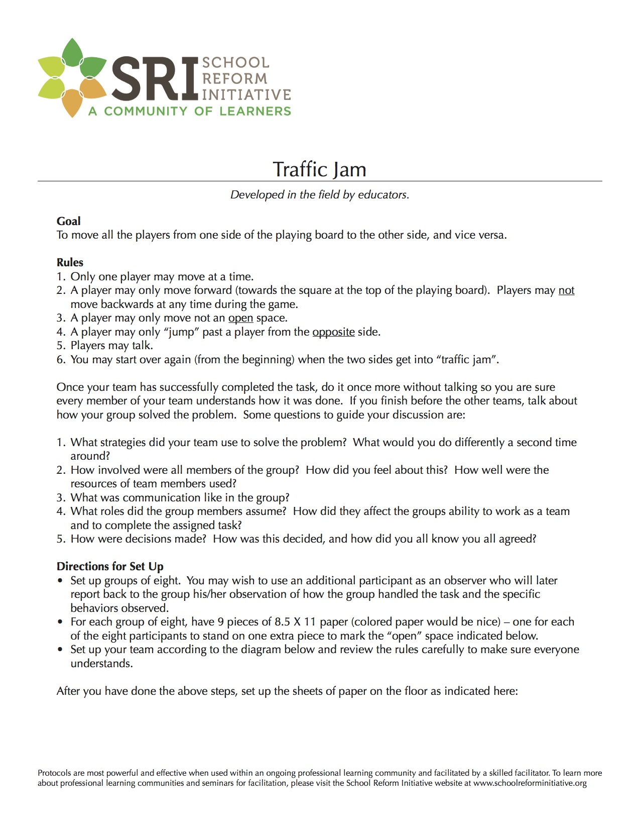
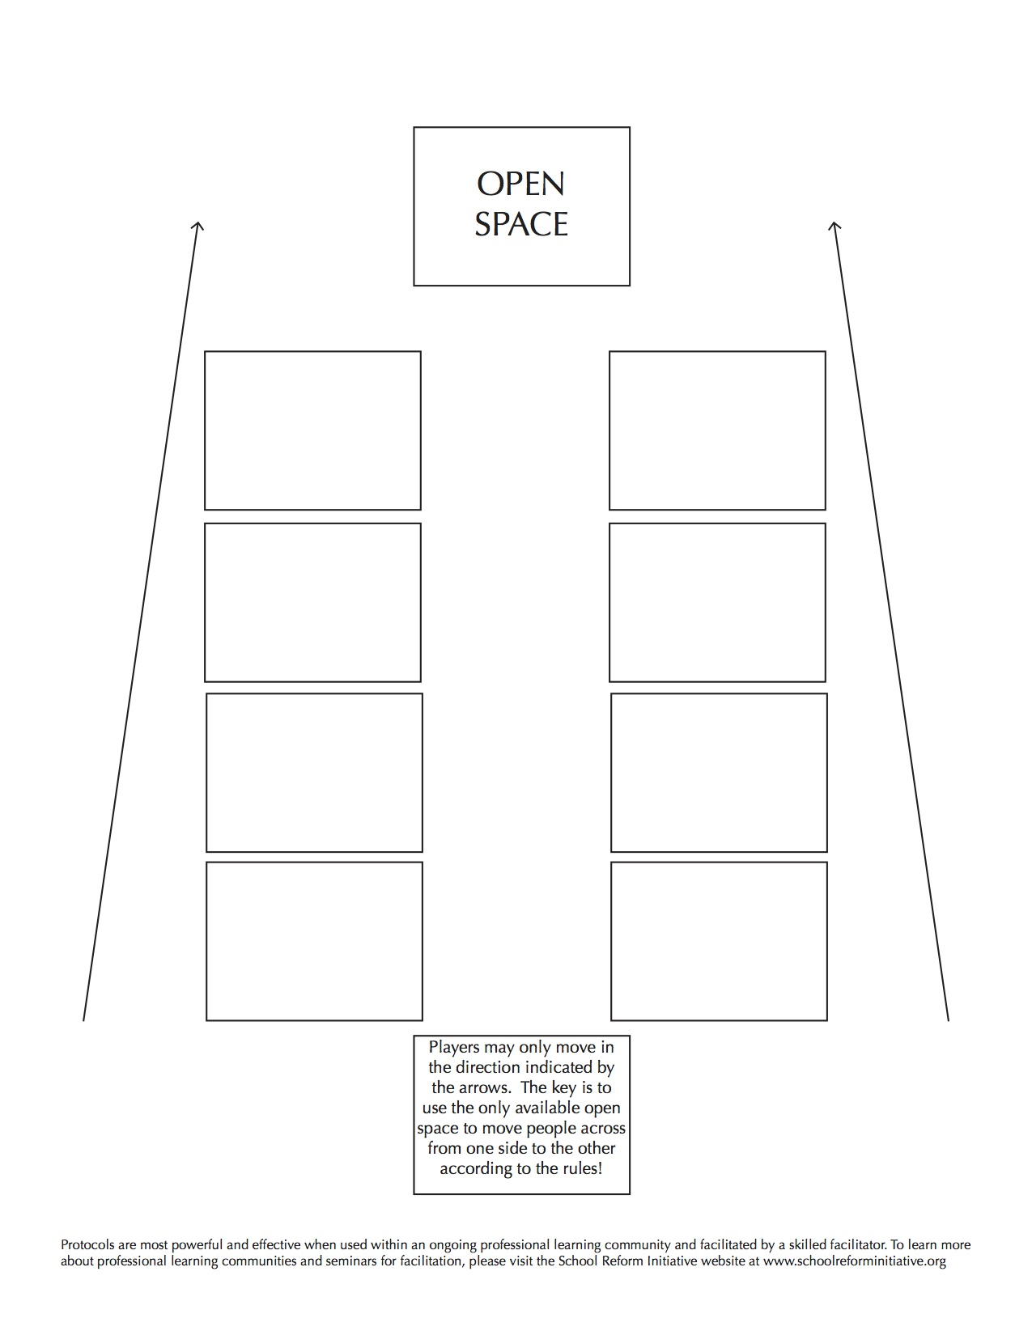

Appendix B (Venables, 2011)

Appendix C (Venables, 2011)
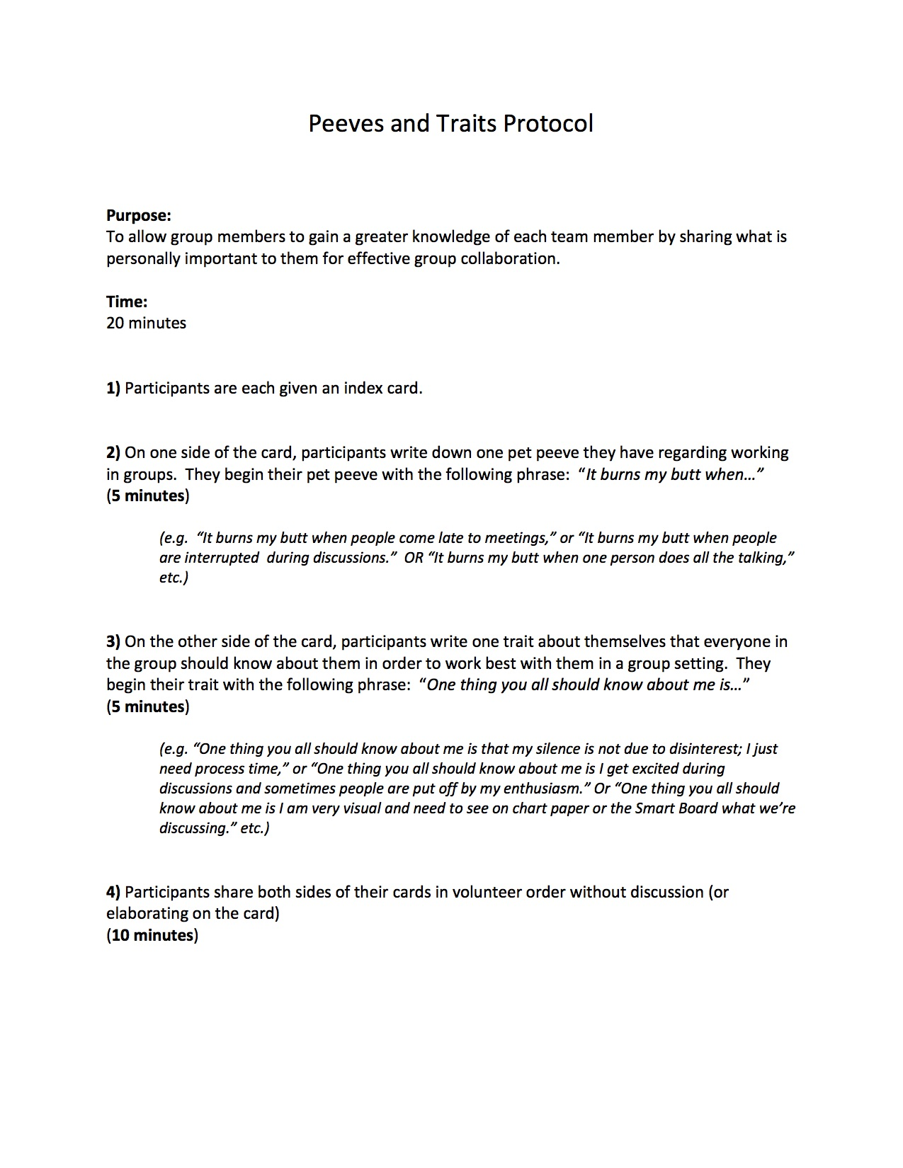

References

Avalos, B. (2011). Teacher professional development in Teaching and Teacher Education over
ten years. Teaching and Teacher Education, 27(1), 10–20. http://doi.org/10.1016/j.tate.2010.08.007
Bean, R. M. (2004). Professional development: Key to effective reading instruction. New
England Reading Association Journal, 40(2), 12-16.
Bean, R.M., Belcastro, B., Draper, J., Jackson, V., Jenkins, K., Vandermolen, J., et al.
(2008). Literacy coaching in Reading First schools: The blind men and the
elephant. Paper presented at the National Reading Conference, Orlando, FL.
Colbert, J. A., Brown, R. S., Choi, S., & Thomas, S. (2008). An investigation of the impacts of
teacher-driven professional development on pedagogy and student learning. Teacher
Education Quarterly, 35(2), 135-154.
D’Ardenne, C., Barnes, D. G., Hightower, E. S., Lamason, P. R., Mason, M., Patterson, P. C., … Erickson, K. A. (2013). PLCs In Action: Innovative Teaching for Struggling Grade 3-5 Readers. The Reading Teacher, n/a–n/a. http://doi.org/10.1002/trtr.1180
Darling-Hammond, L. (1999). Target time toward teachers Retrieved from
http://login.proxy.library.vanderbilt.edu/login?url=http://search.proquest.com.proxy.library.vanderbilt.edu/docview/62362883?accountid=14816
Dietz, M. E., & Dietz, M. E. (2008). Journals as frameworks for professional learning communities (2nd ed). Thousand Oaks, CA: Corwin Press.
Dooner, A.-M., Mandzuk, D., & Clifton, R. A. (2008). Stages of collaboration and the realities of professional learning communities. Teaching and Teacher Education, 24(3), 564–574. http://doi.org/10.1016/j.tate.2007.09.009
DuFour, R., & Eaker, R. E. (1998). Professional learning communities at work: best practices for enhancing student achievement. Bloomington, Ind. : Alexandria, Va: National Education Service ; ASCD.
DuFour, R. (2004). "What is a professional learning community?". EducationalLeadership,
61(8), 6-11.
DuFour, R., & Eaker, R. E. (2005). Professional learning communities at work: best practices
for enhancing student achievement. [United States]: Solution Tree Press :
DuFour, R. (2007). Professional Learning Communities: A Bandwagon, an Idea
Worth Considering, or Our Best Hope for High Levels of Learning?.Middle School Journal (J1), 39(1), 4-8.
Galloway, E. P., & Lesaux, N. K. (2014). Leader, Teacher, Diagnostician, Colleague, and Change Agent: A Synthesis of the Research on the Role of the Reading Specialist in This Era of RTI-Based Literacy Reform. The Reading Teacher, 67(7), 517–526. http://doi.org/10.1002/trtr.1251.
Garet, M.S., Porter, A.C., Desimone, L., Birman B.F., & Suk Yoon, K. (2001). What makes
professional development effective? Results from a national sample of teachers.
American Educational Research Journal, 38, 915-945.
Guskey, T. R. (2014). Planning professional learning. Educational Leadership, 71(8), 10-16.
Hall, G. & Hord, S. (2001). Implementing Change: Patterns, Principles, and Potholes. Boston,
MA: Pearson Education, Inc.
Hipp, K. K., Huffman, J. B., Pankake, A. M., & Olivier, D. F. (2008). Sustaining professional
learning communities: Case studies. Journal of Educational Change, 9(2), 173-195.
Hipp, K. K., & Huffman, J. B. (2010). Demystifying professional learning communities: school
leadership at its best. Lanham, Md.: Rowman & Littlefield Education.
Hollins1, E., McIntyre, L., DeBose, C., Hollins, K., & Towner, A. (2004). Promoting a self-sustaining learning community: investigating an internal model for teacher development. International Journal of Qualitative Studies in Education, 17(2), 247–264. http://doi.org/10.1080/09518390310001653899
Hord, S. M., & Sommers, W. A. (2008). Leading professional learning communities: voices from research and practice. Thousand Oaks, Calif: Corwin Press.
Hord, S.M. (2009). Professional Learning Communities: Educators work together toward a
shared purpose. Journal of staff development, 30(1), 40-43. (ERIC Document
Reproduction Service No. EJ827545).
Jay, P. S., Karen, S. C., Cockrell, D. H., & Valentine, J. W. (1999). Creating professional
communities in schools through organizational learning: An evaluation of a school
improvement process. Educational Administration Quarterly, 35(1), 130-160.
Joyce, B., and B. Showers. (1995). Student Achievement Through Staff Development:
Fundamentals of School Renewal. 2nd ed. White Plains, N.Y.: Longman
Kelly, J. M. (1999). Free to teach, free to learn: A model of collaborative professional
development that empowers teachers to reach diverse student populations. The Journal of Negro Education, 68(3), 426-432.
L’Allier, S., Elish-Piper, L., & Bean, R. M. (2010). What Matters for Elementary Literacy Coaching? Guiding Principles for Instructional Improvement and Student Achievement. The Reading Teacher, 63(7), 544–554. http://doi.org/10.1598/RT.63.7.2
Learning Communities Protocols and Activities. (n.d.). Retrieved June 10, 2016, from
http://www.nsrfharmony.org/free-resources/protocols/learning
Lee, J. C., Zhang, Z., & Yin, H. (2011). A multilevel analysis of the impact of a professional learning community, faculty trust in colleagues and collective efficacy on teacher commitment to students. Teaching and Teacher Education, 27(5), 820–830. http://doi.org/10.1016/j.tate.2011.01.006
Nelson, T. (2008). Teachers’ collaborative inquiry and professional growth: Should we be
optimistic? Science Education, 93(3), 548-579. Doi:10.1002/sce.20302.
Scott, S. E., Cortina, K. S., & Carlisle, J. F. (2012). Understanding Coach-Based Professional
Development in Reading First : How do Coaches Spend Their Time and How do
Teachers Perceive Coaches’ Work? Literacy Research and Instruction, 51(1), 68–85. http://doi.org/10.1080/19388071.2011.569845
Schmoker, M. (2004). Learning communities at the crossroads: Toward the best schools we've
ever had. Phi Delta Kappan, 86(1), 84-88.
Servage, L. (2009). Who is the "professional" in a professional learning community? an
exploration of teacher professionalism in collaborative professional development
settings. Canadian Journal of Education, 32(1), 149-171.
Smith, A. (2009). Literacy learning communities: A guide for creating sustainable change in
secondary schools. Journal of Adolescent & Adult Literacy, 52(5), 454-456.
Stanley, T., & Moore, B. (2010). Formative assessments in a professional learning community.
Larchmont, NY: Eye On Education.
Thompson, S.C., Gregg, L., & Niska, J.M. (2004) Professional learning communities, leadership,
and student learning. Research in Middle Level Education Online, 28(1).
Venables, D. R. (2011). The practice of authentic PLCs: a guide to effective teacher teams.
Thousand Oaks, Calif: Corwin Press.
Vescio, V., Ross, D., & Adams, A. (2008). A review of research on the impact of
professional learning communities on teaching practice and student learning. Teaching and Teacher Education, 24(1), 80–91. http://doi.org/10.1016/j.tate.2007.01.004
Voulalas, Z. D., & Sharpe, F. G. (2005). Creating schools as learning communities: Obstacles
and processes. Journal of Educational Administration, 43(2), 187-208.
Wald, P. J., & Castleberry, M. S. (Eds.). (2000). Educators as learners: creating a professional
learning community in your school. Alexandria, Va: Association for Supervision and Curriculum Development.

