Creating Equity through Services;
Providing Emotional and Mental Health Support to Students in City Schools
Lauren Blakely
Vanderbilt University
Masters’ Capstone
6/15/2016

Abstract: There is a disparity between social classes, when it comes to accessing mental health support. 14.9 million students that attend city schools are part of the low middle class that does not have easy access to mental health counseling. 60% of the 14. 9 million face even more barriers to accessing mental health, because they are part of a marginalized group. Systemic oppression and institutional racism are long standing barriers that prevent youth of color from gaining social capital that their white peers have to help navigate barriers to accessing care. The intersectionality of race and class status makes it less likely for majority of students to access the support, in fact 80% of low income youth will not be able to access emotional or mental health support. Currently, American youth spend 943 hours on average in schools. With the large amount of time spent in schools, schools are a good contact point to reach the students struggling with emotional and mental health problems. This paper will look at the different methods to implement programs that meet the social and emotional needs of students, it will look at the benefits of properly implemented programs, and will also look at barriers that exist in order to implement the programs well.

Keywords: Social Emotional Learning, Targeted Assistance, Barriers, Culture

Introduction
By the time children are 18, 49.5% of them will have or have met criteria for a mental health diagnosis, and only 50% of those children will receive treatment or support. (Speak Up For Kids, 2015). Those most at risk for not receiving services, are students of color who come from low-income families. Majority of these students are also living in cities and attending underfunded schools (Bajari & Kahn, 2001). Of the 15.1 million students that attend city schools, 60% are students of color and 96% are students that come from low-income families (NCES, 2012). The reason that students of color are more likely to be found in cities, can be traced back to systemic oppression and institutional racism with in America. The historical inequality amongst races continues to create a wealth gap between people of color and their white peers. The lack of income equality forces more people of color, than whites, to move into cities where government housing is more common and where accommodations are easier to access; i.e. jobs and stores via public transport or walking (Bajari & Kahn, 2001).
With the concentration of low-income families in one neighborhood added to the current public school funding system in America, these students are also the students that attend underfunded schools. Neighborhood schools are funded partly by federal and state money, but majority by property tax. Government assisted living and low cost housing, leads to lower property taxes, which leads to less funding for neighborhood schools. This sets schools up to have less monetary resources in assisting student’s needs, especially the 5.9 million city students who will meet criteria or be diagnosed with a mental illness, but will not receive treatment (Woodruff, 2008; NCES, 2012). If students are not receiving treatment or support in schools, then only 17% of low-income families will be able to seek and receive outside support for their child (Harrison, McKay, & Bannon, 2004).
There are many reasons that low-income, students of color, are more likely to be a part of the 80% that does not receive mental health support or services (Speak Up For Kids, 2015). One of the major barriers for students of color is the lack of social capital that the 40% of white students have. Social capital is helpful in navigating systemic barriers within the health system. These barriers include dealing with the availability of culturally competent therapists or the availability of therapists at all. Students of color also deal with long waiting lists or inconvenient agency hours, but lastly students of color deal with a general distrust of a system that has failed them many times before (Harrison, McKay, & Bannon, 2004). On top of the general barriers that low income families face, African American and Latino families will face cultural barriers or stigma that will prevent them from seeking assistance. For example, members of the African American community tend to seek advice from significant others in the community first, including church pastors and groups before seeking any formal type of counseling (Harrison, McKay, & Bannon, 2004). For many Latino youth, problems are internalized instead of shared because of conflicts with parents. There are also many Latino families that will seek spiritual healing first, rather than Eurocentric mental health treatment, partly because of their strong ties to religions, but also because of the lack of therapists that understand and respect aspects of the Latino culture (Rastogi, Massey-Hastings, & Wieling, 2012). These barriers prevent students of color from seeking private emotional and mental health support that will help create a better learning environment for the individual student, which is harmful to a student’s success.
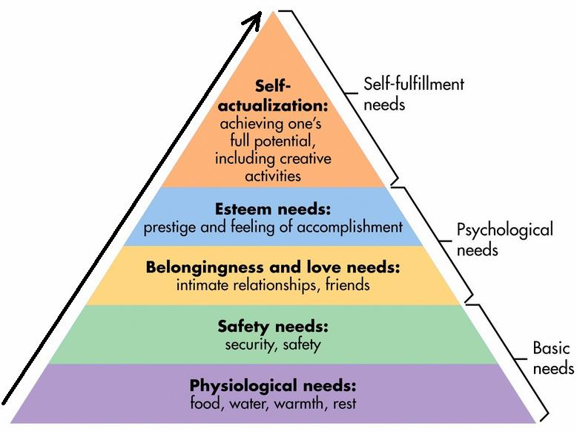
Students need an enviroment that meets their physiological and emotional needs first, before their full potential to learn can occur. These needs include being fed and having shelter, feeling safe and secure, having strong relationships, and feeling valued and of worth. Until those needs are met, students are prevented from “self-actualization”, and full academic success (Maslow, 1943). In order to create an enviroment that will meet these needs, schools would have to switch focus to include emotional and social needs. Currently though, many of the city schools are focused strongly on academics only, creating stringent discipline policies that mimic that of the justice system. Instead of treating or supporting students who have “behavior problems”, schools turn to criminalizing or medicalizing the behavior. Students who are seen as “bad”, are often times removed from the classroom, or encouraged to be put on medicine to be given an individualized education plan (Ramey, 2015). The criminalization of behavior, found at most predominantly African American schools, is a direct cause of the increase in suspension rates for students with emotional behaviors, and also the 69% suspension and expulsion rates in low-income schools (compared to the 14% of high-income schools) (Blackorby & Cameto, 2005).
Figure 1.1: Abraham Maslow’s Hierarchy of Needs (Maslow, 1943)
In order to combat the high suspension rates and low academics scores, schools will need to “integrate efforts to promote children’s academic, social, and emotional learning” (Zins, 2004). Students of color from lower socioeconomic classes, that attend city schools, are less likely to receive mental health services or support. Adding social emotional learning curriculum and counseling into schools would help create equity amongst those who can access private care, but also help increase student achievement.
SEL and Counseling Programs that Have Been Implemented in Schools
There are three routes schools can take depending on what stage they are at in willing or able to commit to meeting the needs of students’ emotional and mental health needs. For many of the city schools who are tight on budget and resources, targeted counseling is a starting point. For schools that are ready to invest as a whole school, whole school social emotional learning is another level. Whole school social emotional learning though, requires teachers and administrators to not only shift the whole mind set of schools, but to also train teachers in various interventions, lessons, and programs (Hoagwood & Erwin, 1997). Lastly, a combination of both targeted counseling and whole school social and emotional learning would be most beneficial in making sure all students’ needs are met.

Targeted Counseling
When mental health support and services are not offered through the school, only 17% of students of color in city schools, will receive outside treatment (Hoagwood & Erwin, 1997). One way this has been combated is through targeted counseling programs. Often times schools partner with outside service providers, who come to the school and provide therapy to students and families that have been referred by the school counselor. In Metro Nashville Public Schools, two private providers offer to come to the school and provide therapy for students. One of the providers is a nonprofit program called Centerstone. Centerstone provides weekly counselors in schools. Their case load is filled with students that have been referred by the guidance counselor that show signs of depression, anxiety, emotional disorders, etc. The sessions can either be one on one with the students, or include the family. The goals of the session are to provide students with coping skills in order to combat the symptoms they are facing. (Centerstone, 2012). Vanderbilt University is also a private party that comes to schools in order to provide one on one counseling. Both programs take the insurance that students have, and bills the insurance directly, relieving the parents and schools of the stress of paying (Centerstone, 2012).
Another targeted assistance program is KEIP, or Kindergarten and Elementary Intervention Program. The Kindergarten and Elementary Intervention Program (KEIP) is a program that works one on one with students three to five hours a week, dependent on need. “The program contains three primary components: 1) use of volunteer aids who work one-on-one with the students three to five hours per week in their classrooms providing support and assisting in problem solving, 2) provision of school-based discussion and support groups to 346 Community Mental Health Journal parents, and 3) consultation with teachers by mental health professionals on assisting and motivating targeted students” (Flaherty, Weist, & Warner, 1996). Targeted counseling is an effective resource that does not use money from the school’s budget, and by bringing therapy into the children’s environment, instead of sending them out to the community, the increase in student treatment jumped from 17% to 98% (Harrison, McKay, & Bannon, 2004).

Whole School/Group Social Emotional Learning
Another route that schools can take in addressing the social and emotional needs of students, is school wide curriculum and programs. Schools can start big and undergo a school wide culture change or schools can start small with specific prevention programs. One program that has seen success across nine large school districts is the nonprofit, CASEL; Collaborative for Academic, Social, and Emotional Learning. CASEL works with schools to create and implement whole school approaches that tailor to teaching social skills and coping methods. The programs usually run whole school, and curb teacher methods and practices to engage in teaching coping skills, problem solving skills, decisions making, and relationship building through various activities (CASEL, 2013).
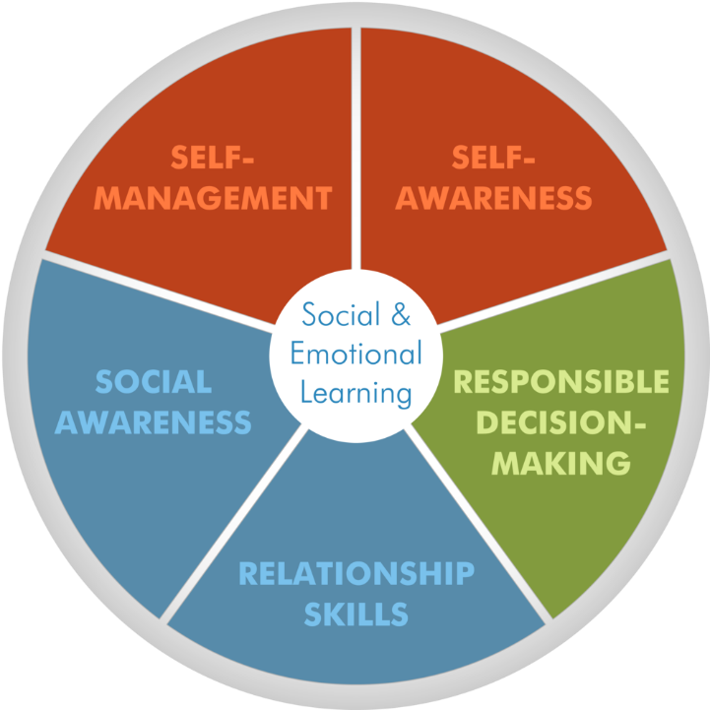
The success in the schools has been overwhelming. In the Austin Independent School District (Texas), parents were even included in the curriculum and were taught the same skills during parent teacher association meetings as the students were in class. The administrators reported “palpable change” could been seen, the school culture shifted for the positive, and behavior referrals are down (CASEL, 2016).
Figure 1.2 The five focuses of CASEL’s social and emotional learning programs (CASEL, 2016).
Project ACHIEVE is another example of switching the culture of a whole school. Project ACHIEVE is a multifaceted approach that “facilitates” “classroom interventions for students with academic and behavioral problems, enhances teachers’ classroom management skills to optimize class time, improve student behavior, and increase support services to students” (Hoagwood & Erwin, 1997). Like CASEL, teachers are constantly reinforcing and modeling self-control, rational decision making, skills to cope with stress, and relationship building, woven into the normal day to day activities.
There are also more focused approaches for schools that are not ready to fully commit as to whole school implementation. These programs are focused preventative programs like PATH; Promoting Alternative Thinking. Instead of shifting the ways teachers and administrators function all the time in schools, PATH offers a 30 week program that can be implemented in any grade. The classes take up an hour a week and provide real life situations, where students are able to work through emotional and behavior conflicts, in order to teach coping skills, relationship building, and self-control. In studies done researching PATHS, it was noted that student’s grades increased, aggression decreased, and teachers and parents reported a decreased in “behavior problems” (Domitrovich, Cortes, & Greenberg, 2007).

Whole School and Targeted Social Emotional Learning Blend
A third approach to addressing the social and emotional needs of students, is through a blend of whole school programming and targeted counseling. For example, a school may implement a 12 week program that teaches students about cognitive behavior and approaches to prevent depression. All students attend the weekly program and receive the same information. On top of that, specific students that have been referred by teachers or who have tested positive for meeting criteria of depression, will also meet with a therapist one on one. This same approach can be taken when working with students and emotional behaviors.
Similar to cognitive behaviors, all students attend a program that teaches coping with stress skills, relationship building, and decisions making. Once again, students can be referred by teachers to receive extra therapy, where they are given one on one sessions, group sessions, or family sessions (Hoagwood & Erwin, 1997). By providing both whole school counseling and targeted counseling, the most number of students can be reached, and the schools are working towards making sure 100% of students who need support and services receive them.

The Benefits and Outcomes of Providing Support and Services
When programs are successfully implemented, the positive impacts are infinite. Whole school approaches that have focused on teaching self-control, promote positive peer climate, and enhancing interpersonal problem solving, has shown an increase in student empathy, an increase in the students ability to express emotion, and an increase in the students ability to make a rational decision. Programs that focused on preventing depression showed test score improvements on the Israeli Index of Potential Suicide. Schools also saw a 75% decrease in aggression amongst students, when programs were implemented to focus on conflict resolution (Hoagwood & Erwin, 1997).
For students receiving targeted counseling services, schools found decreases in “special education referral (75%) and placement (67%), disciplinary referrals (28%), suspensions (64%), and grade retention (90%)” (Hoagwood & Erwin, 1997).
Overall, both approaches removed emotional distresses from the student and in turn improved students’ academic scores, which can be explained through mapping the brain. “The emotional centers of the brain are intricately interwoven with the neocortical areas involved in cognitive learning. When a child is caught up in a distressing emotion, learning is hampered” (Zins, 2004). In a study done by Joseph Durlak and Anne Wells, it was shown that students who had been provided with preventative programs to participate in, “surpassed 59% to 82% percent of their peers [in performance] that had been in the control group (the group without services)” (Durlack & Wells, 1997). Overall, 83% of students who have been exposed to social emotional learning curriculum or therapy make “academic gains” (Zins, 2004). That is why it is important to meet the students’ physiological needs before the ideal learning environment can be created (Maslow, 1943). To the right, a chart breaks down the importance and impact of having social emotional programming and mental health support in schools (Zins, 2004).
Figure 1.3 “Evidence-based SEL programming paths to success in school and in life (Zins, 2004).

Considerations for Future Implementation
Proper Implementation
In countless studies, social emotional curriculum and targeted mental health counseling has shown to improve students’ performance and behavior. The programs that have been reported to be successes are all programs that were thoughtfully and carefully implemented, with all staff on board. If programs are not implemented thoughtfully and carefully, the program can often times have no effect on students (Langley, Nadeem, Kataoka, Stein, & Jaycox, 2010).
The biggest misstep that has been shown that schools take is not balancing fidelity and adaptation. Fidelity is referring to the program being implemented exactly how the developers imagined and adaptation is being able to adapt programs to best fit the needs of students. Programs that stuck too rigidly or strayed too far from the original intentions, were not as successful as those that adapted the original intention to meet their student’s needs (Shute & Sleet, 2016). Another important factor with implementing social emotional learning and mental health programs have to do with the amount of commitment put into programs. The best implemented programs require teacher and administrator training, a shift in the school culture, and integration into school classrooms. The programs should also last long enough to impact students. A program about depression that is implemented for five weeks, will see no improvement in their student’s emotions and behaviors compared to twelve week long programs (Hoagwood & Erwin, 1997). Schools also need to be willing to commit the full time, man power, and resources to the program. When a school attempted to implement a conflict resolution program during recess, they did not nominate enough students to help with conflict resolution. Instead of meeting their goal and seeing aggression on the playground go down, aggression stayed the same (Hoagwood & Erwin, 1997). Having enough man power also means having all the support needed. Programs that did not have the full support of administrators, teachers, and participation by families fell through, and did not have any effect on the students (Langley, Nadeem, Kataoka, Stein, & Jaycox, 2010).
Finally, it is important to note that without more research, programs will continue to be implemented poorly. Alongside of making sure all programs are properly funded, manned, and implemented, the school needs to research, evaluate, and continuously reflect on the outcomes of their programs in order to insure maximum results (Flaherty, Weist, & Warner, 1996).

Funding
In 2010, Congress halted the budget that was given to schools for specific programs in prevention. These programs were used to prevent substance abuse, depression, aggression, etc. (The Center for Health and Health Care in Schools, 2014). This means money is tight when it comes to schools, especially in the city schools, where property taxes are low (Woodruff, 2008). In order to combat the cost of adding additional services, partnering with community agencies is important. Community agencies do not charge the school, but instead charge the families’ insurance company. This allows services to be provided in schools, without messing with the school budget (Centerstone, 2012). Another approach that schools can take is to apply for federal, state, and private grants, like the federal “School Improvement Grant” (The Center for Health and Health Care in Schools, 2014). Grants provide schools with a specified amount of money, for a specified amount of time, for a specified task. Grants would allow schools to create and then invest money into implementing social emotional learning, or would allow schools to invest money into bring more counselors in. (National Alliance on Mental Illness, 2016).
Schools that are given special federal funds are also at an advantage. Schools that are given Title I funds are able to use that money and create school wide programs or targeted assistance programs or students with emotional and mental health needs. This was the route that Mary Todd Lincoln Elementary School in Lexington, Kentucky took when they realized their students needed support. After purchasing a preventative program called Second Step, and implementing it school wide, Mary Todd Lincoln Elementary saw an improvement in academics, student behavior, and teacher happiness (The Center for Health and Health Care in Schools, 2014). For schools that are Title II funded, districts can use the money specifically for teacher development in the areas of meeting the student’s emotional needs. Austin Independent School District was able to implement their previously mentioned CASEL program, because they were able to use their Title II funds in order to train their teachers, and improve student growth (The Center for Health and Health Care in Schools, 2014).
The last route that could happen, would be for United States Department of Education to emphasize the importance of social and emotional support and learning. Currently, not one of the six goals listed by the Department of Education contains a goal for social and emotional development (United States Department of Education, 2016). By supporting social and emotional development, the American Congress would feel more supported to pass the Health in Schools Act (H.R. 1211/ S.1588). This bill would provide schools with an extra 1.2 million dollars to invest into providing mental health services. By passing this bill, the American government would show their support and also the importance of providing these services to children (National Alliance on Mental Illness, 2016).

Upholding the Tyranny of the Normal
Adding mental health and emotional support services into schools can be extremely helpful, but it also lead to a focus on mislabeling and misinterpretation students behavior, as “not normal”. Behaviors have been normalized throughout history. According to Michael Foucault’s Defense and Power, society created a line of “normal”, through observations of the majority of the community. Any person that veered from this line of “normal behavior” was either deemed a criminal or mentally insane (Foucault, 1975). This allowed a group to take power, and continue to stay in power. This group is white middle class people.
Currently the rules of school and the setup of schools follows a long time established set of rules that have been set up by the people in power. These are also the people that decide what is “good behavior and bad behavior”. White teachers who are mainly in black and brown bodied schools, need to be aware of their internal biases they have to behaviors they see as not normal, and before proceeding with criminalization or medication, evaluating if the behavior is hurtful or is it only considered abnormal by the people in power (Ramey, 2015). If student behavior is not approached carefully, schools can end up continuing to oppress students in the name of “normal”, and in turn continue to uplift and uphold the tyranny of the normal.

Conclusions
Insuring that students have the optimal learning environment is the most important step to helping them reach their potential. For 7.4 million students, they will be faced with a mental health symptom or diagnoses and they will have trouble finding help for (NCES, 2016). If schools continue to ignore the importance of treating students social and emotional needs, schools will continue to fail their children. Schools will first continue to see the high suspension and expulsion rates amongst students with “behavior problems”. The current rate of students being suspended in low-income schools is 64%, and this will not change if students emotional needs are not met (Blackorby & Cameto, 2005). With the high suspension rates, schools will also continue to see a 50% drop out rate amongst the 7.4 million city school students who are diagnosed with a mental health disorder. 3.2 million children will not receive a high school diploma, because the schools failed them (NCES, 2016). Suicide will also continue to be a lead cause of death amongst teenagers (National Alliance on Mental Illness, 2016).
One of the most troubling consequences to the 60% of students of color not receiving support and services is the establishment of punishment and criminalized behavior, which directly feeds in to the prison pipeline (Ramey, 2015). Minorities are already overpopulated in the criminal justice system, and if schools continue to ignore the foundational reason for misbehavior and instead solely punish misbehavior, they will continue to send, especially young black and Latino men to prison (Ramey, 2015).
The outcome for not including social emotional learning and counseling into schools is bleak. Our youth come to school for a safe learning environment, and are not receiving it. Our youth come to school in order to receive an education to be successful in life, but cannot learn because their emotional distresses are not being addressed. If schools continue to ignore the importance of addressing the emotional and mental needs of students, schools will continue to fail children yearly, setting them up for a life long struggle that could have been prevented.

Bibliography
Bajari, P., & Kahn, M. (2001, March). Why Do Blacks Live in The Cities and Whites Live in the Suburbs? Stanford, California.
Blackorby, J., & Cameto, R. (2005). Changes in the School Engagment and Academic Performance of Students with Disabilities. Menio: SRI International.
CASEL. (2013). Effective Social and Emotional Learning Programs. Chicago: CASEL.
CASEL. (2016). Collaborative for Academic, Social, and Emotional Learning. Retrieved from www.casel.org
Centerstone. (2012, March 16). Centerstone. Retrieved from https://www.centerstone.org/about/news/press-releases/centerstone-expands-mental-health-services-to-wilson-county-schools
Domitrovich, C., Cortes, R., & Greenberg, M. (2007). Improving Young Children’s Social and Emotional Competence: A Randomized Trial of the Preschool “PATHS” Curriculum. The Journal of Primary Prevention, 67-91.
Durlack, J., & Wells, A. (1997). Primary Prevention Mental Health Programs: The Future is Exciting. American Journal of Community Psychology.
(2012). Education for Life and Work. Washington D.C.: National Research Council.
Evidence of Success. (2001). Expeditionary Learning, 1-53.
Foucault, M. (1975). Discipline and Punishment. France: Gallimard.
Harrison, M., McKay, M., & Bannon, W. (2004). Inner-City Child Mental Health Service Use: The Real Question Is Why Youth and Families Do Not Use Services. Community Mental Health, 119-131.
Hoagwood, K., & Erwin, H. (1997). Effectivness of School-Based Mental Health Services for Children: A 10-year Research Review. Journal of Family and Child Studies.
Langley, A., Nadeem, E., Kataoka, S., Stein, B., & Jaycox, L. (2010, September). Evidence-Based Mental Health Programs in Schools: Barriers and Facilitators of Successful Implementation. School Mental Health, pp. 105-113.
Maslow, A. (1943). A Theory of Human Motivation. Psychological Review.
National Alliance on Mental Illness. (2016, June). NAMI. Retrieved from www.nami.org
National Center for Education Statistics. (2012). Education in America. Retrieved from https://nces.ed.gov/surveys/ruraled/students.asp
NCES. (2012). Characteristics of Public and Private and Secondary and Elementary Education Principals. Washington D.C.: U.S. Department of Education.
NCES. (2016). Racial/Ethnic Make up in Schools. Washington D.C.: U.S. Department of Education.
Ramey, D. (2015). The Social Structure of Criminalized and Medicalized School Discpline. Sociology of Education Online First, 1-20.
Rastogi, M., Massey-Hastings, N., & Wieling, E. (2012, December). Barriers to Seeking Mental Health Services in the Latino/a Community: A Qualitative Analysis. Journal of Systemic Therapies, pp. 1-17.
Rones, M., & Hoagwood, K. (2000). School-Based Mental Health Services: A Research Review. Clinical Child and Family Psychology Review,, 1-19.
Shute, R., & Sleet, P. (2016). Mental Health and Wellbeing through Schools: The Way Forward. Routledge.
Speak Up For Kids. (2015). Speak Up for Kids. Retrieved from Children's Mental Health Report: http://www.speakupforkids.org/ChildrensMentalHealthReport_052015.pdf
The Center for Health and Health Care in Schools. (2014). A Guide to Federal Education Programs That Can Fund K-12 Universal Prevention Program and Social and Emotional Learning. Center on Education Policy.
United States Department of Education. (2016). U.S. Department of Education. Retrieved from http://www2.ed.gov/about/overview/focus/goals.html
Woodruff, J. (2008). PBS. Retrieved from Where We Stand: http://www.pbs.org/wnet/wherewestand/reports/finance/how-do-we-fund-our-schools/?p=197
Zins, J. (2004). Building Academic Success on Social and Emotional Learning: What Does the Research Say? New York: Teachers College Press.

Low income is defined by HUD Housing and the government as a family that makes 80% or less of the median income of that specific metropolitan (Unites States Government, 2016)

