English Language Learners Capstone Portfolio
Chenrui Jia
Vanderbilt University
June 2017

Abstract
This portfolio introduced my educational philosophy, how I learned to become a qualified English language teacher, what I have achieved in TESOL teaching field, and my vision of my future teaching life. This portfolio has four big parts and they work together to illustrate how I am as a TESOL teacher. First, I introduced my teaching belief and the literature that most influenced me. This provides my theoretical framework and my attitude towards second language teaching. Second, I showed my professional knowledge of the TESOL domains supported by artifacts of my work. Third, I talked about my concerns, reflections, direction and remaining questions in my future teaching career. Fourth, I attached several artifacts as evidence.

Table of contents
Table of Contents
Statement of Teaching Philosophy……………………………………………………....4-10
Artifact Analysis………………………………………………………………………….10-29
Domain 1: planning………………………………………………………………………..10-13
Domain 2:Language………………………………………………………………………..14-16
Domain 3: Assessing……………………………………………………………………….16-18
Domain 4: Identify and context……………………………………………………………..18-20
Domain 5: Language Proficiency…………………………...................................................20-21
Domain 6: Learning…………………………………………………………………………21-23
Domain 7: Content………………………………………………………………………… 23-27
Domain 8: Commitment and professionalism………………………………………………27-29
Implication, reflection and vision…………………………………………………………29-33
Reference…………………………………………………………………………………….33-35
Artifact collection………………………………………………………………………….36-118
Artifact A: Lesson Plan-How to make personal statement…………………………………36-38
Artifact B: 40-minutes video recording…………………………………………See attachment 1
Artifact C: Assessment for English Language Learner project……………………………40-69
Artifact D: Language Proficiency analysis project…………………………………………70-97
Artifact E: Macro-analysis of artifact B (Analysis of my instruction)……………………97-103
Artifact F: Community Participation project……………………………………………104-113
Artifact G: Hypertext PPT presentation………………………………………See Attachment 2

Teaching Philosophy
Educational theory
In my belief, being an ELL teacher is a challenging but interesting job because I will face students who have different cultural backgrounds and I will be the one who help them to acquire English as a tool of living. My job is not only to teach a language itself but also teaching student how to better connect the classroom to the real world. As an instructor, I want to design my curriculum and conduct my instruction mainly depends on students’ needs of learning English because “the need to learn English for very specific purposes shapes their reason for learning English” (de Jong, 2011). For example, since some students learn English for getting a job in the United States, their desiring needs will be learning more conversational skills and daily-using English and students will not be motivated if I mainly teach academic English. I should always adjust my teaching focus and expectation based on students’ goals because I want each of my students to feel comfortable and get what they want out of my class. This is first but the most important part of my teaching philosophy-taking student’s needs into account.
My educational philosophy drives most from Vygotsky, as he believed that language could be seen as a social concept, which was developed through social interaction and language acquisition is an interdependent process. (Vygotsky, 1978) As a tool of delivering message, the most important function of language is to interact with others in the society. For example, student will use language to purchase item, to learn knowledge and to exchange thinking. I highly agree with Vygostsky’s perspective that learning has its basis in interacting with others and people develop their skills and strategy through different kinds of interacting.(Vygotsky, 1978). Sociocultural theory becomes largest framework of my teaching because I believe everything that a person encountered in his life will have influence on his development and people build up their knowledge through experiencing and interacting with the surrounding. Vygotsky proposed an important concept in his theory, the “Zone of proximal development”, which is the distance between what a person can achieve by himself and what a person can do under the other’s help. This point gives me a hint that teacher’s role should be the one who can offer meaningful guidance within a student’s Zone of Proximal development. Besides, interaction in the social setting with more knowledge person such as parents and peers can also help students to reach their further potential and build their understanding (Bransford, 2000).
Since the interaction between my students and I is important in their learning process, the relationship between us need to bediscussed. Jimenez and Rose (2010) mentioned, “ It is important to understand the meaningful relationship with students is extremely significant for their academic achievement to some extent.” I wish to design a student-centered classroom where I am not the one who simply convey knowledge to student and let them become the passive receiver. Instead, I wish the learning environment is hospitable that we have the equal right and same respect. Students in my classroom will be encouraged to share any of their thinking and they will be recognized for their contributions. I will ask more open-ended questions instead of setting up one correct answer in order to promote their cognitive thinking and give them rights to discuss their thinking. Besides, I will make sure that my instruction is accessible for everyone that they have the equal opportunity to learn and participate regardless of their social status, cultural identity and belief. For example, I will not create the question such as “Do you guys prefer chopsticks or knives when you are eating?” since many of my students in the classroom never have access to use chopsticks in their culture.
My own strategy:
With respect to the Principle of Educational Equity (de Jong, 2011), my goal is to help students achieve linguistic and academic proficiency and to reach their fullest potential, and it is necessary for me to know their individual background including their prior schooling, experience, their family and their culture because these factors will play together to influence Ell student’s learning outcome. When ELL students get into the places where he needs to use an unfamiliar language, it will lead them to confusion, lose of confidence and frustration. Teacher should make use of each student’ cultural strength and develop an effective culturally responsive pedagogy in order to create a beneficial environment for all Ell learner. For example, I may select material that are relevant to student’s life in order to improve their passion and arouse their interest.
Knowing student’s background information will help me understand how much prior knowledge they have and I could make better curriculum by connecting student’s fund of knowledge because it will make curriculum more accessible for ELL students (de Jong, 2011).
More information about student’s background will help me to develop a fair perspective on how I evaluate my student and I can give them the exactly needed support. Besides, it will help me as an instructor to have better idea of how to give instruction to students (Herrera, 2007). For example, as I investigate the Overton high school, I was impressed that school offers an English SIEF class (students with interrupted education) mainly for the refugees who just experienced war or disaster. Instead of teaching them academic English, school mainly teach those children the daily use English because the social functions of their language use have been taken into account. Since knowing that these students come from the “third world” and may not be able to accommodate daily life here, school assign them this targeted class for helping those students being able to communicate.
Curriculum and Instruction
According to Gay (2010), culturally responsive pedagogy is “providing intellectually challenging and personally relevant learning experiences for socially, ethnically, racially and culturally diverse students” (p.52), which means that designing classroom based on students’ fund of knowledge in meaningful way and create class contents that are relevant to student’s life are more than necessary. In terms of curriculum and instruction, I firstly want my student to feel their funds of knowledge are brought to the classroom and their experiences are respected and this will be lead to the affirmation of identity. I remember when I investigated the Overton High School, the teacher asked students a question of how to express the meaning of “stand” in Spanish for making them have a fuller understanding. I think this was a sign of affirming students’ identity because teacher created opportunities for involving children’s cultural and linguistic resources into the classroom. It shows the teacher’s attitude of valuing students’ native language as a language of learning. Based on Cummins (2001), affirming students’ identities can help them extend their interactions with teachers and other students willingly, and students will be motivated to participate more kinds of activities in the classroom. If we ignore the linguistic or cultural resource students bring to school, they will feel invisible and neglected by the instructor, which may lead to their depression about schooling. I want to create a learning environment where my students feel they could be validated for who they are and their voice could be heard. I may create many activities that allow student identities to be valued such as poetry and visual art gallery. (The Cummins et. al, 2015) Also, I will design my curriculum by thinking that all of my students have their own preexisting knowledge and it will contributes to the classroom. I may let students to bring their community literacy such as the book, tradition, and culture legend to the classroom and let them show to their peer what they brought by using their knowledge, skill and even their native language. It is a meaningful way for students to get in touch with different identities and validate their own linguistic or cultural resources as a tool of learning. I want all of my students to feel proud of their culture.
In addition, I will encourage using their language 1 in the classroom in order to avoid knowledge and skill gap due to their language proficiency because de Jong (2011) mentions that “if the student receive instruction only in their non-native language without any explanation in their home language, they may not quite understand the content of instruction” (p.34), giving instruction and explanation in students’ native language is a way to ensure their learning outcome. I want to create an environment where language will never become the obstacle of describing thinking or obtaining knowledge. Under the principle of promoting additive multilingualism, I will regard student’s native language as resources for teaching and learning and integrate the multilingualism in the curriculum. For example, student’s L1 could be use for explaining abstract information in their grade-level content. Moreover, I may choose books written in two languages, finding volunteer tutors who can speak diverse language to the classroom to assist my student and holding high expectation of tasks in different languages.
As I observe the Overton high school, I noticed that teachers use various format to teach including the power point, movie, images, photo, and music. Besides, when teacher is teaching the vocabulary “cook”, she use her body language to illustrate the meaning.In my instruction, I will use various ways to scaffold students’ learning and make my class more attractive. For example, besides multi-media format, I can develop activities such as inviting guest speaker, playing drama and holding competition in students’ learning process in order to increase the interestingness and make learning more attractive.
The last but not least, e involving their parents and family into classroom and student’s learning process will still be integral to my instruction. I would love to go to students’ house to visit and talk to their parents to learn about their family background, life style, family culture, and put what I have learnt into classroom instructions. Besides, student’s learning will be positively affected if parents could get involved in (Allen, 2007). I will report student’s learning outcome to their parents several times a year and I also want to hear how parents judge their child’s learning process and my instruction. Hearing what parents say and getting their suggestions are ways of evaluating and improving my classroom application. Consequently, creating a collaborative partnership with parents is beneficial to students’ learning.
Language Learning belief:
The theory of Second Language acquisition that Krashen mentioned set up the foundation of the way I understand second Language. The acquisition-learning Hypothesis (Krashen, 1982) has important influence on my teaching belief that language learning needs meaningful interactions in target language and it is more important than teaching knowledge about the language. Thus, I will create as much opportunities as I can for student to put English in practical use instead of drill them to each specific grammar points. I will illustrate grammar points but I will leave more chances for student to find the grammatical rules by themselves through interaction, which is more interesting than tedious grammar knowledge learning. Besides, The input hypothesis explained how learner acquired second language and I agree with the idea of “i+1” that students learn new language but receiving input that is one level beyond their ability. In this case, it is important that instructor can provide the decent “comprehensible input”. It is important to have “comprehensible input” since effective learning requires comprehensive input from the instructor. (Krashen, 1982) But I should carefully prepare my instruction to assure that what I teach is level “i+1” in order to most benefits student’s learning experience. For example, I will carefully select the vocabulary and grammar use, prepare bilingual assistance, use supplementary material to build their understanding and etc. In order to provide student a comfortable learning environment, lowering their “affective filter” is more than necessary. I should build student’s confidence by encouraging them to practice English even though they make mistakes and I will tell them that mistakes is the first step of learning English. Besides, I will try to find compelling materials combined with my instruction such as humorous story, joke, fun pictures and etc.

Artifact Analysis
Domain1: Planning
For a teacher, planning is the most important foundation of a lesson because good planning is the key to ensure student’s learning. Planning gives teacher time and space to think in advance about the activities that she will provide with her students in correct scope and sequence in order to achieve student’s learning goal. Considering my own teaching philosophy, a good lesson plan should not only consider the main theme but also put student’s own need in the front.
Personal statement lesson plan (See artifact A)
The artifact that I selected to demonstrate my achievement of planning is a one-hour SIOP lesson plan designed for my practicum students, which teaches student how to make personal statement and answer questions about their personal information in order to prepare them for their future job seeking. This lesson plan includes media, daily advertisement, interactive activities, samples, meaningful questions and teacher’s modeling as resources for scaffolding. It emphasizes on students practical language use ability and student will be learning through observing, interacting and self-reflecting.
This lesson I created is for my student at my practicum placement is at TIRRC (Tennessee Immigrant and Refugee Rights Coalition) and the English class I worked with aims to prepare new immigrants and refugees to get used to the United States life. The targeted students of my lesson plan were new coming immigrant and refugees and their English proficiency were identified as “Novice” (ACTFL Proficiency Guideline, 2012). I designed the topic of my lesson to be make personal statement is because these new coming students need to introduce themselves to others and they should be able to make their own resumes and answering interview questions since I knew many of them were seeking jobs. Considering students’ needs, I chose materials that mainly from the real life such as hiring requirement and resume prompt. In order to provide decent comprehensible input, questions and activities I designed were suitable for their English proficiency. For example, the video clip that I showed contains the most basic language and characters talked fairly slow and clear. In short, the lesson plan was highly related to students’ life and the content I prepared was accessible to students’ language proficiency.
The learning environment I create is student-centered classroom where I do not play a role of authorization but a role of facilitator and it is supportive, interactive and meaningful. I do not take the main role of talking in this lesson and students are expected to learn through application. For example, I introduced learning objective by asking student questions of how many of them want to get a job and whether they think job interview is important. Moreover, instead of giving instruction by myself, I encouraged student to share what they had seen and thought based on the video and I were the one to conclude their answer and facilitate their next stage understanding. I think my classroom environment meets student’s learning goal because this class aims to develop student’s practical English ability and students gained enough chance to interact and to practice. Too many teacher lectures will not be helpful for them to get used to the use of English language and it will be burden for those “Novice” English learner. Besides, I created meaningful context for student to get involve. For example, I gave student a list of hiring advertisement and they would select a job to interview based on their skills. Later, I paired up student and let them do the role-play activities. Each of them took turns to be the interviewer or the job seeker. I think this is a good way for student to identify their skills, practice introducing themselves and stand from a interviewer’ perspective to think what they should perform once at a real job interviewing. In conclusion, students are actually learning through experiencing different context and I think it will be helpful for them to actually use these abilities into their real life.
The curriculum and assessment are carefully designed based on student’s learning and their needs. The organization TIRRC is statewide, but it did not need to follow any state standard and requirement so I am flexible in designing curriculum. I designed my curriculum by considering students most urging needs-finding jobs. The procedure and materials I selected are what will prepare students to get familiar with the job seeking process. For example, I collected job hiring information from the Nashville job seeking website and it is “authentic” for my student’s later life. The resume prompt that I assigned to student can be used for their later resume design. I want my student to be prepared before they seeks their job and the content I teach will be highly practical in their later life.
There are three ways to assess my student’s learning outcome. First, sample answer from selected students. I will select several students to answer my questions orally at the end of an activity because it is not a time-consuming but representative way to gain the feedback of how my activities goes. Second, I will collect the resume that student make in the classroom to check their understanding through completion and figure out where they need to improve. This is not only a way of checking student’s learning outcome but also a way to reflect my own teaching. I will give every student feedbacks to help them make better improvement. Third, I will let student to draw face expression about how they feel today’s class. Considering their current English proficiency, some of them will feel hard to make verbal description and drawing will be a good supplement. It is the time for them to do self-reflection and it is also my student’s view of my class planning. Although I will not collect the detailed feedback, I can get to know whether they enjoy my class and whether they are confident about what they have learned.

Domain 2: Instructing (See artifact B)
A good instruction is the way teacher act to create a supportive, warm, respectful environment for students’ learning. The instruction mainly facilitates and help student to engage in the class activity and to interact with their surrounding friendly for achieving their learning goals together. A good instruction will provide student opportunities to talk with confidence and to use English in a meaningful way. Besides, a good instruction has its targeted learning goal and student will be guided through instruction to produce the positive learning outcome.
The artifact that I used to demonstrate my ability of giving good instruction is a video recording of my 40 minutes teaching because video is more straightforward to show my instructional steps. The learning objective of this lesson is to introduce background information by using past tense and my targeted student are still new coming immigrants and refugees. Since I was a second language learner, I used my own background as a guideline to facilitate their learning. My teaching consisted a lecture on new elements, especially the past tense grammar, and class interactive communication activities.
Considering my targeted learners, they would need to introduce their background after they arrive at a new country and I think it was a good time for them to get familiar with past tense since we were talking about things happened in the past. I used my story as a guideline and I guided them how to make expression by looking at my modeling. For example, I said in the video “I went to United states when I was fifteen” and I constantly asked question “ when did you come to the United States?” to encourage them to answer my questions based on the sample I gave them. I also gave them chance to interact with their peers to ask and answer their background story by using past tense.
I think the learning environment was meaningful, motivating and friendly. Students were highly active in answering my questions and participating in the class activities and there were laughter all the time during my instruction. I tried to be as energetic and passionate as I could because I believe that teacher’s positive attitude could increase student’s passion as well. I always encouraged student to share without being afraid of making mistakes and I offered kinds of activities for them to interact. For example, I asked Egyptian student to share their cultural background and I asked student to talk in pair to learn each other’s background.
The teaching I gave was connected to the previous lesson because my students just goy in touch with the past tense last time and my teaching aimed to help them build up on what they had already know and to better make it into practical use. Considering the “culturally responsive pedagogy” I mentioned in the teaching philosophy, I tried to connect my teaching content to student’s real life and their cultural background as much as possible. For example, I used pictures of student’s home country to arouse questions and students were more willing to talk things that they were familiar with. I introduced the grammar use and offered them chance to interact with me first. Then, I posed several guiding questions and gave student time to write down the answer individually first because I wanted to give them time to think and prepare for the group discussion. After finishing writing, students were paired up to share their background information and I was walking around to observe them. I also used many techniques to scaffold students’ learning and I thought it was a great success based on the class atmosphere. For example, I used a timeline graphic to show student how different tenses work. I also use images to give student a more straightforward comprehension of my instruction.
In they end, I selected sample students to share with the classroom as a way of assessing their learning outcome. Although I have observed their performance when I walk around while they were doing pairing share, talking in front of the class was s a good chance for me to monitor more carefully and closely. It was a good way for me to analyze and point out areas that students need to improve as a reminder of the whole class. Besides, I looked at several samples of their writing and it could be seen as a supplement way of assessing student’s learning outcome.

Domain 3 Assessing: (See Artifact C)
Assessment plays an important role in applying instruction because it works not only to determine whether the goal of students’ learning has been met but also works as an important factor that influences educational decision such as placement, instruction, and curriculum design. As a teacher, assessment of students can be seen as the feedback of my teaching and it is the resource for me to reflect my instruction based on student’s needs. According to student’s assessment result, a teacher should make appropriate feedback for students in order to determine their areas for growths. I will talk about how I use assessment to not only getting to know my students better but also providing recommendations for my student’s learning process and my own instructing.
The artifact that I provided was a project I made for the Assessment for English language learners course and it used various ways to provide a comprehensive overview of my participant’s English language proficiency, overall background, accessible resources that were related to his language learning. Based on the information I collected back, I also provided recommendations for his language learning and my own teaching.
It is important to use various ways to assess student’s language proficiency because one assessment might not be representative. For example, my participant’s was evaluated as “Low beginning level” by Standardized test and I found his actual oral language proficiency is higher than “low beginning level” by using an observational protocol. It is important that I as a teacher can look at students from a comprehensive perspectives because different assessments can help me better understand student’s ability and challenges.
Besides, It is important to understand student’s background and find their specific needs in order to create a meaningful and supportive learning environment. I used interview form and socio-cultural checklist to evaluate student’s background and I found my participant had strong motivation of learning English and prior educational background but lack of opportunity to interact by using English. However, practicing oral English was urging for him at that moment. Besides, he was new to the Unites states and he was struggling of getting used to the new culture. I wouldn’t be able to get the above information if I just assessed his language proficiency. Based on what I knew, I would create a learning environment where he could have more chance to practice in English and got chance to know people from other country. I would encourage this student to share about his culture with each other and provide him more chance to speak in public in order to increase their confidence. I would set up the class norm with student to make sure that everyone was respected and making mistakes were not embarrassing. I hope my students could be friend with each other and the learning environment in the classroom should be lovely, respectful and encouraging.
I planned to design my curriculum absolutely based on student’s needs, which was to get used to the life in the Unites states and talk more fluent oral English. I will provide more communicative activities for students to practice English based on different context aligned with skills that will help him better adapt his life in the United States. Also, I would allow student to use their L1 in my classroom in order to ensure their understanding. I would encourage my participant to write Journal and I would read it as an assessment because it is not only a tool of assessing his written language, but also a tool for me to understand the his inner change. I would also watch his oral performance by observing him in the class either through observing student’s discussion activity or through his participation in the class. Last, I would also encourage him to study for the TOEFL test because he intended to attend a U.S college and TOEFL test score was required. I thought the preparation process would be helpful for him because this test evaluated people’s reading, writing, listening, and speaking abilities as a whole and my participant could improve a lot through practicing the test. He should be confident talking in English and I would encourage him to create chance of practicing English in different context.
The information I gained from this student and recommendation I had for his learning demonstrated my ability of properly using assessment to understand and trace student’s learning path in order to offer them necessary support.
Domain 4: Identify and context (See artifact D)
There are many factors will influence student’s learning including student’s culture, social status, family, linguistic background, and etc. Teacher should learn this information in order to fully understand student’s expectation and specific needs. Based on knowing student personally, teacher could not only build a positive relationship with student but also put what teacher learnt to actual teaching practice.
The artifact that I chose for showing my understanding of domain 4 is an analysis project of a Chinese student’s language proficiency. There are five parts composed this analysis and these parts are introduction to the learner, description of the learner’s oral and written language ability in terms of phonology, semantic, grammar and pragmatic skills, assessment of learner ‘s current stage of second language learning acquisition, specific instructional plan, and critical reflection. In this analysis, my participant’s identity and context are considered into each part because they play essential influence on different development of skills.
My participant is a Chinese middle school student who has no abroad experience but has been learning English for 7 years. Even though she leant English for more than 7 years, her English proficiency is still far away from skillful. As I learnt her background, I found that China is based on exam-oriented system and English test contains only grammar and writing part. The goal of learning English is to pass the test and her teacher rarely give them chance to practice oral English. Her English proficiency is better than the average Chinese middle school student because she has a well-off business family and her parents send her to a famous foreign language middle school for preparing her to go abroad after high school. Moreover, when I was analyzing my participant’s English abilities, I found that she was influenced a lot by the Chinese sounding system “pinyin”, which she confused a lot with the English alphabet. Besides, she was also influenced by the Chinese grammar structure and she has the strong Chinese accent. For example, she pronounces the word “is” as “/ɪs/” instead of “/ɪzZ/” because the “pinyin” system has no rule of stressing the consonant.
By analyzing her learning environment, I learnt that the difference between foreign language school that my participant attend and regular school is that my participant’s school offers English class everyday while other don’t and each English class lasts 45 minutes. Her English teacher mainly speaks Chinese in the class and most contents they learn are grammar. She has no opportunities to speak English at school and there is no one speaks English in her family either. She spends most of her time to do the grammar practice and recite vocabulary in order to pass the test. She knows many vocabularies but she cannot put them into the practical use.
Based on learning my participant’s background information, I think I can make adjustment to her situation. I will design my curriculum to give her more chances to talk in the classroom and I will also design interactive activities to for her to participate in order to make practical use. Most of English she learnt is “Chinese English” and I will provide her more native-like reading material and video for her to learn the “authentic English”. Moreover, I will focus on my own pronunciation in order to give them the native like comprehensible input and I will teach the IPA to student for making them better used to the English sounding system. Opening an after school English corner program which students can talk with native speakers and play games with them is a great way to get in touch with the “Native English”. .
Based on learning my participant information, I know that she has to take many Chinese standardized test on English and those standardized tests are mainly testing grammar. In order to offer her a comprehensive review of English language ability, I will also assess her reading, listening and speaking ability by using the authentic assessment. For example, I will use the SOLOM, which is an observational protocol to assess her oral language ability and trace her improvement. For another example, I will use the six traits rubric to analyze her writing proficiency by collecting her school writing sample. I plan to observe her monthly and I will offer her a feedback aligned with the assessment to inform her the strength and areas need to improved. In conclusion, learning about student’s different information will provide teacher a clearer path of how to support students.
Domain 5: language proficiency
Teacher’s target language proficiency is crucial for student’s language learning process because student are gaining input from teacher and student need the qualified English speaker to provide them modeling. In order to provide the most authentic input, a language teacher should have strong ability in reading, listening, speaking and writing areas in order to facilitate student’s language learning process and provide student the most “authentic” English. A not qualified modeling figure will provide learner negative learning experience. For example, if a language teacher speaks target language with heavy accent, his student will be influenced by his wrong pronunciation. Thus, I need to ensure my language proficiency before I actually teach.
I came to the United States when I was fifteen years old and I spent a year at an U.S high school as an exchange student. Then I took the TOFEL and SAT test six years ago and I finally got into the University of Washington and majored in Early Education and family study. My TOEFL score at that time was 99 and I believed my English language proficiency must improved after several years study in an U.S institute. Based on the application requirement, I got exempt from submitting TOFEL score again since I attended an U.S college but I took GRE for applying the Master degree and I got a score of 311 (verbal 149, math 162).
I have no barrier of communicating by oral English or studying by using academic English and I believe all of high quality projects that I did at Vanderbilt can demonstrate my English proficiency, which made me qualified for a language teacher.

Domain 6: learning (See Appendix E)
Domain 6 mainly talks about how teacher’s knowledge of language learning including how language is acquired and developed will shape the way teacher teaching. It is also important to consider learner’s language development both in and out of classroom setting in order to give student more comprehensive support.
The artifact that I used to demonstrate in this domain is a video clip of one of my lesson combined with my analysis of it. I did my practicum at TIRRC (Tennessee Immigrant and Refugee Rights Coalition) and students I worked with were new immigrants with little English. The class was for teaching student how to introduce their background by using past tense and how to politely inquire people’s background. It is designed to be a student-centered SIOP lesson because I believe that language learning need interaction in different context and I want to offer more chance for student to practice instead of becoming the one taking in charge of the class procedure. My responsibility is to provide student opportunities to talk and to facilitate their discussion.
Students in my classroom are new coming adult learners who speak very little English. Before I planed this lesson, I had an interview with my mentor teacher to learn about my students and I learnt that their most important goal were to get used to the life in the United States and they were urging to learn English for their daily life. Considering their current language-learning goal, I planed to teach the most basic topic- how to make self-introduction because they were new coming immigrants and refugees and there will be tons of opportunities to introduce their background information such as their home country and background story.
I designed a quite comfortable classroom environment for student because a good language-learning place should offer student courage to talk, respect to share and confidence to learn. I encouraged my student every time they answered my question no matter wrong or correct and I smiled to them all the time in order to decrease their affective filter. Moreover, I think my topic is compelling enough because I saw student were quite engaged in my teaching and some of them asked me questions about the problems they met in their daily life. I said some jokes and planned many fun activities, which students enjoyed a lot because there was laughter all the time through my lesson.
Considering my teaching philosophy, I focused my lesson largely on building background. For example, I linked my lesson content to student’s culture background by providing information of their cultural architectures. Moreover, I think an effective teaching should offer student chance to to work alone, talk with teacher, collaborate with group members and with the volunteer in order to provide them more chances to talk and use English in different context. When I reviewed my lesson, I found there were several places that need improvement. First, I should give student sufficient wait time because it usually takes longer time for ELLs to process information by translating their L1 into L2. Also, I realized that I should encourage student to use their L1 as a tool of learning and I should provide important information in both languages in order to secure Student’s comprehension. We had volunteers who speak different languages and they could be the helpful resources to ELLs who needs bi-lingual clarification. I also encouraged student to use what they have learnt into their real life because applying language in the real setting would help them to deepen their memories.
In order to have a comprehensive view of how much student developed in my class, I used two ways to assess them. First, I observed student’s discussion while they are doing the group discussion. It was a good way for me to understand how their oral English developed and whether they have achieved the learning goal. Second, I collected their answer sheets that I require them to write as a summative assessment. By looking at student’s writing piece, I got to know his grammar, writing development and understanding of the class content. It is also a reflective resource for me to evaluate my teaching for making adaption.
Domain 7: content (See appendix F)
Most of students are learning language for genuine communicative purposes. As a teacher, I not only teach a language itself, but also teach the content that language delivered in order to help student to learn the language that they need to successfully communicate in different content areas. I need to carefully consider student’s language learning goal and provide more authentic language learning opportunities in the classroom. Therefore, Content language integrated learning will be most beneficial for student’s development of language proficiency.
The artifact I chose to demonstrate my ability in domain 7 was a one-hour Task-based learning lesson plan that I designed for my targeted students who were newly arrived immigrants and refugees. The theme of this lesson is “Grocery shopping in the United States”, which mainly focused on helping students acquire the language they need to communicate with in the grocery store setting. This lesson was modeled by the TBLT learning cycle, which contains a pre-task, task, planning/report, analysis, assessment and practice, which address authentic language using. I would give introduction and modeling first, and students would have chances to use meaningful language in context to accomplish goals through a collaborated task solving.
Since most of my students were newly arrived immigrants with poor English proficiency, helping them use language in their daily life was the most urgent thing because grocery shopping was integral to student’s life and they need skills to communicate within the supermarket. I made a “Can do statement” for my students. 1. I can categorize common grocery vocabulary in to their right family. 2. I can ask for assistance in the supermarket. 3. I can communicate with the cashier. 4. I can use the polite and proper language. Considering student’s needs, I did a research before planning this lesson and I concluded what students want to learn into this “Can do” statement. Considering students language proficiency, I carefully selected the teaching materials. For example, I worried that some students would not be engaged in my teaching because they cannot understand what I spoke. Thus, I chose to play a universal cartoon in order to introduce the topic and basic grammar structure in order to enhance student’s engagement.
I envision my learning environment to be mainly student-centered aligned with teacher’s facilitation and modeling. Everyone will be guided to finish their assigned activities and tasks, and we all have chance to share our thinking and give recommendation at the ends of the activities. Each individual will receive equal amount of respect and I hope my students to feel comfortable to speak English in my classroom. Also, I used multi-media in the classroom and I hope the cartoon, Power-points, images that I selected will bring humor to the classroom, which make the classroom have more laughter.
The curriculum design follows the TBLT learning cycle, which student would learn through a complete task-based learning cycle First, I would give a lecture in the beginning as a pre-task in order to motive students and introduce the new knowledge of this class. I would do a modeling to prepare students finishing their own task. Second, student will do a role-play activity. One student became the customer and one become cashier and they would take turn to change roles. Each Student would at least buy 3 stuffs and cashier wrote down what customer want to buy and the total price. The whole process was authentic like and student gained chance to practice to use meaningful language in the supermarket setting. Third, student would report to the bigger group about his partner’s purchasing information. Forth, student shared their feeling about today’s lesson. I provided student opportunities to interact with different group and different person, which offer them chance to practice shopping skills by using English.
For assessment, I designed a worksheet for my student.

Worksheet: Fill in the blank spot

- Question: What would you like?

Answer: (apple)

- Question:

Answer: He wants some banana.

- Question: How much are these apples?

Answer: (5 dollars)

- Question:

Answer: It is 2 dollars.

- One bag of chips is 2 dollars
Two cokes are 3 dollars.
How much do I pay if I buy one bag of chips and two cokes?

This worksheet questions covered nearly everything about what we leaned in the classroom and it not only asked student to answer based on the questions but required student to pose questions based on the answer. I believed it was a great way to show student’s understanding of today’s content and their spelling and writing abilities. I would collect student’s answer sheet and analyze it after class because this was an useful reflection for my teaching and their learning outcomes. Besides worksheet, I walked around when they were doing group reporting in order to find out how student’s oral ability developed in this content area.

Domain 8: Commitment and professionalism (See appendix G, H)
Teacher’s commitment and professionalism are important factors influencing their teaching process and student’s learning because these two factors are the predictor of teachers’ work performances and motivations. Good teachers can consider students and community’s needs at the most important position and they will be willing invest their best resources to their teaching career.
The artifact I selected to demonstrate my commitment and professionalism was a Community Literacy project that I did for my ELL foundation class. This project descried how I got in touch with Asian students’ local communities and what I had found special related to Asian student’s culture, family and living environment. Besides, I proposed several adjustments of better language teaching for Asian students based on what I found through visiting their communities. For example, I realized that even though many Asian children were born in the United States, they still used their language 1 to communicate and follow their ethnic culture in their community and the only time they used English was at school. Those students hold different culture believes from native students and I as a responsible teacher should realize their differences and tried my best to learn their culture in order to avoid misunderstanding. Besides, learning about their community will help me to understand students’ specific needs and give them the most effective assistance. For example, I found that Asian students were lack of chance to communicate by using English and many of them were too shy to talk. Thus, I designed an activity for Asian students to be the bilingual translator in the supermarket since many Asian customers in the supermarket were having trouble of communicating because of language barrier. Volunteering as translator would help Asian student to build confidence and it was a good way for them to practice English in different social setting. I love my students and I have the faith in my heart that I want to do my best to offer enthusiasm, friendship and care for my student’s development not only in the classroom but also their entire development.
Moreover, besides building a positive relationship with students, a good teacher should always update and adjust her teaching method in order to enhance student’s interest and provide them the joyful learning environment. The artifact I used for demonstrating my commitment and professionalism of giving good lesson was a hypertext power-point material. I intended to teach a poem “The song of wondering Aengus” by W.B.Yeats. The reason why I designed this Hypertext power point was because students were easy to get bored learning poem and it was hard for them to concentrate. In order to make learning more interesting, I designed this colorful, creative and multi-media lesson. In this power-point, I used pictures, sounds, video clip to teach the “boring” content and I used hypertext all the time for illustrating important clue. For example, when I clicked the phrase “a little silver trout” and “a glimmering girl” in the poem, it would directly skip to the page that had the related image about these two phrases. Students thus will gain a more clear and straightforward conception of the meaning that this poem wanted to deliver. After finishing explaining the poem, the related movie “The Bridges of Madison County” would be played as a wrap-up of the whole lesson. The character read this poem in the movie and students would think about the connection between the poem and the movie after they watched it. I gave a presentation in my class last semester and all of my peers told me that they were more engaged than just learning the definition of the poem.
Good teacher should not only assess students’ performance but also mark their own progress and performance. Teachers should have a routine journal to record their teaching practice, students’ performance and student’s learning outcome in order to find their shorts and make better adjustment. Also, teachers may design questionnaire to collect students’ feedback to check their feeling and attitude.

Implication, reflection and vision
After I have presented my teaching philosophy and showed my professional knowledge of the TESOL domains, I would like to discuss my concerns and directions towards my future teaching path based on what I have experienced so far.
Concern 1: language 1 use
As I stated in my teaching philosophy, I valued students’ affirmation of identity a lot because students would be more comfortable interacting and participating in the classroom. (Cumming, 2011) I encourage students to use their L1 in the classroom because it is not only an effective way for confirming student’s cultural identity but also a tool to ensure students’ learning outcome. (de Jong, 2011) However, I find it is hard to decide the amount of L1 use for students’ learning. For example, I used to allow students to use their language 1 all the time during the class but I found the result was not what I expected. Students would rely too much on their L1 use such as searching for translation online all the time or just talking with people who were from the same country. Thus, those students lost some opportunities to practice their English in the classroom. In order to avoid too much native language talk, I think it is better to set up an L1 using rule. For example, teachers can give a specific period of time for student to communicate and translate by using their L1 or integrating their language 1 use into my instruction. In this way, students can benefit from their L1 while not spending too much time searching. For example, the translation activity is a good way for me to integrate student L1 into my instruction because Jimenez mentioned that” Students who participate in TRANSLATE activities (i.e., modified guided reading, collaborative translation, and metacognitive reflection) improve their strategic reading, translation, and engagement, which then improve their English reading comprehension.” (Jiménez, 2015). I can find the bilingual materials based on students’ different L1 prior to class and assign them to students in order to run the activities. Besides, I could circle the core vocabulary and difficult phrases in advance and made a handout for students with their L1. ELL teacher need to carefully control the frequency and amount of language 1 using in order to make L1 the tool of learning instead of the obstacle.
Concern 2: student-centered classroom.
I mentioned in my philosophy that I would create a student-centered classroom where teacher played the role of facilitators rather than authoritarians and there would be lots of chances for student to work together. I agree that student’s group work is beneficial because “ELLs work collaboratively, which builds their English language proficiency through discussion” (Goodwin & Jiménez, 2015). However, it is not always an easy thing to control the student-centered classroom since I have met several tough situations. First, it is hard to control the pace of my instruction. For example, students work longer than I expected or students have trouble when they work together. These issues will make me unable to finish my instructional plan on time. Second, unsuitable grouping will not be beneficial. For example, if I put an English beginner with a fluent English speaker in a same group, they will not create a harmonious collaborative work. Third, Student will waste time and chat with each other. Forth, if I will teach a class which has a big size, it is a problem for me to group student and give them sufficient time to work in several groups.
Considering the problems I mentioned above, I think it is better for teachers to have preview before the actual class begins in order to try in advance whether the time is sufficient and envision the time students will need to finish each question or project. Teacher need to get familiar with each students’ background information including English level, culture, mother language and prior schooling in order to make the most suitable grouping. In order for everyone to participate equally and get most benefits from the group discussion activity, I could also set up the “shared conversation norm” (Zwiers & Crawford, 2011) with students. Besides, teacher should walk around to observe student’s collaboration in order to avoid wasting of time.
Concern 3: Score or Language?
As we all know, English language is a major subject in school that every student has to take exam to pass. Besides school, many people learn English passing the TOEFL or IELTS exam to go abroad. However, does the score on the exam can truly reflect a person’s language ability? I have seen many people who got high TOEFL score but are unable to communicate in their real life once they go abroad. I asked myself why this phenomenon happened all the time and I got two conclusions. First, high exam score is somehow the reflection of high exam skill and the degree of familiarity of the exam. Second, most of exams mainly focus on writing, reading and grammar while ignoring the communicative ability. This is a contradictory questions for every teacher because teachers want students to gain high score while learning the authentic English.
The solution I came up with is to clarify the learning goal for standardized test while including more communicative chance for student to practice and apply the knowledge in the classroom. Student will be learning what they should learn for the test but also has chance to learn how to use the language they learned into the real life. For example, if I teach the grammar of the future tense, I will firstly clarify what will be on the test and I will also give student chance to interact with this knowledge because “ effective communication requires frequent opportunities to apply what is being learned and students should have various opportunities for practice in authentic interactive context.” (Chamot&Malley, 1996) Besides, I will introduce the culture and manner of English language because I believe that language is based on culture. More culture you know about this language, the more native your language will be.
Concern 4: how to maintain enthusiasm for teaching
I interviewed some of my friends who are teachers and they said the most difficult thing about teaching is to always have enthusiasm for this job because a teacher might continuously teach the same thing. I haven’t started my job yet but I have some thoughts about this issue to share. First, a teacher should always and learn and try new things. The teaching content will not change but the way I teach can be various. I should always update my knowledge and bring new things to the classroom by keep reading, learning and changing in order to make my class more colorful and attractive for my students. Second, everyone needs the sense of achievement and teacher is not an exemption. I can make a journal or portfolio of my teaching path including the mistakes I made, prize I won, students I taught, families I met and materials I used. These stuffs will always remind me that I am doing something meaningful and I probably make slight change to students’ life.
Concern 4:
Currently, I think the NCLB (2011), which requires all the students to pass their grade level expectation by 2014 has a side-effect on the ELL education because it pushes for more assimilationist perspective. Ell students will feel many pressures under such policy because they have to learn English while catching up the subject learning. I have noticed many students who are at the high grade level but have little English ability to deal with the subject matter. Even though there is an exemption for students who have English barriers, there are not a lot of schools actually follow this policy. As a future ELL educator, my task is to find out how to help my ELL students get the most beneficial educational outcome of both subjects content and language development under the NCLB. There are many challenges are in front of my teaching career and I hope I could get more practical experience in the later study.

My final thought:
After studying at Peabody College, I have gained new understanding of second language learning and new skills of teaching. Teaching second language is a long but interesting and meaningful way to go and I look forward to my later teaching path and more opportunities of development in this field. I love meeting students from all over the world and I think it is an attractive job for me. I will do my best job to support English language learner for their lifelong benefits.

Reference
Allen, J. (2007). Engaging Families Creating welcoming schools: A practical guide to home school partnerships with diverse families. New York: Teachers College Press and International Reading Association.
Bransford, J., Brown, A., & Cooking, R. (2000). How people learn: Brain, Mind, and experience &school. Washington, DC: National Academy Press.

Chamot, A., &O’Malley, J.M. (1996). The cognitive academic language learning approach: A model for linguistically diverse classrooms. The Elementary School Journal, 96(2), 259-273.
Cummins, J., Hu, S., Markus, P., & Kristiina Montero, M. (2015). Identity texts and academic achievement: Connecting the dots in multilingual school contexts. TESOL Quarterly, 49(3), 555-581.
de Jong, E.J.(2011). Foundations for multilingualism in education: From principle to practice. Philadelphia, PA: Caslon, Inc.
Gay, G. (2010). The power of culturally responsive caring. Culturally responsive teaching: Theory, research, and practice, 2nd ed, 3, 470-475. New York: Teachers College Press.
Goodwin, A., & Jiménez, R. (2015). TRANSLATE: New strategic approaches for English learners. The Reading Teacher, online ahead-of-print.
Herrera, S.C., Murray, K.G., & Morales-Cabral, R. (2007). Assessment accommodation for classroom teachers of culturally and linguistically diverse students. Boston: Pearson.
Krashen, S. (1982). Principles and practices in second language acquisition. Oxford: Pergamon
Rose, Brian C; Jiménez, Robert T (2010). Knowing How to Know: Building Meaningful Relationships Through Instruction That Meets the Needs of Students Learning English; Journal of Teacher Education
Vygotsky, L. S. (1978). Mind in society: The development of higher psychological functions. Harvard, Cambridge, MA.
Zwiers, J., & Crawford, M. (2011). Academic conversation: Classroom talk that fosters critical thinking and content understanding. Portland: Stenhouse. Chapters 2 and 3.

Artifacts collection
Artifact A:
SIOP LESSON PLAN
STANDARDS: I do not have a standard because my placement aims to teach English to Spanish speaking woman who just arrived in the states.

THEME: how to make personal statement

LESSON TOPIC: Going to a job interview

OBJECTIVES:
Language:
Student will be able to describe himself to others.
Student will be able to write about his basic information and list his skill.
Student will be able to tell the interviewer why he is qualified for certain job based on the job requirement.

Content:
Student will be able to create their own resume
Student will be able to identify his skills and find the most suitable job
Student will be able to introduce themselves properly to the interviewer and learn the interviewing skill.

LEARNING STRATEGIES:

KEY VOCABULARY:
name, age, from, job, clean, cook, resume, learn, husband, children, responsible, housewife, baby -sitting, care, salary

MATERIALS:
power point and video clips
Hiring advertisement
resume prompt
sample resume

MOTIVATION:
(Building background)
Remind student that they come to the United states due to their desire of a better life for them and their children..
Remind student that getting a job is the first step of living better
Ask student "How many of you want to get a paid job?" and "Do you think job interviewing is important?"
Remins student that Knowing what to say at a job interview is important because you want to tell the boss why he can hire you.

PRESENTATION:
(Language and content objectives, comprehensible input, strategies, interaction, feedback)
Introducing the content and language objective.
Let student watch a video clip about an job interview
Ask student what the boss care about and what the job seeker said about himself.
Why does the boss hire this job seeker finally?
Gather student's answer and write on the board.
Making conclusion abou this video. There are 4 reasons why the job seeker get hired.
1.His basic information is qualified. 2. His skill is qualifed enough. 3. He has great passion and reason in order to get this job.4. the salary is ok.
Introducing the proper way of how to composing sentences based on the information we just wrote on board. For example, My name is Chenrui Jia, I am from China….I hope my salary will be …..
Assign student a form of resume and let them fill in the blank and make their own version of resume.

PRACTICE AND APPLICATION:
(Meaningful activities, interaction, strategies, practice and application, feedback)
Divided student into several tables and assign each table several hiring advertisement.
Student is supposed to pick one of the most suitable advertisement for himself.
Student will take turns to be the job-seeker while the rest play the roles of interviewer.
The job seeker will introduce himselfs and introduce the reason why he is qualified for this job. (talk about the characteristic and skills they have)
The interviewer will ask questions to the job seeker.
Let student do the peer review and give each other suggestions.

REVIEW AND ASSESSMENT:
(Review objectives and vocabulary, assess learning)
Sample answer from selected student.
collecting the resume student made in the class.
Let student to draw face expression about how they feel today's class.

EXTENSION:
let student write a personal statement based on the iinformation they put on the resume in complete sentence.
Let student turn in their personal statement the next day.
Let student practice orally what they have learnt today to their family.
(Reproduction of this material is restricted to use with Echevarria, Vogt, and Short, 2008. Making Content Comprehensible for English Learners: The SIOP® Model.)

,

Artifact B: See attachment

Artifact C:
Assessment project:

EDUC 6550 Language Assessment of English Language Learners Analysis project
Chenrui Jia Vanderbilt University

PART 1:
My practicum information: My practicum placement is at TIRRC (Tennessee Immigrant and Refugee Rights Coalition) and this is a statewide organization that aims to help immigrants and refugees to have a better life and to become positive contributors to State. This organization has offered all kinds of resources to the immigrants such as job fair, law consulting, and English class with which I worked. The class I attend is free-conducted over the spring cycle and anyone who needs to improve his English is highly welcomed. There are two sections of class and each section will meet three times a week. I mainly worked with the morning section and the classroom is at the southeast community center that is next to the global mall. The education coordinator told me that this area has lots of immigrants and refugees so that they set one of the classrooms here. (Personal communication, Feb 14th, 2017) There are around 17 students in my classroom but there are no exact ethnic proportions I can tell because there will always be students coming in and quitting. The teacher told me that most of the students that are coming are Spanish speakers and a minority of them will be Arabic speakers. Students’ level varies a lot because there is only one class and the organization has to put student from all level into the same classroom. (Personal communication, Feb 14th, 2017)
The classroom adopted the “English innovation” model that the teacher will use online tools with the collaborative classroom setting to foster English learning. TIRRC will lend a tablet for each student and students will be encouraged to use the devices to obtain more information and design their project. In the classroom, normally students will be given a topic and they will discuss with their table first. Then, the whole class will become in a big group and each person will share his thinking. The teacher will introduce vocabulary and grammar rules and she will always give worksheet for students to practice. Volunteers play important roles at this time and each volunteer will be assigned to a table to help students. For those whose English are at the very beginning level and have great difficulties for finishing the activity, the teacher will assign volunteer who speak the same language to them. The class is a great resource for immigrants and refugees because they will not only learn English but get more chances to interact with other people and different culture. The Teacher always introduces all kinds of immigrant resources that may benefit their life.
Participant’s Cultural Background: I selected one of my students whose name is Maher Gergis as my participant to assess. I used an interview form (See Appendix 1), which was designed by myself to learn Maher’s cultural information. Maher is 36 years old and he is a newly arrived immigrants student from Luxor, Egypt. His First Language is Arabic and he started to get in touch with English when he was in the middle school because English language is a required subject in his country. Besides, he was learning French and he was at the very beginning level. Maher is single and he comes to the United States because his mother and 3 brothers are early immigrants and he wants to reunite with them. He is a Christian and he goes to the church in his community every Sunday. He had an Egyptian master degree in Law and he was a lawyer in his country. However, the degree he holds in hand is not recognized by the United States because these two countries have different system of judgment and he is trying to find his way out. Maher now works at an industrial factory and he was a little upset about his current situation because his life in Egypt was much better than here. Maher told me that he will never give up and he used his leisure time to attend this English class at TICCR in order to improve his English as soon as possible. He wants to get a certified degree in Business administration in the United States and he worked very hard in the classroom. Egyptian culture values education and the job of teacher at the very high position and Maher displayed highly respectful and humble behavior in the classroom. Marher’s cultural background gave me an important knowledge of his prior education, current situation, cultural norm, language experience, background knowledge and it is better for me to adjust my teaching in the classroom in order to fit his needs.
Sociocultural information: I used the informal oral interview and Collier’s sociocultural checklist (2002) that measures students’ acculturation level, cognitive learning style, culture and language, sociolinguistic development, and experiential background (See Appendix 2) to learn his sociocultural information. Maher has been in the United States for 4 month and he does not have close friends here. Communities he interacts with are his family, his co-worker and this English classroom. He told me that he missed his friends and life in Egypt and he is still on the way of getting used to the American life. He is struggling with the cultural shock currently because things and norms are totally different from what he experienced before. Even though he is facing some difficulties, his attitude is positive and he believes he will be better in the future. His co-workers are mostly Spanish-speakers and they always communicate in their own language, which makes him feel isolated and upset. He does not have too much chance to interact with the majority cultural group because he has no access. He feels much better to be in the English classroom because most of his peers share the same situation and feeling of being in this new country. He went to the church every Sunday and his church is English dominated. Based on the social cultural checklist, his acculturation level is 50% and his cultural and language is 83%, which indicates that he might need intervention or instructional support such as culturally and linguistically appropriate instruction to help him better in this transition period. (Collier, 2002)
Linguistic background: I used an informal conversation and a language use interview to talk with Maher to learn his linguistic use information (See Appendix 3). Maher uses Arabic to communicate with his family and even though some of his family members immigrated to the United States several years ago, they still cannot speak fluent English. When Maher is working, he speaks English to his co-workers because most of his co-workers are Spanish speakers and they cannot speak the Arabic language. He prefers to watch Arabic movies, listen to Arabic music and talk in Arabic because it is easier for him. Besides his family, most of the time he uses English to communicate such as talking with neighbors, going to the market and going to the barber shop. Maher has learned most of his English from middle school to college but he is not skillful. He knows simple English grammar and his oral English has heavy but understandable Arabic accent. Maher’s major is law so that he knows many law terminology. However, he rarely had the chance to make practical use of English before he came to the United States because his job was not related to the international affair and he didn’t have any English-speaking friends. After deciding to move to the United State, Maher attended a 3 months oral English training class in hid country. The language use interview gives me clear information of Maher’s path of English development and I can tell that at least 70% of his conversation is in Arabic. He has the high motivation to learn good English but lack of resources to interact within different context.
PART 2:
For an adult Language learning program with ELL students, my placement TIRRC is accountable for offering a supportive learning environment for students. Although students at TIRRC are adults who do not needs to follow the federal and state requirement such as the No child left Behind (NCLB) or ESSA (Every Student Succeeds ACT), there are still recommendations provided by authorization in order to facilitate students’ learning. According to the article “Issues in Accountability and Assessment for Adult ESL instruction”, there are 12 criteria for states to take into account when states are funding adult language program. (Duzer, 2002). The article says that “ Among these criteria are establishing performance measures for learner outcomes, determining past effectiveness in meeting or exceeding these performance measures, and maintaining a high-quality information management system for reporting learner outcomes and monitoring program performance against the established measures.” (Duzer, 2001) In order to meet these criteria, each state can make their own standard to indicate how much student has improved and how much instruction student can receive. In this case, I do not think my participant Maher’s learning needs will be met because TIRRC embraces everyone who wants to learn English into the same classroom in regardless of his level of English proficiency. Students that are sitting in the same classroom have different English proficiency level and they will not be treated accordingly to their level. Consequently, it is difficult to make the instruction effective to everyone. As I observed in the classroom, Maher sometimes exceeds the instructional level and he is eager to learn more. Also, students will not be able to move to the higher levels classroom even if they have made great level gain. TIRRC will report students’ learning outcome to the states by letting student take the same standardized test twice, which one is at the beginning of the semester and the other is at the end of the semester. The standardized test is called “BEST Plus 2.0” and I think it is not an representative assessment because it is mainly used to assess oral English proficiency of adults.Students will get two scores and the difference of these two scores will indicate student’s level gain.
The National Reporting System for Adult Education (NRS) set up 12 level descriptors for States to describe students’ performance. There are 6 out 12 descriptors are used to describe how much ESL student knows and can do.in three areas. “(a) Speaking and listening, (b) reading and writing, (c) Functional and workplace skills.” (U.S Department of Education, 1999-2001) and the English language proficiency was divided into six levels, starting from ESL Literacy to High Advanced. In the classroom, Maher got chance to practice speaking, listening, reading, and writing, but I think he should receive more knowledge of functional and workplace skill because I did not see these skills was taught in the classroom a lot. From the interview I had with Maher, it is necessary for him to learn the functional and workplace skill because he just started to work in a new country and teaching these skills will help him better get used to his work place.
In the hope of improving the adult educational program, I think the organization should use combination of assessments such as student’s goal attainment and observation of their performance to generate more comprehensive understanding of the student. Classroom will become more helpful if legislative requirement, learner’s need and assessment specification can be taken into account before classroom designing.
Part 3:
Best plus 2.0: BEST Plus 2.0 is an individually administered oral interview used as a tool to assess oral English proficiency of adults who need to use English in their daily life in the United States and it is typically designed for adult Education program to use. The test administrator uses an Examinee Test Booklet and a reusable corresponding Picture Cue Book for each administration. The test takes 3 to 20 minutes, depending on the proficiency level of the examinee. This assessment is aligned to the National Reporting System and the Student Performance Level ESL descriptors. (Best Plus Technical Report, 2015) The purpose for taking this test is to help teacher identify student’s oral and listening level in order to give them the proper instruction and students will take this exam again at the end of the semester in order to measure how much they improved.
In the very beginning of the semester, Maher took the Best Plus 2.0 standardized test but I didn’t have access to Maher’s test file due to the policy of the organization but I leant from the teacher that he has been placed at the low beginning ESL level and his performance level is 2 according to the Best Plus scoring system. Low beginning ESL level has several characters. First, The person can only understand basic conversation such as greeting and personal information and he speaks very slow and with repetition. Second, the person has limited vocabulary related to immediate need. Third, the person has no control or little control over grammar. Based on Maher’s classroom performance and conversation between us, I am confident to say that his proficiency level is beyond the Low Beginning ESL given by the Best Plus 2.0 rubric.
Reliability and Validity: For reliability of the assessment, Brown says that “A reliable test is consistent and dependable.” (Brown, 2010, p27) The Best plus 2.0 technical Report analyze its reliability by evaluating its classification accuracy and consistency and it concludes “Overall, the accuracy and consistency of NRS classification at each cut point is very high, confirming that BEST Plus is classifying examinees accurately and consistently with respect to the NRS EFLs.” (Best plus 2.0 technical Report , 2015, p13) Besides the test itself, Inter-rater reliability was evaluated as “the degree of inter-rater reliability that can be achieved using the BEST Plus scoring rubric is quite high, even when including a novice rater.” (Best Plus technical report, 2015, p14). Besides, I looked at the reliability checklist, which is provided by Brown and Abeywickrama to determine whether students receive the same quality of inputs. (Brown, 2010) Based on the checklist, I found that the quality of input is not always consistent. For example, the third item on the checklist “Is Video input clearly and uniformly visible to all?” (Brown, 2010, p 41) cannot be met because it is the test administrator who read to the test taker each time. Although the test administrator was trained under strict standards and direction, the quality of input cannot be guaranteed as the absolute same since it is individual administered. It would be improved if the test administration can guarantee the uniformity of the input.
The validity of this assessment aims to ensure that BEST Plus assessment can address all aspects of the descriptor of the National Reporting System EFL and the validity was evaluated following 7 claims, which each claim was analyzed by the evidences collected from the test and the test taker. (Best Plus technical report, 2015) Brown’s checklist mainly focuses on content validity, which mostly tests identification of objectives and specifications. However, the BEST Plus test is not a Unit test, rather it is a tool to assess the comprehensive oral English proficiency of adults. Maher took this class when the semester just started and he hasn’t get any chance to know the Unit objectives in the classroom. I cannot perceive Maher’s performance as a reflection of the classroom object and I do not think the content validity can be made
Observational protocol: I used the SOLOM as my observational protocol because of it is convenient to use because I can observe my participants at various situations. I am supposed to assess students’ oral language proficiency by analyzing their comprehension, vocabulary, fluency, grammar, and pronunciation performance. I observed Maher from our interview and the classroom observation. Regarding his comprehension proficiency, I noticed that Maher shows the confused face and his reply is occasionally different from what I asked him once I speak little faster. I told him it was OK to interrupt me if he felt I spoke too fast and he asks for repetition for 3 times during our conversation. I gave Maher a score 3 based on the point scale because I think he can understand the majority of our discussion if I speak at the slow or normal speed with occasional assistance of asking for repetition. For his fluency, I noticed that he always had the language pattern like “Umm,Umm….”, the repetitive pattern like “It is…..is…..” , and he has many pauses in his conversation due to his vocabulary repertoire and English knowledge so that he cannot search for the correct expression right away. His fluency does not hinder comprehension a lot so that I hesitate between giving him a score 2 or 3. Finally, I decided to give him a score 2 in order to give him more room for making improvement. For his vocabulary, I think a score of 4 will be appropriate because Maher has the vocabulary repertoire for his daily life use but he sometimes misuses certain words that will hinder understanding. Although Maher learnt English in his country for many years, he only had little chance to use it so that he need to improve his lexical knowledge of vocabulary by making more practical use. For pronunciation, Maher has strong Arabic accent, which sometimes lead to misunderstanding. I can understand Maher for most of the time but I need to occasionally ask him for repetition or writing the words down for me to understand. I assign him a score of 3 because his Arabic is tolerable during our conversation and his accent did not hinder much of his classroom participation. For his Grammar, I assigned him a score of 3 because his grammar didn’t obscure conversation that much but sometimes causes confusion. For example, he doesn’t know the difference between phrases “how many” and “how much” and he uses the “how many” when he wants to know the prices of my kettle.
Based on the SOLOM analysis, I think Maher ‘s proficiency exceeds the low Beginning level by using the Best Plus assessment because even then many errors occur, Maher’s English is understandable and tolerable, and his English ability does not hinder any immediate use for daily life. I think it is necessary to give Maher another standardized test that may test his Speaking, Listening, writing and reading in order for us to get a more comprehensive result from him.

Part 4: Part 4: Oral language, reading and writing abilities in a content area.
My practicum is an Adult English learning class and I have no access to observe my participant in other content areas besides this English class. I made observations in this beginning level English language learning environment and I will analyze my participant’s language proficiency in oral language, reading and writing.
Oral language: As previously mentioned in part 3, I used two assessments to evaluate Maher’s oral proficiency: one is a standardized test called BEST Plus 2.0 and another is an observational protocol called SOLOM. The BEST Plus 2.0 test is an individually administered oral interview used as a tool to assess the English proficiency of adults. Maher got a score of 41 (See Appendix 4), which labeled him as the low beginning ESL and performance level 2 based on the BEST Plus 2.0 scoring system. The score indicates that the person who is placed at performance level 2 can only understand basic conversation and speaks very slow with repetition. Also, the person has no control of the grammar and very limited vocabulary. However, from the daily observation and interaction with my participant, I felt his English proficiency exceeded the low-beginning ESL and I chose to use an observational protocol called SOLOM to assess his oral English proficiency by analyzing his comprehension, vocabulary, fluency, grammar, and pronunciation performance. As I concluded in the part 3, I assigned my participant a score 3 for his comprehension, 4 for vocabulary, 2 for fluency, 3 for grammar and 3 for performance based on an interview I gave him.
In observing my participant in the classroom setting, I can tell his English proficiency exceeds the low- beginning ESL level and he can communicate with teacher and peers easily. Maher is an active and hardworking student because he is motivated to learn English in order to get a new college degree in the United States. In the group discussion, he always takes a leadership role and he has great ability in facilitating discussion. He is always the first one to spark discussion and he loves to tackle challenging ideas. For example, we were doing role-play in our table group, wherein everyone plays a role of either supermarket staff or customer. We had five people in our group and Maher became the one to assign people roles and to kindle conversation. When everyone else was talking about the item that they were familiar with, Maher used many vocabularies that seemed challenging such as “pharmacy, diary, and instant noodle.” It shows his desire to practice and learn English and a greater proficiency in the language.
While I was giving the instruction, Maher was eager to participate and interact with the instruction. For example, I had video-typed one of my lessons and I transcribed Maher’s interaction with me. (See appendix 5). I was introducing vocabularies of different kinds of meat and my participant was very excited to share what he knew. I asked him whether Egyptian people eat lamb a lot and he not only answered my question but also described their religious habits: “yes, lamb and beef. Christian people eat pork. Muslin people no pork.” After I had concluded the lesson and commented on his talk, he started to tell me new information that Egyptian people eat different kinds of meat. All of these sign showed his desire to practice English and although there were grammatical mistakes, there were no difficulties in comprehension. His vocabulary was sufficient for this basic conversation and his sample sentence shows he has a basic knowledge of grammar structure.
Reading: Since the participant's language class focuses primarily on practical oral English development, we have few opportunities to do the reading activity in class. In order to test Maher’s reading ability, I made an appointment with him after class to assess his reading ability. I gave him an “embedded reading” story (See Appendix 6) for him to read aloud and comprehend. An “embedded reading” story has three versions: the first version contains the basic information with the simplest grammar structure; the second version contains new information and descriptions; and the final version is the most challenging piece. Considering the participant's language level, the material I chose used very simple sentence structures and it was not very long. In the beginning, I let him read aloud all three versions. He read very slowly with inconsistent tone and a heavy Arabic accent, but his pronunciation was basically understandable. He made five obvious mistakes. He read the word “swam” /swam/ incorrectly into “ /swam/. The word “ocean”/ˈəʊ.ʃən/ into“/ˈəʊsən/”. The word “Lonely/ˈləʊnli/” as “/lanli/. The word “alone/əˈləʊn/” as “/aˈləʊn/”. Also, he tried many times but he was unable to pronounce the word “unfortunately.” This indicates that my participant is still struggling to form the correct vowel sounds, especially when the vowel has several sounds. He is clearly influenced by his L1 Arabic, and told me that the sound of /ʃ/ is rarely used so he has difficulty pronouncing this sounds. Furthermore, he has difficulties pronouncing words with long syllables.
After reading aloud, I asked the participant to read the first version again. He silently read it word by word and he finished it within one minute. I then asked him to read the second version and he was supposed to tell me what new information appeared on the second version compared to the first one. He told me that he knew the ant went to the ocean to find a friend. He said, “Hello fish,” and the ant was poor because he did not find his friend. I think he understood the meaning of these two versions so I moved on to the next version. He was not as relaxed as reading the first two versions and was trying to ask me the meaning of the word “ unfortunately” and “alone.” I did not tell him because I wanted to observe his reaction when he was facing unknown vocabulary. He took two minutes to finish reading and he told me that the new information he found was that the ant was lonely, ant thought, “Great! New friends.” The ant walked down the beach and wondered why fish swim. It is obvious that my participants did not know how to describe the second sentence, “He saw many fish swimming around in the deep blue waters of the ocean,” as he just skipped over it. He knew it was new information but he had difficulty interpreting this more complicated sentence. Also, he did not know the vocabulary “unfortunately” and “alone” so he just skipped these two descriptions as well. I asked him whether he could answer the question, “Why did they swim away?” and he replied, “It is because fish want to be friends only with fish.” Based on his answer, I think he understood the meaning of the reading but needs to enlarge his vocabulary repertoire and support of reading pronunciation.
Writing: We do not have many opportunities to practice writing in the class but I assigned a writing topic to my participant to let him write about his imagined business. He returned the assignment the following day, and I told him in advance that he was required not to use any tools such as the dictionary to help him write (See Appendix 7). Maher had not had many chances to write before because there was no need for him to write a lot in his life. The writing piece he gave me was pretty short and the first obvious mistake was that he used capitalized letters randomly. For example, he wrote “StuDenTs” and “ChristiAn,” and the reason for misusing the capitalized letters was because he did not receive any writing instruction and a lack of practice. Besides the superficial mistake, I chose to use the 6-Trait Scoring Rubric to analyze his writing ability by looking at voice, word choice, sentence fluency, idea, organization, and conventions.
1. Voice: voice is the writer’s personal tone and his emotional message that he wants to deliver. Based on the 6-Trait Scoring, I give Maher a score of 3 because I did not see the writer show his attitude about this topic and there was no targeted audience in his writing. He was simply describing his dreamed business but I as a reader could not sense any strong desire to develop this business. However, he mentioned in the very last sentence that “ I hope to make money,” which shows his goal despite a lack of engagement.
2. Word choice: Word choice requires me to think about whether the participant used appropriate words to convey a correct, powerful and engaging message. I would give Maher a score of 4 because the vocabulary he chose was functional and understandable even though it contained several mistakes. However, his word choice could be more attractive and precise. For example, “ I call people” could be changed into “telephone advertisement.” The word “paper” could be changed into “brochure” or “flyer.” Even though I was able to understand his meaning based on the context, I would say that he needs to improve his vocabulary repertoire in order to make more appropriate word choices. He also made up words. For example, he wrote “I sell things in homestore.” Based on the context, I thought his original intention was to say that he would sell his product in the store run by his family but he might be influenced by words such as “ hometown ” and “home country.”
3: Sentence fluency: I assign him a score 2 for sentence fluency because his writing did not flow very well and his mistakes in sentence structure took me longer to comprehend. He had many grammar mistakes and there was no transitional word to aid my comprehension. For example, he wrote “Student, christian people, citizen, tourists will sale to,” and I did not intuit his meaning when I first read it. It took me a long time to figure out what he wanted to say and I finally understood he intended to describe his targeted market based on the context. Moreover, he wrote, “there no competition in my city,” right after describing his target market without any connection, which confused me as to his intention to say there was no competition in his city. Maher’s writing could be understood if I read the whole thing to understand his context, but it was hard to figure out without contextual knowledge.
4. Idea. I gave Maher a core of 4 for ideas because I could fully understand the main idea of his writing piece. He clearly detailed how he planned to start his business, what he would sell and how he would sell his inventory. The content stayed on the topic I assigned him but his main idea still needed further support with richer detail and evidence.
5. Organization: I gave my participant a score 1 for organization because as I mentioned previously, his writing had no direction and transitions, and I was hindered by the random appearance of information. It was hard for the reader to connect his ideas and follow his theme and there was no lead or conclusion in his writing. 6: Conventions: I assigned my participants a score of 2 because he had many errors in language use. As I mentioned in the beginning, he had errors in making capitalization and he did not know when he was supposed to capitalize word. Moreover, He had too many obvious grammatical mistakes. For example, he had no control of verb usage and he wrote “there no competition” instead of “there is no competition.” In addition, he wrote, “my store name E3M,” rather than, “my store is named E3M.” Also, he used incorrect punctuation. For example, he wrote, “I call people. Use sales man. Paper” when he should use commas. Based on my analysis, I conclude that his writing proficiency is at the beginning level and still need lots of instruction and practice. His writing ability is lower that his oral and reading ability because it contains more mistakes and it is more difficult to grasp his meaning.
Part 5: Instructional recommendation and assessment plan
The assessment of language is not merely a tool for evaluating a learner’s language development and proficiency, but also an important resource for a teacher’s instructional improvement. After working with my participants for several months in addition to observation and several assessments of his language performance, I formulated an instructional recommendation and an assessment plan for my participant that I hope would be helpful for his language development.
Instructional plan:
Based on Maher’s cultural, sociocultural, and linguistic background information that I collected for Part 1, I learned that Maher spoke Arabic primarily, and has a lack of opportunities to interact with native speakers of English outside of class. He was a highly motivated English language learner because he was a lawyer in his home country and wanted to find success in the United States. Based on his situation, I will try my best to provide him more opportunities to interact with native speakers such as mentor teachers, volunteers and guest speakers because interacting with native speakers will help students to become more comfortable using English. I will also recommend Maher to practice speaking English within different contexts because language learning supported by contextual clues is helpful for promoting a student’s understanding. (Chamot&O’Molly, 1996). Since his goal is to get a new certified diploma in the United States, I will find him resources on college and try to provide him connections to organizations that could help facilitate this. Maher just arrived in Nashville so he is not yet familiar with the resources that could help him. I will organize an orientation or field trip to show these new immigrants how and where to find resources that better help them adapt to life in the U.S.
Secondly, I observed that Maher is more active if the teacher is talking about things that relate to his culture, and I will try to make my teaching more connected to his daily life in order to increase his engagement. Also, I will try to combine my teaching with his L1 because de Jong (2011) mentions that, “if the student receive instruction only in their non-native language without any explanation in their home language, they may not quite understand the content of instruction” (p.34). In order to ensure his learning outcome and understanding, I will put his L1 translation on the handout if there is a Arabic speaking volunteer to help him.
Specifically, I suggest focusing on the participant's oral English development, based on the SOLOM and BEST Plus 2.0 assessment, with several ways to improve English.
1. As a teacher, I will help Maher to enlarge his vocabulary repertoire by introducing new vocabulary and its usage in every class. I will also provide chances for my participant to practice the new vocabulary in different contexts. I will assign him a notebook for recording down the words that he is unfamiliar with.
2. I will encourage him to watch more English movies and pay attention to how the characters pronounce and use a variety of vocabulary and sentence structures.
3. I will run more interpersonal activities for students to practice English such as group discussion, pair talk and role-play.
4. I will teach the IPA( international phonetic alphabet) to Maher and encourage him to use IPA to make the most appropriate sounds.
For reading development, I have the following suggestions:
- I will find the reading material that is equivalent to Maher’s English proficiency and I will always implement the "read aloud" activity. I will find his pattern of common mistakes based on observation and correct him in a proper and supportive way.
- Each time after reading, I will provide questions that are useful for promoting comprehension. Students can work in groups to solve the questions or they can work individually.
- Scaffolding, by using the reading material such as emphasizing the important grammar structures and explaining the unfamiliar vocabulary.
For his writing development, here is my recommendation:
- Maher has never received formal writing instruction so I will scaffold him from the very beginning based on the six traits of writing. I will explain to him what the six traits are and how these traits work together to create good writing.
- Focusing on grammar structure and making sure he understands the basic grammar rules so that he will be able to make complete sentences. I plan to let him write in his journal every day and I will check it every week to correct and point out his mistakes.
- I will learn the grammatical difference between his L1 and L2 in order to give him more support. I will let him point out the grammatical difference between his L1 Arabic and English in order for him to better comprehend and memorize.
- I will have him write a story in his L1 first and let him point out how he make transitions and make the content flow well and then scaffold him about how to organize English writing based on his feedback.
Assessment plan:
As I mentioned in part 2, although the program that my participant attends is a statewide organization, students do not need to follow the federal and state requirements such as the No child left Behind (NCLB) or ESSA (Every Student Succeeds ACT) and there will not be required assessments or standards that the program is required to follow. However, in order to ensure the student’s language learning outcome and bringing useful feedback for teacher’s development of instruction, it is necessary to use an assessment tool. Based on my knowledge about Maher, I will introduce my recommended assessment plan for him on a daily, weekly and quarterly basis in the following paragraphs.
Daily: The goal of using daily assessment is to check whether the student has achieved the class objective, and I will choose to use assessments that are easy to use and quick to record due to the limited class time. I will write my own anecdotal record to write down the student’s specific behavior, communicative details and reaction to my teaching. These records can be evaluated as a valuable reflection of my own teaching and the student’s performance. This is a great resource for teachers to improve and to make changes to their lesson preparation. To ensure the student’s daily learning outcome, I will also design exit slips for student to answer in order to assess his understanding of teaching content. If a student did not do well on the exit slip questions, I will analyze his answer and help him eliminate his confusion in the next class.
Weekly: The goal of using weekly assessments aims to measure a student’s grasp of the weekly objective, and I will prepare a more detailed assessment for students to finish. For one thing, I will give students a quiz on content we have learned that week to check their understanding and progress. It is a time not only for checking student’s learning outcomes but also a tool to measure my teaching effectiveness. A weekly quiz can help me determine the weaknesses of students, and I can give students extra practice or instruction based on feedback. Moreover, I can assess students' learning outcomes by letting them report orally. For example, students can make their own presentation based on what they have learned. Students can group together and perform a role-play for the class. I may interview students individually to check learning outcomes. Also, students can be required to write a weekly learning reflection to discuss their feeling about their leaning experience.
Quarterly: Quarterly assessments are used to assess how much students get out of this class. In order to evaluate a long-term learning outcome, I believe TIRRC will do the BEST Plus 2.0 standardized test, which has been used in the beginning of the class, again to check their improvement by comparing the score difference between these two tests. It aims to assess how much a student’s English proficiency improved after three months. Even though BEST Plus 2.0 can assess student’s general oral English proficiency, it cannot assess whether a student achieved his learning objectives. I will give the student a comprehensive exam, which covers all the learning objectives covered in this class to check his learning outcome specifically for this class. Besides the written part, I will have a personal oral English interview with student individually to check whether he has achieved the oral language objective. In the end, I will assign students a writing topic that is related to the tense, vocabulary and structure we covered in the whole semester and check their application if using written language.
Last but not least, since my participant dreams of obtaining a diploma in business administration in the United States, I will encourage him to take the TOEFL standardized test, which is an English Proficiency test for foreigners. Most U.S institutes require people to take this test before they apply and I think it will also be a useful resource to determine where Maher’s English language proficiency is and where he still needs improvement.

Reference
BEST Plus Version 2.0 Technical Report (2015). Center for Applied Linguistics
Brown, D.H. & Abeywickrama, P. (2010). Language Assessment: Principles and Classroom
Practices (2nd Edition) 2nd Edition. Pearson, NY.
Chamot, A., & O’Malley, J.M. (1996). The cognitive academic language learning approach: A
Model for linguistically diverse classrooms. The Elementary School Journal, 96(3), 259-
273.
Cummins, J. (1979). Linguistic interdependence and the educational development of bilingual
Collier, C. (2011). Chapter 11: Integrated services. In Separating difference from Disability, 5th ed. retrieved from www.crosscultured.com
de Jong, E.J.(2011). Foundations for multilingualism in education: From principle to practice. Philadelphia, PA: Caslon, Inc.
Personal communication with Mary Faulk, Feb 14th, 2017
U.S。Department of Education. (1999-2001). NRS online. Washington, DC: Author. (Available at http://www.oei-tech.com/nrs)
Van Duzer, C.(2002). Issues in Accountability and Assessment for Adult ESL Instruction. National Center for ESL Literacy Education.

Appendix 1

ANALYSIS PROJECT
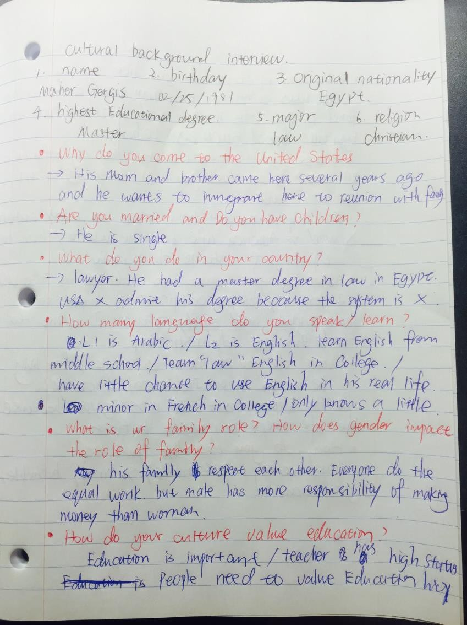

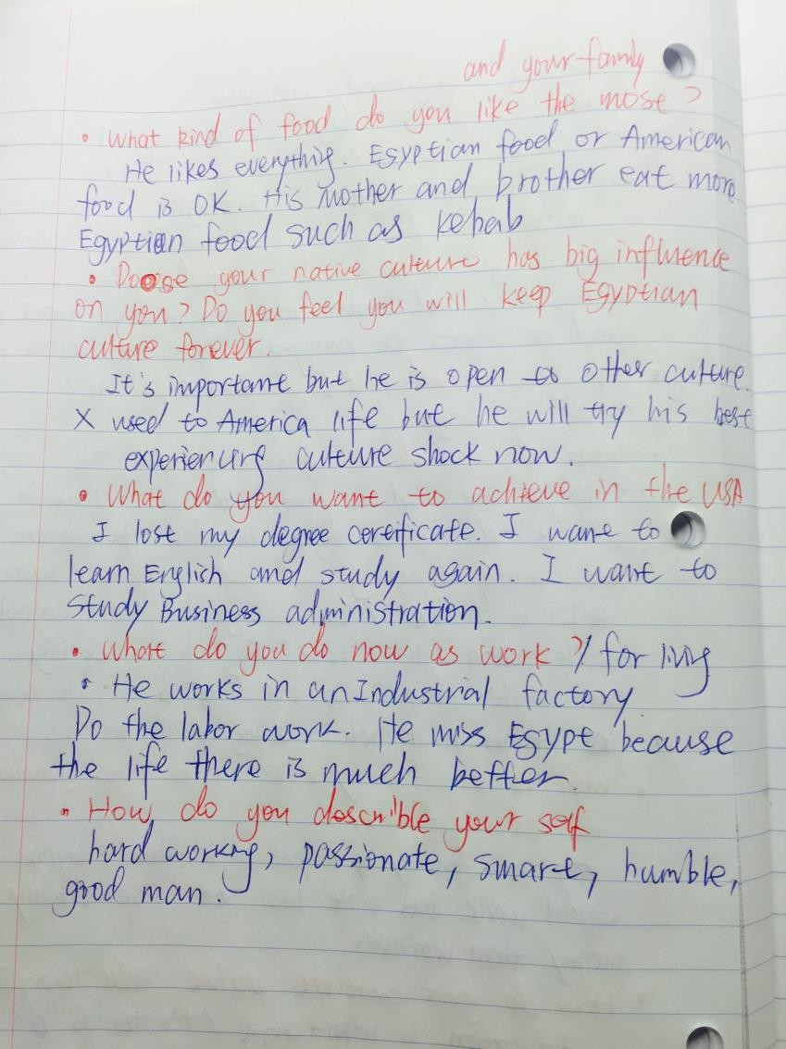

Appendix 2

ANALYSIS PROJECT 24
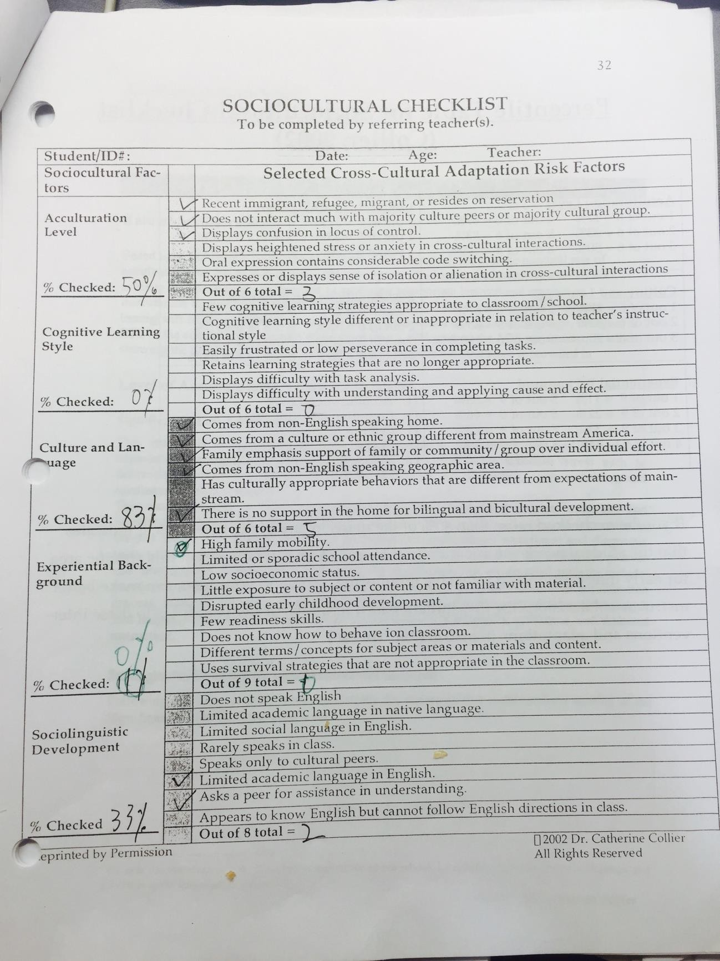

Appendix 3

ANALYSIS PROJECT 25
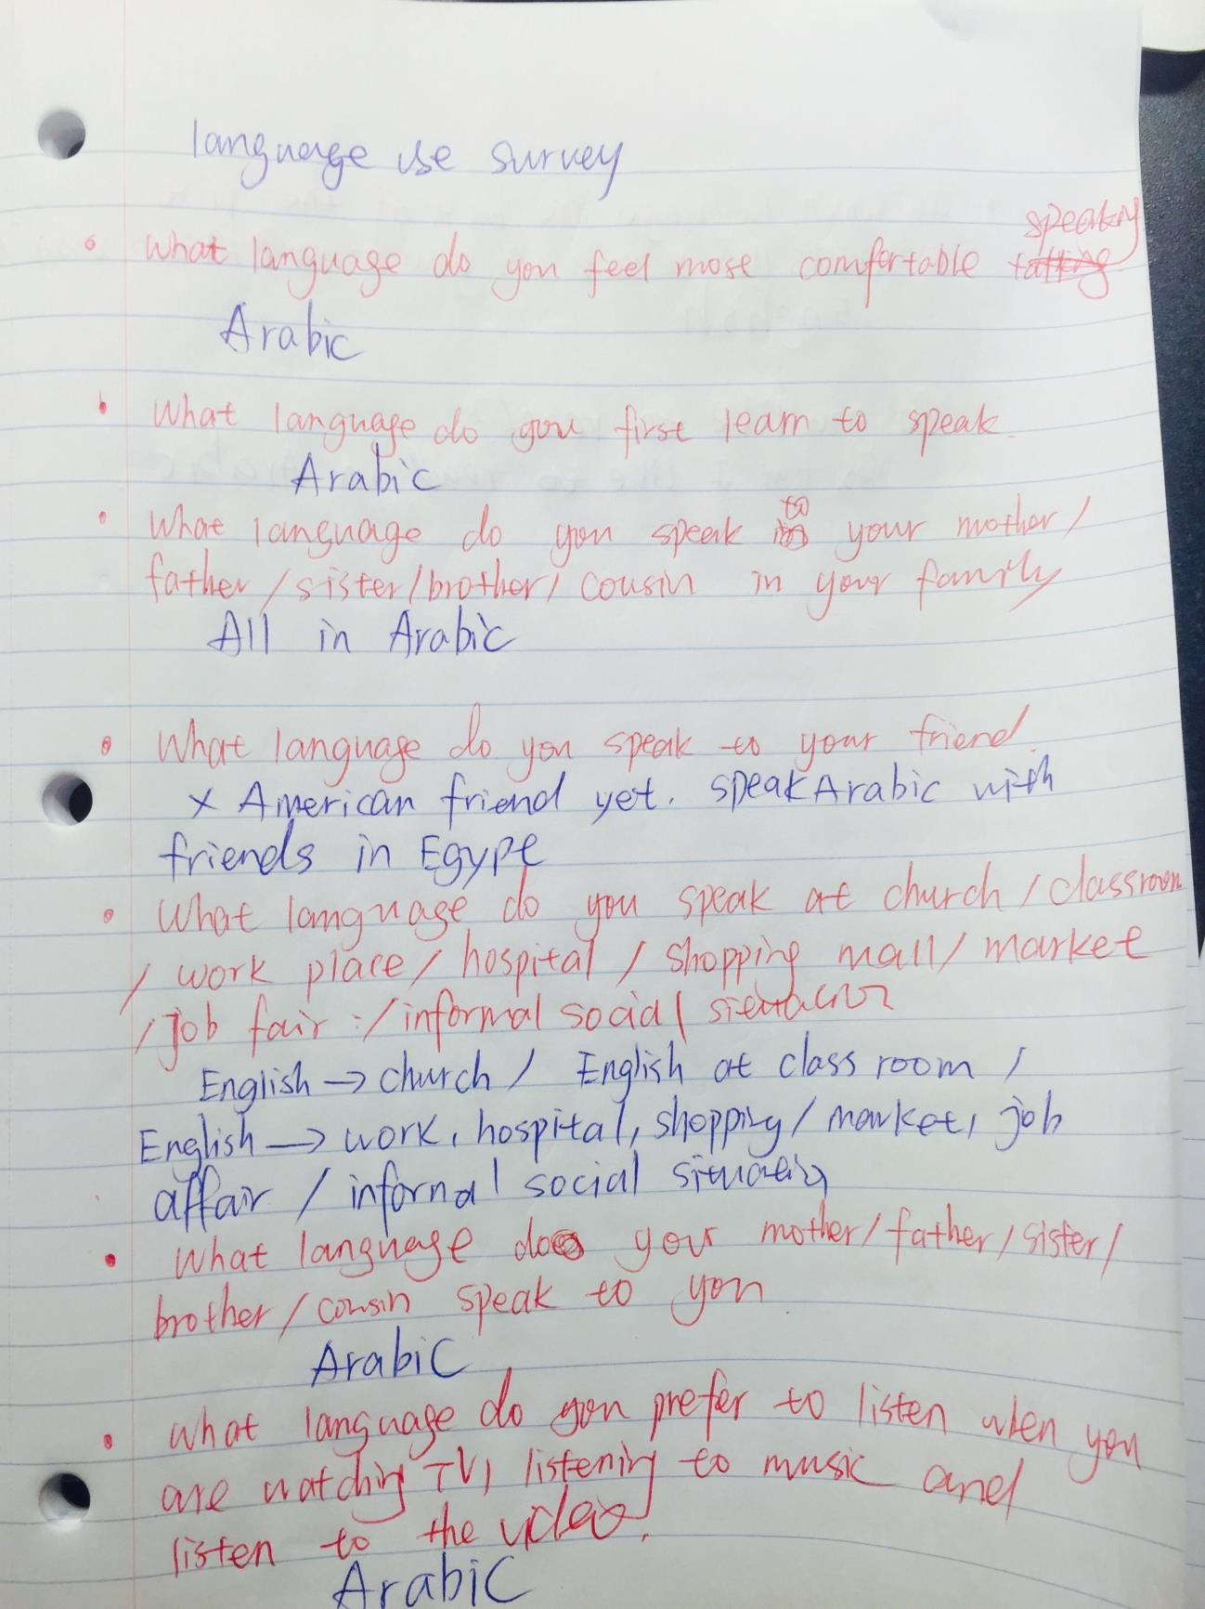

ANALYSIS PROJECT 26
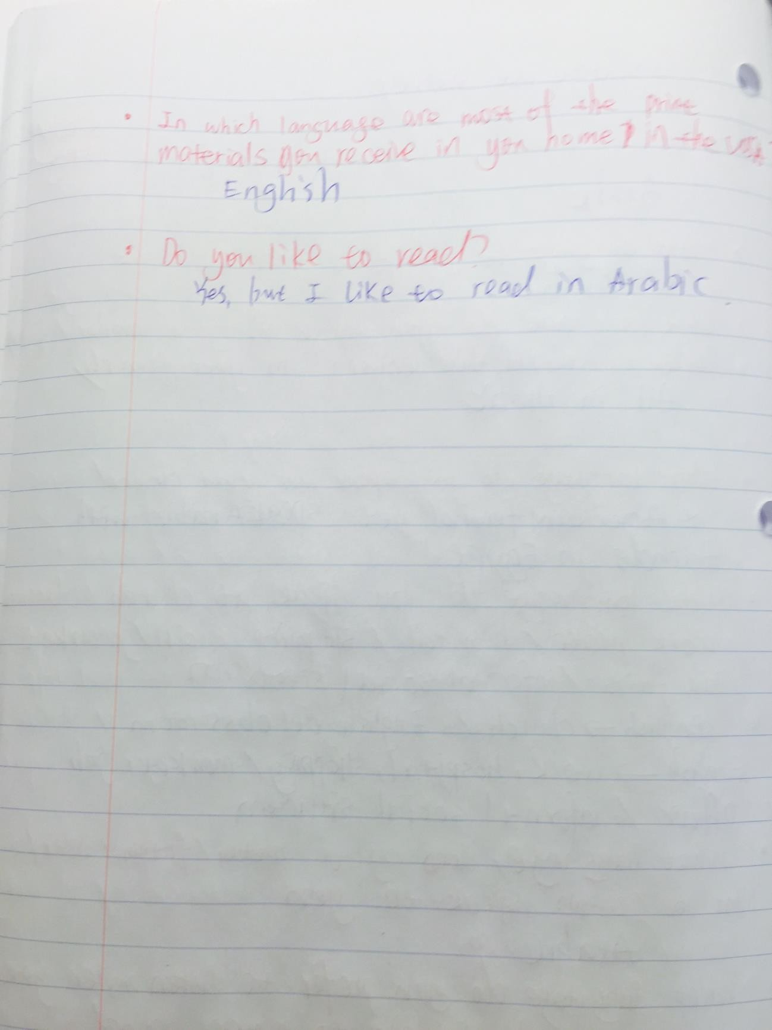

Appendix 4

ANALYSIS PROJECT 27
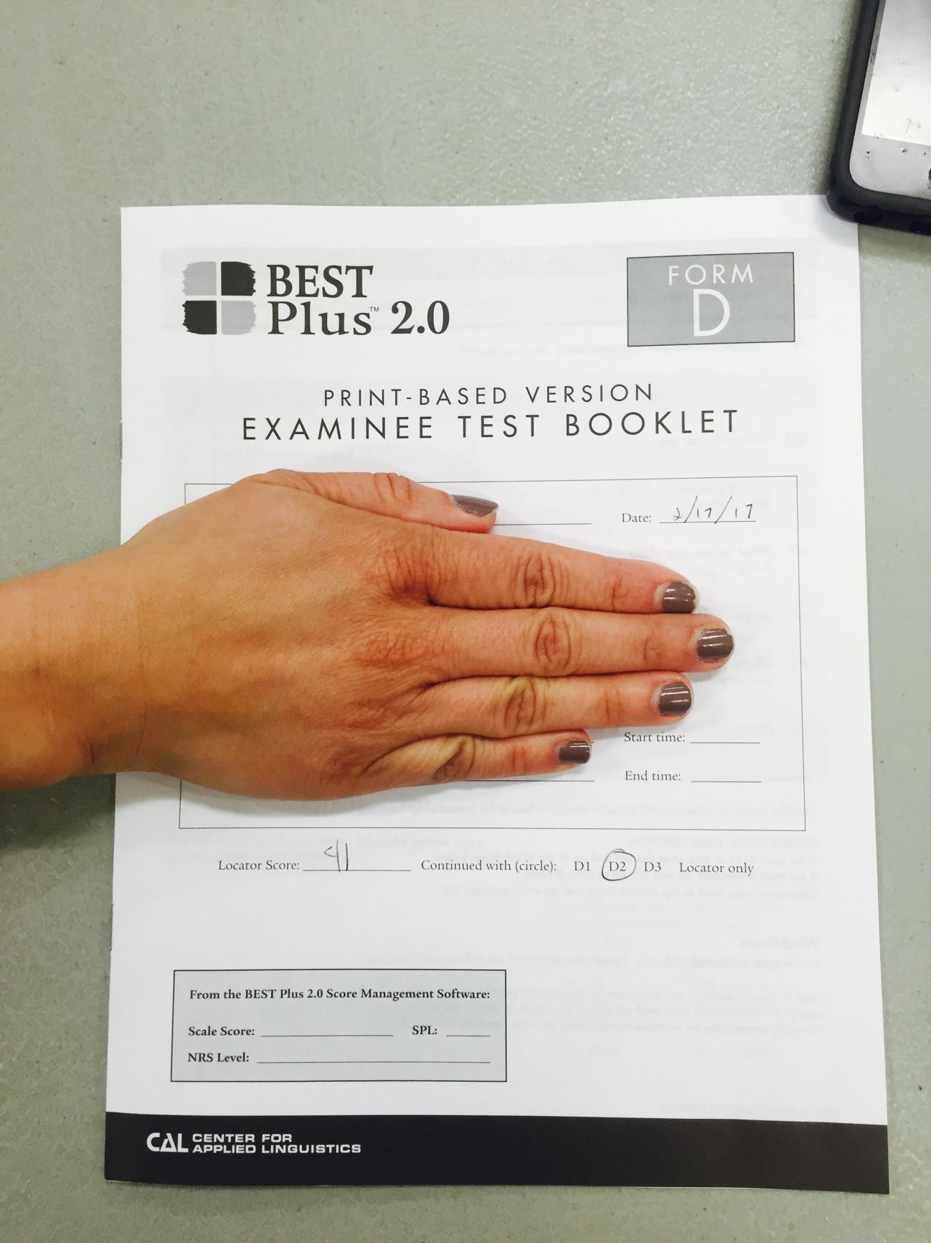

Appendix 5

Transcripts from the lesson on Mar 21st.

T: Now we will go to the meat department. The first, beef, you guys all know what is beef? It is the meat of cow. Next one, pork, it is the meat of pig. Next, lamb.
S8: It is the meat of sheep. Mei, mei.

T: yes, I think Egyptian people eat lamb a lot?

S8 (from Egypt): yes, lamb and beef. Christian people eat pork. Muslin people no pork. T: Thanks for telling me. So in your country, muslin people do not eat pork.
S8: our beef is different. We use.. baffa…. Mary: buffalo?
S8: yes, buffalo.

T: do you guys barbecue the meat? I thought Egyptian people like barbecue a lot. S 8: we use oven…oven to cook.
T: Oven. So you use Oven to cook meat. And thanks for telling me beef and lamb are popular in your country. Is lamb expensive in your country?
S8 :for now, it is same price. Before, lamb is cheap than beef. T: Lamb is cheaper than beef before but now they are sam?
S8: yes.

Appendix 6:
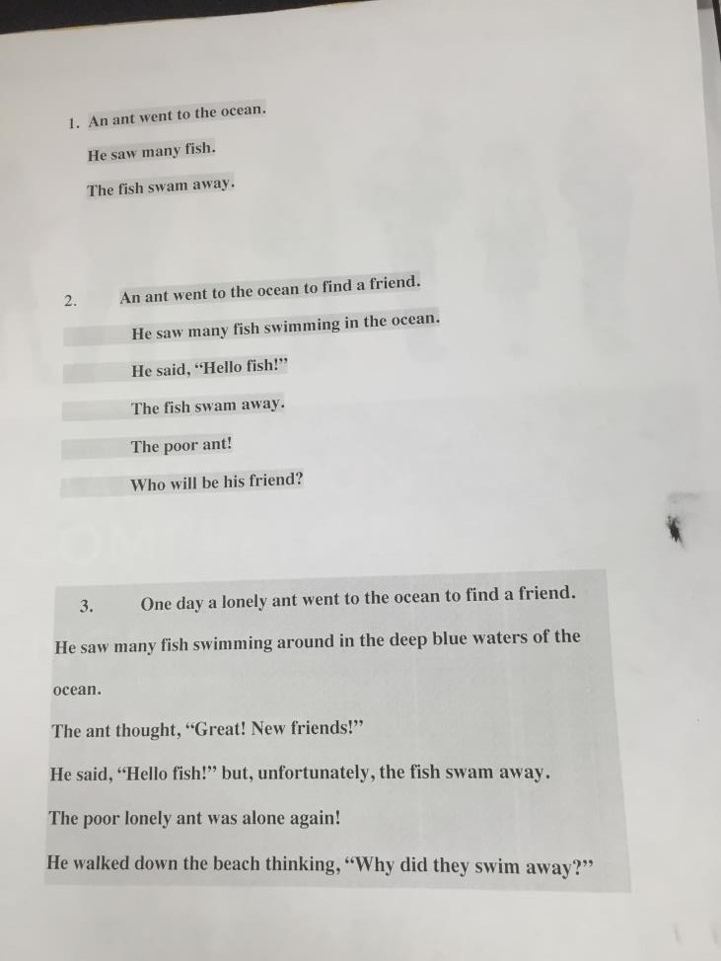

Appendix 7:
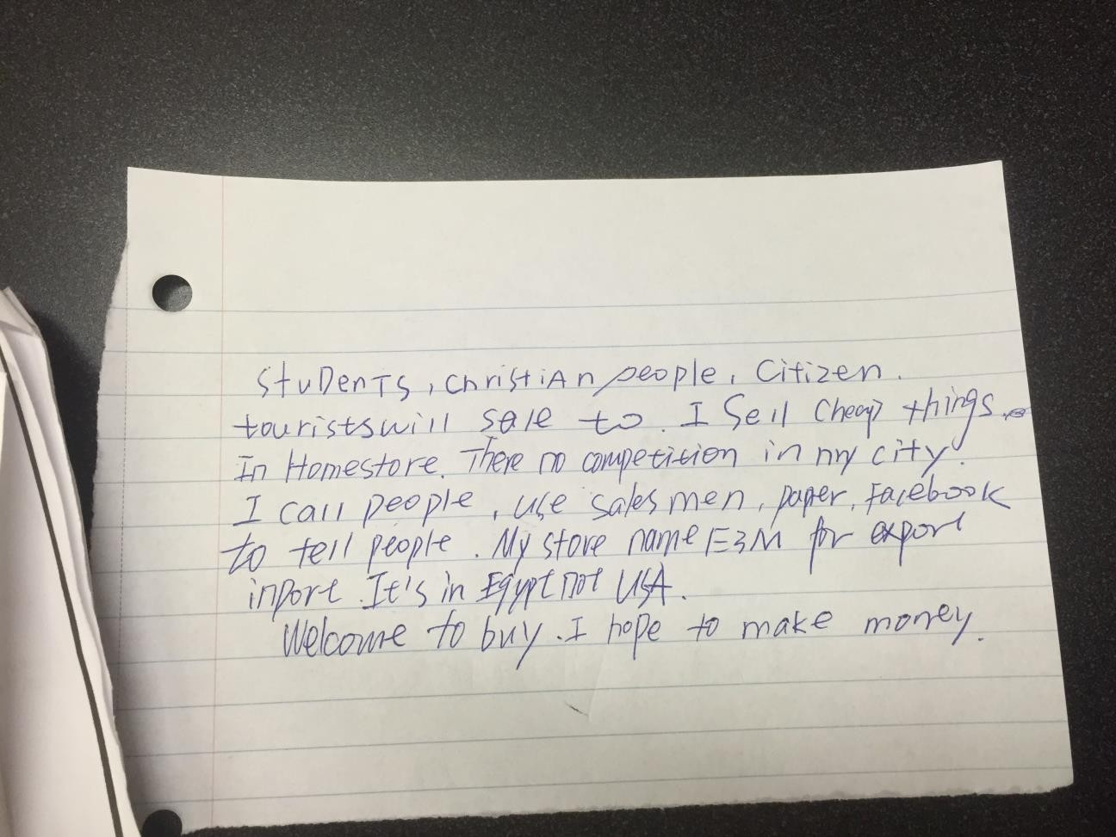

Appendix D：

Linguistic analysis report

Part 1:Introduction to the participant
The person that I interviewed is my 14 years old cousin Qiqi who is in middle school 9th grade and has been learning English for seven years since she was in elementary school. She was born in Luoyang, a small city situated in the middle of China. She was the only child of the family so she received full attention since the day she was born. Everybody spoils her and the whole family tries to give her all the best. Her father is a businessman who is busy of making money everyday and her mother works as an office assistant who mainly spends time to take care of Qiqi. Her father spoils her most and he only cares whether his daughter is healthy and happy instead of pushing her to study and get a good grade. In the contrast, her mother is serious and strict of her behavior and education. Her mother has a high requirement for Qiqi’s grade and she will give punishment to Qiqi if she dose too “terrible” on her test. Her family has a good economic conditions so she can get involved in assorted activities such as traveling abroad, going to good school and get sufficient educational resources. Her family is well educated and the language use in her family is friendly and polite. Qiqi’s mother requires Qiqi to always use the proper language.
Linguistic background
Qiqi speaks standard Chinese at school and the Henan dialect at home. These two languagesonly have differences about how to make sounds. Qiqi started to speak when she is two years old and she was able to communicate fluently with the surrounding when she was three. None of her family member knows English and she never speaks English until she attended the second grade. Chinese language uses “pinyin”, which has the exactly the same appearance as the English 26 letter but has totally different sounds compare to English, as the tool of marking pronunciation of the Chinese symbol. Chinese language does not have the 26 alphabets to make up words as English but uses a logographic system, which every Chinese symbol represents different meaning. Qiqi learnt how to write and read Chinese by learning the meaning of each Chinese symbol. Consequently, it is hard for Qiqi to get used to the English language system, which uses various letters to make up words. Moreover, Chinese language has no morphological changes and people have to distinguish the word meaning by the tone. Qiqi struggles for English listening because how English uses pitch and stress are different and there are many English sounds do not exist in the Chinese language system at all. Qiqi started to learn “pinyin” and Chinese symbol when she was in the first grade of elementary school ands she started to get in touch with English when she was in the second grades. In her Elementary study, her school focus on Chinese language education mainly and she only learnt English for 2 hours a week. Later, she went to a famous foreign language middle school and English became a main subject there. Her middle school offers 45 minutes English class everyday and the school hires American teacher to teach students oral English twice a month. Besides, her mother also found a tutor program for her to practice her English grammar and oral English at the weekend. She learnt her oral English mainly in the tutor program because her teacher at school only focuses on teaching grammar and writing, which is the test requirement.
She is good at talking and writing in Chinese and she loves the Chinese literature. She is skillful of using craft in Chinese and she is a really good Chinese writer. However, when it comes to English writing and speaking, the way she use English is highly influenced by her language one and it is due to her lack of thinking in English language logic.
Educational and cognitive background
Qiqi is at the middle-level student in her classroom. She does not like math or science and it could be seen obviously on her grades. She loves Chinese, literature and English class and she could perform well on these tests. The elementary school she went to is not a competitive school so she spent a really relax and happy childhood there. However, since China is under the exam-oriented educational system, her parents decided to send her into a more competitive boarding middle school in order to attend a good high school and a good college. Qiqi spent a long time to get used to her middle school and she was the very bottom student in the beginning but she spent effort and time to move up. This school is a foreign language school so it offers more English class and English activities per week for students compared to the regular middle school. This school holds a language competition each year and Qiqi won the prize of the oral English competition last year. During her second middle school year, she attended the student union and became the leader of English department. She is responsible for holding the English activities and decorating the English corner, which motivate her to learn English a lot. This school also equips student the most experienced English teacher. Qiqi’s English teacher is 40 years old and she has been teaching English for forty years. She is skilled at teaching grammar, writing, and testing skill and her past student performed well on the high school entrance test. However, she learnt her English in China around 1985, and her pronunciation and vocabulary use has not been updated since then. She has heavy Chinese accent when speaking English and she is unable to distinguish the British accent and the American accent. The oral English she taught to student is not correct enough and Qiqi’s pronunciation is influenced by the instruction. Although she is good at teaching student how to pass the test, she did not teach them the most appropriate English. The school did not pay much attention to this problem because having a good grade is what they mainly care. School offers native -American teachers to teach oral Englsih but they only comes to Qiqi’s classroom twice a month, which is not enough for the teacher to give student individual correction.
Qiqi lives in the boarding school and she has a pre-reading class every morning at seven o’clock before breakfast. Her English teacher usually comes to the classroom to lead student read textbook together. Besides, she will leave time for student to memorize vocabulary and give students dictation. Her English teacher cares for student’ spelling severely since it is crucial for the test. If the student did not pass the spelling dictation, she will call them to her office to do the dictation again. Qiqi has a good memorizing ability and she is a good English speller so that she rarely fails the dictation. Qiqi does tons of grammar practice everyday and her English teacher will come to the classroom to solve student’s grammar questions every night around 8 pm. The grammar on the exam usually contends the morphological change, tense, spelling, word use, preposition, article use, linking devices, manner and so on. Those contents are flexible when using in the daily life but strict on the test. Qiqi is trained to use the most correct grammar and she does lots of grammar practice everyday even though she thinks it is very boring. Besides grammars, there will be a writing project on the exam, which asks student to write a short essay based on the topic it assigned. The writing test does not require student have a deep thinking on the topic, and it only requires students make no mistake on the sentence structure, word use, and grammar mistakes. The way Qiqi practices writing is to write all kinds of topics before the exam so that she will not feel nervous to see an unfamiliar topic when she does exam. Qiqi has to write three different essays each week and her teacher will mark all of mistakes for her to correct. Qiqi is practicing English writing for just taking the test.
Personality
Qiqi is an outgoing girl and she loves to communicate with people. She never feels shy when people talk to her and she is able to express her needs, feeling and thinking. We used to travel abroad together and she is brave enough to talk to foreigner by using the English she knows. When there are certain barriers occur, she smartly uses her body language or sign language. However, when I interviewing her, I could feel she was little nervous. Her sounds will become incoherent when she is trying to search for the right words. I think it is because she knows I am recording her and she feels responsible for making the perfect answer for me. Qiqi is a super fan of Disney movie and the Snow White is her favorite character. She watches lots of English version Disney movie and she always imitates how those characters talk, which I think it is a good thing for her because she could learn the most real pronunciation. She also loves to read Disney storybook and she uses dictionary to search for the meaning of words she does not know. She is serious about everything of Disney and I am glad she has this hobby because it could motivate her to learn English. She plays piano for 10 years and she is familiar with western music. To my surprise, she can sing lots of English songs even though she does not understand lyrics. She is a person who loves to show herself and it makes her performing very well in the classroom and participating actively at the “English corner” activity. Being outgoing is helpful for learning English because she can create some chance to use as much English as she can in the Chinese-dominated society. She loves to ask questions and she goes to her English teacher’s office a lot. Her dream is to become an English teacher in the Elementary school and she wants to major in English or English education in the college. She has a great passion of learning English and I think she will speak a fluent English soon.

Part 2: Description of the learner’s oral and written language abilities

A person’s language ability should be evaluated from four parts, which is her Phonology skill, Semantic skill, grammar skill and pragmatic skill. I will introduce these four skills separately in the following paragraphs.
Phonology

The sample I collected for phonological analysis is a casual chatting. Qiqi uses the online voice platform to talk with me, and our discussion content range is basically casual talk. We discussed parts of her language study, her life at school, her interest, and she is offered an image to narrate in English.Qiqi ‘s talk is comprehensible and she also has ability to comprehend most of my talking and questions. Qiqi’s pronunciation is understandable but contains the heavy Chinese accent that is far away from standard pronunciation. Her accent could be integrated to the following problems.

First, her language habit is largely influenced by her Language 1 Chinese. She always forgets to stress consonant when it is necessary and she pronounces words by using the way she learn the Chinese Pinyin. For example, she pronounces the word “is” as “/ɪs/” instead of “/ɪz/” and the word “because” as “/bi’ kɔs/” instead of “/“/bi’ kɔz/”, because the letter “s” is pronounced “/s/”in pinyin system. She pronounces the word “speak” as /spi:k/ instead of /sbi:k/ because the letter “p” is pronounced as “/p/” in Chinese “Pinyin” system. She did not stress the consonant because she pronounced the words from the other language system and she has not developed the English speaking habit. Moreover, she is avoiding making the sounds that not exist in her Language 1. For example, he pronounces the word “have” as “/hæwu:/” instead of “ /hæv/” and the word “movie” as “/muwei/” instead of “/muvi/” because the sound “/v/” does not exist in Chinese language and it is hard for Qiqi to pronounce this sound. Consequently, she finds the sounds “/wu/”, which she is more familiar with, to substitute the correct sounds “/v/”. Besides, I asked her what her favorite subject is and she told me “match”. Based on the context, I know she wants to say the word “math” with the sound “/mæθ/”. Chinese language does not pronounce the sound of “th”, so Qiqi misconnect “th” with “ch” to pronounce and this phenomenon could be explained as Qiqi is avoiding the sound “th” because it is hard for her to pronounce. According to the speech and learning model, how difficult Qiqi learns English depends on the similarity between English and Chinese. If these two languages are less different, Qiqi will learn English easier. Chinese language has no rule of stressing the consonant so that Qiqi will always forget to change the sounds of consonants. Also, Chinese language has certain sounds that do not coexist in the English language such as the sounds “/θ/” and “/v/” as I just mentioned. It explains why the mistakes I mentioned exist in Qiqi’s oral pronunciation constantly.

Second, she cannot distinguish the nuance between different vowel and she often makes the wrong use. For example, she pronounces the word “like” as “/lek/” instead of “/laɪk/”, the word “nine” as “/nen/” instead of “/naɪn/”. She is unable to make the correct distinguish between “/e/” and /aɪ/ since they sounds similar. She also pronounces the word “football” as /fʊt bol/ instead of “/fʊt bɔl/”, the word “story” as “/stori/” instead of “/ɔ/”, which indicates that she confuse the sound “/o/” and “/ɔ/”. I asked her whether she uses the IPA to learn pronunciation and she said she use the sounds of Chinese alphabet to memorize the pronunciation. For example, if she wants to remember sounds of “happy”, she marks Chinese words “海皮”, which has a similar sounds to “Happy”, to help her memorize. This misleading her to a similar but not standard pronunciation and I think her English teacher does not pay attention to mistakes like these. The third mistake she has is the grammar and word use mistakes. For example, She says “our teacher tell us in Chinese” instead of “tells us” with a sound of “/s/”, “seven year” instead of “seven years”, “be a English teacher” instead of “be an English teacher” and etc. She neglects these nuance grammar mistakes although it does not hinder understanding. This phenomenon is because Chinese language system has no morphological change so Qiqi is still spending time on getting used to the English language system.
Aside from pronunciation problem, Qiqi’s fluency in speech needs a long way to improve. She shows a pattern of using the sounds “Umm, Umm” or “I think….umm….maybe.” in the beginning of the sentence and she always pause in the middle of the sentences to repeat the same pattern “Umm, umm..” Also, certain Chinese transitional word such as “Dui, Nage” appears. Those patterns occur when she is trying to search the right vocabulary and expression in order to keep the coherence. For example, she says “Umm, umm, maybe, umm our teacher tell us in Chinese but we write in English, dui.” Besides, she has the repeated vocabulary use pattern. For example, the word “like” appears 5 times in her conversation and she could use other words or phrase such as “fall in love with” or “enjoy” to make her writing contains variety. These problems are due to her lack of the vocabulary repertoire and she should try to enlarge her vocabulary. 2. Qiqi could deliver the main meaning but fails to speak English with the fluency and the appropriate expression.
Semantic
I chose two things from her to analyze. First, I chose to analyze several pieces of her English writing homework (word analysis-see table 2) Second, I audio recorded an oral conversation between us online. (word analysis-see table 1) I asked her several questions about herself and her English learning situation and I also presented a picture to her and let her describe the picture. I told her in advance that it was a casual chat so it is unnecessary to be nervous. Our whole conversation was conducted casually.
For the audio sample analysis (table 1), we can see that Qiqi is conducting a casual conversation because the lexical density is only 32.18%. She is capable of using word to deliver meaning and her has the vocabulary repertoire for daily using. According to this data, it indicates that she has many re-used words in her conversation and it lacks variation of vocabulary. For example, she uses “speak”(5 times), “maybe”(6 times), “teach”(6 times) and “like” (9 times). She could use various vocabularies to describe those repeated words. For example, she could substitute the word “like” with the words “enjoy, fall in love with, adorer”. Words that she uses to chat are more for daily use since there are only 7 hard words, which is the 1.8 percent of the whole conversation. Many hard words such as “exercise”, “success” and “dormitory” which contain more syllables rarely occur in her conversation. She is not confident enough when she is using the harder words and she try to use the simplest expression in order to deliver meaning. This is because she is not skillful about the word use so that she worries about making mistakes and she avoid to use the harder words because it is harder to pronounce. She loves to use the sound “umm” while she is thinking about how to say a word and she used the sound “umm” for more than thirty times in the conversation. She wants me to give her time to process thinking because it is challenging for her to come up with the word that could describe her thought right away even though she knows the word in her language 1. For another example, she intends to tell me that she lives in the dormitory with her but she makes the sound “Umm” for three times before trying to think of the word “dormitory” and she finally says that “I live in the school”. She uses more common and broader words to describe what she want due to lack of vocabulary. Many times I asked her questions, and she uses the same pattern “Umm, Umm…” when she is unable to recognize my vocabulary. Although she is able to deliver what she wants to say for most of the time, the error of the word use still occurred a lot. She likes to translate Chinese into English directly with the surface meaning so that she uses many inappropriate words. For example, I asked her what the English class looks like in her school and she answered “Our teacher tells us in Chinese and we write in English.” The word “tells” should be either “speaks to” or “teaches” and the reason this mistake happens is because these three words could mean the same thing in Chinese in this context. Qiqi is not qualified to totally follow her L2 word use pattern and she is still influenced her L1. Also, it is obvious that she is lacking of practicing because she has not get the logic of English language. There is evidence to show her inadequacy of word use. For example, I asked her why she wanted to become an English teacher and she said “I think teaches us umm, is very well.” In this sentence, I bet she wanted to say that teaching students is a very good job. However, she failed to use the correct form of the word “teach” if she wants this action to become the subjective and the correct use should be “teaching”. Also, she should change the vague word “us” to “students” in order to find a clear audience. She has the basic concept in mind but is unable to organize the words and put them into the right place. The lack of vocabulary hinders her comprehension ability. For example, I asked her “How many people are there in your dorm?” She answered “a thousands”. She gave the wrong answer mainly because misunderstand the word “dorm” as “school”, which indicate her lack of vocabulary repertoire.
As for her writing sample analysis (table 2), the lexical density, which is 47.73%, is higher than the oral sample, and it shows that she has a better semantic capacity for writing. Her writing is clear to understand and she is able to write words for deliver meaning. However, even though the lexical density rises in writing, she still displays the inadequacy in many ways. First of all, there are many semantic repetition occurs in her writing. For example, she said that “it is very cute and lovely” where “cute” and “lovely” have the same meaning and they overlap with each other. She knows these two words have different appearance but she ignore the truth that these two words share the same meaning, which indicates that she is not skillful about word use. Secondly, there are only two hard words( 1.14%, table two) in the whole writing and it indicates that she does not have a large repertoire of vocabulary and the word use is too simple and shows lack of variation. For example, the word “good” occurs 4 times and she could substitute some more complex words such as “fantastic and fabulous.” Even though she could deliver meaning, learning more vocabulary will help her to offer more precise information in her writing. Besides, She has the root concept of certain words but not the word form. For example, she uses “I am very scary” to describe she is afraid of the earthquake and the right version should be “I am very scared.” She has the semantic knowledge of this the word “scare” but misapplied it. Also, she wrote that “ Ti’an men square is a very seriously place.” which indicates that she is unable to recognize the form of a word and use the word properly. She should not use the word “seriously” since it is an adverb and she should use the correct form “serious”.
Although both her oral recording and writing sample could deliver the information that she wants to convey, she is still very far way from being skillful about semantic capacity. Her misunderstanding of the vocabulary, her lack of lexical density and the low repertoire of vocabulary attribute to her inadequacy of semantic skill. She needs to learn more vocabulary and the exact meaning of each word. Moreover, she should realize that she should stop using repeated word and increase the sophistication of word use.
Grammar
The two samples include a casual conversation and three writing essays from my 14 years old participant Qiqi’s homework. The content of the oral talk is her description of a photo and a narration of a story based on the image I showed her. The three writing samples are Qiqi’s English writing practice based on assigned topics. Those three topics were about her favorite thing, an important event in her life and a story of a trip. Each of these samples contains approximately 80 words, which meet the Chinese junior student’s English writing expectations
Morphological Ability Qiqi’s Mean Length of Utterance is calculated as the following. In order to find the mean length of utterance, we take the total number of morphemes and divide it by the total number of utterance. For her oral sample, besides the influent sounds such as “Umm” and the repeated word pattern, the transcript contains 250 morphemes and 238 utterances so her MLU is 250 divided by 238, which is 1.05（see table 3. For her written sample, the written sample contains 297 morphemes and 276 utterances, so her MLU is 297 divided by 276, which is 1.071(see table 4). In analyzing her oral sample (MLU=1.05), we can notice that she has developed some morphological skills but still has areas in need of improvement. Qiqi is able to add prefix and suffix to alter verbs based on tense, person and voice and she can change the singular form of a noun to the plural form. For example, words like “stairs”, “exercises”, “decided”, “trees”, “elephants”, “finally”, “exciting” “reducing” demonstrate these morphological abilities. Also, she can change tense of the irregular verb such as “go” to “went” and “do” to “did”. However, there are still grammatical mistakes in her conversation. First, she should sustain the appropriate tense within her narration instead of using different tenses in one sentence. Second, she confuses characteristics of certain words and fails to use the proper suffix. For example, she says “I was very exciting about this trip”, and the word “exciting” should be changed into “excited” because the word “excited” is used for describing people’s feelings and “exciting” is used to describe a thing.
For her writing sample, which has a MLU of 1.07, she showed similar morphological skills as oral sample. The word “seriously”, “happened”, “remember” “important”, “ancient” “memories” show that she is able to use the prefix and suffix to alter words. She made fewer mistakes compared to the oral sample when using the suffix. For example, “ed” and “s” are used in the proper places, which unifies the tense and content in her language. Compared to her oral sample, the sentence in her writing flow more fluently because she uses more linking devices. The appearance of the words “because”, “and”, “in” “a” indicates that she is able to use grammatical functional words such as prepositions, conjunctions and determiners to transit her sentences. However, some grammatical errors existed in her writing. First, she misuses certain prepositions. For example, she should say “on that day” instead of “in that day”. Second, she confuses words with similar morphological characteristics. For example, she should say, “I am scared” instead of “I am scaring” to describe her emotion.
Syntactic Ability Based on my analysis of both samples, Qiqi is able to put words in proper grammatical order with occasional mistakes. She mainly follows the rule of “subject+verb+object” and she can form complete sentences. Orally, she sometimes fails to bring up the subject of the sentence but is still understandable based on the context. For example, she says, “my mother and I laugh (laughed). umm, is because we were very happy!” She fails to use the word “It” to represent the incident “My mother and I laugh” because she assumes listeners know what event she is referring to. Moreover, she sometimes uses the pattern “subject+be+verb+object”. For example, she says, “She is succeed reducing weight”. She is using verbs incorrectly and applies the wrong grammatical structure. In terms of cohesion, the appearance of the words “later” and “finally” indicates that she can use transitional words to make a logical link. She consistently uses the sound “Umm, Umm” to give her time to process the right expression due to her lack of vocabulary and she use this skill a lot to avoid pause. As for the writing sample, since Qiqi has time to proofread and revise, she does better in arranging words in their proper grammatical order. She can use the logical linking devices such as “and”,” but” “then” “because” and she can use pronouns such as words like “it” “she” to serve as grammatical linking devices. However, she occasionally misuses the logical devices. For example, she uses the word “but” independently in a sentence without any logical link to any prior sentences and it is hard to understand what she refers to.
Based on the analysis of Qiqi’s oral and written sample, she shows a basic knowledge of grammar despite some mistakes that do not interfere with comprehension. Both of her MLU scores show that she has morphological ability but is still at the beginning level. She knows basic rules of making morphological change based on different circumstances. However, she still needs improvement in sustaining the proper tense, conjugating verb and understanding the characteristics of a word to add the proper suffix. In addition, she shows a good syntactical ability. She can put words in their correct order, make proper sentence structure, and use linking devices to generate meaningful sentences while still needing improvement at using linking devices to create logical transitions and forming correct sentence structures. Compared to her oral sample, Qiqi’s written sample has similar MLU score, which indicates that her oral and writing have similar morphological level. Even though she has fewer mistakes of grammar use in writing due to the proofread, she still displays a common mistakes pattern with her oral sample. On a syntactic level, the incomplete sentence occurs more in her oral sample, which indicates that she lacks oral practice. Also, the linking device is more often used in the written sample and as a result, her written sample is more fluent.
Pragmatic
The content I chose to analyze is a conversation between my participants Qiqi and I. This conversation was supported by “We chat” (Chinese chatting app) without visually looking at each other. The conversation is basically an interview, which contends topics of her school life, hobby and her latest trip. I am the one who ask her questions and decide the topic, and she gives me response based on my questions. This talk is relatively casual because the topic is all about her common life. She was not nervous when she talked to me because I was her cousin and she was pretty familiar with me. However, she was little nervous when she felt she has trouble for searching the right expression to answer my questions.

Situational contexts didn’t play a part in our conversation because we did online talks without video assistance so that there is no references to situations. As for social contexts, Qiqi is my cousin and we are members of a big family. We love each other and we always chat about our daily life so that there is social context in this analysis based on our relationship. For Linguistic contexts, it plays the most important role in this pragmatic analysis because it refers to the context within our conversation, which I observed a lot. For example, I asked Qiqi what her English class looks like and she told me her teacher was the only one who talked, and she will only be tested on English grammar and writing. When I asked her whether she prefer English writing or speaking, she told me that she like writing more because she was trained to write more. This evidence shows our conversation transits based on what we discussed before. Qiqi likes writing more because her teacher teaches her writing more. In general, linguistic contexts count most in pragmatic analysis for the samples.
Adherence to Grice’s Maxims First, Qiqi’s response achieved the maxims of quality (Grice, 1975) with little deficiencies. She knows how to use evidence to defend her statement. For example, she is able to correctly describe an image “There are two people in the photo, my mother and me. There are trees, umm, elephants and ... On the picture, my mother and I laugh, umm, is because we were very happy!” I then ask her why they are laughing and she could offer me adequate evidence “I am happy because I love to play and I don’t need to do homework. My mother is happy because she don’t need… umm….umm…work.” However, she occasionally shows inadequacy to me. For example, I ask her why she wants to become an English teacher and she answer “I think teacher, umm, umm, I think teaches us umm, is very well.” Although this sentence contends mistakes to read, I can still know that she thinks teaching is a good job based on the context. Even though I can get what she wants to say, she still need to more details to state why teaching is a good job.
Secondly, he performs well on maxims of relevance. She stayed focused on my questions and gives the corresponding response without randomly shifting topic for most of time. However, her answer occasionally deviates from our topic. For example, I asked her “how many people are there in your dorm?” and she answered “ one thousands, more than one thousand.” Her answer is irrelevant to my questions because she is answering the total number of students in her school instead of her dormitory. She didn’t stick to my questions because of her lack of vocabulary. .
Thirdly, Qiqi did a good job on quantity maxim. She is not a very voluble person and she just answered what I exactly asked. I played a more dominant role in this conversation and she never talk before me. If I want to know more information, I need to keep asking. For example, She said she use Chinese at school and I am curious where she learns her English. I ask that “How do you learn your English? You have the English class?” She just simply responded that “Yes, I have the English Class”, without adding any other details. She answered all of my questions with no extra information but I expected she could say more about the situation of her English class. Consequently, I have to pull more information from her by keep adding questions even though she follows the rule of maxim of quantity tightly.
Finally, as for maxims of manner, Qiqi’s word use is not hard to understand because of her current English proficiency and the limited vocabulary. Most of her sentences are short with the most basic structure such as “I speak Chinese at home” and they are understandable. However, if she is trying to use longer and more complex sentences, her utterance will be incoherent and the meaning of the sentence will become vague. For example, I asked her what is her English class looks like in China, she answered “ Umm, umm, maybe, umm our teacher tell us in Chinese but we write in English, and the ,umm , my teacher, umm, my teacher also speak in English, maybe ask us question.” This sentence fails to provide a clear explanation and I think she is not good at making up long sentences. In general, she did relatively well for the maxims of quality and quantity. Her major problem, however, is the violation of maxims of relevance and manner, which needs to be further developed.

Part 3: Assessment and SLA theoretical framework
Overall assessment
According to the Language Acquisition chart, the global English ability of my participant is at the Level 3 “Low Intermediate”. Firstly, as for phonology, the participant is able to communicate with the experimenter for the daily using topic mostly with the simple sentences and the tolerable Chinese accent. Although she is able to communicate, there are many mistakes existed in her grammar, word order and word usage that obscure the meaning she wants to deliver. Those mistakes will be more obvious if she is trying to make up a long sentence. For example, when she is describing how her English teacher give instruction, she says “Umm, umm, maybe, umm our teacher tell(tells) us in Chinese but we write in English, and the, umm , my teacher, umm, my teacher also speak(speaks) in English, maybe ask(asks) us question.” When she is trying to provide information within one sentence, her words become incoherent and mistakes occurs a lot.
She has limited comprehension ability and sometimes needs experimenter to use the more simple words to explain the meaning again. She pauses and makes the sounds “Umm” a lot, which indicates that she needs long processing time to search for words and the correct way for expressing and she does not have a large vocabulary repertoire to use. Secondly, as for semantic, the participant has vocabulary for daily using and she is able to use word to deliver meaning. However, her vocabulary repertoire is not large enough for supporting the deeper or more academic discussion. The vocabulary and the phrase she uses are simple and short and she shows a consistently repetition pattern for word choice. Thirdly, as for grammar, the participants could produce complete sentence and she is able to make morphological change based on the tense, quantity and context. She is able to choose the correct sentence structure and set up the correct frame of a sentence. However, she still make some mistakes on sustain tense and quantity. In addition, she has confusions of characteristic of words and she has trouble of forming the sentence structure occasionally. Those defects do not hinder understanding but still need further improvement. For pragmatic part, my participant could give expected response when it is necessary and she knows what to talk in different context. However, sometimes Qiqi delivers meaning rely on context due to the limited comprehension and vocabulary. Based on the information I collected from my participant Qiqi, I could assign her for the “low intermediate level”
Influencing factors
Qiqi’s native language is Chinese and she has not get chance to speak English until she becomes a second grader. Chinese and English belong to different language system and there is a little common in both languages. Chinese is logographic language system, which uses symbol to deliver meaning, while English uses the different combination of letters to make up words. Qiqi needs to adjust to this change by learning how to use letter to form vocabulary. Moreover, Chinese has no grammar and sentence structure, and the meaning is delivered through using different tones. Qiqi has to learn English grammar system and English grammar rule, which it’s totally new to her. Besides, there are many sounds only existed in Chinese, and it is hard for Qiqi to pronounce those sounds when she is speaking English because she is unfamiliar with them.
Qiqi lives in the Chinese-only society and she has no change to speak or use English in her life. She does not know how to use certain words in the daily life and she has little chance to practice her English. Although Qiqi learns English at school, she learns what exam requires such as writing, grammar, words spelling instead of making English into practical use. People cares how many point students get on the test, while ignore their practical language ability and the teacher never gives correction on student’s oral English such as pronunciation and tone. Qiqi’s English teacher even speaks English with the heavy Chinese accent and Qiqi is influenced by that a lot. What’s more, there are 45 students in her classroom and it is also hard for her to get teacher’s individual support.
Description of SLA theoretical framework
According to the Speech and Learning Model, the distance between a learner’s L1 and L2 will determine how many difficulties this learner will go through when learner a new language. In other words, how difficult Qiqi learns English depends on the similarity between English and Chinese. If these two languages are less different, Qiqi will learn English easier. Since Chinese language and English language shares little in common, Qiqi is likely to use her L1categories to classify her L2, which set many barriers for her to learn English. For example, Chinese language has no rule of stressing the consonant so that Qiqi will always forget to change the sounds of consonants. Also, Chinese language has certain sounds that do not coexist in the English language so that it is hard for Qiqi to pronounce. Qiqi also use the Chinese “pinyin” system to mark the English pronunciation and it stopped her to pronounce like the native speaker. Moreover, Qiqi is unable to distinguish words like “talk”, “speak” and “say” and put them in the correct use when she is using English because these words have the same meaning in Chinese. Those mistakes constantly existed in Qiqi’s English and those are barriers for Qiqi to compose native-like sentences in English.
Secondly, based on the Critical Period Hypothesis, there is a “best” time for learning the phonology of a new language and it is usually before puberty. However, this hypothesis is not absolute because some adults can still speak their L2 like the native speaker without any accent. In Qiqi’s case, she started to learn English when she was seven years old, which was before puberty, and she still talk influent and non-native like English. The reason was that even though she started to get in touch with English when she was seven, she only learned English several hours a week in an English classroom instructed by a Chinese teacher. Also, she lived in a Chinese-only society and she has little chance to talk to the native speaker or listen to the native speaker. She mainly use English when she is taking the paper-based exam and taking the test becomes her goal of learning English. Although she started to learn English early, she was lacking a good language environment, which makes her still talk Chinese-like English.
Part 4 Specific instructional plans
After evaluate Qiqi’s English ability, I will gave her suggestions based on each part of her English ability.
Phonology ability
In order to improve her phonological ability, I will suggest Qiqi to pay more attention on the pronunciation since she has a heavy Chinese accent. I will help her to list sounds that she has trouble to pronounce such as the sound “/θ/” and “/v/”, which do not existed in her L1. Besides, I will make a list of the sounds that she cannot distinguish such as “/e/” and “/ai/” to help her find the nuance. She should not use the Chinese “Pinyin” to imitate the English pronunciation. In contrast, she should use the IPA to learn the standard pronunciation. Second, I will suggest her to watch more English language movie. Since “Listening and speaking are closely associated and integrated” (Peregoy&Boyle, 2012, p133), listening standard English will help Qiqi to find the gap between her speaking English and the standard English. She may also imitate how the movie character speaks to obtain the most original pronunciation. Third, I will create chance for Qiqi to talk to the native speaker. The city library has an “English corner”, where many English native speakers will volunteer to practice English with students. It is a good chance for Qiqi to participate her oral English.
Semantic
First, due to my observation, she translates Chinese directly into English and she ignores the gap between these two languages and I think this explain the reason why her English structure and word use is not appropriate. I would suggest to her to read more native English books or to watch more English movies in order to find out the how the native speaker use vocabulary and getting used to the English language logic. Second, since she has a repeated vocabulary use in her English, I would suggest her to buy a vocabulary book that fits her age. She could spend half an hour a day to memorize and it is a good way to expend her vocabulary. As her teacher, I will try to vary my vocabulary use instead of just using one word and one sentence structure constantly. For example, I will ask her the first time “what is your favorite food?” and the second time I will change to “What food do you enjoy the most?” In this way, she will unconsciously learn many synonyms and diverse sentence structure. Also, she needs to explore usage of each word because she has many misunderstanding of certain word use. For example, she is unable to distinguish the difference between “serious” and “seriously”. As her teacher, I will explain the different use and characteristic of words to her.
Grammer
Based on the analysis of Qiqi’s oral (MLU: 1.05) and written sample (MLU: 1.07), she shows a basic knowledge of grammar despite some mistakes that do not interfere with comprehension. First, I will suggest her to proofread every time after she finishes writing in order to sustain the proper tense, to conjugate verb correctly and to add the right suffix. Qiqi needs to improve her oral morphological skills by being cautious about the tense she should use as well as the form of the word. Secondly, she needs to study words with similar morphological characteristics to ensure the correct usage. For example, the word “scared” and “scaring” have the same morpheme but the use will be different and Qiqi confused about that. She should buy a dictionary or use the electronic devices to look up the meaning if she encounters words that have similar appearance. Thirdly, for developing her syntactical skill, she should try to learn the English language logic by reading more English stories, watch more English TV or movie. She needs to deeply study the English grammar rule in order to avoid mistakes like “subject+be+verb+object”. She could improve her grammar use by practicing writing more and doing the revision. For example, she may write her Journal in English everyday. In terms of cohesion, it is necessary for her to by a dictionary and learn words that functions as linking devices. Also, I will let her to circle out the transitional words while she is reading and ask her why the transitional words occur. She needs to add more transitional words for making her language more fluent.
Pragmatic
Pragmatic is about the ability of use of language in different situations. Since Qiqi is a Chinese students who devotes more time on practicing the test content such as grammar and writing, while ignoring the English speaking part, I will suggest her to 1. Making some foreign friends at the city library English corner. 2. Attending an oral English training course. 3. Chatting with me in English regularly. 4. Read English storybook aloud. Qiqi is not confident to communicate by using English because she is not skilled at talking English due to the lack of practice. Moreover, she still needs to build up her vocabulary repertoire because she will feel nervous when she is unable to understand other’s vocabulary. Qiqi should buy a journal book and write down the vocabulary she learnt everyday. She will not only record the vocabulary but also gain confidence after a longtime collection.
Part 5: Critical reflection
What I have learnt:
Before I was attending this class, I simply evaluate people’s language ability by whether they can talk English fluently or not. If a person speaks incoherently, I will regard him of low-level language learner. However, at the end of this course, I have a clearly conception of how to evaluate the language ability of students. Student’s language ability covers many aspects such as phonology skill, semantic skill, grammar skill, and pragmatic skill and I should comprehensively look at these aspects when I want to evaluate a person’s language ability. I also learnt how to categorize people’s language ability by using the Language acquisition Learning chart instead of simply categorizing people as “good English speaker” or “bad English speaker”. Besides, I learnt many theories that can help me to understand reasons why certain problems happened during a student learning process. For example, I learnt that L1 has huge influence on student’s L2 learning according to the speech and learning model. It could explains why some of the ELL learner cannot use the most proper language.
As a second language learner myself, learning how to improve language ability is meaningful to me as well. I realized many problems that I have not noticed before. First, I will avoid of using repeated vocabulary in my English language later in order to improve my lexical density and make my paper more professional to read. Also, I will continue to enlarge my vocabulary repertoire because I find that I also show the pausing pattern “umm,umm…” when I am searching for the right expression. Second, I will try to improve my pronunciation because I am avoiding certain unfamiliar sounds when I speaking English and it hinder understanding too. I talked to several native speakers at Vanderbilt University and they said I do have a Chinese accent, which needs to be further developed. Thirdly, I realized my Language 1 influenced me a lot. I always translate what I have read in English to Chinese and process information by using Chinese, which cause much information lose since there is a gap between these two languages. I will read more English book and watch more English movie to help me develop the English language logic. Forth, after I learnt the grammar ability, I re-read my own essay and I found there are tons of mistakes that I have not paid attention to before. For example, I am not good at using the linking devices and my essay flows not very well. I used many preposition word wrong as my participants. For example, I use “at 1994” instead of the correct version “In 1994”.
Future work with my student:
When I work with my student, I will design my instruction and lesson plan after I get to know their prior language background because their language 1 influences their language 2 learning. I will learn the grammar rule, language system, pronouncing habit of their L2 because knowing students’ prior language will help me to give them instruction based on their funds of knowledge. Also, my instruction will be based on student’s needs. For example, I will provide more oral practice to students who just come to the United States because they need to use oral English to communicate with others. If a student already achieve the high level English proficiency, I will switch my instruction more on the literature, test taking and craft writing.
In addition, I will analyze students’ language ability periodically and try to find their problem pattern. I could design individual suggestion for children based on their unique pattern and I think targeted suggestion will be the most helpful. I will do this analysis at a regular turn in order to make up the alteration based on their situation change.
Thirdly, I will encourage students to develop their English ability comprehensively. Listening, reading, writing and speaking are integral to each other and I will not focus on only one. Even though the standard test only requires writing and reading, I will still lead student to make improvement in their speaking and listening because language is a tool for delivering meaning and these four aspects should be developed together.
The last but not least, I will keep my students writing English journal three times a week and I will collect them and give correction. Writing journal is a good way to apply their grammar and vocabulary knowledge into reality and doing the revision will help students to correct their language mistake.

Reference

Brown's Rules for Counting Morphemes. (n.d.). Retrieved November 9, 2015,
from http://cd3366.tripod.com/id15.html
Byrnes, J.P. & Wasik, B.A. (2009). Language and Literacy Development: what educators need to know. New York, London: The Guilford Press.
Grice, H. (1975). Logic and conversation (p. 41–58). New York: Academic Press.
Peregoy, S.F.& Boyle. O.F. (2013). Reading, Writing and Learning in ESL: a resource book for teaching K-12 English Learners, (6th Ed). Pearson Education, Inc.
[Text Content Analysis], retrieved from:
http://www.usingenglish.com/resources/text-statistics.php
Type IPA phonetic symbols for all languages. (n.d.). Retrieved October 12, 2015, from http://ipa.typeit.org/full/

Appendix
Table 1: Text Content Analysis of part 1(casual conversation)
Total Word Count: | 376
Total Unique Words: | 121
Number of Sentences: | 48
Average Sentence Length: | 7.83
Hard Words: | 7
Lexical Density: | 32.18

Table 2: Text Content Analysis of part 2(writing sample)
Total Word Count: |  | 176
Total Unique Words: |  | 84
Number of Sentences: |  | 13
Average Sentence Length: |  | 13.54
Hard Words: |  | 2（1.14%）
Lexical Density: |  | 47.73%

Table 3:
MLU of Casual Conversation
Utterances | 238
Morphemes | 250
MLU | 1.0504

Table 4:
MLU of writing sample
Utterances | 276
Morphemes | 297
MLU | 1.076

Artifact E:
Analysis of my lesson

Lesson description:

I did my practicum at TIRRC (Tennessee Immigrant and Refugee Rights Coalition) and students I worked with were new immigrants with little English. The class I will analyze aims to teach students how to introduce their background by using past tense and how to politely inquire people’s background. I started the lesson by saying that we are all from different culture and we need to introduce our background information in order to let other know who we were before we came to the United States. I made a PPT with my background story as the mentor text because I want my student to know me and I told them that they would make similar style power points to show us their background story as well. I introduced where I was born and I asked student why I use “was born” in order to remind them about the past tense. Besides, I used a timeline to clarify that past tense was something happened before the current moment. Then, I introduced my home country China and my hometown Luoyang including culture, food, and famous architecture. After introduction about my hometown, I asked student about their hometown by using the sentence “Where were you born?” “Where were you from” “Where did you come from?” and I emphasized the word “where” including by provide its meaning, usage and practicing with examples. Then, I told students I came to the USA when I was fifteen years old and I was homesick a lot at that time. I explained what “homesick” is and I asked student about their feeling after they arrived at USA. I kept asking student why I use the word “came” to remind them past tense and I selected sample students to tell me when they came to the USA. I introduced the meaning of the word “When” and its usage, and I provided some practical examples such as “when do your children go to school?. I then introduced I went to college after high school and I asked students what they did after high school. I introduced the usage of “what” by using several examples as well. Finally, I introduced my hobby and students are selected to share about their hobbies. I emphasized tense again because I used present tense to describe the hobby. I asked student why I chose different tenses in order to help them clarify the difference. I wrote leading questions in the board for asking students’ background information and students are expected to write down their answer by complete sentences. After writing, I assigned one volunteer at each table to lead the group discussion and students will take turns to ask and answer questions that they just wrote down. After finishing group discussion, we came back as a big group and I selected volunteers to share their story. In the end of the class, I collect students’ answer sheet as feedback.
Lesson analysis:
Based on the SIOP observational protocol, I think there are several parts that I did well. In the video, students were willing to ask questions, pay attention to their writing assignment and group discussion and there were full of laughter during the lesson. I focused my lesson largely on building background in order to link my teaching to student’s prior experience and knowledge because “effective teaching takes students from where they are and leads them to a higher level of understanding (Vygotsky, 1978). For example, I consistently link my lesson content to student’s culture background. For example, when I introduced my home country, I added on a comment that “China has very long history like Egypt” since there are many Egyptian students in my classroom. I then asked “ does Mexico has long history?” because rest of the students are mainly Mexican. Also, I emphasized that this lesson was integral to their life because they would ask and answer questions about background information a lot in their life and I told them that they would make a similar presentation to show their background later. What’s more, learning occurs when new information is integrated with student has previously learnt (Rumelhart, 1980) and I intentionally build bridge between what students had already learnt in the class and the new learning content. For example, I want to teach some vocabs and phrases about hobby and I asked student “remember we have learnt the word ‘hobby’ in the previous lesson? What does it mean and can anyone tell me about his hobby?”
Additionally, I highlight the comprehensible input in my lesson. According to Echevarria, Vogt, and Short (2014), “It is difficult for students to learn if a teacher’s way of delivering information is too fast, complex, or inarticulate.” (p.99) I carefully selected the vocabulary and grammar that I would include in my teaching in order to fit students’ proficiency level and I use lots of paraphrase and repetition to clarify confusion. I monitored my voice and I tried to speak every word with clear and acceptable pronunciation. In believing that “ high-quality SIOP lessons offer students a variety of ways for making the content accessible to them”, I choose to used variety of techniques to enhance understanding. For example, I use the timeline graphic to teach tense and I used pictures with the sad face to teach the new vocabulary “homesick”. Besides, I gave out clear explanation of academic task by leaving the question on the power point and I lead students to go over each question together in order to make sure they know what they are supposed to do. I also assigned each table group a volunteer to clarify questions as well.
Furthermore, the interaction component is worth to mention in my lesson. According to Echevarria, Vogt, and Short (2014), “effective SIOP classes are characterized by a variety of grouping structures, including individual work, partner, triads, small group of four or five, cooperative learning groups, and whole class.” In my lesson, I designed assorted opportunities for students to interact with teacher, peers, volunteers and I also gave students time to work alone in. For example, I assigned student questions that they need to finish individually and they will take turns to ask and answer the questions with their table group including the volunteer.
Area for growth
Based on the review of my lesson, I found there are many areas that need to be improved. First, I did not give student sufficient wait time for them to provide answer. For example, When I just finished introducing the new sentence “where did you grow up”, I immediately call on one student to answer my question without give him time to digest and think. I should realize that ELLs need extra time to process information in English because there is a translation process happened between their L1 and L2. Also, since I only had 30 minutes in total to teach, I only provide students around 8 minutes to discuss with their table group, which I think need to be improved in the next class. I should give students more chance to work in collaboration because “ELs work collaboratively, which builds their English language proficiency through discussion”. (Goodwin & Jiménez, 2015) Sufficient discussion time will help students to make more practical use of English. Moreover, I found that during the group discussion activity, some students will be very silent and some student will take the leading role, which causes uneven participation. In order for everyone to participate equally and get most benefits from the group discussion activity, I could also set up the “shared conversation norm” (Zwiers & Crawford, 2011) with students. For example, each group member should take the same responsibility in his discussion and students respect other’s idea and language use.
Second, I did not offer students any chances to use their L1 as a tool of learning. de Jong (2011) mentions that “if the student receive instruction only in their non-native language without any explanation in their home language, they may not quite understand the content of instruction” (p.34), and I think giving instruction and explanation in students’ native language is a way to ensure their learning outcome. For my students who are beginning learner, clarifying key concept in students L1 by bilingual aide, bilingual material and peer collaboration is helpful. (Echevarria, Vogt, Short, 2014) I will talk with volunteers in advance for next class because some of them are able to speak other language and I think I may assign them to tables based on their language skill. Also, I should choose the more scaffolding techniques to promote student’s learning. For example, I asked my student “ Where were you born?” and he just answered in one word “Mexico”. I should encourage student to use complete sentence and detailed information to answer my questions in order to offer them opportunities to improve their language skill.
Third, even though I clarified student’s task with many efforts, I still fould there were slightly misunderstanding. For example, I posed the question “What did you do after you finish school?” Originally, I mean to ask what did students do after they have graduated, but one of my students answer “I like to garden after school” because she thought I was asking what she would do after today’s class. I will make sure I give an example for my students next time when I pose questions in order to eliminate any misunderstanding. Due to the time restriction, I did not provide chance for student to review key vocabulary and key content concept, which is a highly useful activity to ensure their understanding. Similarly, I do not have time to assess their group discussion outcome and I only got their answer sheet as a feedback.

Reference:
de Jong, E.J.(2011). Foundations for multilingualism in education: From principle to practice. Philadelphia, PA: Caslon, Inc.
Echevarria, J.,Vogt, M., &Short, D. (2012). Making content comprehensibile for English learners: The Siop model. (4th edition). Boston, MA: Pearson.
Goodwin, A., & Jiménez, R. (2015). TRANSLATE: New strategic approaches for English learners. The reading teacher, online ahead-of print
Rumelhart, D.e. (1980). Schemata: The building blocks of cognition. In R.J. spiro et al. (Eds.), Theoretical issues in reading comprehension (pp. 33-58) Hillsale, NJ: Erlbaum.
Zwiers, J., & Crawford, M. (2011). Academic conversation: Classroom talk that fosters critical thinking and content understanding. Portland: Stenhouse. Chapters 2 and 3.

Artifact F:
TBLT lesson plan:
Lesson Plan Template

Teacher / School: | Chenrui Jia/TIRRC English beginning level class
Unit Theme: | Grocery shopping in the United States
Which “Can Do” statements for this unit will students be making progress on today? | I can categorize common grocery vocabulary into their right family  I can ask for assistance in the supermarket  I can communicate well with cashier.  I can do role-play with peers.  I can use the polite and proper language.
Which standards will students be making progress on today? | The learner will use English effectively in a variety of setting and for a variety of purpose。  The learner will think, communicate, and act in ways that showing understanding of cultural contexts  The learner will be able to finish the task that teacher assign.  The learner will converse with others on class topics
Time: | 1 HOUR
Materials Needed: | Video clip  Power point  Volunteer  Marker  Blackboard  Picture
Methodological Approach: | This lesson plan use the IPA aligned with TBLT cycle for student to engage in the language learning.
What is this lesson’s connection to other lessons in this unit? | This lesson and other lessons in this unit share the same topic and vocabulary.  The learning activity of this class is aligned with the other lesson in this Unit.  It is a build up of the previous lesson.

Stage | Teacher Activity | Student Activity | Issues Anticipated | Time | Materials Used
- Preparation the night before | Clarifying and review the lesson plan.  Check and prepare the material. | Suggest student to go to the supermarket and pay attention to the kinds interaction happened while they are shopping. | Some students will not be able to go to the supermarket. | For teacher, 15 minutes.  For students, depends on their own.. | Internet, computer.
- Pre-Task | 1.Introduction: mentioning that they all need to grocery shopping and they will have to interact within the supermarket like staff or cashier.  2. Tell student we are going to learn the common language use in the supermarket and they will do a role-play task.  3. Based on the cartoon, brainstorm with students the core language structure and write them down on the whiteboard.  Ex: how much are they?  I’d like | 1. Do students have difficulties to interact within the supermarket?  Let student do 1 minutes shoulder share.  2. Student will watch a video clip or a cartoon..  3. Take notes and asking questions if they do not understand. | Student have language barrier to do the pair share. | 15 minutes | Video clip of a cartoon, whiteboard, marker, notebook.
- Task | Facilitate student’s activity  Observing | Student role-play activity. One student becomes the customer and one become cashier. They will exchange their role after finishing a conversation. Student will at least buy 3 stuffs and cashier will write down what customer want to buy and the total price. | Grouping problem: students might have different level of English proficiency and it is hard for them to communicate perfectly.  Student might not able to spell and write the vocabulary. | 15 minutes | Paper,  Pen
- Planning/Report | Facilitating and leading the report. | Report to your table what your partner buys and how much he pays.  Choose two students from each table and let one ask questions about rest of the student and one would answer as the cashier. For example, “what would tom like to buy?” “How much does he pay?” | Students are not willing to become the volunteer to share.  Students are not confident enough to speak English.  Time is hard to control because students may talk slow and inconsistent. | 15
- Analysis/Assessment | Giving student worksheets to finish. | Student will do the work sheet. | Trouble of recognizing and writing words. | 8 | Worksheet and pen.
- Practice | Emphasize the language structure focus. “What would you like?” “I’d like“ “How much….”  Tell student they should apply these knowledge in their later life | Student will discuss whether they feel what they have learnt are useful. | Trouble of communicating in the group.  Feel bored about the re-emphasize | 7 | Blackboard, marker.
- Student follow up work after class | Revise the lesson plan based on observing student’s reaction and feedback. | Review today’s lesson.  Applying these language expression in the real life. | Student will forget today’s teaching content. | ------- | Lesson plan,  Classroom feedback.

You might need to change some of the descriptions of the steps in the left-hand column to reflect how you interpret the task-based teaching cycle. That is fine! Just make sure it is very clear that you are using a TBLT format.

Any other notes that you think would help me understand your lesson plan, please feel free to add them here:
Video clip: https://www.youtube.com/watch?v=vEjpp8kgnZc
The work Sheet questions I will give my student:
Worksheet: Fill in the blank spot

- Question: What would you like?

Answer: ( apple)

- Question:

Answer: He wants some banana.

- Question: How much are these apples?

Answer: (5 dollars)

- Question:

Answer: It is 2 dollars.

- One bag of chips is 2 dollars
Two cokes are 3 dollars.
How much do I pay if I buy one bag of chips and two cokes?

Rubric: I will use all components from IPA interpersonal mode rubric and presentational mode rubric of novice learner section.

Artifact G:

Community Literacy project
Sep/17th/2016

On September 16th, we took a filed trip to the K&S world market and I got a chance to get in touch with the local community closer. The K&S world market is mainly an Asian grocery store and it also serves a few Mexican foods. I talked with one of the staffs who are from Philippine and he is the second immigration in Nashville. He told me that the majority customers that come to the store are Asian, especially Chinese, and Vietnamese. Some of them are the immigration and some of them come to the states as workers. I found there are many Asian unique vegetable that I may never seen in an American supermarket such as the Enoki mushroom and the seafood mushroom.
I am a Chinese student and I saw many Chinese groceries stuff on the shelf. The price compare to China is much higher on the same product. I asked the staff how the customers get to know this supermarket and he told me that this supermarket has opened for several years. People are quite familiar with this store since it is the largest Asian grocery store in the city. They do print posters to advertise, but he thinks people get to know this market mainly from other people who are from the same community. I asked him the literacy ability of the customer here and he told me that many of the customers speak English but the English level is kind of low. Those customers communicate with their family mainly using their first language.
We then went to the Fiesta E-mart, which is a heavily Korean market. There are Korean ramen noodle, unique spice sauce, and even the Korean make up. I noticed that the customer is mainly from Korea and China. One interesting phenomenon is that although the item is from Korea, it is tagged with Chinese language. I talked to a staff from Korean and she told me that Korean food and Chinese food have many things in common. Tagging in Chinese will also help Chinese customer to find what they like since the Korean customer is more familiar with the product. She told me that the Korean community is composed of immigrant and mainly the people who work here. There are several Asian car companies own their business in TN state so that those people from Korea come here for working. Some of those company staffs bring their whole family here and most of them can speak English but their family did not. Those people are educated and they receive high salary.
Besides the field trip visit, I also stepped into a Chinese restaurant called Sichuan hot pot bistro and interviewed a waiter there. He was only 25 years old who is from the Fujian Provence in China. Since it is too hard to find a job in China without a college diploma, he went to the States to be a waiter. He said he could earn lot more money for being a waiter here. He comes to a cram school to learn a few “restaurant English” before he came here and it is enough for him to serve the custom. His boss is a Chinese immigrant and he advertised his restaurant by putting picture online, and advertising in the Chinese community. The majority customer groups are the Chinese student and the Chinese immigrant.
From the investigation, I gradually gained a sense of the Asian community group culture, literacy and social group looks like. I think in the Asian community, many people are experiencing the “Transnationalism literacy” which is a notion that Jimenez Smith mentioned in his work, which people use language to make connection between different nations. For example, many of the Korean immigrant children go to a English speaking school but they still use Korean language to talk with their family. As a prospective teacher who will teach ELL students, I hope I can build a tight connection with my student by incorporating Community literacy and transnational literacy. Jamenez mentions “We believe that the act of embracing and implementing transnational and community literacies is one way for teacher to begin to build productive relationships with students who are English language learner.”(p.1) I, as a teacher, can learn about student’s family background, culture, and habit by visiting student’s community, living environment and their home. Understanding children’s community is for avoiding certain misunderstanding when interacting with children because ELL children’s literacy might incorporate their own community literacy that teacher may not fully understand. For example, if a Chinese student is writing his favorite food “phoenix feet”, which is the chicken feet, the teacher might wondering what his student is writing about. However, if the teacher could understand his student socially, he will know what “phoenix feet” is indicate and will not misunderstood his student’s community literacy. Secondly, we may use student’s community literacy to broaden the class discussion and bring student more generative possibility. For example, Asian food is new to many students from other part of the world. We may let the Asian student to introduce several Asian foods to rest of the class. I believe the Asian student will be more willing to do this since they are familiar with the topic. Student from different group may rotate to lead this discussion and it is a good way to let students get to know each other also. Jamanez’s article also said “these literacies could likewise be used to engage students more completely in their learning.” Thirdly, Jamenez propose that teacher could lead student to do the translation activity, which let student to translate their familiar language to English. I really agree with this idea because it will give student a chance to consider the English language use such as the word choice, sentence structure and grammar use. It is a good way for student to think in English. For example, as a teacher, I could take some Chinese language newspaper from the K&S world market and let my Chinese immigrant student to translate a few part. The translation from the community literacy to the school literacy will improve their literacy ability as a whole. Jamenez also point out “Not all instruction and learning takes place during the regular school day.” Based on this theory, we may set up various setting for students to practice literacy. For example, since many customers in the K&S supermarket speaks poor English., we may take ELL children to the markets to be the interpreter for the customer. Being a good English speaker, student cannot just learn “School language” and they should be capable of speaking at different situations and speaking to different audience. James and Barbara mentioned in their book Language and Literacy Development “Competent speakers know many different ways to express the same communicative goals (eg.,they can ask for something politely or rudely);the most skilled and successful language users choose ways of communicating that accomplish their goals while also helping them to maintain positive social relationship with others.” （p.37）. In this way, I think give student the real experience to be a translator will develop their ability to use language properly at different situation. As a competent ELL teacher, I hope I can understand each of my student situations and bring them all kinds of possibility to become a good English speaker.

Artifact H:
Hypertext Power-point:
I have attached this PPT in the

